http://pathofjainism.blogspot.ae/2008/09/bhaktamar-stotra-transliteration-hindi.html
http://jainismbasics.blogspot.ae/

Introduction
How To Use This Book

1Disturbances Are Destroyed
2Headache
3Eyesight
4Drowning
5Eye Disease
6IQ and Memory Skills
7Remove Snake Poison
8Eradicating All Troubles
9Birthing A Son
10Employing People - Creating A Team
11Purifying Water - Salty to Sweet
12Relationship - Creating and Healing
13Preventing Theft & Avoiding Fear On Journeys
14Destroying Fear Of Enemies
15Attain Honor & Get Rid Of Nightmares
16Extinguishing Fire
17Gastrointestina
Diseases & Kidney Failure
18Eradicating Illusive Vision
19Earnings - Getting a Job, Promotion and Increment, Expanding Business
20Improving Fertility & Infertility By Unknown Cause
21Keeping Family Members Under Control
22Removing Turbulence By Ghost and Devil
23Eradicating Headache & Court Cases
24Eradicating Half Headache & Vertigo
25Rescuing From Enemy Attack And Evil Eye
26Birthing Pains
27Subduing Enemy
28Curing Leprosy
29Addiction
30Prosperity & Victory
31Skin Diseases
32Abdominal Pain & Diarrhea
33Fever
34Prevention Of Premature Abortion
35Saving From Epidemics, Hysteria & Famine
36Gaining Wealth In Trade Of Gold & Other Metals
37Changing Cruel Persons
38Intoxicated Elephant & Gaining Wealth
39Finding Forgotten Way & Lost Items
40Extinguishing Fire & Fear Of Fire
41Curing Effect Of Poison and Controlling Snakes
42Removing Fear From Fierce War & Terrorism
43Removing All War Fears In Battlefield & PTSD
44Removing Fear Of Storm In The Sea
45Curing Incurable Diseases
46 For release from prison
47Get out of Fear
48Money & Wealth

INTRODUCTION
Dear Friends,
I am going to share my story of getting into chanting of Bhaktamar Stotra and knowing the powers of Bhaktamar Shlokas with their Riddhi and Mantras. I never in my dreams thought of entering this giant field of mystic powers. Since my childhood my Mother Smt. Manorama Jain would chant this Stotra whenever anybody will fall sick and the person will recover from his disease. We saw so many people coming to learn mantras from her. She used to use our Holy Book Jinvani to predict future of people and it would come true. All these deeds she did just to help people. As our family was big joint family and all auspicious occasions an Akhand Path of Bhaktamar was kept for 24 hours and we all cousins use to wait eagerly to chant whole night in different laya / rhythm on mike. It was very interesting program. We all of us did not know Sanskrit but we learnt Bhaktamar by playing LP record of Bhaktamar Stotra in Sanskrit and kept seeing the book and learnt it by heart. Every day we use to read all 48 Shlokas by singing in different tones in Temple, our friends use to joke that yes the way you are chanting it, it will be over by evening. But we use to enjoy doing this. After the Akhand Path there was Havan with Fire and obliminum and all Ahutis/ offerings of Mantra and Riddhi were given to Fire God. The Panditji/ Priest use to explain that by chanting this Shloka- Snake can be controlled etc. and we cousins would look at each other and sarcastically smile and again ask about the powers of Shlokas. He uses to explain by chanting this Shloka Fire can extinguished etc.

When I have experimented these Shlokas I saw that whatever the holy priest said was so true. Once a small snake entered my house and servants started screaming, I said do not kill the snake and get milk for him and I started chanting the 45th Cloak, by the time they brought milk snake had already left. My hand was still on my heart chanting Shloka. The amazing power of Bhaktamar Stotra. We, all Jains, have read in scriptures that Acharya Mantungacharyaji wrote Bhaktamar Stotra in Stuti (praise) of Lord Adinath in Jail as he was put behind bars by Raja Bhoj for not showing his mystic powers. By writing each Shloka one lock would open and all 48 locks of prison opened one by one as he completed the Stotra. I have made an animation movie on how Acharya Mantungacharyaji wrote this Stotra and how each lock opened one by one and he came out of jail by writing 48 Shlokas. All chains we unlocked and guards and King found him sitting under the tree. (Here I would like to share the animation movie which I produced got selected in International Film Festival where 20 best film of world were shown and this movie was chosen as being special in character. Although with my small budget I used green carpet technology.) This is the power of Bhaktamar. All this we studied in Holy Scriptures.
Once my mother and my father took me to Shikharji with a delegation headed by Sahu Ashok Kumar Jain (Chairman Times of India) Shikharji is our most popular pilgrimage as 22 Tirthankars (Lords of Jains) went to Moksha (Nirvana) from this holy mountain. While we were climbing the mountain we saw one an old Muni / monk climbing and my mother immediately got down from Doli / chair and started walking with him. He was Acharya Arayanandi Ji who was 99 years old and while walking he narrated his story how he had became a monk. His story was very interesting, he was working for Hyderabad Nizam and for some reason he was given 'sentence to death'. After saying goodbye to family members he thought of Acharya Mantung Acharya Ji Bhaktamar Stotra and started chanting it in cell throughout the night, next morning the British Jailor came and opened the lock and set him free.
While he was returning home he thought nobody accompanies you in death, whether she is wife or they are your own children, you have to die alone. When he reached home all his family members were astonished to see him alive. He gave up everything, even clothes and became Muni acquired Sainthood.
Now comes the most interesting point in story Acharyaji said that I have been practicing 28 Moolguna of Jain Saints since 50 years , (having meal once a day, walking bare foot and pulling hair each month) but till date I have not chanted the Bhaktamar with same intensity as I did in prison. Now you understand it is the devotion with which we chant Bhaktamar that brings all the results. Dr. Mrs. Manju Jain is a Spiritual Healer working on the Jaina Method of Curing. Her spiritual healing revolves around the philosophy, “Where faith in God is an Essential element”. Her spiritual inclination and immense faith in her spiritual healing has cured incurable diseases - defying logic & science. Even doctors have endorsed her unique style of spiritual healing and the miraculous results obtained - reducing the sufferings of her innumerable patients. She has worked on cancer, psoriasis, kidney failure, tuberculosis, skin problems and many more - successfully. She has given surprising results on a patient suffering from deflection in spinal cord - thus avoiding surgery on his spinal cord. In another case, the patient suffering from throat cancer that had lost his voice - got his voice restored - due to the intense spiritual healing process of Dr. Mrs. Manju Jain. She attributes these phenomenal
Recovery - not to any magic, but, to the immense healing powers in the 48 Shlokas mantras of Bhaktamar Stotra.

Dr. Mrs. Manju Jain is a Managing Trustee of the Indian Federation of Spiritual Scientists (IFSS), based in Bangalore. She is the Vice President of Integrated Healing Forum, Nagpur. She is associated with various spiritual Organizations and spiritually inclined persons. She has attended and addressed innumerable Conferences on Spirituality and related areas in India and abroad. She has written and compiled books like: Saadhak - A Journey of Divine Image - both in English and in French language; Jainism and its Antiquity; Mantra cards in English, French and in Hindi - based on Bhaktamar Stotra, and others. She has produced Documentary Movie on “A Tale of Jain Saint” and animated movie on Acharya Manatunga, the creator of Bhaktamar Stotra. She derives her energy, inspiration and enthusiasm from Bhaktamar Stotra and the Jain Philosophy of Life, Living and Curing. She is a noble soul - who has always done - Spiritual Healing and everything that she does - with a missionary zeal; in a selfless manner - to its utmost purity and perfection.

Title: Is Chanting Shloka of Bhaktamar Stotra an effective cure for
Cancer and other incurable disease?
Objective: The study objective was to know whether chanting of 45th Shloka of Bhaktamar Stotra is an effective cure for cancer and other incurable disease.
It is the Hypothesis that chanting mantras releases Melatonin, effect
of Melatonin as Anti carcinogenic agent as gives by Dr. Ringe Singh.
Reference: Dr. Ringe Singh found chanting of specific mantras results in shrinkage of tumors and enhances sleep.
Mitchell L. Gaynor, (MD Oncologist) Can chanting prompt us to heal? These five cancer patients think so.
Study Design: In all 40 subjects included in the study, 20 subjects had
Volunteered for chanting while another group of 20 subjects were
Controlled i.e. Non -Chanting.
Method: Interventional Study
Participants: 40 patients of 4th stage of cancer.
Intervention dose: 9 times chanting of 45th Shloka of Bhaktamar
Assessment on 4 parameters. QOL Pain Management, Emotional Stability & Spiritual Upliftment.
Study period-21 days.(17th July 2014 to 5th August and 22nd August to 5th September 2014)
Inclusion Criteria: Cancer of any kind e.g. ascites - liver, stomach,
ovary, breast, Oral-submucous fibrosis.
Exclusion criteria: persons who do not believe in Faith healing.
Physicians monitoring: Spiritually evolved medical doctors and nurses
in Snehachal Palliative Care Centre.
Final Review: assessment of effect/improvement after 3 months.
Results: Data on 14 patients (7 from chanting group and 7 from Non chanting group)
Study findings suggest that many patients with chanting lived longer,
the patients reported higher Quality of life through final course of
their illness.
Conclusion: A remarkable improvement was seen in chanting group Verses non-chanting a score of approximately +14 improvement
Patients with chanting showed +13.57 improvements.

Measure- improvement in QOL/ Survival

It was a great Experience preparing for participation in16th World Congress of Psycho-Oncology (Integrating psycho oncology-oncology into mainstream cancer care: from research to action at Lisbon, Portugal from 20 to 24 Oct 2014.
From submission of Abstract: effect of mantra chanting on terminally ill cancer patients to its acceptance 0285 number given to abstract was quite interesting.
Although I had applied for oral presentation but I got an opportunity for poster presentation. During this journey correspondence with Marta was very prompt.
Designing the research and intervention of mantra chanting for 21 days was awakening. Chanting 45th Shloka of Jain Bhaktamar which states it is cure for Incurable disease, especially cancer for 15 minutes with each patient on his bedside was effective. Generally patients chant on their own, if required the relative- spouse or child recites for his recovery.
Electronic gazettes were also provided with recorded mantras in
Healer’s voice of 45th Shloka of Bhaktamar for 108 times.
After 42 Days observation report is made.

Main Results:
40 patients were studied in the pre intervention period. Today was great day for me, after chanting mantras for 15 days starting from 17th July. To 05 August at Snehachal -Palliative care centre for cancer patients, Sr. Bhawan revealed only 3 patients are there, 5 of them were relieved, gone home happily after showing at
Regional Cancer Institute. One factor Palliative Care center is to facilitate peaceful death, we found that 7 patients could prolong the effect of disease they overcame the disease and went home happily after showing at Regional Cancer Institute.

My Experience
Dr.Manju Jain, Spiritual healer.

Research findings on effect of Bhaktamar:
Bhaktamar is a prayer of devotion in stuti of Lord Aadinatha. The promoter (founder) of Jainism - 1st Tirthankara. How I got inspired to enter such a minute field showing great vastness? In 1875, a professor from Germany came to India learned Sanskrit and translated all 48 Shlokas of Bhaktamar in German language. The professor was none other than renowned Philosopher Prof. Hermann Jacobi who has contributed 22nd Vol. & 45th Vol. (on Jain Sutras)in Max Muller's ‘Sacred of East Series (1 to 50 Volumes). This German Philosopher’s work triggered my mind that, when a foreigner can came to India, learn our language and translated our literature in his language, WHY NOT ME? More so, being an Indian and a Jain. Since my childhood, whenever anybody would fall sick or in times of any danger by mother would chant this Shloka and his health recovered and things took shape in proper order. After completing my MBA, CS and Lead Assessor Course, something pulled me to take up this research in a scientific manner. I started going to Hospice - Snehachal - Palliative Care Centre, Medical Square, Nagpur with the holy water of this Mantra & the 45th Shloka.
A cure for incurable diseases, as stated in Bhaktamar, to test the truthfulness behind the verse, the following are the cases taken up for study and amazing results have been endorsed by well known Doctors in this field. After experimenting in Hospice which says, “We cannot cure you but only can taken care of you” the life of these terminally ill cancer patients got an extension period in life - otherwise within a week - the patient would have passed away - as shown by records of Hospice.

in Belgium. His word is final and any drug, whether millions of dollars go waste on a drug.

He permitted me to chant these specific Mantras - during critical surgery for Leukemia, Breast Cancer, Intestinal Cancer and tongue removal in throat cancer cases, where all the operations showed very good results. The world renowned Oncologist certified that, this Spiritual Healing through 45th Shloka - as an alternative medicine was showing amazing results in recovery of cancer patients. The faith in the system got stronger day by day.

My dear old friend Ms. Anju Malaiya from - Delhi who refused to recite the Mantra earlier - started understanding - the powerful power of this shloka. Kidney cells rejuvenation was nothing short of a miracle.

Seeing my documentation and case study, Dr. M.K.Oza working on sound energy field, filed my application for Doctorate in Alternative Medicine in Zoroastrian College affiliated to the United Nations Peace University (USA) and the World University (USA). When my synopsis was submitted to Hon.Dame Dr. Meher Master Moos - President, Zoroastrian College, Mumbai affiliated to the Open International University. The recovery of these hopeless cases as told by Doctors through their experience brought a confidence in me about the effectiveness of the system. Seeing the results, the Administrator of Hospice introduced me to Central India Cancer Institute. I started working with well known Oncologist, Dr. Ajay Mehta. Dr. Ajay Mehta is very fine Surgeon and his Research Development is very strong and assisted by R&D Cancer Centre for Complementary Medicine (Sri Lanka) - She advised me to take up other Shlokas, as well, other than the 45th Shloka - for the welfare of humanity.

My Experience - a different angle
Effect of Bhaktamar on emotional intelligence / emotional stability:

My personal experience of chanting Bhaktamar Stotra regularly has developed an emotional stability in me. How nothing can irritate me or make me angry, earlier this was not the case, and I was very short tempered. I can understand that the behavior of person is due to some frustration. I empathies for that person and I do not get hurt, anymore. This feeling has helped me a lot in my work, business and in my life. The other day, our Company’s GM got annoyed on some matter but I kept on hearing him with patience. Later on he realized and apologized. Only patience can calm him with patience. Later on, he realized and apologized. Only patience can calm another’s anger. Still, there is a lot much to be improved. I should not get too pleased when somebody praises me. I will continue chanting Bhaktamar Stotra to overcome this attribute. Lure for power should not drive me. I should focus on inner self and understand the deeper meaning of Bhaktamar. The prayer of devotion of the infinite virtues of Lord Adinatha, the first Tirthankara of Jains.

Till date, I was working for the healing of the others, now I request Lord Adinatha to change my focus to my inner self. May I introspect my faults and see your virtue entering my soul? May I receive the divine energy from you? Lord Adinatha gives me the strength to feel the powers of Bhaktamar.

Once I want to see Acharya Manatunga Ji Maharaj, who wrote this Bhaktamar And all 48 chains broke and he was released. When will this kind of devotion, bhakti come to me? Will I be able to teach the Bhaktamar to the whole world? Is it possible for me? I think Lord your silence is golden on this question of mine, but I can feel your presence while writing. This pen is moving on its own, the thoughts are pouring and vocabulary is flowing automatically. I will, one day, teach this in the Parliament of Religions. Your divine grace and blessings have unknowingly brought me into this system? Why Acharya Manatunga Ji Maharaj has chosen me to work on it? And, why I got this whole system translated in French language? You only know, but yes, one day my sincere efforts will bring out excellent results - for the world to appreciate. People will come to know about this method of healing. A day will come, when people of the world will come to know the power of Bhaktamar.

Irrespective of the way of chanting these holy mantras from the Bhaktamar Stotra will help each one realize his goal in life. His wishful desires and amazing developments for the goodness of the society. Ramdev Baba, the Yoga Guruji, says that he has reached the heights by just two things, Guru Bhakti and service to Cows. So also, this mission has helped me to spread Bhaktamar throughout the world.

With the blessings of Acharya Vidyasagar Ji Maharaj, I want to teach people the fine art of dying - gracefully. Death is certain to each of us living. This is very totally true and real. So, when suffering from some incurable disease, instead of extending life, one is prepared for the change of body - as the soul never dies. Hence, the soul needs to be liberated once and for all. How will we understand that, body and the soul are totally two different things? Why can we not stop concentrating on body and realize our soul, understand its very physique. The soul is the essence of the spirit, of which senses cannot feel it in our physique. This great thing called soul has been covered with layers and heaps of karmas; the karmic matter; and the atoms and the molecules are to be removed - by chanting the mantras of Bhaktamar Stotra with full devotion and faith and concentration.

Interview with Dr. Manju Jain, Spiritual Healer for UCN Channel, of Nagpur, India by Ms. Nilofer.

In an interview for the television Dr. Manju Jain talked about her work and importance of Bhaktamar Stotra.
All of us know that all are in need of wealth. Dr. Manju Jain has worked not only for incurable diseases, but she has given mantra for wealth creation to many people also. One of her patient of Dr. Ajay Mehta’s Hospital, who is cured by chanting of 45th Shloka of Bhaktamar. His wife told her that they have some problems with their loan case. Dr. Manju Jain then advised to chant 48th Shloka, last Shloka of Bhaktamar Stotra. After some days their problem resolved, they have purchased another Siyaram’s Shop also. They thanked her for this Bhaktamar Shloka. After this case, Dr. Manju Jain has gain more confidence on Mantra Chanting.
One Insurance Advisor, Mr. Gaurav Manik has come with his problem that not getting the insurance policies. First of all she has advised to chant 19th Shloka of Bhaktamar which for earnings. He with full faith chanted 19th Shloka 108 times at 5.00 a.m. daily. He gets benefit from this chanting of mantra. Then he asked for any mantra for abundance. Dr. Manju Jain advised him to chant 48th Shloka. He has started to chant 48th Shloka 108 times. Within one month his boss informed her that Mr. Gaurav has done very good job. He has completed his 73 insurance policies. With the addition of only two more policies he will get a chance to trip to Switzerland by his Company. One more interesting thing is that Mr. Gaurav has recorded Shloka in his cell and listening this shloka while going to people for insurance policies. He gets benefit from this.
This is what all Shlokas of Bhaktamar Stotra are miraculously effective for fulfillment of different purposes.

Miracles of Chanting:

Case No.1 : Shiksha Jain, Kolkata
She was diagnosed with colon cancer in 2012 and afterwards Ovarian cancer also in 2014. She has given her experience in her own words.

"I am Shiksha Jain from Kolkata. Life became upside down when I was diagnosed with colon cancer in 2012. While receiving the treatment in 2014, I was also diagnosed with Ovarian cancer.

During my second chemotherapy for ovarian cancer, infection in my stomach forced me to use a colostomy bag. Doctors were slowly giving up on
me and the only source of my will were my parents, who were continuously praying for me and this is when my mom induced in me the powerful chants of BHAKTAMAR.

During my painful treatment I inculcated the habit of listening to BHAKTAMAR on a regular basis. The divine 48 Shloks of BHAKTAMAR has miraculous powers of curing the incurable diseases. Some people recover because they believe in doctors and some do because they have faith in god. Slowly there were positive changes in my life and all the negativities of the harsh treatment were washing away.

This is when my parents told me about the significance of the all powerful 45th Shloka in healing diseases.
To know the inner meanings of the 45th Shloka I started to Google and gathered all the knowledge I could get of this Shloka.

It was then I found out about Dr. Manju Jain who holds a Ph.D in BHAKTAMAR. Reading about her life and how she helped in recovering people
Worldwide from incurable diseases gave me an uncontrollable urge to meet her as soon as possible.

How only chanting and belief in the powers of the mantra could heal someone was astonishing to imagine. After meeting her and spending a good few days with her
I was shocked to see the changes that had taken place in my life. Not just physically but those Shlokas were healing me mentally. Later after a few days of having cough and cold
I was asked to get a CT scan done in which the doctors found nodules in my lungs.

I had again undergone a few tests for tuberculosis. During this period of 10 days I started
putting more emphasis on the 45th Shloka in particular and the entire BHAKTAMAR in general. After 10 days my reports were out and no signs of tuberculosis were found and
the nodule had resolved. Everybody was surprised to see my results and I was extremely happy. So this is how BHAKTMAR has brought a positive change in my life and I am sure it will also help each and every person who chants these Shloka with utter faith and belief. Not only the BHAKTAMAR but any spiritual chant should be chanted with 100% belief and faith in the almighty.

When I walked out of the treatment alive, it put a lot of things in perspective for me.
It made me believe that we’re all a speck in the universe, and the things like position, power, fame and money that we strive for our entire lives - mean so little.
It humbled me because when you’re in something like this you realize that it doesn’t matter who you are, where you come from,
What position you hold or how much money you have — no matter what you do, you cannot buy yourself a life. Stotras of BHAKTAMAR can make your life better."

Research finding in Dental Medical College:
Case No.2
Mr. Ramesh Sahu, the patient of DMC, had oral cancer (submucous fibrosis) was treated for 12 years. His mouth opening for 25 mm and doctors stated that it takes 5 to 6 months for 1 mm opening to increase. After one month, the opening increased from 25 mm to 30 mm. I do not know how this magic works.
PATIENT’S CASE HISTORY FORM
Doctor’s Name: Dr. Vinay Hazare
Patient: Mr. Ramesh Rahu
Complaint: Submucous Fibrosis
The Patient was suffering from Submucous Fibrosis. His mouth opening increased to 25 mm in 12 years of treatment at Dental Medical College under Dr. Vinay Hazare, Dean.
On 23rd October, Dussehra, he was given mantra for chanting for 21 days to see recovery in patient. After 10 days of chanting – Ramesh Sahu visited my house and reported that pain has been vanished during opening and closing of mouth. He was feeling good and happy.
On 21st November - He will be called to Dental Medical College for check up by Vernier Caliper to see the increase in mouth opening.
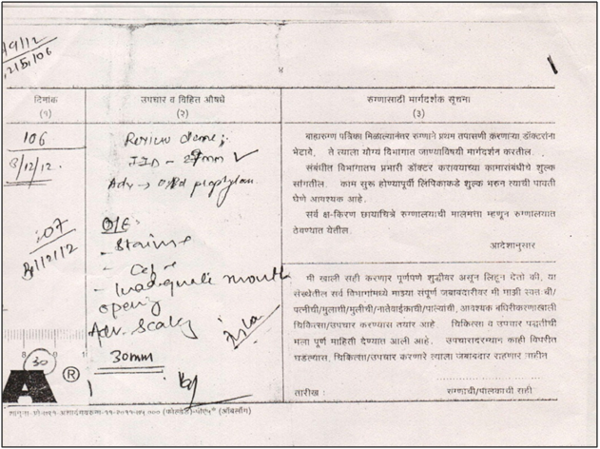

Case No.3

Doctor’s Name: Dr. Ajay Mehta

Patient’s Name: Mr. Raghunath Shambharkar, tea stall holder, a patient of Pyriform fossa Carcinoma (Lt Side), whose voice had totally gone due to radiotherapy. He had started chanting 45th Shloka for Mantra healing. There was an improvement in voice. It was better in swallowing chapattis. He had started abhishek of yantra. His voice was recovered completely within span of 21 days improvement was seen in his health. After investigation in hospital, Dr. Ajay Mehta gave certificate, No residual cancer, all nodules cleared. His voice restarted and cancer got cured
Dr. Ajay Mehta speaks, Spiritual Healing is not a very aggressive and it help in bringing down anxiety level of patient, so the painkillers and antibiotics start working on him smoothly. It is a very good complementary medicine.

PATIENT’S CASE HISTORY FORM
Raghunath Shrawan Shambharkar
Age: 53 years Sex: Male Address: Dr. Nagrale’s House, Ambika Nagar, Nagpur.
Patient’s Complaint: Difficulty in swallowing
Reports of previous treatments and names of doctors to whom patient has previously gone:

Tele Therapy Treatment - Govt. Medical College & Hospital, Nagpur
Relevant Investigation:

Laryngoscopy & Biopsy - 28/05/09 - Pyriform fossa Carcinoma (Lt Side)
Histopathology - 03/06/09 - Moderately differentiated squamous cell carcinoma
General Examination - 15/06/09 - Ca Pyriform fossa, Lt Side (T2 N0 MX)Growth find over Lt left pyriform fossa and extending to medial and lateral wall of pyriform fossa
Radiography - 16/06/09 to 03/08/09 - 33 radiations given.
Endoscopy - 16/09/09 - Oesophagitis. No residual or recurrence.
Detailed reports:
Diagnosis: Pyriform fossa Carcinoma
09/08/09 - Started chanting 45th shloka for Mantra healing.
12/08/09 - Improvement in voice.
24/08/09 - Feeling better started swallowing chapattis.
02/09/09 - Recovered his voice completely.
09/09/09 - Starting doing abhishek of yantra.
11/09/09 - Improvement in health.
14/09/09 - Check up done in operation theatre. Cannot see any nodule. There is nothing seen in throat. No saline required after 20 mins. The patient was asked to follow up after two months.
15/11/09 - The patient recovered his voice completely within span of 21 days.

Importance Of Mantra & Shlokas
In various cultures Mantras have been known to create amazing results because of sound vibrations that permeate every cell of your being. They let the mind dissolve. Mantras are impulses or rhythms of consciousness. They create spiritual vibrations [Narsimha, 2011].
Ohm is the manifestation of Divine – A symbol of infinity. ‘Hrim’ signifies siddhas – who have conquered themselves.
In the same way Bhaktamar Stotras states that alignment of mind, body and soul takes place while chanting this magical powerhouse full of 48 miraculous shlokas with mantras - tool of mind which causes shift in consciousness when chanted for 21 days regularly at same time and same place.

LITERATURE REVIEW : Bhaktamar is a very old prayer of devotion in the stuti of Lord Aadinath, the first Teerthankar of Jains. It is written in almost all languages.
Bhaktamar is a prayer of devotion in stuti or reverence of Lord Aadinath, the promoter (founder) of Jainism – the 1st Thirthankar.

Bhaktamar Bharti is collection of 124 Bhaktamar in various languages and it is published by Khemchand Jain Charitable Trust, Sagar (M.P.). This Trust was started by my Grandfather and my Uncle Shri Motilal Jain worked for years with great scholars to complete this Great Collection of Bhaktamar.
In India a Pandulipi – original manuscript is published by Jain Sanshodhan Kendra, Mahavirji in Rajasthan with pictures. The credit goes to Mr. N.K. Sethi (I.A.S) President (Mahavirji). Another book by Acharya Kam Kumarnandiji Maharaj have produced ‘Kavya a Karishma’ - a Bhaktamar compilation – which has meaning of shloka in Hindi, English & Telugu with Ridhi & Mantra and evidential stories with pictorial representation. I have referred all these books for my main research work. Although, there are numerous transaction of Bhaktamar in various languages.
An animation movie ‘Kavya ka Karishma’ is produced by the author (Spiritual Healing Centre) & Marina Creations under the direction of Mrs. Sarika Pendsey and Mr. Sanjay Pendsey of Radhika Creations about the creation of this stotra by Author ‘Acharya Manatunga Maharaj’ in 600 BC.
For the convenience of reader Bhaktamar is brought out in ISO format by the present author with the help of Dr. Raja Iyer (Quality Management Systems, ISO Certification body) and a ready reckoner with scope – purpose – method & resources and the benefits acquired by chanting the Shloka is made. This system is in process of ISO accreditation almost 90% of work is audited and final certification is yet to be received.

In June 2011 the author’s book called ‘Jaina method of Curing’ was published and released in Houston, Texas, USA at Jaina Convention by ‘International School for Jain Studies’. Sanskrit beej mantra in Bhaktamar was original in ancient language which was translated in Hindi by Prof.Bhag Chand Jain (author of 22 book in Jainism), it was later translated in english by Dr. Jawahar Lal Jain, Dean (Sagar University) and included in the above book.
BACKGROUND: In 1875, an academician from Germany came to India, learned Sanskrit and translated all 48 Shlokas of Bhaktamar in German language. He was none other than the renowned philosopher, Professor Hermann Jacobi who contributed 22nd & 45th Vol. n utras) in Max Muller's ‘Sacred book of East Series’ (1 to 50 vols.). His work was admirable especially since he was foreign to the Indian culture and language.
Prof. Hermann Jacobi’s work was a great inspiration to the author and she urged Prof. O.P. Verma to translate this work in French. Prof. O.P. Verma, the Head of foreign linguistic department and retired head of History and culture (from RTM Nagpur University) spent three years translating the Stotras, Mantras, Ridhi Yantras and evidential stories in the French language. Professor reported that an inner transformation took place within him during the undertaking of this translation work.
Shlokas and mantras have been part of author’s life since childhood. The author’s mother would chant a particular shloka if anybody fell sick or was in times of danger and as a result his health recovered and things would fall into place appropriately. The author’s interest in the healing powers of shlokas and mantras increased as she grew older.
Beej mantra – each letter of composition of mantra- “seeds of mantra
Yantra - is a copper plate on which the mystic diagram with powerful energy symbol is made
Shloka – 4 line verse in praise of God

My Story on Bhaktamar:
After completing my M.B.A., C.S. and Lead Assessor Course, something pulled her to take up this research in a scientific manner. She began going to a Hospice with the holy water of this Yantra & and the 45th shloka which claims to cure incurable diseases as stated in Bhaktamar to test the truthfulness behind the verse.
The case-studies taken up for her research brought out astonishing results which were endorsed by well known medical doctors in the field. After experimenting with the mantra and the 45th shloka in Hospice which says “We cannot cure you but only can take care of you”? The life of these terminally ill cancer patients got an extension of life, (2-3 months) who otherwise were alive for a week as shown by the records of Snehachal – a Palliative Care Centre, Medical Square, Nagpur.
The recovery of these terminally ill patients touched the author and gave her increased confidence and belief in the amazing effects of the chanting of the Mantras and Shlokas. Consequently she worked along with various doctors treating some very ill patients. The healing rates of these patients have been very successful. Dr. Ajay Omprakash Mehta, a well known, award winning Oncologist had certified the healing through the chanting of 45th Shloka – (a cure of incurable disease) as follows:-
Patients have benefited by this technique. It has strengthened their mental and physical health and helped in early recovery. I strongly recommend “Spiritual Healing” as a complementary therapy showing amazing results” (M. Jain, 2011, P.26).
Her Ph.D Supervisor, Dame Meher Moos inspired her to try and test the powers of other Shlokas as her next research project. If this would be successful, it would benefit people at large the public by drugless therapy. One of the millennium goals of UNITED Nations is Drugless therapy.

ETHICAL CONSIDERATION: An informed consent will be taken from all the school Heads and Teachers. It is possible that students of different faiths may feel uncomfortable about chanting of jain mantras. In cases such as these there will be no compulsion to participate in the research.
LIMITATIONS: It could be possible that some children / students may chant mantra without firm faith or belief. It remains to be seen how the result could eventually be affected.
It may be possible that some children may opt out from chanting for 21 day and may affect result.
Mandatory Precaution
Girls will not chant these mantra during menstruation cycle. During menstruation, jain tradition and belief carrying or touching of the book of Bhaktamar is forbidden.
For period of 5 to 7 days these girls can chant it in the minds without uttering the word verbally. Girls to be very careful during this period NOT TO TOUCH the book and not to chant mantra orally.
How To Use

You have to have faith in the system. That chating these shlokas i am going to achieve this. You have to chant with full intensity so that when you chant frequency of vibration matches with the cosmos.
Continuously chant the shloka 9 times till you feel the vibration in your left palm then right palm then left sole and right sole.
You can chant the Shloka 9 times or the mantra 108 times which will bring changes in the cellular structure of your body.

Keep the yantra in front of you while chanting.

For women, don't touch the book and yantras during the menstrual cycle. You can however chant in the mind.

We have created audios of the mantras and Shlokas. When you send us the purchase receipts you will get a download link. Listen to the Mantra and Shloka at night while sleeping.

If you cannot chant everyday just play the MP3 recording of the Shloka and Mantra everyday.

Someone sold 73 life insurance policies in one month. He would listen to the MP3 recordings while travelling to meet his clients.

Selecting the Mantra:

This is very important. Each mantra is specific.

Each human being has his own unique mantra that his consciousness resonates with. Just open the book and go to the mantra which you are drawn to irrespective of whatever the name or description of the mantra is.

You could just open the book to any page and chant that mantra that time.

There is no specific way of using the mantras. Just follow your inner guidance.
Someone used the Shloka for saving from drowning in water to get 4 major contracts worth 2 million dirhams. I have used the shloka for incurable diseases to have a snake leave my property. Someone used the shloka 1 for Disturbances are destroyed to selling his huge property.

1st Shloka: Disturbances are destroyed.

l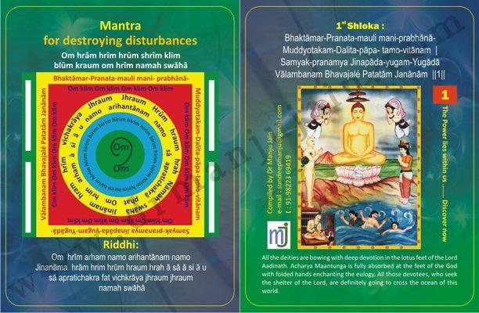

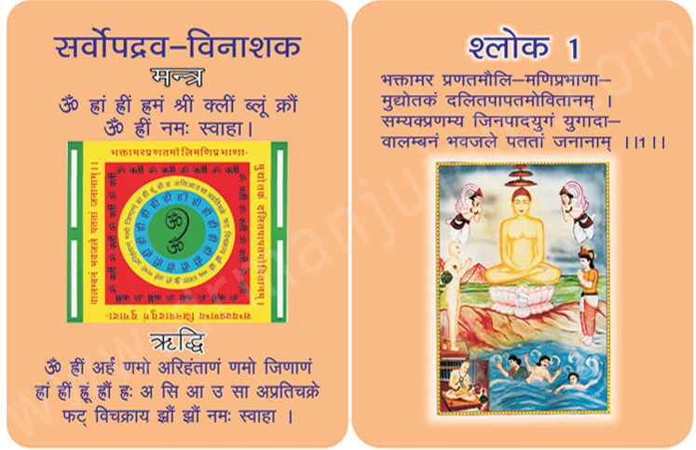
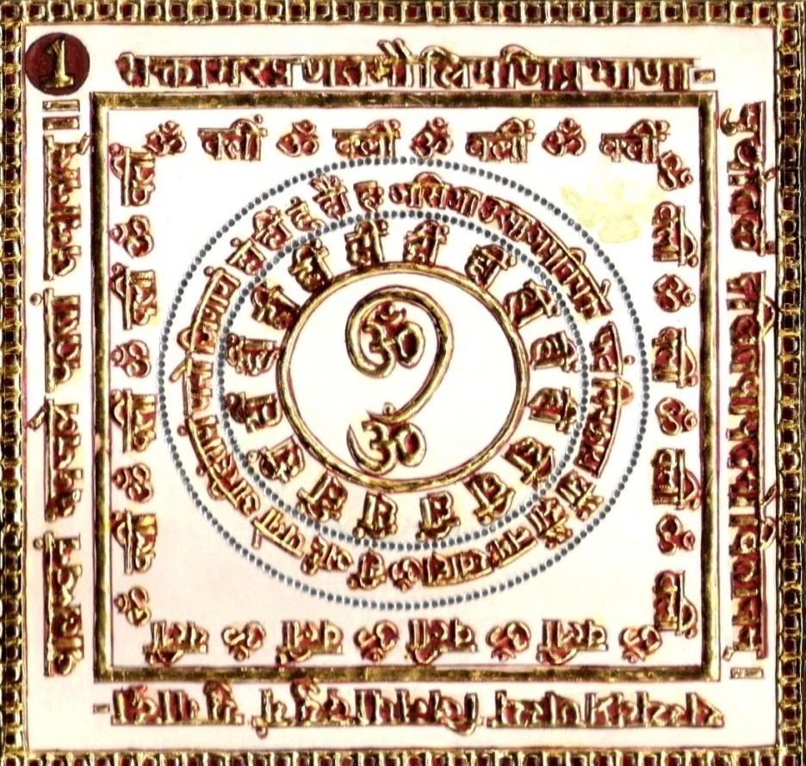
1.0 Purpose
1.1 Disturbances are destroyed.
1.2 Fortune is attained.
1.3 Wealth is gained.

2.0 Scope
2.1. Destroys the spreading darkness of Sin.

3.0 Method
3.1 Having dressed in white; and seated on a white base, facing towards the east, one lac chants be completed with adoration of the Riddhi and Mantra syllables 108 times everyday in pure phases.

4.0 Resources
1st Yantra, Mantra and Riddhi, White base and White dress

Shloka - Repeat 9 times
BHAKTAMAR-PRANATA-MAULI MANI- PRABHANA-
MUDDYOTAKAM - DALITA - PĀPA- TAMO-VITĀNAM
SAMYAK-PRANAMYA JINAPĀDA-YUGAM-YUGĀDĀ-
VĀLAMBANAM BHAVAJALÉ PATATĀM JANĀNĀM
Meaning
Oh! The mankind and all creatures are helplessly sinking into the ocean of worldly attachments!
Who can be the savior, and save them from sinking?
We are all engrossed in the darkness of sins and ignorance. What can absolve them; within no time?
While the deities with their gem-clad crowns on their heads offer their prayers and bow down, the bright and dazzling rays of gems spread all over.
What can brighten even such rays. There is only one answer: Jina-Pada-Yuga: The lotus-like feet of Bhagwan Adinatha.
Mantra - Repeat 108 times
Om hrām hrīm hrūm shrīm klīm blūm kraum Om hrīm namah swāhā
Riddhi (le pouvoir surnaturel)
Om hrīm arham namo arihantānam namo Jinanāma hrām hrim hrūm hraum hrah ā sā ā si ā u sā aprati chakra fat vichkrāya jhraum jhraum namah swāhā

Evidential Story -1

Sudutt - Falsehood Defeated by Truth

This is a story of the great middle ages when the country was divided into small kingdoms. There was an expert thief named Sudutt who was so smart that he could never be caught in spite of all the efforts of the State Administration.
The king was much worried and disturbed. On a fine day, to his bad luck, Suddutt was caught red handed at the king’s palace. He was presented to the king. The king felt quite proud and happy. The king asked Sudutt “at last you are caught. After all your tricks I see you in rags, but what about all the stolen property” ? He was not an only expert at robbery but also quite charming with his lies and magics. He replied saying Maharaj, all the stolen goods are kept with merchant Hemdutt. At this reply both the king and the merchant. Hemdutt were taken aback Hemdutt. The merchant quickly stated that he had never seen the fellow. “We Jains are very much against all sorts of violence and the 5 sins, and take a lot of care of every step we take. How am I connected to this man who is only telling us lies to escape. Hearing the truth of the Seth, Raja seemed pleased. So the thief started a new drama. Weeping he asked the Seth “are you not afraid of righteousness? If you want to be drowned you may do so, why do you want this poor man to be drowned? I have handed all the stolen goods to you, I did only what ever you had told me, Is this the reward for that, you save yourself and ruin me? My family will be starved to death. Doing such injustice you are not afraid of God, eve ?” Before even the thief could finish his story the king ordered his soldiers saying that the merchant is a traitor and the chief of thieves. Tie his feet hands and throw him into the dark well in the dense forest. The soldiers executed the orders. With out food & drink, hungry & thirsty the merchant lay in the well as he was bound hands and feet for 3 days. He understood that this was the fruit of his inauspicious deeds, with this realisation he lost all the body pains and began to get deeper into himself. 1st Tirthankar Bhagwan Adinath began to become visible to him. With excruciating pain he began to chant the yugal shloka from Bhaktamar Stotra. With the divine light his eyes were opened, all his bindings removed he found a bejewelled throne & there he found a Devi, she spoke saying “I am the administration Devi Vijaya. Your yugal sloka & mantra have brought me here. Saying this she disappeared. After some time his guards saw the light and the feth quite well, comfortable. This miracle was reported to the king. King understood that the merchant was innocent and the king came himself and with much honor took the seth to the palace, sought his forgiveness and punished the thief. Inspired by the yugal sloka of Bhaktamar stotra created by Muni Thungacharya, the king and his subjects accepted Jainism.

With the power of Bhaktamar Stotra the falsehood was defeated and truth triumphed

Practising the virtue of justice the king, punished the thief severely.

Testimonial
1st Shloka for destroying disturbances in life.
Mr. Pampalia speaks on litmus paper test for Bhakatamar. He took pledge that if within 7 days this materialistic not been sold for past one year. He took pledge that if within seven days this materialistic deal happens, then he will assume that this tool works. To his surprise the very fourth day a guy came who had seen the property earlier and give handsome token amount on fifth day for the purchase of this huge property. Mr Pampalia was also practicing celibacy vow while chanting mantras for past one month. This is the power of chanting and practicing celibacy.

2nd Shloka : Headache is destroyed.

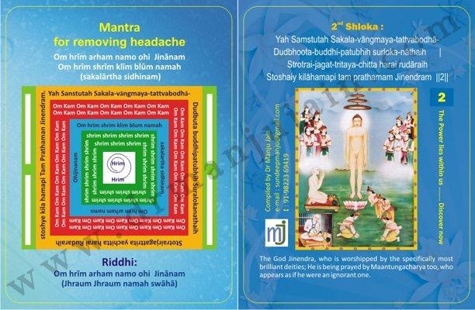

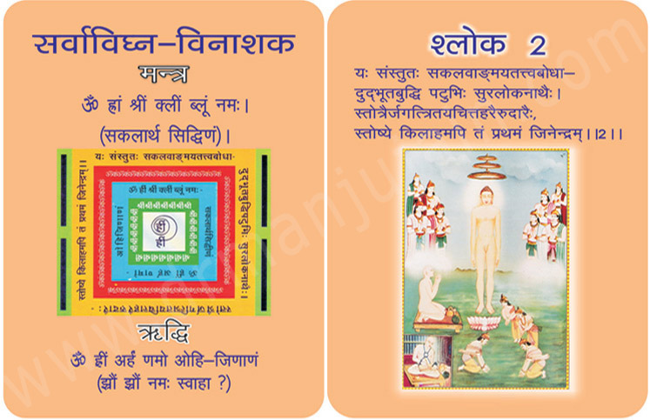
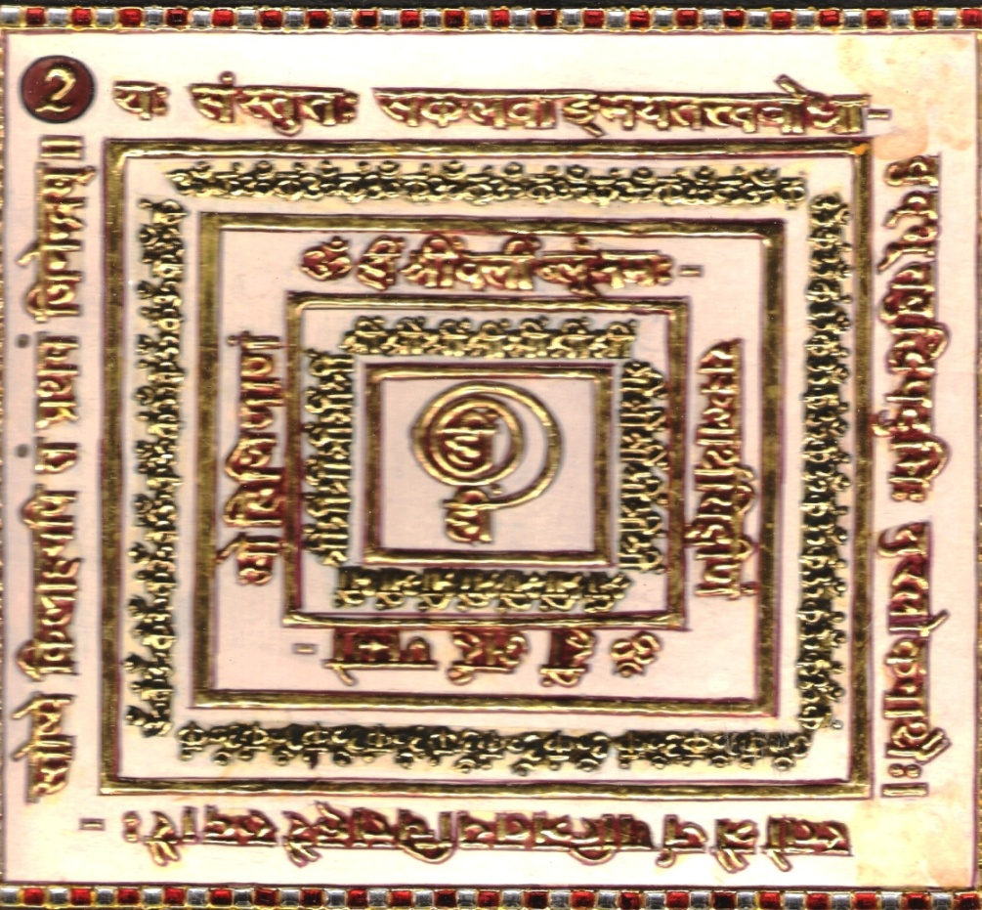

1.0 Purpose
1.1 Headache is destroyed.
1.2 Enemy is destroyed.
1.3 Illusive eyesight is removed.

2.0 Scope
2.1. Worshipping of the God by the especially most brilliant deities who are proficient in talent developed by knowledge of true and essential principles of Supreme Dadachanji. The devotee appears as if he were an ignorant one.

3.0 Method
3.1 Having dressed in black, with black rosary while sitting on black base facing the east, in Dandasana. Riddhi and Mantra Syllables are chanted at the rate of 108 times everyday for 21 or 30 days or else at the rate of 1000 times a day for 7 days. Meal should be taken once a day without salt.

4.0 Resources
2nd Yantra, Mantra and Riddhi, Black Dress, black rosary and black base,
Food without salt

Shloka - Repeat 9 times

YAH SAMSTUTAH SAKALA-VANMAYA-TATTVABODHA-
DUDBHOOTA-BUDDHI-PATUBHIH SURLOKA-NATHAIH
STROTRAIR-JAGAT-TRITAYA-CHITTA HARAI RUDARAIH
STOSHAIY KILAHAMAPI TAM PRATHAMAM JINENDRAM

Meaning:
Shree Manatunga soorishwarjee’s heart is in great decisive delight. He says, “I will positively compose a Stavan of Lord Adideva, the first Jain Tirthankara, who existed in the beginning of this age”.

There is a definite reason behind his decision. The leaders pave the way to be followed by common men.
Lord Rishabhadeva is worshipped by the Indras. These Indras have mastered the secrets of all the Shastras. They are highly intelligent. They have worshipped him with their generous and spell binding Stotras.

Therefore only, Manatunga Surishwarji Maharaj, with his highest perseverance, energy and confidence decides to pray Bhagwan Adideva through this extra-ordinary verse-The Bhaktamara Stotra.

Mantra - Repeat 108 times

Om hrīm arham namo ohi - Jinānam
Om hrīm shrīm klīm blūm namah (sakalārtha sidhinam)

Riddhi (le pouvoir surnaturel)
Om hrīm arham namo ohi - Jinānam
(Jhraum Jhraum namah swāhā)

Evidential Story: 2
To calm the Sea storm - Case Study of Sudutt & his wife

This story is also from the middle ages. Wearing yellow clothes and with folded hands Sudutta stands with his wife, who is holding a kalash - at the gate of his home. They were calling out to the Param Digambar muni to have pure food and water. Even today we feed the Digambar munies but the number has dwindled greatly in the case of munis as well as those who feed them.

The melodious voice of the young couple was spreading joy and peace all around, as it was full of devotion, respect and humility.

The munis passing by them stopped and had their meals. The couple asked them humbly for tatvagyan. Those were the times when by chanting mantras miracles were performed. Accordingly the great muni imparted the second yugal Kavya (third and fourth shloka) of Bhaktamar stotra to them and departed towards the forest. Sudutt was a merchant. He believed that “Lakshmi dwells in business”. So he loaded the ship with his goods and proceeded towards Ratnadweep.

In the evening there was a great storm at the sea. The ship started rocking dangerously. People were screaming with fear. Sudutt’s meditation was disturbed. Sensing the danger he started reciting the third and fourth shloka along with mantras. As a result of clear chanting, a divine form appeared before him with a divine aura. She introduced herself as Prabhavati and disappeared after giving him, Chandrakantmani. Immediately the storm began weakening, clouds started dispersing and there was a bright moon in the sky. The danger had warded off.

Early in the morning when the ship reached safely at Ratnadweep, the passengers were greatly humbled to know the greatness of Bhaktamar Shloka which was a reward for a humble and (devoted) feeding of the munis. They too developed faith in Bhaktamar Stotra and Jaina religion.

It is rightly said that annadan (giving food) yields great virtue. God also becomes small in front of a humble donor. Lord Adinath too became small in front of king shreyans at the time of meals. Deva praised shreyans for his benevolence and showered him with twelve crore jewels. This is the glory of a humble food distribution.

Testimonial
2nd shloka of Bhaktamar is said to relieve you from headache. This
magical tool brings harmony in your brain , tension is released by
chanting in rhythm, when the 84 meridian points of tongue touches the
upper pallette , sound vibrations in Sanskrit simulates neuropeptides
secretion and reaches tranquility state of peace , - no response to
stimuli.

3rd Shloka: For improving Eyesight

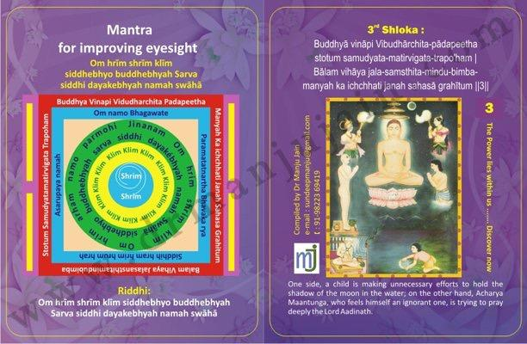

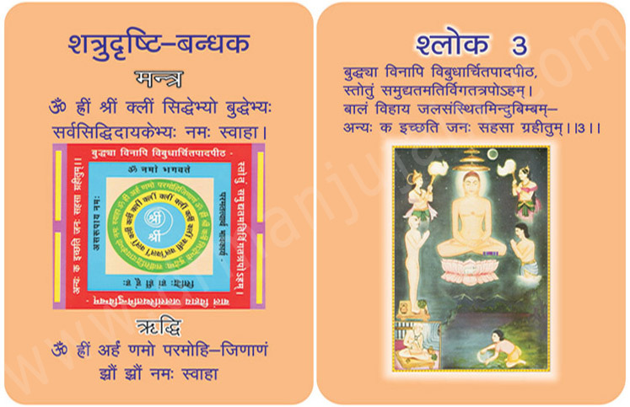
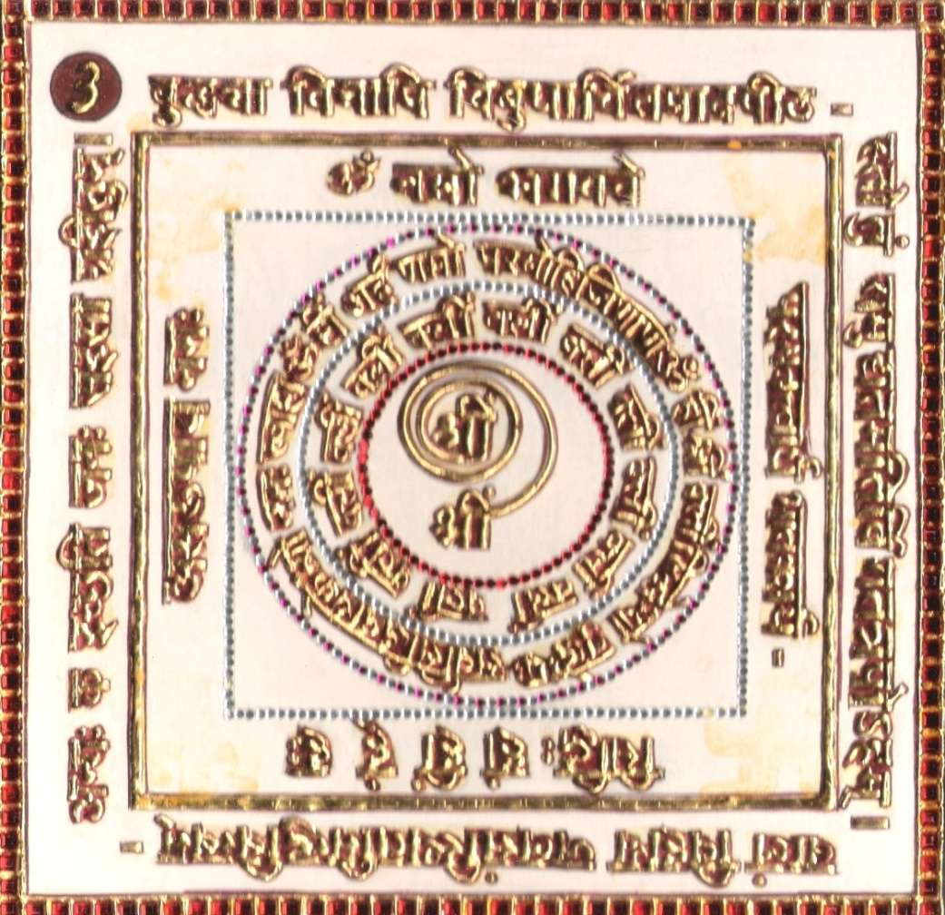
1.0 Purpose
1.1 Happiness of people
1.2 Eyesight is improved.
1.3 Enemy is unable to see.

2.0 Scope
2.1. Being devoid of wisdom the devotee has decided to eulogize Adinath God whose feet has been worshipped by God, like an infant suddenly wishes to grasp the disc of moon reflected in water.

3.0 Method
3.1 Dressed in Black with black rosary, syllables are chanted 108 times a day, 1000 times in 7 days. Blooming roses are offered. A handful of water is made mystic through mantra and sprinkled on the face for 21 days.

4.0 Resources
3rd Yantra, Mantra and Riddhi, Black Dress, Black rosary, Blooming roses and water.

Shloka - Repeat 9 times

BUDDHYA VINAPI VIBUDHARCHITA-PADAPEETHA
STOTUM SAMUDYATA-MATIRVIGATA-TRAPO’HAM
BALAM VIHAYA JALA-SAMSTHITA-MINDU-BIMBA-
MANYAH KA ICHCHHATI JANAH SAHASA GRAHITUM

Meaning-
Oh Lord! The Devas have bowed down and rubbed their heads in your pious feet and Padapatha, in adoration. Oh Lord! You are great. Lord, allow me to worship you. Please shower your blessings on me. You know that I have no wisdom: But in spite of that, I have decided to compose a verse of prayer on you. I have a burning desire to feel you in my physique and mind; and rightly so, I have no reservations at all. Lord! I am your child. I am innocent.
A lovely full moon in the sky is reflected in the lake. How cute does it seem! A child will crave – and even dare – to pick the moon up from the lake! Many bigger and elderly people may not do so. However, I am your kid; and so not ashamed to pray you.

Mantra - Repeat 108 times

Om hrīm shrīm klīm siddhebhyo buddhebhyah
Sarva siddhi dayakebhyah namah swāhā

Riddhi (le pouvoir surnaturel)
Om hrim arham namo paramohi-Jinānam
(Jhraum Jhraum namah swāhā)

Evidential Story - 3
Darkness of Sin Disappear to purify the Mind the devotee prostrates at the feet of Adinath

This Stotra is written by Sri Manathungacharya who is bound by iron chains in a dark prison from where he writes this to his beloved Adinath Bhagwan. At this time he prostates before him with full devotion to accomplish the work properly. With both hands touching the forehead panchang purvak namaskar is done. If it lacks devotion, faith and respect then it is dravya namaskar. It does not have the achievement of its aim and obstruction less work.

The creator of the stotra Acharya Mantungji describes the lotus feet of Shri Adinath Bhagwan. Jewels of the crown of the devotees who bow down at the Sri Jineshwar Dev start glittering heavenly, due to the rays eminating from the nails of his divine feet.

One crore deities (devas) are constantly at the devoted service of Jineshwar Dev, secondly the divine feet destroys sin. It means that the darkness of sin is dispelled as soon as a person bows at his feet. To purify the mind there is no more better and beautiful means than service at the Jina feet.

Thirdly the divine feet are like a beautiful strong boat to carry the devotees who take refuge in them across the ocean of Samsara (world)

Stotra creator Acharya Shri says that saints or Devas with great powers also bow reverently at the lotus feet of Lord, then who are we ordinary mortals?

When devotee wants to attain the supreme place. Namaskar comes first in this bhakti, we should not forget that.

In this pad, the creator of the Stotra first prostrates at the feet of his beloved first Teerthankar, Shri Adinath Bhagwan Deva, where Devis also sing his glory.

Testimonial
M. Mohini Sharma, An Angel Healer had come to Nagpur for our 2nd International Conference on 11th July 2010. Her Sister-in-law was looking after their Rosary stall. She came to me after my presentation on Bhaktamar and distribution of 48 Mantra Healing Cards. Her Sister-in-law inquired with me that, is there any mantra for curing eye disease? Her daughter was blind, I gave her 3rd Shloka, a cure for eye sight and 5th Shloka a cure for eye diseases to chant for 21 days.
She had called on 25th July saying that her daughter’s eye balls have started rotating and she is feeling good. She further asked me, what further action can be taken to improve the recovery? I told her that, if they can give up salt, that would bring a wonderful recovery in this therapy.

4th Shloka: For saving drowner from water

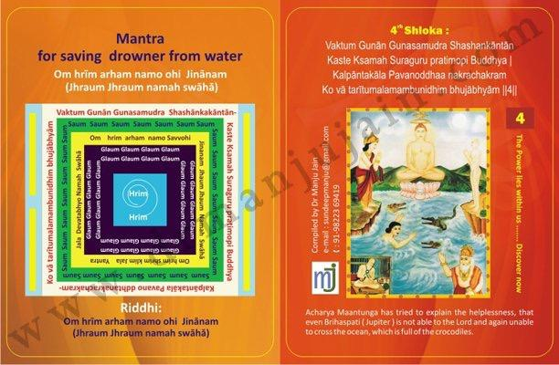

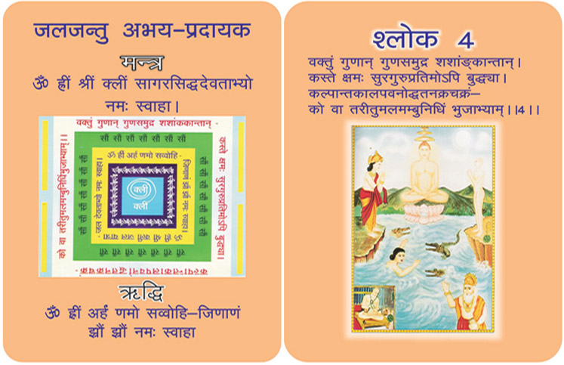
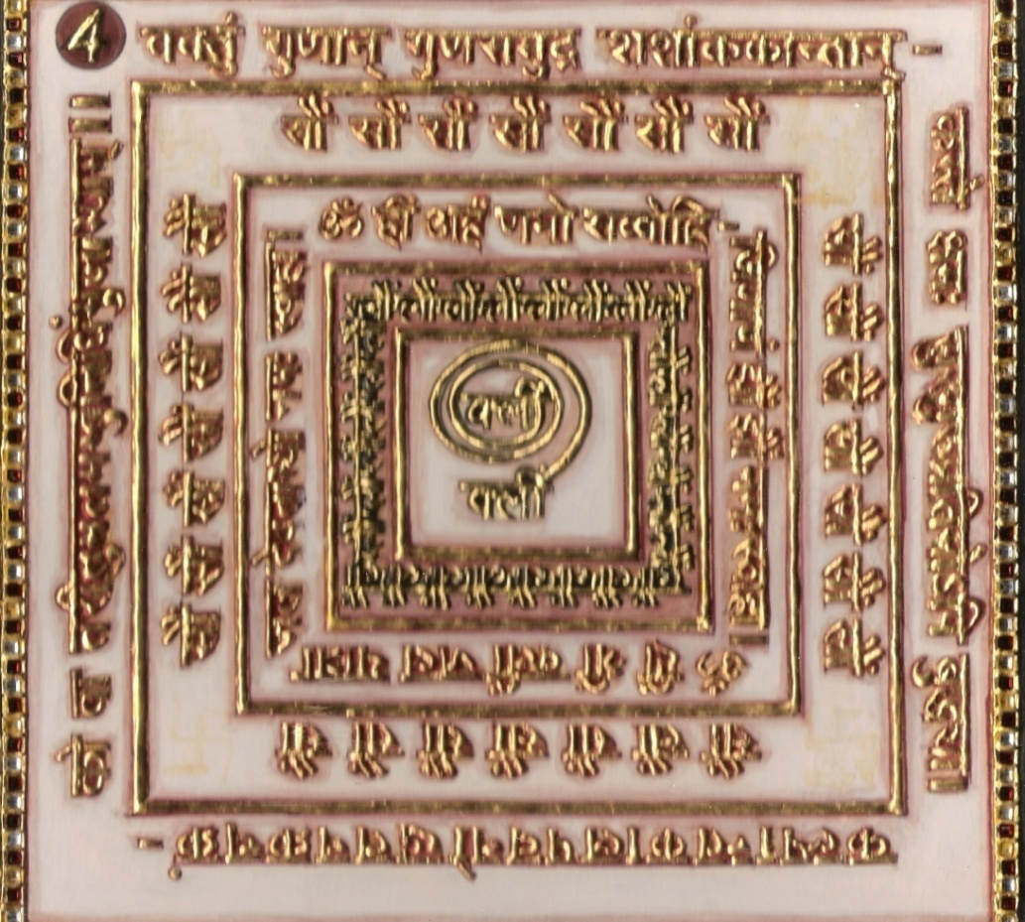
1.0 Purpose
1.1 The adorer does not drown in water and is safe from currents.
1.2 Fish, etc are safe from nets in river/tanks.

2.0 Scope
2.1. Even Jupiter (Full of wisdom) is unable to praise the infinite virtues of Adinath Tirththankar

3.0 Method
3.1 After bath, clothed in clean white, Yantra is established and worshipped. Riddhi and Mantra are chanted 1000 times a day for 7 days with rosary crystal quartz. Offering 108 flowers everyday. One meal a day. Sleeping on the earth. Every pebble made mystic through 7 chants of Riddhi mantra.

4.0 Resources
4 Yantra, Mantra and Riddhi, white dress, rosary crystal quartz, flowers, 21 pebbles thrown in river.

Shloka - Repeat 9 times

VAKTUM GUNAN GUNASAMUDRA SHASHANKANTAN
KASTE KSAMAH SURAGURU PRATIMOPI BUDDHYA
KALPANTAKALA PAVANO DDHAANAKRACHAKRAM KO VA
TARITUMALAMAMBUNIDHIM BHUJABHYAM

Meaning-

Oh, the ocean of virtues!
Where is the question of sharp intelligence for praying your virtues!. Even the Guru of Devas is not capable of assessing your pious attributes, charming like the moon. And so, if I do not know how to pray you, why should I be ashamed of it?
Oh, look at that ocean; at the time of Pralaya it thunders. The wild and mountainous gigantic waves and dangerous crocodiles make it impossible to swim.
Oh my God! What would happen if someone asks to swim across his horrifying sea…? Who can do so…?
Oh Lord! Oh Lord! Who can narrate your qualities?
Lord! Your attributes are infinite! I am finite.

Mantra - Repeat 108 times
Om hrim klīm sagara siddha dévatabhyo namah swāhā

Riddhi (le pouvoir surnaturel)
Om hrīm arham namo savvohi - Jinānam
(Jhraum Jhraum namah swāhā)

Evidentual Story - 4

Deep Devotion & Faith in Child’s Case

Shree Mantung Acharya took an oath to create stotras. He says that Jinendra Dev is the supreme God. The devas worship the stool where his feet rests. One should undertake a task which is with in his power. Otherwise one may have to leave it half way and become a laughing stock. “But I am so eager to worship you that I have ignored my capability”.The beautiful reflection of the moon appears in water. An intelligent person would not try to go after it. But an innocent child tries to hold the reflection. My eagerness for you is just like the creator of the stotra Acharya Mantungji describes the lotus feet of Shri Adinath Bhagwan. Jewels of the crown of the devotees who bow down at the Sri Jineshwar Dev start child’ s. Although the Acharya is an able scholar and poet yet he considers himself small. The great glittering heavenly, due to the rays emanating from the nails of his divine feet.
One crore deities (devas) are constantly at the devoted service of Jineshwar Dev, secondly the divine feet destroy sin. It means that the darkness of sin is dispelled as soon as a person bows at His feet. To purify the mind there is no better and beautiful means than service at the Jin-feet.
Thirdly the divine feet are like a beautiful strong boat to carry the devotees who take refuge in them across the ocean of Samsara.
Stotra creator Acharya Shri says that saints or Devas with great powers also bow reverently at the lotus feet, then who are we ordinary mortals?
A devotee wants to attain the supreme place. Namaskar comes first in this bhakti, we should not forget that.

In this pad, the creator of the stotra first prostrates at the feet of his beloved first Tirthankar, Shri Adinath Bhagwan Deva where Devis also sing his glory.
People never talk big because by being nothing or small we reach God whereas by feeling great
(Considering oneself great) God is realised much later. The Acharya further says that “Oh Adishwar you are peaceful like the virtuous ocean. Your virtues shine like the moon. Even Lord Brahaspati cannot glorify (praise) your virtues, then who am I to sing your glory? Who can swim across a stormy ocean full of crocodiles meaning thereby who can do the impossible task, no one! Speech can not glorify even a single virtue of the tirthankar. Stavan (worship?) is the main feature of bhakti.

Testimonial

I was in the Capri in the midst of Mediterranean Sea. We had hired a yacht and all of us were sailing in the middle of sea. Suddenly my friend had sea sickness and I started chanting this shloka and within few minutes her nausea stopped and she did not vomit. I was thinking in all the evidential stories a goddess Devi appears whenever the devotee is chanting shloka but in my case when will goddess appear. Suddenly the guide said the boat will be passing under the arch where goddess of Capri lives and you can ask for any wish which will be fulfilled. This is the amazing power of chanting bhaktambar shloka.

5th Shloka for Eye Disease
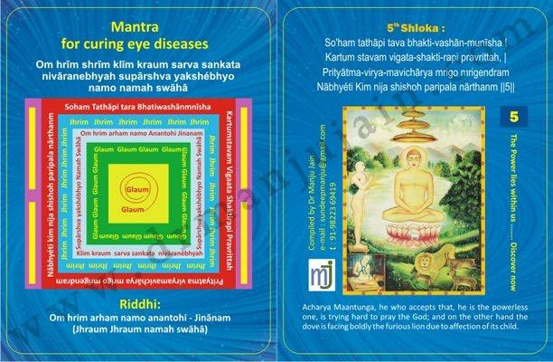

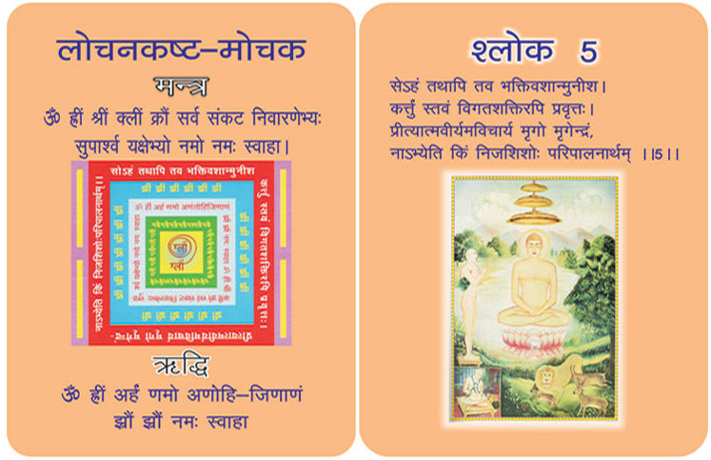

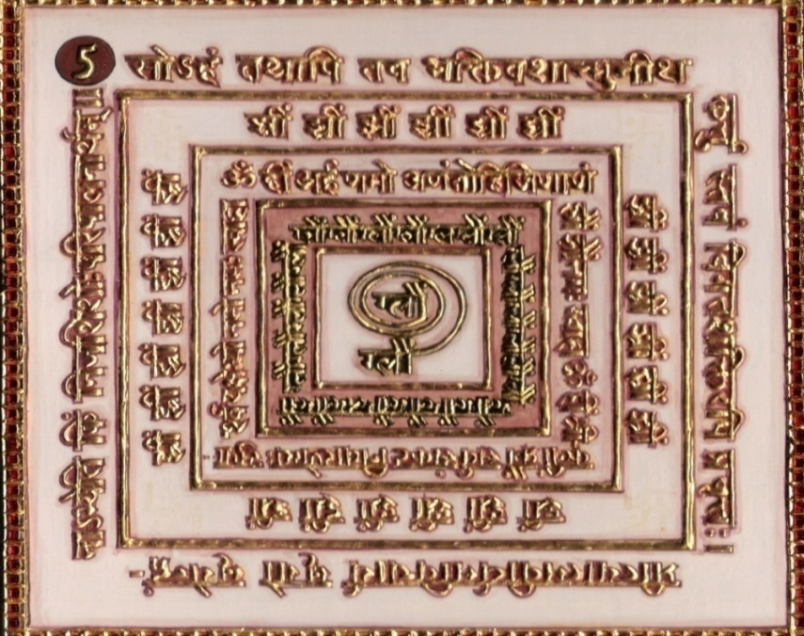

1.0 Purpose
1.1 Water of well can be made red germless. Eye disease and pain is relieved from the dreadful pain by pouring the water made mystic by chants of Riddhi and mantra syllables.

2.0 Scope
2.1. Though devoid of power yet urged by devotion the devotee is trying hard to pray to God like the deer, not taking into account its own might faces boldly the furious lion due to affection of its young one.

3.0 Method
3.1 Having bathed and clothed in yellow establishing the Yantra, one should worship then having sat on yellow seat he should chant the Riddhi and Mantra syllables 1000 times a day for 7 days with yellow flowers and pure phases incensing with oblibanum every time.

4.0 Resources
Yantra, Mantra, Riddhi, Shloka, Yellow clothes, Yellow Seat, Yellow Flowers, Water.

Shloka - Repeat 9 times

SO’HAM TATHAPI TAVA BHAKTI-VASHAN-MUNISHA
KARTUM STAVAM VIGATA-SHAKTI-RAPI PRAVRITTAH,
PRITYĀTMA-VIRYAM-AVICHĀRYA MṛIGO MRIGENDRAM
NĀBHYÉTI KIM NIJA SHISHOH PARIPALA NĀRTHANM

Meaning
But oh Lord! Oh Leader of great sages!
May be that I have no words or ability to sing about your great qualities. Doesn’t matter if I am considered a fool, may be, so am I.
In spite of my senselessness, I want to sing you sincere devotee. All of my shortcomings will be pardoned in front of my sincere and craving devotion.
Look at that deer. She has just delivered her cubs. Her children are as dearer as life to her. The lion roared to her, but the mother deer said, “Oh come on lion, I am willing to protect my children. I have accepted your supremacy till now, but today I will fight with all my Will and Valor for my children. I am willing to fight until death!”
Who can challenge the mother’s love?
Who can put to test the love of a mother?
Here, ya Mantunga Sorishwarjee compare the critics of poetry with Lions and hails himself and Bhaktamara Stotra with Mother Deer and her cub.

Mantra - Repeat 108 times

Om hrīm shrīm klīm kraum sarva sankata nivāranebhyah supārshva yakshébhyo namo namah swāhā

Riddhi (le pouvoir surnaturel)
Om hrim arham namo anantohi - Jinānam
(Jhraum Jhraum namah swāhā)

Evidential Story - 5
Carpenter Deval gaining wealth

A poor carpenter used to live in Subhadravati in the Konkan region. All of a sudden carpenter Deval became very wealthy. All wondered how a person in tatters with a family deprived of proper food ever could now construct a temple for Lord Adinath and a palatial house for himself.

His neighbours grew jealous of him. Where as some people who ignored him earlier started flattering him.

Some wise people asked him for the mantra which changed his destiny. Deval was a simple and innocent man. Politely he informed them that the simple game of gilli - danda changed his life. He said “While I was in my shop a small boy of 7 or 8 years came to the ground with a book. He was intently watching the game but could not play it, for he had nonstick. A kind boy gave his stick to this boy. But the stick soon broke and the little boy was very much saddened because felt much pain for having broken the other boy’s stick. I called the boy to me and enquired about him. He was Somkranti the son of merchant sudhan. I enquired about the book he had. It was the holy Bhaktamar Stotra. I was very much fascinated by his innocence and made two sticks for him, one for himself and the other to be returned. The boy happily handed me the book and ran away to play. I started reading the fifth shloka. I felt so delighted, and I by hearted it with riddhi and mantra and read the method of its meditation by the time the boy returned with the book”.

With faith and devotion I chanted the shloka with riddhii and mantra in a cave. One night after many days Devi Ajita appeared to me and told me to ask for a boon. I asked for wealth. Spreading divine aura she asked me to dig the earth around a peepal tree on the north east direction and I obeyed. There I found a big treasure, lots of jewels. I promised to construct a grand temple for Lord Adinath with Bhaktamar stotra along with riddhi and mantra inscribed on its walls. After fulfilling my promise I made a house for my family”. This impressed everyone and all became devotees of Bhaktamar Stotra.

Testimonial
Roshan Rajendra Jain, who was not able to see and was not able to appear in exams. He was not able to see and tears use to fall so his mother, Mrs. Bali was advised by Dr. Manju jain to chant 5 th shloka and do 108 times mantra and riddhi for 21 days and he was able to appear in exam easily in 21 days . Everyone should do it for their well being. Mrs. Bali now teaches all the children Bhaktamar in temple voluntarily although she is not a jain but her devotion to bhaktamar even cured her son from Spine problem .

Mrs. Saroj savla from Mumbai had been operated 6 times in 6 months to stabilize retina and she had lost vision also. It was her turn to get operated 7th time and doctors were trying to fix retina which would get displaced. This time she got mantra & shloka of Bhaktamar for curing eye disease. She started chanting on Friday and when she visited her doctor on Monday, he said retina has been stabilized and you do not require surgery. Her vision also improved.

6th Shloka for IQ and Memory Skills

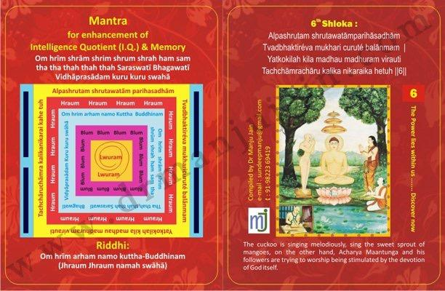

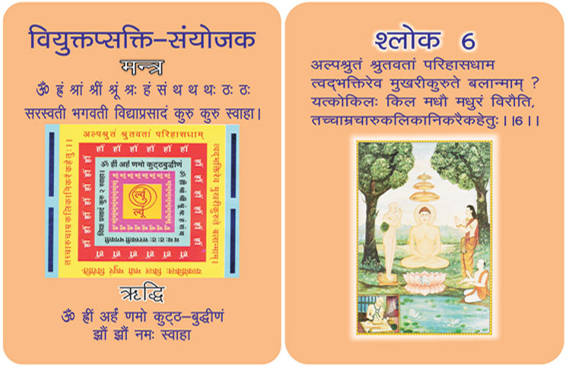
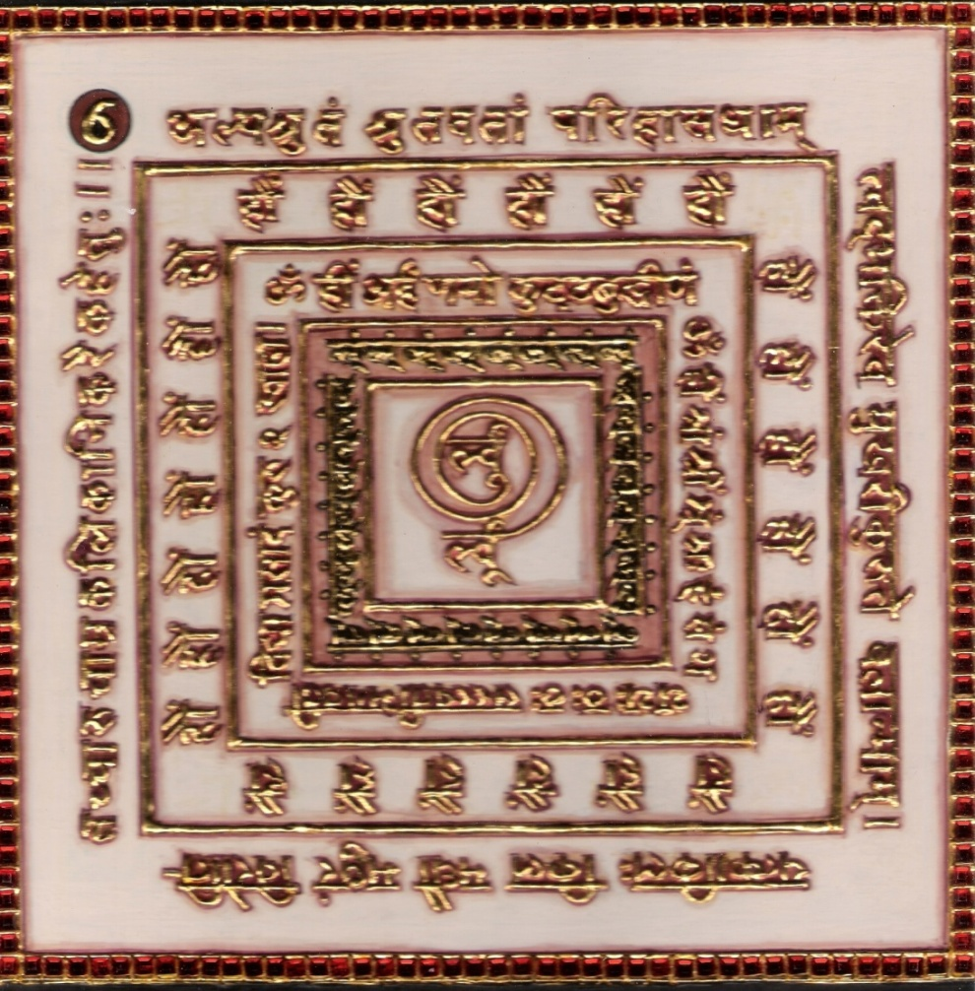

1.0 Purpose
1.1 The advantage of chanting this Mantra & Riddhi. The person separated also reunites. Remembering the sixth verse and Riddhi Mantras syllables everyday and keeping Yantra near you increase the memory, capacity to learn very soon.

2.0 Scope
2.1. The devotee who is conversant with only scanty knowledge and can become an object of ridicule in the eyes of well versed and proficient still tries to worship the virtues of God like the cuckoo sings melodiously only when she sees a collection of mango sprouts in spring season. (if cuckoo had melodious voice why doesn't she sing in other season).

3.0 Method
3.1 Having bathed and dressed in red, the yantra is placed and worshipped and seated on red seat the Riddhi and mantra syllables are chanted 1000 times a day for 21 days. Every time oblibanum is offered. A one time meal a day and sleeping on earth is followed.

4.0 Resources
Red clothes, Red Seat, Yantra, Mantra, Riddhi and Shlokas, One time meal a day, sleep on earth.

Shloka - Repeat 9 times

ALPASHRUTAM SHRUTAWATAMPARIHASADHAM
TVADBHAKTIREVA MUKHARICURUTE BALANMAM
YATKOKILAH KILA MADHAU MADHURAM VIRAUTI
TACHCHĀMRACHĀRU KALIKA NIKARAIKA HETUH

Meaning

Oh Lord! I know my limitations and I cannot vie with highly knowledgeable people. I have not even heard as much as them, my humble creation is just not to be compared with their great verses, prayers and poetry. I would ask all of them:-
“See, have I created all these prayers deliberately? No, not at all. My small heart is overflowing with the love of God; therefore some words and stanzas have fallen here and there from it! What can I do for that?”
Just look at that cuckoo. Just ask her if she knew the rules of music. Just ask her whether she knew about the meters and Ragãs: Tala & Laya (Rhythm)?
She will reply that she is not singing in an orchestra. Nor she is willing to get auditioned for music.
“See! Springs have come. That mango tree smiles, In fact, it is blossoming. The atmosphere is full of fragrance and very tempting.
The blossoming mango, full of fragrance, tempts me to sing. If you want to listen, do so; and if you like, you may also sing.
You name it a poem or a pun as you like. Who cares?”
Similarly, Acharya Manatungasoori states that whether critics consider this Bhaktamar Stotra as a beautiful poem or a mere pun, he is indifferent.

Mantra - Repeat 108 times

Om hrīm shrām shrim shrum shrah ham sam tha tha thah thah thah Saraswatī Bhagawatī Vidhāprasādam kuru kuru swahā

Riddhi (le pouvoir surnaturel)
Om hrīm arham namo kuttha-Buddhinam
(Jhraum Jhraum namah swāhā)

Evidential Story - 6

Dull Headed Boy Bhupal who sought after Wisdom Intelligence

All of as know that every one does not have the same level of intelligence and talents. Due to one’s past life’s karma some are exceptionally intelligent and talented. In the same way due to past life’s karma some are foolish dull and sluggish. Such persons feel miserable when they fail to grasp the lessons in the class and such has to tolerate insults and humiliations. They feel inferior and unfortunate. In spite of all their efforts to learn and obey their teachers, they do not succeed. It could be that in his previous birth, they had disturbed some one’s studies, hidden or stolen someone's book or been irresponsible with someone’s books.

Here is a story about such a dull headed boy who by reading sixth shloka with mantra and riddhi became a great scholar.

In olden days Hemvahan used to rule the capital of India. The king had two sons. Bhupal was the elder and Bhujpal was younger. The elder brother was very dull whereas the young Bhujpal was extremely brilliant. Both were sent to Pandit Shrutdhar’s ashram for learning scriptures and various other streams of knowledge. Guru taught them for 12 years with zeal and devotion. Bhujpal became an expert in the scripture and many other streams of knowledge. The older brother could not learn due to his past misdeeds. All the efforts the guru put in the case of Bhupal were in vain.

Bhujpal advised his elder brother to read Bhaktamar Stotra. After reading the 6th shloka with mantra Riddhi with utmost devotion and faith, after 21 days he had darshan of Brahmi Devi, who blessed him with wisdom and intelligence.

With the greatness of Bhaktamar stotra Bhupal became a great scholar and earned a position in Puranas. The greatness of Bhaktamar stotra is such the worst of sins can be washed out by the devoted recitation of it with deep faith.

Testimonial
Solution for increase the memory, capacity to learn, reunites the separated persons

Advantages of Chanting 6th Shloka
-The person separated also reunites.
-Remembering the sixth verse and Riddhi Mantras
-syllables everyday and keeping Yantra near you increase
- the memory, capacity to learn very soon.
-6th shloka activates latent talent and abilities.
-Hypothesis chanting of “6th Shloka” gives effects:
-Changes the pattern of intelligence.
-Changes the aspirant for good behavior.
- Improves memory retention capacity of students.
-Enhances the of concentration in students.

We all have been hearing mantras since ages- the sages, saints and masters from all walks of life have been asking people to repeat prayers and chant various mantras, also meditate and follow rituals. These processes and actions have been giving tremendous solace to people. We hear from common people that these methods are peaceful, tranquil and bring positive changes. But we have not heard rather our ignorance that any scientific research has taken place for proving. This particular study has been conducted with all possible limitations and scientific approach to prove that the resonance of
chanting mantras and repetition of prayers have positive effect on human intelligence so that this will help people at large to solve their children's problems, rescue them from anxiety and improve their behaviour.
Tittle: Mantra for improving I.Q and Memory Skills
Chanting of 6 th Shloka of Bhaktamar gives positive effect on child's performance.
1) 6 th shloka changes the pattern of intelligence.
2) 6th Shloka changes aspirant for good behaviour
3) 6th shloka improves memory
4) 6th shloka improves concentration
5) 6th shloka chanting improves pronunciation.
Sampling: Controlled group and Treated Sample 2000 school students
Preliminary studies conducted in Mordern school Jingle Bells.
410 students between age group 2.5 to 5 years for a period of one month

Findings:- I.Q. and memory enhancement
Improvement in concentration.
Improvement in grasping power.
Improvement in behavior at home.
Classwork and Homework completion on time.
Clarity in pronunciation.

Mrs. Anita Agarkar has cured 20 mentally challenged children in period of 2 years. Chanting with them daily except for Saturday & Sunday. These children have benefitted so much that now principals of school have started sending Autistic children, children with low IQ and having dyslexia and dysphasia of her school. Anita agarkar’s mind dare for curing this type of illness in children.

7th Shloka for Removing Snake Poison
Image

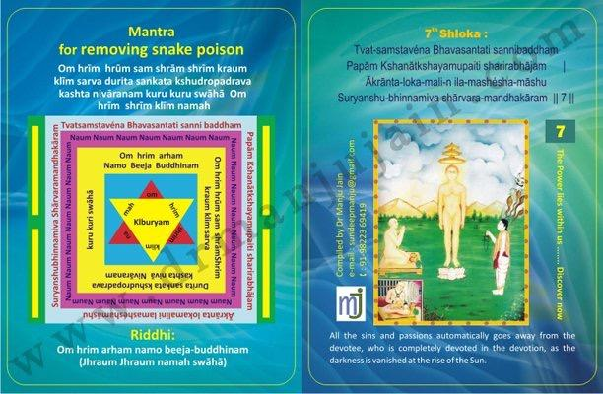
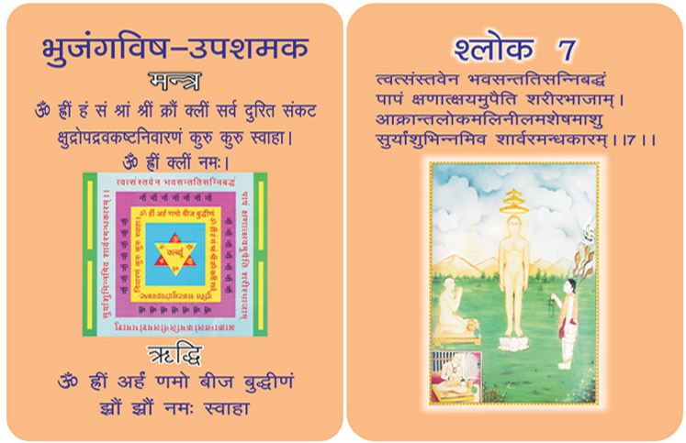
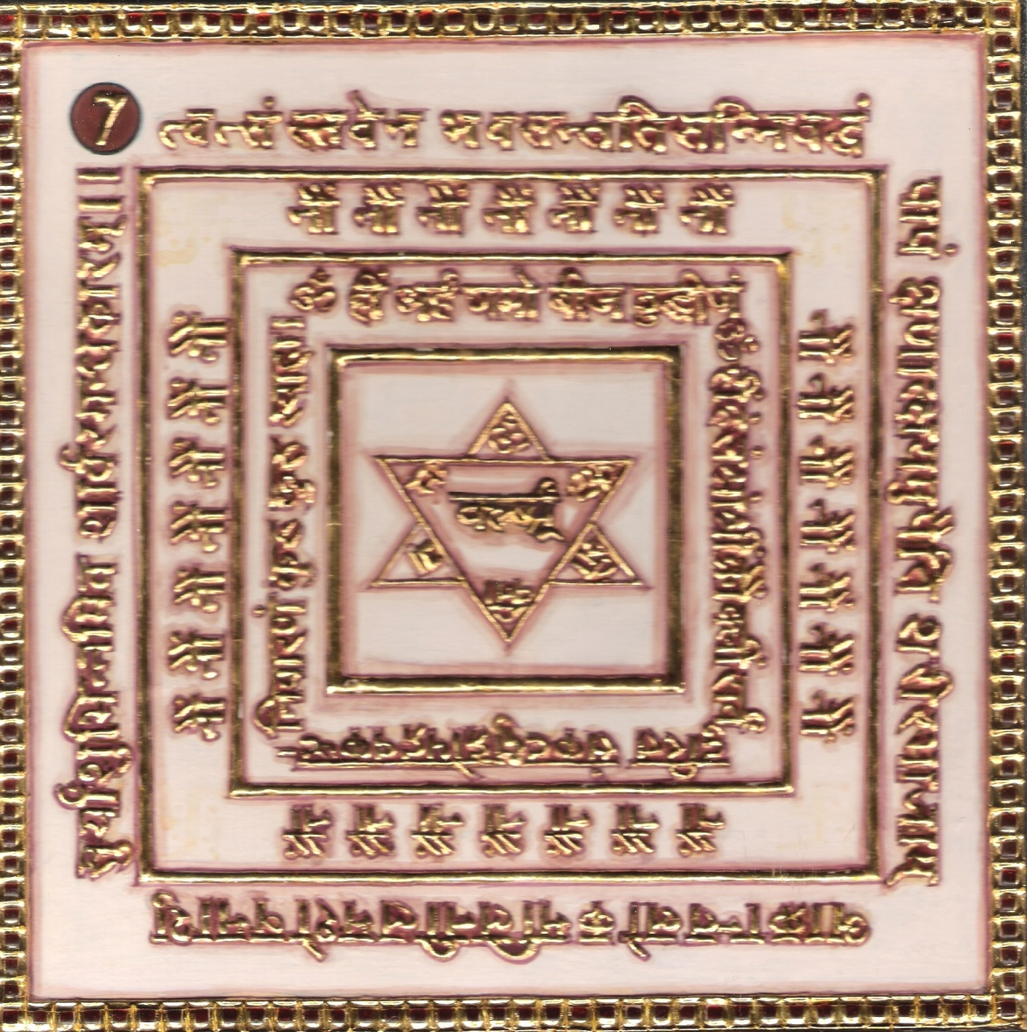

1.0 Purpose
1.1 To remove the snake poison and other poisons.
1.2 Snake can be paralyzed.

2.0 Scope
2.1. The continuous sins and crimes of all the living beings automatically goes away from the devotee, who is completely devoted in the devotion, as the darkness is vanished at the rise of Sun.

3.0 Method
3.1 Having bathed and clothed in green, seated on green base. The 7th verse, Riddhi and Mantra syllables be chanted 108 times a day for 21 days with a green rosary and olibanum of benzoin is offered every time.

4.0 Resources
Yantra, Mantra, Riddhi and Shlokas, Leaf of birch tree and pebble,
Green Clothes, Green Seat and Green Rosary

Shloka - Repeat 9 times

TVAT-SAMSTAVENA BHAVASANTATI SANNIBADDHAM
PAPAM KSHANATKSHAYAMUPAITI SHARIRABHAJAM
ĀKRANTA-LOKA-MALI-N ILA-MASHESHA-MASHU
SURYANSHU-BHINNAMIVA SHARVARA-MANDHAKARAM

Meaning
Oh God! The cycle of birth and death rules us since beginning less time, in course of which attraction of happiness and hatred to agonies have accumulated heaps and heaps of karmas, but why should I be worried about them? I will loudly sing your prayers and merge myself with you. Then?

The mountains of sins will disappear and perish within moments under the impact of your prayers.

Yes! Sins do perish; perish within seconds and there is no surprise in that. The night slowly went on gathering the darkness. She eventually sunk the whole world into her pitch darkness; but the sun will rise in the morning and melt away the entire darkness within no time.

Mantra - Repeat 108 times

Om hrīm hrūm sam shrām shrīm kraum klīm sarva durita sankata kshudropadrava kashta nivāranam kuru kuru swāhā Om hrīm shrīm klīm namah

Riddhi (le pouvoir surnaturel)
Om hrim arham namo beeja-buddhinam
(Jhraum Jhraum namah swāhā)

Evidentual Story - 7

Dharmapal (Patna)

This is a middle age story. King Dharmapal used to rule Patliputra (Patna). There was a rogue named Duliya who with his lies and frauds cheated innocent people. He had attained Vaitali Vidya which can be attained by people with no character at all. Due to his evil deeds and terrorism the people of Patliputra even the king himself had to bow at his feet. But such evil can never survive long.

A disciple of Lord Jinendra by the name Ratishekhar watched all these miracles which were meant to bring evil fruits. He was waiting to burst the bubble. He was a keen follower of Jainism. He had realised spiritual knowledge to a certain degree and also knew mantra-tantra. Once Ratishekhar was in the temple study room studying when an important disciple of Dhuliya sat close to him expecting Ratishekhar to bow before him. Ratishekhar continued to be immersed in his study ignoring the disciple. The disciple went to Dhuliya and reported the matter. Dhuliya was infuriated. He meditated on Anugamini Devi of Vaitali Vidya and asked her to kill Ratishekhar. She said that it was impossible to kill him but she would disturb his growing influence by a dust storm.

Immediately a terrible dust storm broke out. Buildings started shaking. People were fear- struck. The big mansion of Ratishekhar was also hidden by the dust storm.

At this time he was at the study room. He immediately started reciting the great 7th shloka (twatsanstaven bhavasantat sannibad dham) along with riddhi and mantra. In his meditative state he saw, Devi Jrambh mounted on the chest of devi of vaisali vidya, cursing her for creating trouble for the devout disciple of Lord Adinath.

When Ratishekhar opened his eyes he found the dust whirlpool had shifted from his village and was hovering above the hut of Dhuliya. Dhuliya fell at the feet of Ratishekhar along with his evil disciple and asked for pardon. He showed eagerness to be initiated into Jainism.

It is said in Jain religion that if a person who does penance, for some materialistic gain or for tantra mantra, it goes in vain.

Testimonial

8th Shloka Eradicating All Troubles

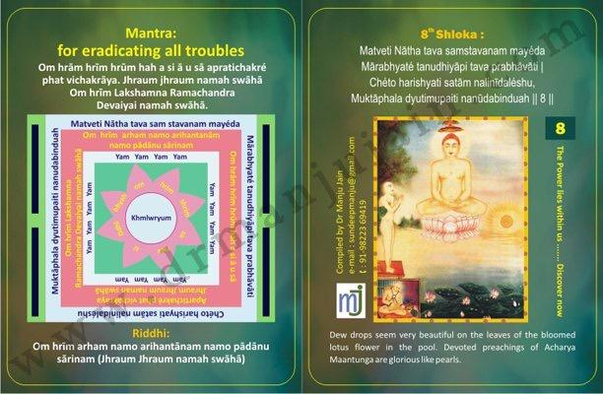

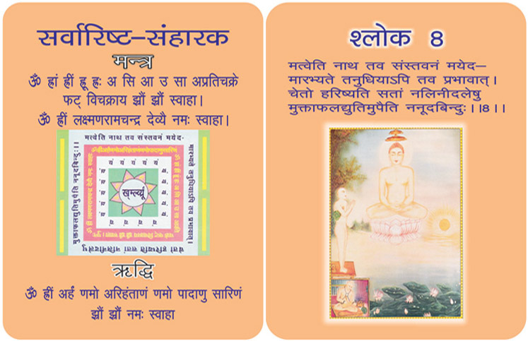

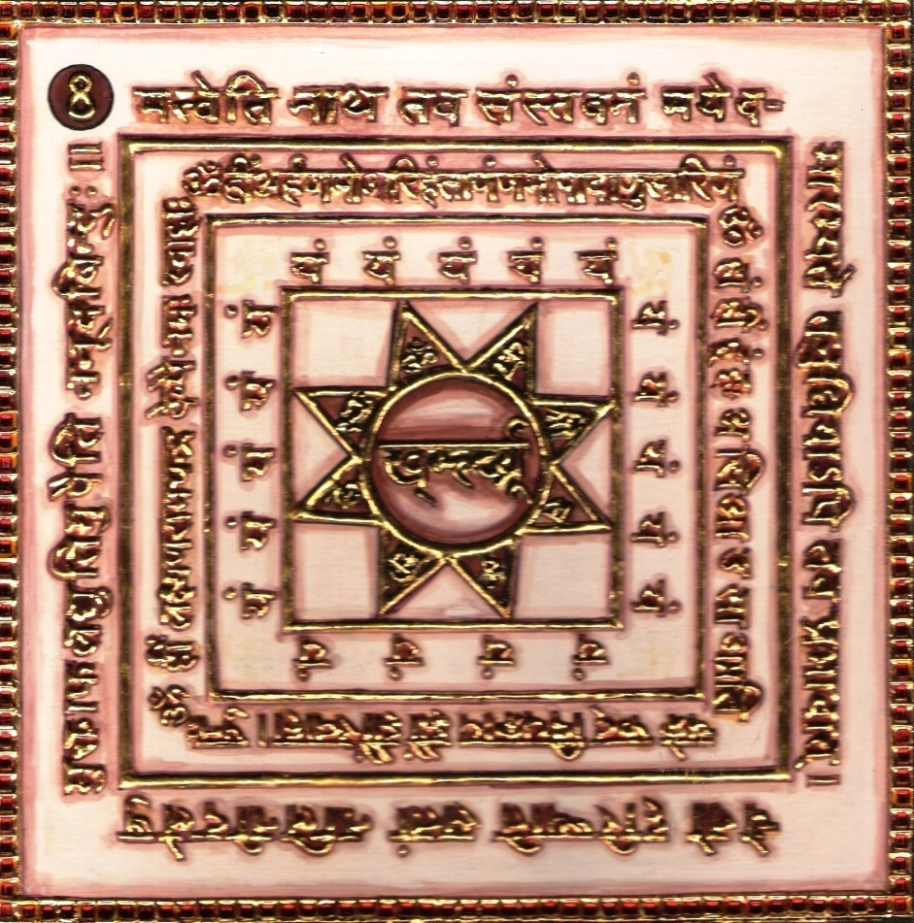

1. Purpose
1.0 All troubles are removed.

2.0 Scope
2.1. Like dew drops on the leaves of bloomed lotus flower in pool assume the luster of pearls due to the nature of leaf, the devotee with his little intelligence begins this eulogy in praise of Lord which will through Lord’s magnanimity, captivate the minds of the righteous.

3.0 Method
3.1 With the rosary chants of Riddhi and Mantra syllables 1000 times a day for 21 days offering incense of bdellium mixed with ghee. Burnt offerings of salt are necessary.

4.0 Resources
Yantra, Mantra and Riddhi, Rosary of seeds of neem tree.
Bdellium mixed with ghee (butter).
Salt is made mystic through chants.

Shloka - Repeat 9 times

MATVETI NĀTHA TAVA SAMSTAVANAM MAYÉDA
MĀRABHYATÉ TANUDHIYĀPI TAVA PRABHĀVĀTI
CHÉTO HARISHYATI SATĀM NALINĪDALÉSHU,
MUKTĀPHALA DYUTIMUPAITI NANŪDABINDUAH

Meaning

Oh God! I firmly believe that prayers to you will clear the sins of all my previous births and therefore I only seek your glorious impact.
My composition may be taken as a prose or poetry, a prayer or a hymn, or just anything, but, it wills be accepted and enjoyed by true devotees.
A drop of water is just a drop of water. But, how nice it looks when it has fallen on the leaf of the Lotus, which looks better than the real pearl. God! There is no doubt that my prayer like that drop of water fallen on lotus will be a rare contribution for the Bhaktas (devotees)

Mantra - Repeat 108 times

Om hrām hrīm hrūm hah a si ā u sā apratichakré phat vichakrāya.
Jhraum jhraum namah swāhā
Om hrīm Lakshamna Ramachandra Devaiyai namah swāhā.

Riddhi (le pouvoir surnaturel)
Om hrīm arham namo arihantānam namo pādānu sārinam
(Jhraum Jhraum namah swāhā)

Evidential Story - 8

It is a mockery of nature to have a name such as Nayansukh when the person is blind. Or shersinath who is a coward. There is not much in a name. It is only the karma of the past life that decides the fate of a person. A good name can only bring self satisfaction.

Vaishya Dhanpal also had such a fate. He was a Jain, a merchant and kindhearted but he was very poor and childless. Although he had by hearted the Bhaktamar stotra he did not understand the meaning or had any feelings.

One day two benevolent sages, chandrakirti and Mahakirti visited the town. Dhanpal bowed before them told them and about his misfortunes. The sages advised him to understand the Bhaktamar Stotra. They told him the meaning of 2nd bhav of the first few shlokas. By the grace of the sages Dhanpal started unraveling the meaning of the shlokas, as he had the darshan of gyan jyoti, he started reciting the eighth shloka with utmost faith and devotion every day. When once he was immersed in meditation Devi Mahima the deity of the eighth shloka appeared to him and said that she was aware of the two worries he had but she would only remove one of them.

Dhanpal pondered over it and opted for wealth as without wealth he could not look after his progeny properly. Wealth could be used for the benefit of mankind, as well thereby he could earn good name also.

As a result of chanting the eighth shloka with devotion and purity of heart, he became very wealthy.

The moral of the story is that by reciting a stotra without understanding one can benefit to some extent only. But if the same is recited with clear understanding the virtues of the Lord start shining in words as well.

Testimonial
All Troubles are removed. Mr. Jigar Mehtalia came from Bombay to take training on Bhaktamar’s 48 tools for manifestation. I asked him to pick up one card and he got attracted to Card No. 8 without seeing for which purpose it was. When I read the card he agreed he was facing troubles and by chanting 6th Shloka Riddhi for past one month. All his troubles have been eracticated. Now Mr. Jigar is a certified training of Bhaktamar from International School for Jain Studies. He is into angelic and twin heart meditation also.

9th Shloka: Birthing A Son

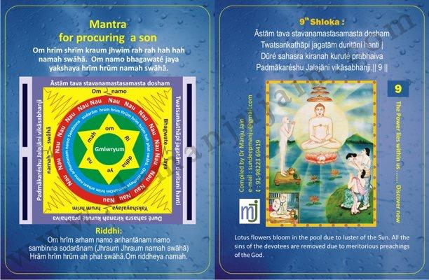

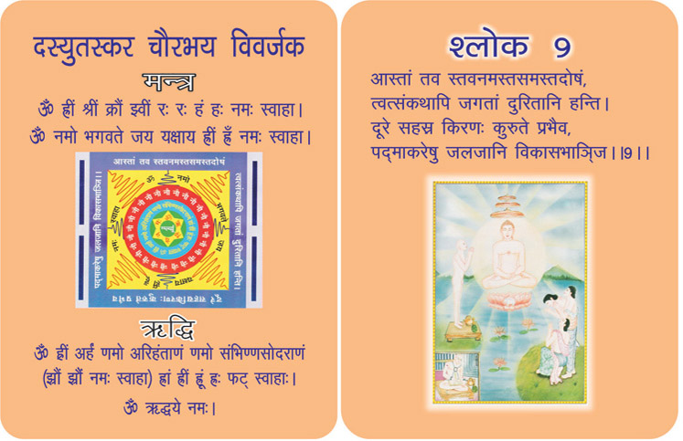
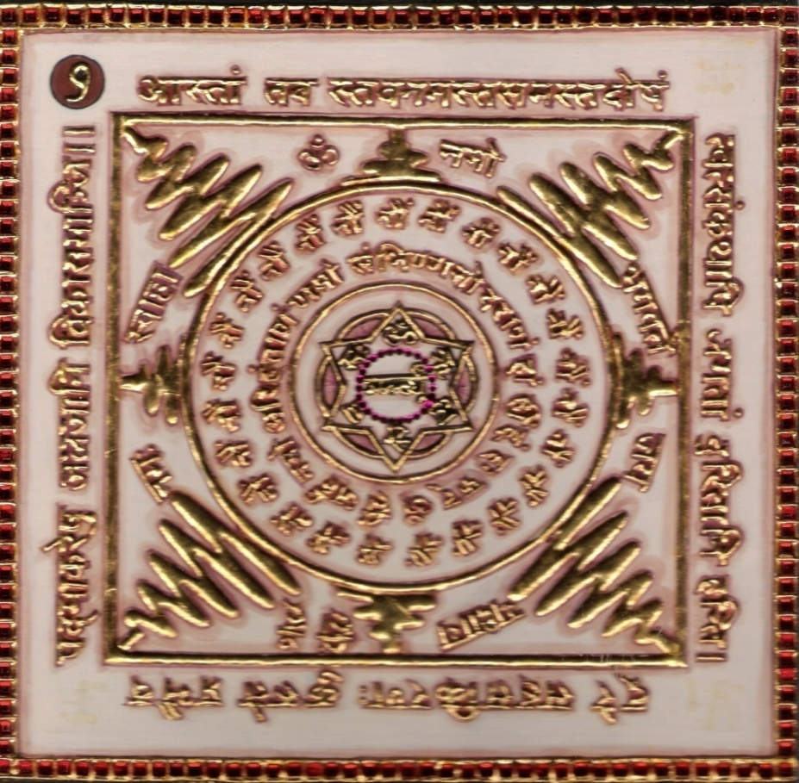

1.0 Purpose
1.1 To be blessed with son.
1.2 Free from fear of thieves and dacoits.
1.3 There can be no theft.
1.4 All the sins of devotees are being removed.

2.0 Scope
2.1. ‘O’ lord! By only talking about your faultless praise the account of your doings will prove destructive to the evils of the living beings. Like Sun before rising, by its luster make the lotus flowers bloom. By meritorious preaching of Lord all sins are removed.

3.0 Method
3.1 The verse, the Riddhi and Mantra syllables are chanted 108 times a day. Yantra kept in front. The 9th verse written with saffron on a plate of silver and water poured on it and given to lady will help her in conceiving a male child.

4.0 Resources
Yantra, Mantra, Riddhi and Verse. Verse written on plate with saffron.
Water poured on it.

Shloka - Repeat 9 times

ĀSTĀM TAVA STAVANAMASTASAMASTA DOSHAM
TWATSANKATHĀPI JAGATĀM DURITĀNI HANTI
DŪRÉ SAHASRA KIRANAH KURUTÉ PRABHAIVA
PADMĀKARÉSHU JALAJĀNI VIKĀSABHANJI

Meaning
God! A perfect poem addressed to you and free from faults of prose and verse, words and literature, grammars and derivations, is no doubt full of power to eliminate Karmas.
Sweet and serene prayer in high esteem is one thing, but oh my Lord! Even a small exchange or word about you repels most ably the sins of all beings.
Sun shines with thousands of his rays and wakes up the Universe. But leave him aside. Even a thin line of ray opens up silently sleeping petals of lotus within seconds.

Mantra - Repeat 108 times

Om hrīm shrīm kraum jhwīm rah rah hah hah namah swāhā.
Om namo bhagawaté jaya yakshaya hrīm hrūm namah swāhā.

Riddhi (le pouvoir surnaturel
Om hrīm arham namo arihantānam namo sambhinna sodarānam
(Jhraum Jhraum namah swāhā)
Hrām hrīm hrūm ah phat swāhā. Om riddheya namah.

Evidential Story - 9

King Hemabrahma & Queen Bhamashre wish of having child

A childless woman feels incomplete, A child brings joy with his laughter. Even when he is bathed in dirt, he is still charming. A woman pines to hear the word 'Ma', she is ready to bear the unbearable Pangs of childbirth for the sake of her precious baby.

King Hemabrahma and the queen Hemashree of Bhadravati’s Kingdom had spend half their lives pining for a child.

The king seeing his sad and worried wife explained to her. “I find you very unhappy for the want of a child. This is surely due to some misdeed. But with auspicious deed this situation can be changed. You have read the bio-graphy of the eighth tirthankar Lord chandraprabhu. He was also born very late to his parents. It also could have been due to some misdeeds in the past life which was mollified by good deeds by now.

At last the day came when the result of his past misdeeds ended. The king with his queen started for a forest safari (trip) They found vitragi Digambar muniraj deep in meditation on a rock. They prostrated before him and sat at his feet. Before they could say anything the muni read their thoughts and asked them to construct a Jain temple and offer a swarna kalash and the idols of 24 tirthankars. He also asked the king and the queen to write the IX th shloka of Bhaktamar stotra with saffron on a gold, silver or a copper plate then wash it with water and drink that water with faith and love, and their desire would be fulfilled. The king and the Queen accepted his advice faithfully and returned after prostrating before him. They did what was told to them. In the spring season when the nature was most beautiful, bees hummed on lotuses and the birds chirped on trees, on a basant Panchami day the queen conceived a child. After nine months a son was born to them.

With the grace of muniraj and their faith in Jain religion the fruits of the past life’s misdeeds were wiped out. The whole atmosphere was joyous with shainai playing at the palace and the festival of lights was celebrated in the city, and the newborn was named Bhusan.

Women have to suffer the misfortune of being childless due to past life’s mistakes such as “you make me so unhappy! You should have died! It is better to be childless than giving birth to a person like you”. This misfortune of childlessness can also happen to those women who are jealous of other women who are fruitful.

Testimonial

Anees brought his friend Nirbhay to me. He had 2 daughters and he was longing to have son. He asked me is there any shloka in Bhakatmbar for having son. I searched & found 9th shloka. His friend’s wife chanted the shloka for 9 months like a mad person forgetting everything else, she chanted for day & night. The result was that she gave birth to a baby boy after nine months and anees posted on facebook. She was chanting shloka for 9 months , nothing happened except for giving birth to a baby boy. The miracles of chanting this shloka are noteworthy.

10th Shloka: For getting employees - Creating a team
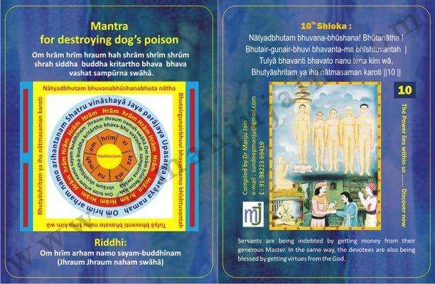

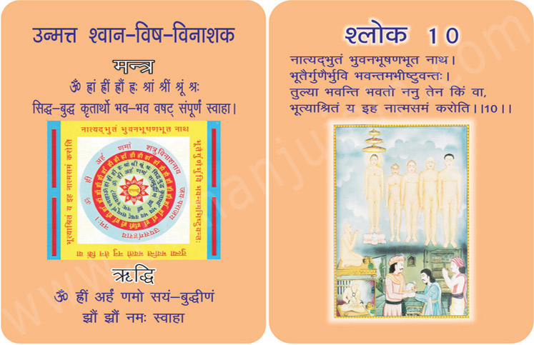
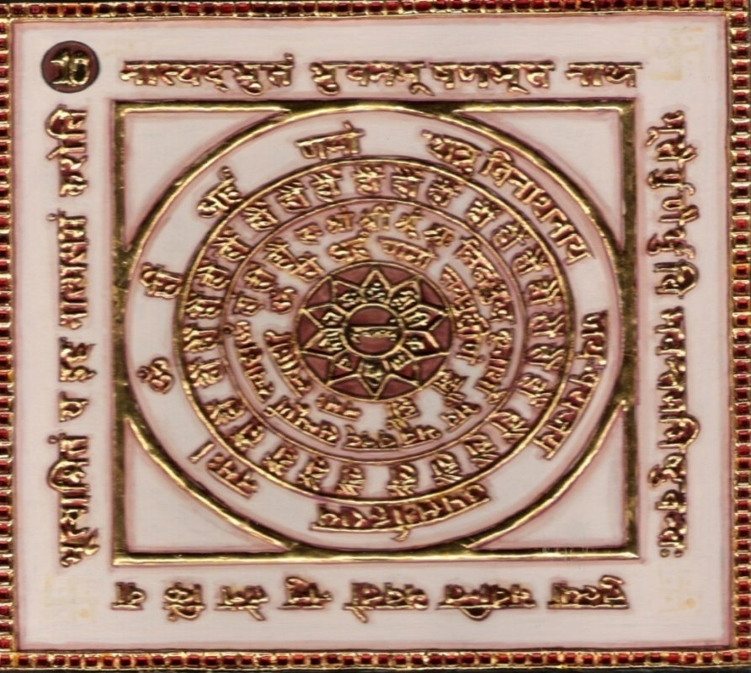

1.0 Purpose
1.1 The poison of dog is destroyed.
1.2 The poison of dog can be made ineffective.

2.0 Scope
2.1. The devotee who praises Lord of Living properly and duly praises
you in this world may attain equality with you. What is the use of the matter if he does not make his dependant equal to himself in wealth? Devotees are being blessed by getting virtues from the God.

3.0 Method
3.1 Having clothed in yellow dress chants of the verse Riddhi, Mantra syllables are performed 108 times a day with yellow rosary.

4.0 Resources
Yantra, Mantra, Riddhi & Verse, Keep Yantra near you.
Yellow dress & Yellow rosary, Offering of oblibanum.
Seven pieces of salt made mystic.

Shloka - Repeat 9 times

NATYADBHUTAM BHUVANA-BHUSHANA! BHUTANATHA !
BHUTAIR-GUNAIR-BHUVI BHAVANTA-MABHISHTUVANTAH
TULYĀ BHAVANTI BHAVATO NANU TENA KIM WĀ,
BHUTYĀSHRITAM YA IHA NĀTMASAMAN KAROTI

Meaning
God! You take care of all the beings for their spiritual upliftment. You are the ornament and the whole world shines because of your light of knowledge.
He who sings the songs of your virtues, if becomes like you, what is surprising in it?
A noble master (Boss) bestows his wealth on his servants to bring them on equal status. Oh Lord! Thou art the Master of Triloka.
The people of the world will become egoless by singing your virtues. I will also throw away the bundles of my sins… to become Veetaraga, exactly like you.

Mantra - Repeat 108 times

Om hrām hrīm hraum hah shrām shrīm shrūm shrah siddha – buddha kritartho bhava – bhava vashat sampūrna swāhā.

Riddhi (le pouvoir surnaturel)
Om hrīm arham namo sayam-buddhīnam
(Jhraum Jhraum naham swāhā)

Evidential Story - 10

Shreedutt eradication of Poverty

A Jain devotee may also deviate from the righteous path due to misdeeds. As a result he suffered great hardships and it ends only when he goes back to the right path. Such was the case with Shreedutt seth from Varanasi. Due to his misdeeds he suffered great loss in his business.

Shreedutt maintained his composure during his tough times. One day a Digambar sadhu came to the city. Shreedutt went for his darshan and offered him food. Later he told the Munishree about his poverty. He was advised to chant clearly the 10th shloka (Natyadbhutam…) explaining to him it's the meaning, riddhi and mantra.
His misfortune had not ended yet. One day while returning home from a far off business he fell in a dark well from where it was impossible to get out. Shreedatt sensing his danger started chanting 10th shloka of Bhaktamar Stoth with riddhi and mantra. He continued his devotion and chanting for many days. One day suddenly he heard Cham Chama Cham (tinkering) and opened his eyes. He was delighted to find a Devi like Lakshmi standing in front of him. She was Devi Rohini devoted to Jain Dev. She said that she was pleased with his devotional chanting of 10th shloka of Bhaktamar stotra and she would make him wealthy again. She asked him, “How did you fall into this well ? Did you lose the path of righteousness ? He said, “Yes mother I became a captive of greed. Greed destroyed my discrimination. While returning home from business abroad I was about to visit a Jain Temple, when I saw a sadhu distributing a certain juice which when taken in a vessel would turn the vessel into gold. I forgot all about the temple and stood in the queue to collect it. By the time my turn came it had finished. The sadhu took me along with him to a dense forest to collect some more juice. He lowered me into this well on a wooden plank tied to a rope. I brought out the juice many times filling his vessel. When he took from me the last vessel, wickedly he cut away the rope with a sharp knife and dropped me back into this dark well. He probably did not want his secret made public. Now please help me mother”. The kind Devi brought him out of the well and gifted him with lots of wealth. She said “today the whole world is in the dark well of greed. You can do your bit to improve the situation. You will have to inform the people about the greatness of the tenth shloka of Bhaktamar Stotra with riddhi and mantra. Also always remember Vitragi Digambar sadhu who gave you this great gift.” Saying thus she disappeared.

When Shreedutt reached home he was astonished to see a palatial house in place of his old house with all comforts and wealth & everybody was surprised with the sudden change. They were highly impressed by the result of chanting the Bhaktamar stotra with love, faith and devotion.

Testimonial

Creating a team – generating employees. Monks say that while chanting this Shloka if you can just visualize that my employees become like me forgetting about what will happen if they become like me? Who will do my errands etc., then God promises you and number of employees. You will create a team of employees in coordination and harmony. Just your simple thought process of well being of employees will do wonders.

11th Shloka: for Purifying Water- Salty to Sweet
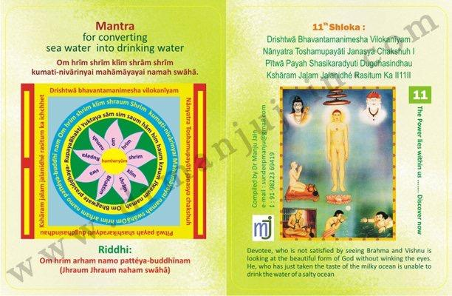

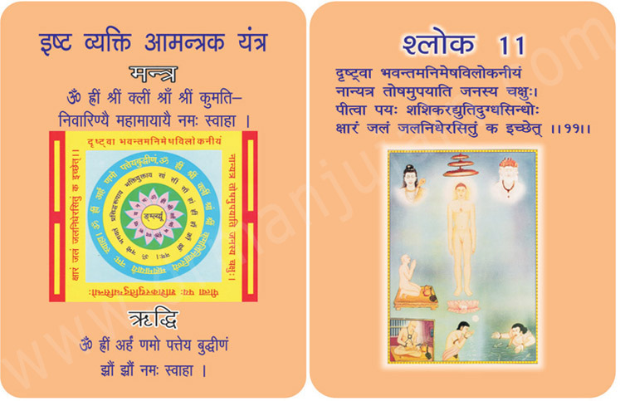
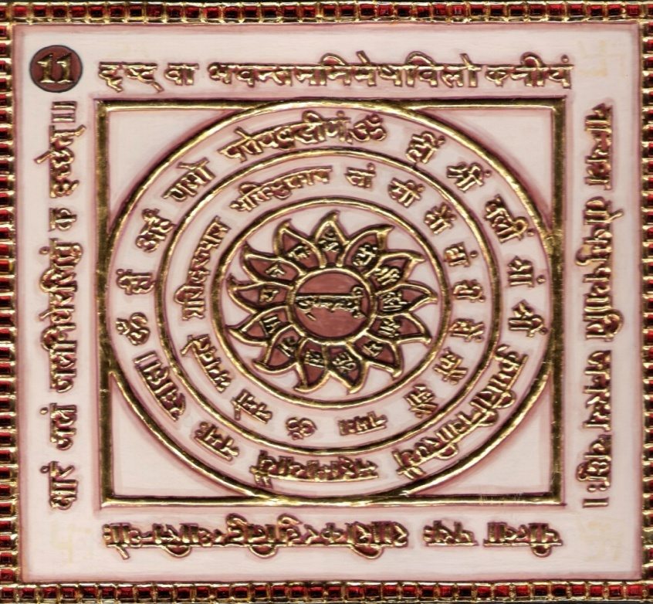

1.0 Purpose
1.1 Keeping Yantra near the desired person comes back or near.
1.2 There is rainfall if a handful of mustard seeds are made mystic through 12000 chants.
1.3 Seawater can be converted into drinking water.

2.0 Scope
2.1. You can make salty water convert to sweet water by talking impure water in 5 small vessels (Kalash) made of silver, gold or ceramic (mud) bathe (Abhisekh) the God Jina. After that make pure food with that salt water and feed (Aahar) some Jain Muni (Digamber). While filling the salty water from that pond or lake chant 11th verse of Bhaktamar Mantra & Riddhi. He, who has just taken the taste of the milky clean is unable to drink the water of salty ocean as the devotee after seeing Lord Adinath gets no satisfaction elsewhere.

3.0 Method
3.1 Having bathed and clothed in white worship be cone in a temple with pure phases. Chant 11th verse 108 times a day for 21 days with white or red rosary in isolation with joy. Offering of olibanum is made.

4.0 Resources
White clothes, white or red rosary. 5 small vessels (Kalash made of silver or mud)
Mustard seeds are made mystic through 12000 chants for rainfall

Shloka - Repeat 9 times

DRISHTWĀ BHAVANTAMANIMESHA VILOKANĪYAM
NĀNYATRA TOSHAMUPAYĀTI JANASYA CHAKSHU
PĪTWĀ PAYAH SHASIKARADYUTI DUGDHASINDHAU
KSHĀRAM JALAM JALANIDHÉ RASITUM KA

Meaning

Oh God! I saw you and I was lost in you. My eyes have stopped twinkling because of your majestic appearance!
You are so magnanimous, that now all the fragrance and beauty of worldly objects or tantalizing deities cannot drag my attention.
God! My heart and soul cannot see any other object. It looks for you and you and you only. N Bound to be; who will prefer to drink salty and ugly waters of the sea when pure and cool milk from the Kshirasagar is ready to quench our thirst!
God, nothing is sweeter and soothing than you. For me, the entire world is sour.

Mantra - Repeat 108 times

Om hrīm shrīm klīm shrām shrīm kumati-nivārinyai mahāmāyayai namah swāhā.

Riddhi (le pouvoir surnaturel)
Om hrīm arham namo pattéya-buddhīnam
(Jhraum Jhraum naham swāhā)

Evidential Story - 11

Everybody knows that water quenches thirst. But water also increases thirst. Whereas sweet water quenches thirst, salty water only increases it. In Sanskrit sweet water is known as amrit or nectar. According to modern science, salt is compared to poison. It is due to salt in our body that the poison of snake works in us adversely. If we abstain from salt for 12 years snake poison would be ineffective on us, as the snake it would die, after biting us. This is the reason why mothe’s nature has provided us with sweet water for drinking whereas 75% of the earth’s surface is covered with salt water for other purposes. Ancient puranas tell us that in South India, on the banks of river Kaveri, there was Ratnavati Puri kingdom. It’s prince Tarang Kumar, by chanting mantras, had turned the salt water in a tank into sweet water.

King Rama Rudrasen had a beautiful garden for the Prince Tarang Kumar’s amusement, who used to recite the 11th Shloka of Bhaktamar with utmost faith & devotion. He got a great tank constructed in the middle of the garden to provide water for his subjects. As the earth was dug - water burst out from its sources. But, the water tasted salty. The king tried all the means to turn its saltiness in to sweetness. But to no avail. At last, he went for the darshan of Nirgrantha or salty water into sweet. Munishri asked the king tried to fill water in a fine kalash of gold, silver or tin, to do abhishek for the Lord Jinendra. Later on with that, salty water prepared pure food for a Digambar Sadhu and fed him. But, he said that the person who had the tank constructed should only fill the water and while filling the water should chant the effective 11th Shloka of Bhaktamar Stotra with riddhi and mantra. Two days later, the Prince did as he was told and the water of the tank became overjoyed.

Today salty water is a matter of great concern. The pure river water is polluted due to the self interest of man. Today we are trying to make the seawater drinkable. How shall we achieve that except by the 11th shlok of Bhaktamar Stotra with utmost devotion, riddhi and mantra.

Testimonial

I experimented on this shloka for purifying the water of the well of our new house. As was written in scriptures I took out water from the well early morning at 5.00 am while chanting the shloka. Took that water to the temple got the abhishek done of the lord (both the statue & yantras of Bhaktamar with that water after making it luke warm & filtering it.) This holy water was put in well and again I cooked meals for saint with this water of the well and after having meals the saint & lady saint said the water is very tasty.

12th Shloka: Relationship - Creating and Healing

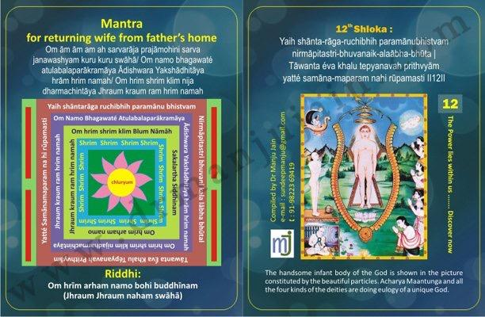

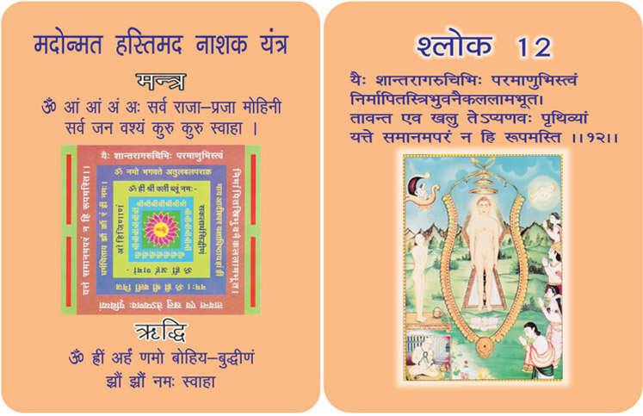
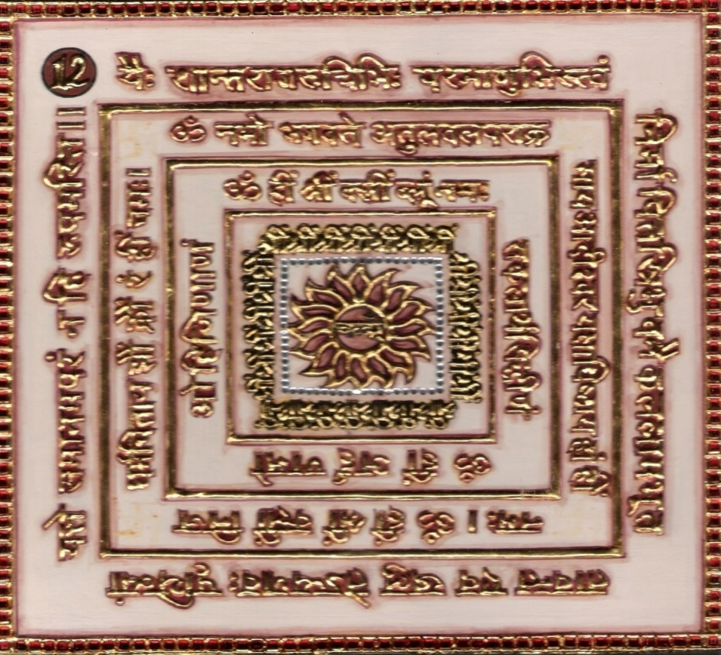

1.0 Purpose
1.1 Remembering the verse, Riddhi, Mantra syllables and keeping the Yantra near, the elephant can be controlled
for its intoxication and ecstasy by giving him the mystic made oil through 108 chants.
1.2 Frequent remembrance causes the wife to return from her father’s home.

2.0 Scope
2.1. ‘O’ Supreme ornament of all three worlds. There were only as many atoms possessing luster of non attachment, that went into composition of your body and that is why no other form like that of yours exists on this earth.

3.0 Method
3.1 Having bathed in red the Riddhi and Mantra syllables are chanted with a red rosary 1000 times a day for 42 days. The olibanum with the constituents is offered.

4.0 Resources
Pure mind, meditating and chanting Mantra, Riddhi, Shloka and Yantra.Red Sari or clothes and Red rosary. The olibanum with ten constituents is offered.

Shloka - Repeat 9 times

YAIH SHANTA-RAGA-RUCHIBHIH PARAMANUBHISTVAM
NIRMAPITASTRI-BHUVANAIK-ALAABHA-BHUTA
TAWANTA EVA KHALU TEPYANAVAH PRITHVYAM
YATTE SAMANA-MAPARAM NAHI RUPAMASTI

Meaning
Oh Tilak (auspicious mark) on the forehead of Triloka! I roamed around the world and saw the king of kings, king of Devas and also the masters of sages the Gandharas… but no one appeared as glorious as you. God, there is a crystal clear reason for this. The holy atoms which subside all the worldly desires have already been utilized in formation of your physical self frame. And hence there are no such atoms left from which a gorgeous personality like yours can be formed.
Obviously, the atoms left behind are not at all capable of creating a majestic personality like your physical frame.
Billions of offerings to your gorgeous and majestic personality.

Mantra - Repeat 108 times

Om ām ām am ah sarvarāja prajāmohini sarva janawashyam kuru kuru swāhā/
Om namo bhagawaté atulabalaparākramāya
Ādishwara Yakshādhitāya hrām hrim namah/
Om hrim shrim klim nija dharmachintāya
Jhraum kraum ram hrim namah

Riddhi (le pouvoir surnaturel)
Om hrīm arham namo bohi buddhīnam
(Jhraum Jhraum naham swāhā)

Evidential Story - 12

Mahi Chandra - Kam Dhenu Cow
We may read any scripture or any subject many times but unless we contemplate its meaning we achieve nothing much. What is contemplation? atma, body, truth untruth, we have to learn to discriminate a house holder who can imbibe the essence of scriptures if he contemplates on it whereas without contemplation even a yogee may not benefit much. Even a fool who reads just a sentence with utmost devotion and faith may reach great heights.compared to poison. It is due to salt in our body that the poison of snake works in us adversely. If we there is a true story of staunch devotion in 12th shloka of Bhaktamar Stotra (Yeih abstain from salt for 12 years snake poison would be ineffective on us, as the snake it would die, after biting us. This is the reason why Mother Nature has provided us with sweet water for drinking where as 75% of the earth’s surface is covered with salt water for other purposes.

Ancient puranas tell us that in south India on the banks of river Kaveri there was Ratnavatipuri kingdom. It’s prince, Tarang kumar by chanting mantras had turned the salt water in a tank into sweet water.

King Rama Rudrasen had a beautiful garden made for the Prince Turang kumar’s amusement of used to recite the 11th shloka of Bhaktamar stotra with utmost faith and devotion. He got a great tank constructed in the middle of the garden to provide water for his subjects. As the earth was dug water burst out from its sources. But the water tasted salty. The king tried all the means to turn its saltiness in to sweetness. But to no avail. Al last he went for the darshan of Nirgranth or Digambar Muni Chandrakirtiji Maharaj. He asked him for a remedy for turning the salty water into sweet. Munishri asked the king to fill water in a fine kalash of gold, silver or tin, to do abhishek for the Lord. Jinendra, Later on with that salty water prepare pure food for a Digambar sadhu and feed him. But the person who had the tank constructed should only fill the water and while filling the water should chant the effective 11th shloka of Bhaktamar Stotra with riddhi and mantra. Two days later the prince did as he was and the water of the tank became sweet. His subjects were overjoyed.

Today salty water is a matter of great concern. The pure river water is polluted due to the selfish interest of man. Today we are trying to make the sea water drinkable. How shall we achieve that except by the 11th sloka of Bhaktamar stotra with utmost devotion, riddhi and mantra ?shantrag). King Kumarpal ruled the kingdom of Ahilyapuri in central Province (Madhya Pradesh of today). Vilachandra was his minister. His son Mahichandra was the friend of a businessman. Both studied 12th shloka of Bhaktamar stotra with riddhi and mantra from a Digambar muni. The son of the businessman learned it by heart but did not try to understand it. But the minister’s son read it carefully with devotion and contemplation every day. As a result one day Mohini Devi appeared to him and presented him with a “Kamdhenu (cow)”. Whenever the cow's milk was sprinkled a heap of gold would form. Mahichandra sprinkled the milk in his kitchen and many delicious edible items appeared. Thousands partook of the same yet the stock remained full. Many miracles were happening but Mahichandra’s eyes were fixed on the path of liberation.

It is clear that the mere reading of the scriptures is not enough. Contemplation of the same is essential. There was a panditji who was an exceptionally good orator. Unfortunately he never tried to understand the power of his discourses. Once a farmer's wife was passing by carrying some errands, when she heard Panditji's words, “He who contemplates on Ram can cross the ocean without difficulty”. She was very much moved by these words. Faithfully she started repeating these words. She went to the panditji and humbly requested him to have dinner in their home.

While she was returning home it started raining heavily. The rivulet on the way was flooded. She hesitated to cross it but immediately she remembered the golden words “He who contemplates on Rama can cross the ocean without difficulty”. Repeating it with great faith she stepped into the river and crossed it without any difficulty and reached home. After preparing the food she started waiting for the Panditji. Hours passed by and night broke out into day and day into night yet he did not reach. He arrived only at 12 noon.

The farmer's wife said to him “I have been waiting for you so long and the food has become stale now. Panditji said. “Oh fool, don't you know that the river was flooded. How could I come? When the water came down, I sat, in a boat and came here.” The devoted lady said, “But Panditji I came back immediately. Your great words showed me the way. How could a small rivulet stop me?”

True devotion faith and good work surpasses all difficulties. “There is no difficulty that true devotion faith and good works cannot surpass (overcome).

Testimonial
Mrs. Preeti Lakhani from Chennai came to take training for Bhaktamar. She attended panch kalyanak at ramtek and with the blessings of Acharya Vidya Sagarji Maharaj she learnt all the shlokas their purpose & meaning. She wanted to be trainer for storehouse of amazing powers Bhaktamar. While returning to madras she said there are many young girls in her family and are not getting married will 12th shloka of Bhaktamar help in finding a nice match. I said yes definitely. They did for 21 days continuously and found a very good boy for their young niece. This is the power of the 12th shloka.
13th Shloka: Preventing Theft & Avoiding Fear On Journeys

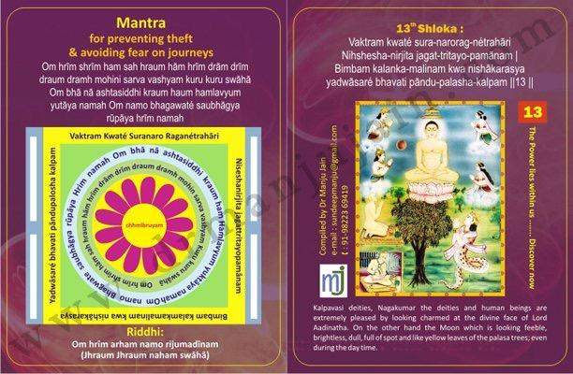

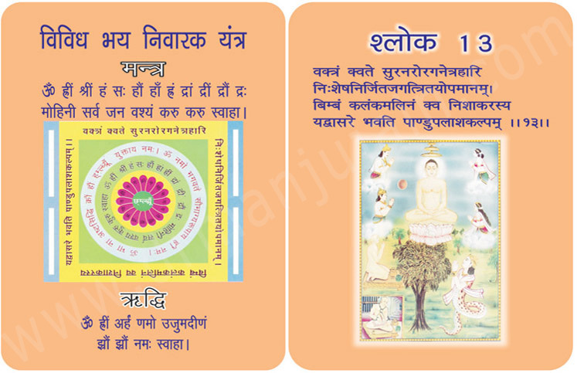
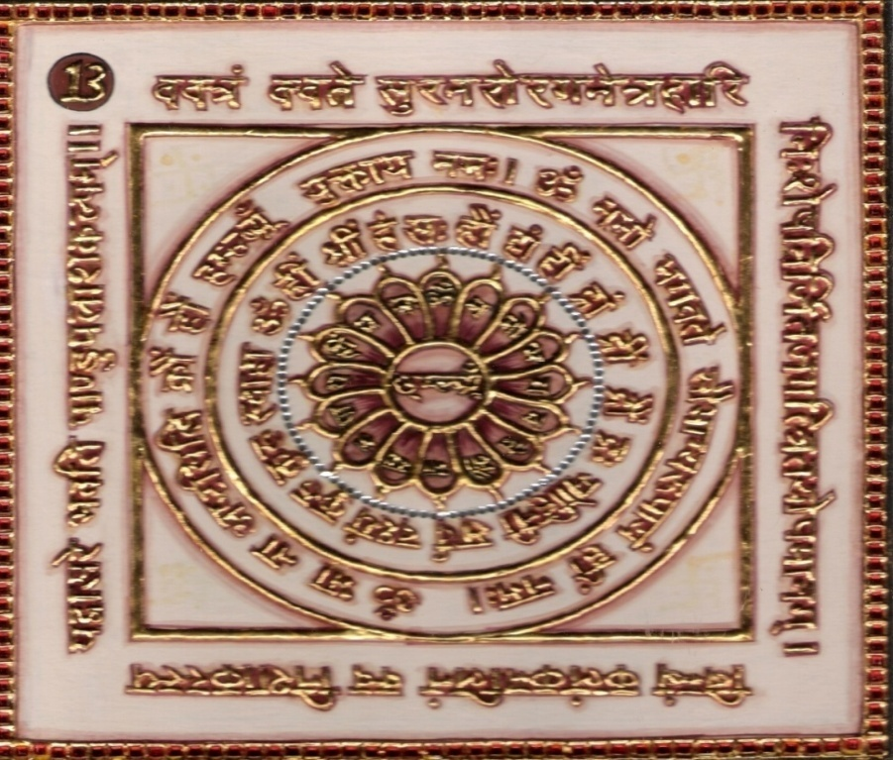
1.0 Purpose
1.1 Acquiring wealth, preventing theft and avoiding fear on journeys.

2.0 Scope
2.1. How can there be comparison between God’s divine face and the
moon. The latter is snailed with dark spots and looks pale as well in the day like the Palash Leaves, while your divine face which focuses the eyes of men, Gods and Nagas, surpass all (the objects of) comparison in this threefold world.

3.0 Method
3.1 After purification and having clothed in yellow with a yellow rosary, the Riddhi and Mantra syllables are to be chanted 1000 times a day for 7 days. The of olibanum is offered to the fire of the altar.

4.0 Resources
Yellow clothes, yellow rosary, Olibanum Yantra, Mantra, Riddhi & Verse
7 Gravels are made mystic through olibanum.

Shloka - Repeat 9 times

VAKTRAM KWATE SURA-NARORAG-NETRAHARI
NIHSHESHA-NIRJITA JAGAT-TRITAYO-PAMANAM
BIMBAM KALANKA-MALINAM KWA NISHAKARASYA
YADWASARE BHAVATI PANDU-PALASHA-KALPAM

Meaning

My Almighty, how aesthetically pleasing do you appear!
Deities are attracted to you; men are happier to have you in their eyes and hearts; even the animals and birds are grateful to have your glimpse. No metaphor is enough to narrate your appearance.
All the comparisons and metaphoric descriptions fall short…
The moon has no value in daytime; though it looks like a prince in the night, but it is pale in daytime…
Oh God! The whole world looks pale and tasteless when compared with you.

Mantra - Repeat 108 times

Om hrīm shrīm ham sah hraum hām hrīm drām drīm draum dramh mohini sarva vashyam kuru kuru swāhā Om bhā nā ashtasiddhi kraum haum hamlavyum yutāya namah Om namo bhagawaté saubhāgya rūpāya hrīm namah

Riddhi (le pouvoir surnaturel)
Om hrīm arham namo rijumadīnam
(Jhraum Jhraum naham swāhā)

Evidential Story - 13

This too, is a middle age story. Emperor Karna was seated on the throne. There was an all religion conference at the court. Scholars, Yogees, Pandits, poets and artists were present. Everybody spoke about the greatness of his own religion. Emperor Karna was not impressed. Suddenly a man said that he could give people darshan of Brahma, Vishnu, Mahesh, Ganesh and Buddha. In reality he was a fraud trying to take people for a ride. Those days some people used to impress others by putting on the disguise of Gods, there by commercializing God. Such things do not have very good effect on people and the Jains never allow such things.

Karna wanted to make his kingdom secular. Whereas, his minister Sumati wanted to establish Jain religion there.

The man in disguise suddenly disappeared and a voice was heard “Beware Shankarji is arriving”. People witnessed Lord Shankar sitting on Nandi with garland of snakes around his neck and ash smeared on his forehead. People admired and hailed victory to Lord Shiva. This way Ganesh, Brahma, Vishu, etc also appeared. Some people were annoyed. On the fourth day the arrival of Lord Jinendra Dev was announced. Sumati was annoyed and thought that only a person who undertakes great austerities can put on the disguise of Lord Jinendra Dev. Sumati started chanting the 12th shloka of Bhaktamar stotra with riddhi and mantra. Chakresh devi appeared in her divine splendour mounted on the chest of the fraudman and said “If you want to become Jinendra Dev then leave the path of falsehood and violence. He begged the devi to pardon him and promised not to put on the disguise of Gods any more. People shouted in joy “hail the Jain religion” and Emperor Karna announced that all his kingdom would follow the Jain religion.

Testimonial
Mrs. Shah from Ujjain had come to Nagpur as she had fear of recurrence of her breast cancer which had appeared 10 years back. She completed 3 days of chanting program workshop and her fear was overcome and felt confident starting a school of bhaktambar at Ujjain.
My sister in law’s family was broken by thieves and took away all the jewelry and 100 gold coins. I told her mother to chant this shloka and the thieves were caught and all her belongings were returned.

14th Shloka: Destroying Fear Of Enemies
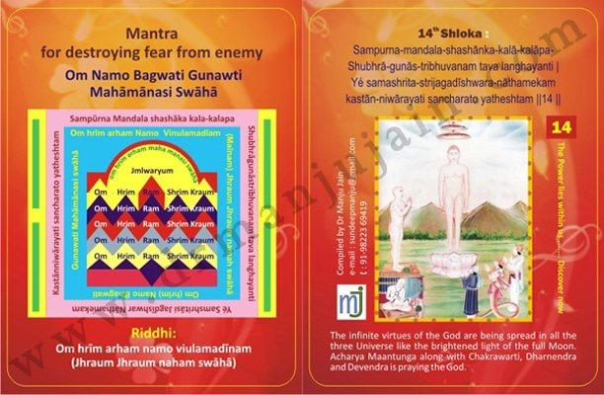

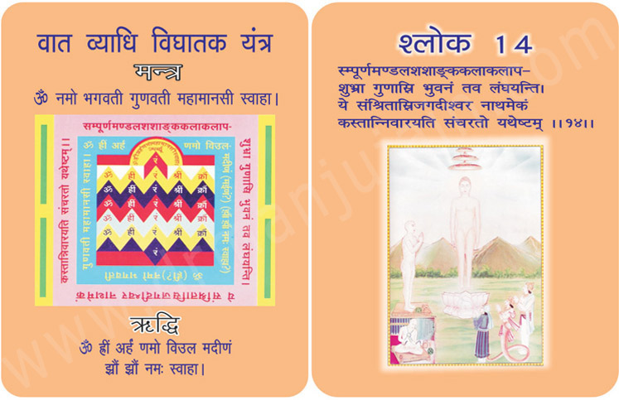
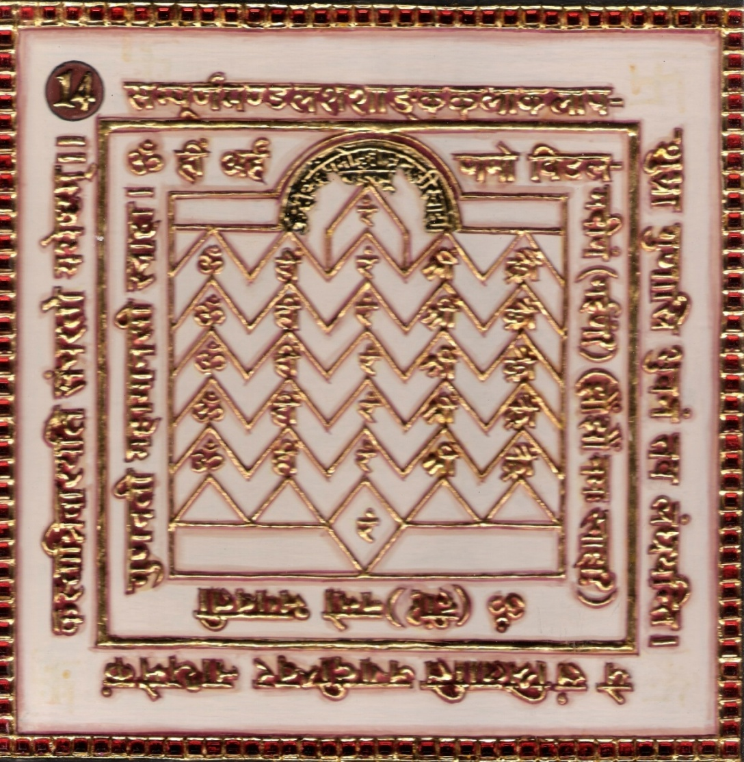

1.0 Purpose
1.1 All troubles and distresses and fear from enemy is destroyed.
1.2 Saraswati deity is pleased.

2.0 Scope
2.1. ‘O’ Lord of three worlds, your merits, as shining and white as silvery rays of full moon, extend over all the three worlds for who can prevent them from moving in this work being sported by the singular and matchless patron like you.

3.0 Method
3.1 After having purified and clothed in White with a rosary of quartz crystals the verse Riddhi and Mantra syllables are chanted with candle and offering of olibanum is performed. The burnt offerings of guggulu are given everyday.

4.0 Resources
Yantra, Verse, Mantra and Riddhi, White Clothes Rosary of Quartz Crystal
Mixture of Guggulu (odelium), Kasturi (musk), Kesara (Saffron), Kapura Camphor) Silarasa (liq. Storam)
Ratanjali (red sandal wood) Tagare Agara (Indian Valerian Rhizome) Dhupa (Long leaved pine) Ghee, etc
given everyday.

Shloka - Repeat 9 times

SAMPURNA-MANDALA-SHASHANKA-KALA-KALAPA-
SHUBHRA-GUNAS-TRIBHUVANAM TAVA LANGHAYANTI
YE SAMASHRITA-STRIJAGADISHWARA-NATHAMEKAM
KASTAN-NIWARAYATI SANCHARATO YATHESHTAM

Meaning
O, the lord of Triloka! Your virtues are as pleasing and bright as the full moon in the cloudless sky, but it is surprising that how the virtues which remained in your Atma, have spread throughout the universe! But one need not get astonished, as you are the lord of universe and virtues have taken shelter in you.
No one can stop (prevent) the roaming of a person according to his desire, who has taken refuge into the gigantic and majestic personality like yours.

Mantra - Repeat 108 times

Om Namo Bagwati Gunawti Mahāmānasi Swāhā

Riddhi (le pouvoir surnaturel)
Om hrīm arham namo viulamadīnam
(Jhraum Jhraum naham swāhā)

Evidential Story- 14

Ketupur Nagarin Bihar

Love and lust are two different things. Love is a blessing, a fragrance in marital life, where as lust is a curse, it is the cause of all downfall.

The king of Ketupur Nagar in Bihar also fell for lust. His physician prepared a medicine called Kaltol Kamini for him. It had such a bad effect on the king that he fell for his maid servant. She too lost her balance and was allured by lust. If the beginning any addiction seems small and controllable but slowly it becomes your master and does not let you free from its clutches. Now the king was controlled by the servant-champa. Lust destroys the accumulated virtues in a man. Shame and discrimination also leave such a fallen man.

The queen came to know about the illicit relations between the king and the servant champa. She was very much shocked. She was worried that the king was setting a very bad example for his subjects. Moreover how could a fallen king punish others ? She tried to make him reason. But the fallen king would see no reason.

The queen vowed that she would keep no physical or any other contact with the king. The king was infuriated. He got her thrown into a well in a nearby forest. Queen Kalyani became devoted to God. She was an ardent and faithful follower of Bhaktamar stotra. She started reciting the powerful Bhaktamar Stotra. She chanted the 14th and 15th shloka with riddhi and mantra.

Next day at midnight the king opened his eyes from sleep surprisingly, to find Jrumbh devi in a very angry mood standing before him. He fell at her feet and asked for pardon. He promised her that he would keep away from other women. By the grace of the devi the queen safely reached home. As a result of the powerful Bhaktamar stotra the king was reformed and lived his life with his queen in pure love and devotion.
Testimonial

15th Shloka: Attain Honour & Get Rid Of Nightmares

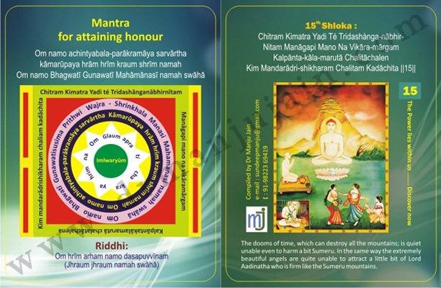

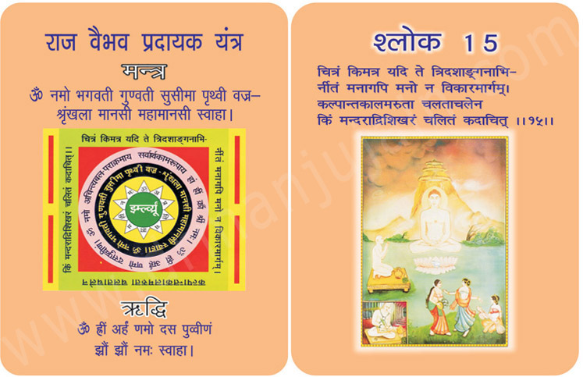

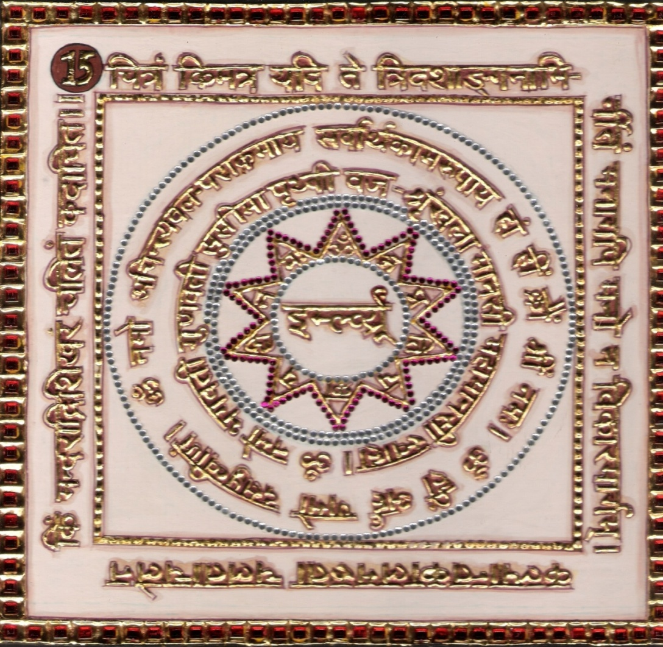

1.0 Purpose
1.1 The royal court is impressed and honor is attained.
Keeping the Yantra on the arm makes a man chaste without loss of semen virile and night emissions.

2.0 Scope
2.1. It is no wonder if the celestial nymphs could not rouse, even in the least the casual passions are quite unable to attract even a little bit to Lord Adinatha who is firmed like Sumeru Mountains like the dooms of time, which can destroy all the mountains, is quite unable even to harm a bit to Sumeru.

3.0 Method

3.1 After bath, clothed in red, seated on red base the 15th verse the Riddhi and Mantra syllables are chanted everyday for 14 days with a red rosary offering the olibanum and one meal in a day.

4.0 Resources
Red clothes, Red Rosary, 15th Verse, Riddhi, Yantra and Mantra, offering the olibanum one meal in a day.

Shloka - Repeat 9 times

CHITRAM KIMATRA YADI TÉ TRIDASHÀNGA-NĀBHIR-
NITAM MANĀGAPI MANO NA VIKĀRA-MĀRGAM
KALPĀNTA-KĀLA-MARUTĀ CHALITĀCHALEN
KIM MANDARĀDRI-SHIKHARAM CHALITAM KADĀCHITA

Meaning

O Vitaraga! In spite of all your qualities, you are so much indifferent and unconcerned that even the fairies of the heaven neither attract you, nor detract you!
The disastrous storm at the end of an eon topples other mountains as well. But no sooner it approaches Mount Meru, the king of Mountains, turns into breezes. Thunder is well aware that its might will not work there. God, I have come to know by your grace that the Veetaraga cannot be lured even by the3 best and most beautiful fairies. The one who is never lured is veetaraga, and veetaraga can never be lured.

Mantra - Repeat 108 times

Om namo achintyabala-parākramāya sarvārtha kāmarūpaya hrām hrīm kraum shrīm namah
Om namo Bhagwatī Gunawatī Mahāmānasī namah swāhā

Riddhi (le pouvoir surnaturel)
Om hrīm arham namo dasapuvvīnam
(Jhraum jhraum namah swāhā)

Evidential Story - 15

Oh Jagadishwar ! The demotion of Arihant dev is not from body but from soul. Shri Manatungacharya then sings the glory of Jineshwar devi, he says that the fragrance of Arihant Dev's virtues Pervades the three worlds. Just as the relatives of a king have the freedom to go about anywhere in his kingdom and no one dares to stop them so also the fame of your virtues spreads everywhere. As the rays of the moon from its start grows into full moon so also your bright and clear virtues have fully developed like the full moon.

Then he describes his shining character which is devoid of attachment, lust, hatred. You have achieved a pure character and you are not affected by the ill effects of the outer world. Nobody can disturb your peace. You have destroyed the ruler of Darshan Mohaniya and karma Mohaniya Karma.

Shri Manatungacharya further glorifies the character of the lord by saying that even when 13 types of heavenly ladies, apsaras and fairies could not entice you as your mind is immovable like sumeru Mountain which can not be shaken even by great storms you are not a small mountain like other gods and goddesses but you are the great sumeru the embodiment of patience, bravery, seriousness and unconquerable victor.

Testimonial

PPROTOCOL
My Aunty use to get wild dreams after death of my uncle who had kidney failure and was on dialysis for long time. She told me that I do not get good sleep because of Scary dreams. She looked for the verse and starting chanting 15th Shloka. –Night mares stopped and she had sound sleep and also attained honor in society.

16th Shloka for Extinguishing Fire
Image
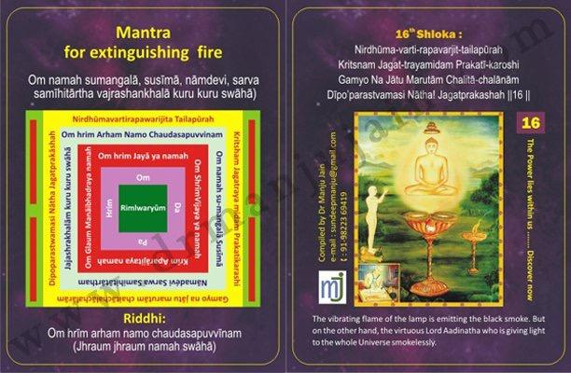

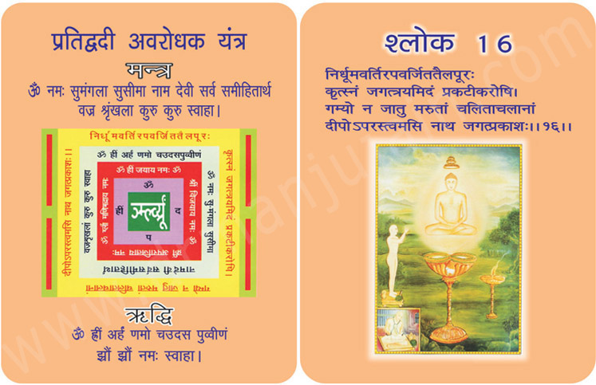
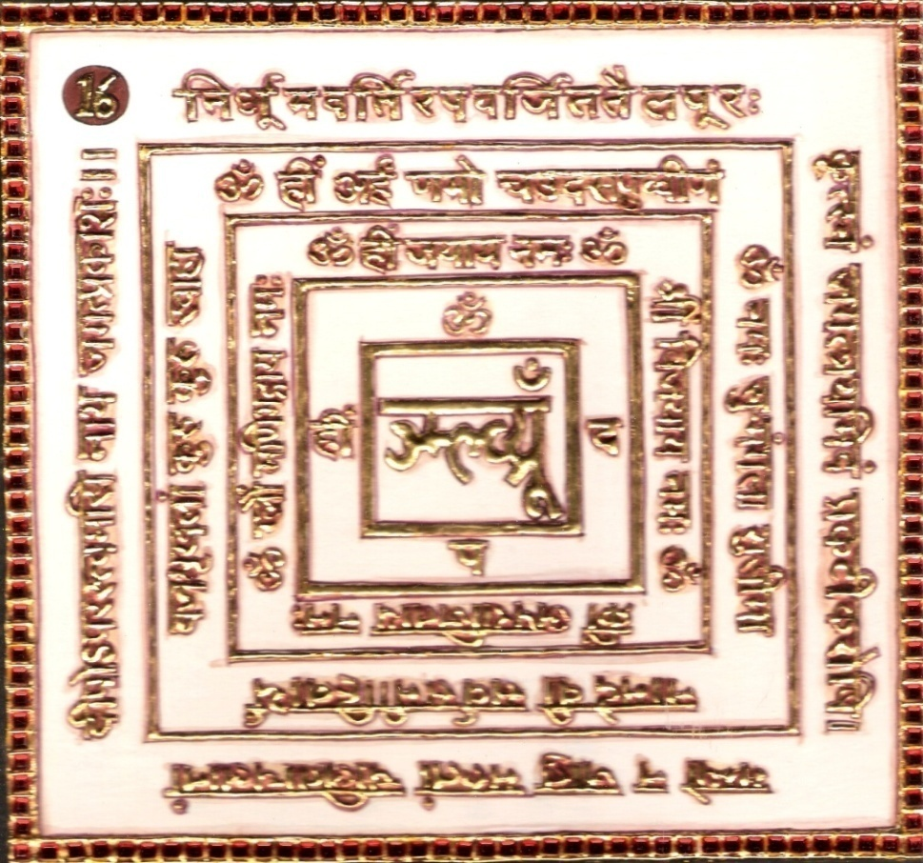

1.0 Purpose
1.1 Fire is extinguished if mystical water is sprinkled after chants. The royals in court subdue their rivals and enemy.

2.0 Scope
2.1. ’O’ Lord! In this world you are the illumining light of rare singularity which giving light to the whole sphere, has not smoke wick and supply of oil in it. It is unaffected by the wind which has shaken the other mountains.

3.0 Method
3.1 After bath, the verse, Riddhi and Mantra syllables are chanted 1000 times a day with green rosary and offerings of olibanum (Kundaru) Cast into fire of alter. After both the 16th Verse Riddhi and Mantra syllables are chanted with green rosary and pine of olibanum (Kundaru) be cast in the alter.

4.0 Resources
Pine of Kundaru, Riddhi, Mantra, Yantra & 16th Verse
Green Rosary, Fire

Shloka - Repeat 9 times

NIRDHŪMA-VARTI-RAPAVARJIT-TAILAPŪRAH
KRITSNAM JAGAT-TRAYAMIDAM PRAKATĪ-KAROSHI
GAMYO NA JĀTU MARUTĀM CHALITĀ-CHALĀNĀM
DĪPO’PARASTVAMASI NĀTHA! JAGATPRAKASHAH

Meaning

Oh God Almighty! You are a self-lit lamp and hence you do not need any external fuel of preaching of other saints. The stormy winds of illusions cannot extinguish or fade your light of infinite knowledge. Your unique existence does not emit the smoke in the form of Raga and Dwesha. You also do not depend upon the help of others on the path of salvation like an ordinary lamp relying on a cotton wick.
In fact you are the unique lamp to lighten the whole universe at a time by your theory of Anekantavada.

Mantra - Repeat 108 times

Om namah sumangalā, susīmā, nāmaevi, sarva (Le vers mysti – samīhitārtha vajrashankhalā kuru kuru swāhā

Riddhi (le pouvoir surnaturel)
Om hrīm arham namo chaudasapuvvīnam
(Jhraum jhraum namah swāhā)

Evendial Story - 16

Childhood is like a sapling or a creeper which can be trained to bend towards which ever direction. But a fully grown tree does not have such flexibility. During a storm such big tress are uprooted by strong winds but a small and flexible plant saves itself by bending.

It is easier to imbibe righteousness during childhood. Mitra, the daughter of king Mahipchandra was a virtuous and cultured girl from her early childhood. Although she could have led a very luxurious life being in the royal family, she was spiritually inclined form her very childhood. At that tender age also she would ponder about dharma and the meaninglessness of the outer world. King Mahipchandra was very happy with his daughter. He sent her to acquire further knowledge to Aryika Smt. Mataji. There she learnt that it was important to follow what one’s religion teaches.

After staying and gaining knowledge for many years Mitra asked for Mataji blessings.

Blessing her Mataji said, “It's the duty of every family-person to have Jin-darshan daily and without it one should not partake of food or water”. She agreed and came back home. Every day she would have darshan and then worship the bejewelled idol in the temple.

One day the queen reminded the king that the time had come to marry off their daughter. Soon the king selected Kshemankar, the son of a noble person. Everybody was very happy with the match. At the wedding people discussed that the groom was not Lakshmipati but dhankuber. Someone said that he was a great scholar. A boy said that when Kshemankarji recites Bhaktamar Stotra at the temple, daily, people sit enchanted.

The marriage party returned with the groom and the bride. At her new home her mother-in- law asked her for lunch. Mitra respectfully told her that she would not have food before having darshan of Parshavanath. The mother-in-law asked her to go to the nearby temple and worship the stone Parshvanath idol. Mitra replied that she was routinely worshipping the bejeweled idol. Kshemankar told them not to worry and that he would do something about it. He started reading the 16th shloka of Bhaktamar stotra with faith and devotion. He was so immersed in his worship that he lost track of time. He came out of this deep meditative state only when devi chaturbhuji appeared to him and fulfilled his wish. Next morning the town people were amazed to have darshan of a bejeweled idol of Shri Parshvanath in front of the stone idol at the temple. The public hailed victory and rejoiced.

Testimonial

17th Skloka for curing Gastrointestinal Diseases & Kidney Failure

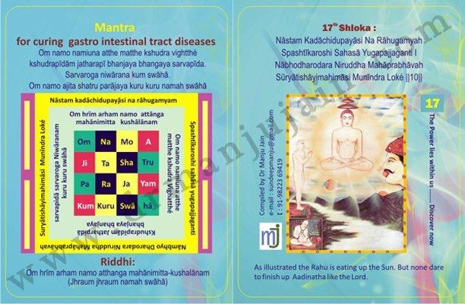

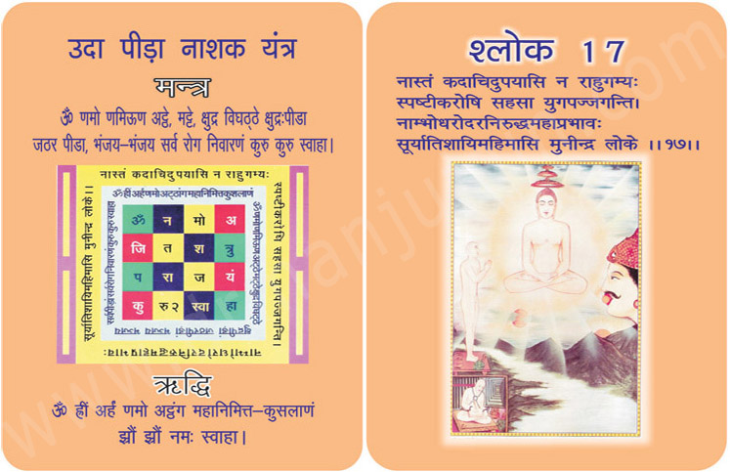

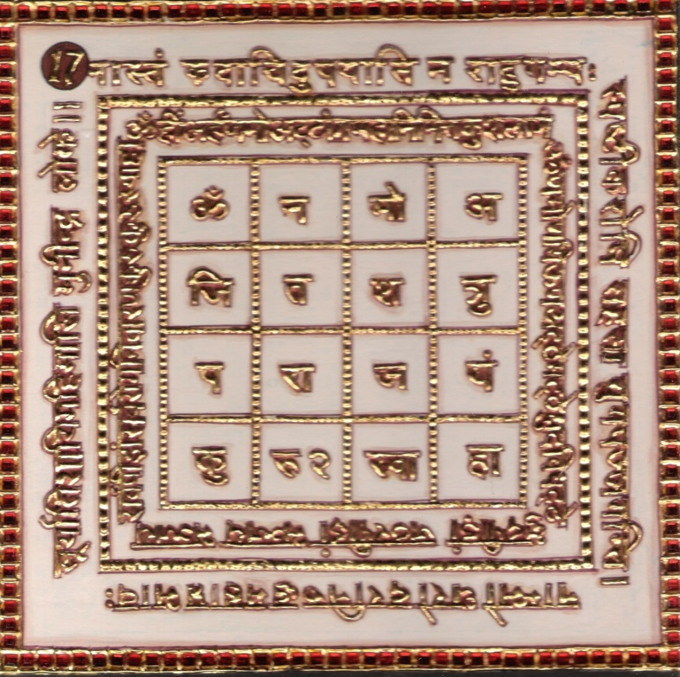

1.0 Purpose
1.1 The disease of gastrointestinal tract are cured even if incurable when Yantra is tied and pre untouched water is made mystic through the chants 21 times and served.

2.0 Scope
2.1. ‘O’ Lord as you neither set, nor you are affected by Rahu and nor
your brilliance is even hidden by the thick and dense clouds and as you simultaneously enlighten the whole sphere you are. O best of sage! Superior in pre-eminence to the Sun.

3.0 Method
3.1 The verses, the Riddhi and the Mantra syllables are chanted 1000 times a day for 7 days with white rosary in pure phases. The pines of sandalwood to be cast into fire of alter.

4.0 Resources
The 17th Verse, Riddhi, Mantra & Yantra
Pine of sandalwood, White rosary

Shloka - Repeat 9 times

NĀSTAM KADĀCHIDUPAYĀSI NA RĀHUGAMYAH
SPASHTĪKAROSHI SAHASĀ YUGAPAJJAGANTI
NĀBHODHARODARA NIRUDDHAMA HĀPRABHĀVAH
SŨRYĀTISHĀYIMAHIMĀSI MUNĪNDRA LOKÉ

Meaning
Oh Master of Munis! It is also not possible for us to compare your qualities with the Sun, because Sun rises and sets everyday. You are ever self-luminous and hence rising and settings are not there.
The star of solar energies enlightens only a small part of the universe, and then slowly moves t the other parts, leaving darkness behind. Occasionally, Rahu also eclipses him.
But oh Master of Munis, as you enlighten the whole universe at a single time and as you possess the infinite knowledge as your preaching’s (Agamas) can never be challenged by any logical and as your most glorious Shashan (Jain Dharma) can never be shadowed or overcome by other schools of philosophies, you surpass the sun.

Mantra - Repeat 108 times
Om namo namiuna atthe matthe kshudra vightthé kshudrapīdām jatharapī bhanjaya bhangaya sarvapīda. Sarvaroga niwārana kum swāhā. Om namo ajita shatru parājaya kuru kuru namah swāhā

Riddhi (le pouvoir surnaturel)
Om hrīm arham namo atthanga mahānimitta-kushalānam
(Jhraum jhraum namah swāhā)

Evidential Story - 17
Ketupur Nagarin Bihar

A righteous, patient and a wife with deep rooted faith can bring back her husband from wrong path to the right path.

Attachment which is considered the worst of eight karmas which clouds the divine light emitting from the atma, is all also called love (of inferior type) or lust, with good company (satsang) we can overcome this weakness. But with bad company a man becomes depraved and it, really happened with Ratnashekhar. He came into contact with such a yoga who was a fraud who would misuse ladies who came to him with some problem to him.

Ratnashekhar unfortunately became worse than his master. His parents married him off to Kalyanshree. She was just as her name suggested. Probably it was the misdeeds of her previous life that she had such a depraved husband. Where as she was a pious and scholarly Jain, she used to recite the Bhaktamar stotra with riddhi and mantra. Slowly Ratnashekha restarted improving due to the efforts of his noble wife. When his guru saw him changing for better he increased his efforts to bring him back under his clutches. Kalyanshree invited him for meals. She recited the 17th shloka of Bhaktamar with mantra and riddhi and drank the abhimantrit water and then gave it to the guru. Suddenly Gandhari Devi appeared to him and gave a gold ring to the yogee to make it fly. How could he fly the divine ring. Devi Gandhari threw it upwards and as it fell, at the very peace a beautiful Jinalaya appeared. Seeing this he fell at the feet of Devi asked for her pardon and became a Jin devotee himself. Ratnashakhar felt very ashamed, and vowed to redeem himself. People living in the town also became Jinbhaktas and started living peacefully.

Testimonial

Kindney failure Patient:
Ms. Anjali (Anju) Malaya, who resides in Delhi was on dialysis, for almost 2 years had dialysis twice a week. Doctors had assumed that, she needs kidney replacement and convinced the family. In year 2009, I went to meet her and told her about this therapy but, she did not believe in this curing method.
On 5th June 2019, I met her at her residence and told her again about this mantra which can cure incurable diseases. This time she was quite serious and had no other option. She asked me to write the mantra on a piece of paper and she promised me that, she would chant the 45th Shloka while lying down during dialysis.
On 9th July, my mother called up from Delhi saying that your friend Anju Malaiya had called up. She was looking for you. She could pass urine from last two days. I was overwhelmed with joy on hearing that her kidneys are functioning well.
As my second INternational Conference on Spiritual Healing was on 10th and 11th July 2010, I told all the participants about this case after my powerpoint presentation on Jainism Method of Curing. The launching of chip and memory card of 45th Shloka of Bhaktamar by Dr. Dara Rupa of Bioenergetics from Mumbai was done on the same day. With the help of this memory card, the patient can continuously listen to the 45th Shloka 108 times on the speakers. My 48 mantra cards were released by Dr. Meher Master-Moos, President of Zoroastrian College, Mumbai. By God’s grade, each delegate received the card, which he wished for Dr. R.N.Shukla from Institute of Bio-field (MIT, Pune) launched my booklet on 48 shlokas.

18th Shloka for Eradicating Illusive Vision

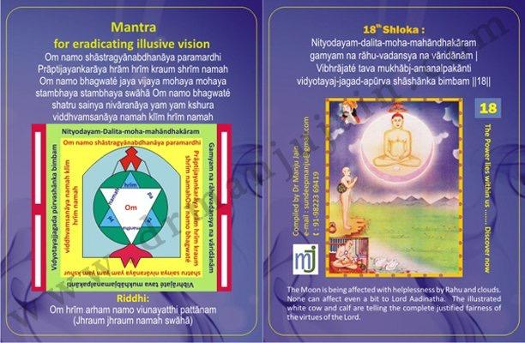

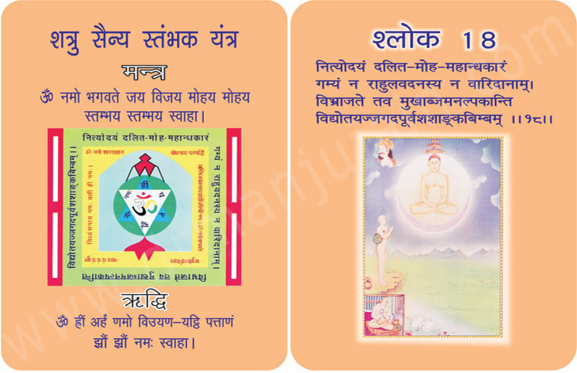
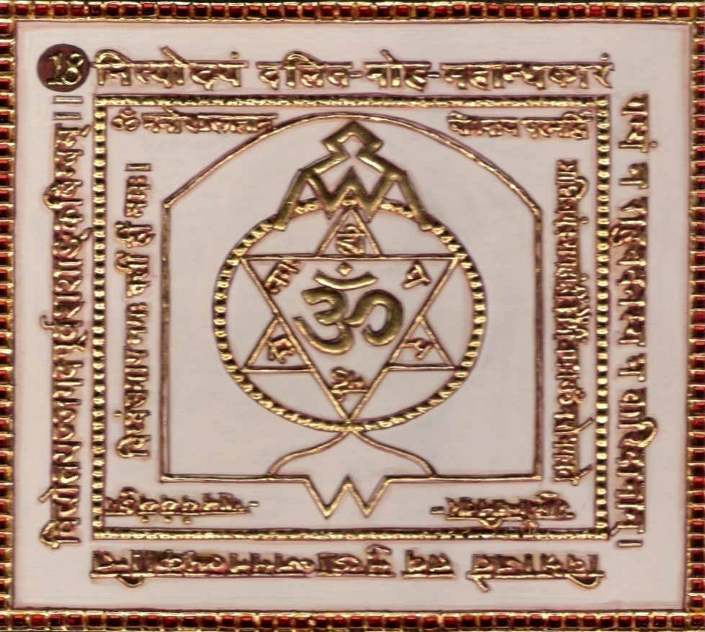

1.0 Purpose
1.1 One can meditate naturally.
Ill thoughts and illusive vision is removed.

2.0 Scope
2.1. The moon is being affected with helplessness by Rahu and clouds. None can affect even a bit to Lord Adinath. ‘O’ God! Your lotus like mouth of immense luster, which always remain risen, has destroyed the great darkness of delusion.

3.0 Method
3.1 After purification, the verse, the Riddhi and the mantra syllables are chanted 1000 times a day for 7 days with red rosary. The pine olibanum with ten constituents is cast into the fire of alter. One meal a day is to be taken pure.

4.0 Resources
18th Verse, Riddhi, Yantra & Mantra
Olibanum with 10 Constituents, One meal a day, Red Rosary.

Shloka - Repeat 9 times

NITYODAYAM-DALITA-MOHA-MAHANDHAKARAM
GAMYAM NA RAHU-VADANSYA NA VARIDANAM
VIBHRAJATE TAVA MUKHABJ-AMANALPAKANTI
VIDYODAYA-JAGAD-APURVA SHASHANKA BIMBAM

Meaning

Oh God! Since you can never be compared with the Sun, can we now look for the Moon?
Alas! Moon rises and sets at indefinite times; it shines in the night only. God, you are ever-risen and showing the path of salvation to your devotees during the day and night alike.
All deserving should suffering from their illusions from time immemorial are benefited by your preaching and by undertaking the penance had destroyed their pitch darkness within no time.
The moon is eclipsed by Rahu time and again; but oh my Lord, you are so good to mankind, that you eclipse the fallacies and ill-thoughts for ever.
The black spots are apparent on the face of the moon; whereas, while we see you, your clean personality glows with cool and soothing halo. Moon looks pale in front of you!
Moon rises on one end of the earth and sets on the other; whereas you spread your aura in entire universe (Triloka) at all times.

Mantra - Repeat 108 times

Om namo shāstragyānabdhanāya paramardhi Prāptijayankarāya hrām hrīm kraum shrīm namah
Om namo bhagwaté jaya vijaya mohaya mohaya stambhaya stambhaya swāhā
Om namo bhagwaté shatru sainya nivāranāya yam yam kshura viddhvamsanāya namah klīm hrīm namah

Riddhi (le pouvoir surnaturel)
Om hrīm arham namo viunayatthi pattānam
(Jhraum jhraum namah swāhā)

Evidential Story - 18

In the present times joint families are breaking up as a result of economic and scientific progress and due to the western influence, traditions, and business. Children get diverted from their family.

But this true story is about those times when the son used to follow their fathers occupation. King Chandrakirtee was the ruler of Barbar city in Kalinga. As fate would have his minister Sumati passed away. According to tradition King called for Bhadrakumar his ministers son to take up the vacant post. His mother told him to behave in a manner worthy of the court. But Bhadrakumar was very worried, because he was only 16 years old and out of which 12 years were wasted playing and just enjoying the father’s love and care and never bothered to learn anything inspite of his fathers insistance. More over 4 years he enjoyed looking after the animals. Such an uncultured Bhadharkumar reached the kings count. He was unable to understand the civilized ways of the court so he sat in a corner. Then the king asked him “will you be able to do justice to the post your father held?’’ Bhadrakumar replied “Yes my mother also has told me that I have to be a minister. All the courtiers laughed at his reply as they realised the real worth of him, no one can hide his real self for long. The king said’’ Bhrdrakumar without wisdom and knowledge how you can fulfill the duties of a minister?’’ Bhadrakumar has now realised his unworthiness and the exquisite ways of the court. He answered, saying that even after the great efforts of his father I kept myself away from literature and grammar. So I am not worthy to be a minister”. And then requested another appointments with which he could earn his livelihood.’’ For the idiots and ignorant there is no room in my court. If you want to be here then you need to study and get knowledge’’ Only after hearing some harsh remarks many scholars like Kalidas, Tulsidas and Valmiki were able to walk the path of truth. King or beggar, literate or illiterate, scholar or fool, strong or weak, no one likes to be insulted. Insults and humiliations make man be come disturbed. Bhadrakumar also decided after being humiliate that he would become somebody great. While roaming around, he met a naked vidaragi Digambar muniraj. Bhadrakumar taking the dust from the feet of the mumi, humbly said to him I am ignorant give me knowledge so that I can take up the post of the minister. Due to my ignorance I was badly humiliated at the king's court.” The compassionate muniraj understanding the pain of Bhadrakumar advised him to leave behind the false hood some yukta and follow the path of truth. Believing the words of Jinendra, he recited the 18th sloka of Bhaktamar stotra (Ntyodagam davit moth Mahamdhakar Greak darkness) he explained it to them and made him learn it. By chanting this shloka with ridhi & mantra daily all your desires will be fulfilled”. Bhadrakumar was a great person and for 3 days he was immersed in Jin devotion and 18th sloka of Bhakatmar stotra with ridhi & mantra.
Then he saw Brajadevi who appeared to him and questioned him what he wanted ? Bhadrakumar said “Devi, please bless me so that I can become a scholar. Devi blessed him and disappeared. Now Bhadrakumar himself totally transformed, and became a great scholar. When he reached the Royal court all the courtiers & other were wonder struck at his knowledge and wisdom. None of them could expect so quick a change in Bhadrakumar. With great humility he replied’’ oh king with the help of Jainism lot of knowledge & wisdom can be attained. This knowledge which I have now is nothing compared to all that can still be achieved
Hearing this king the courtiers was impressed and inspired by Jainism all of them accepted Jainism and Bhadrakumar were appointed as the minister again.

Testimonial

19th Shloka: Earnings - Getting a Job, Promotion and Increment, Expanding Business

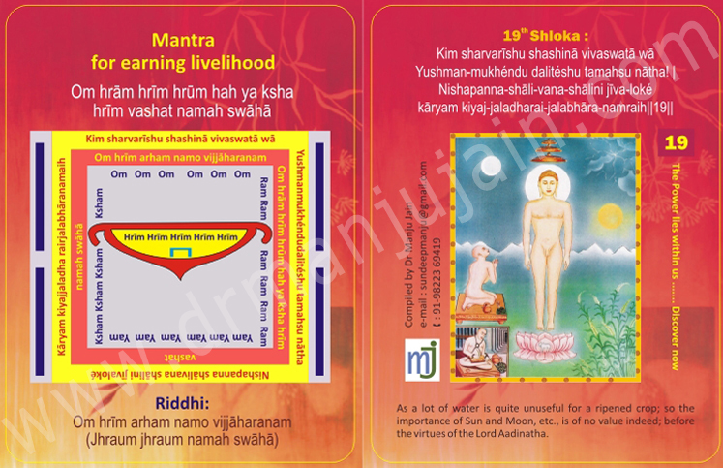

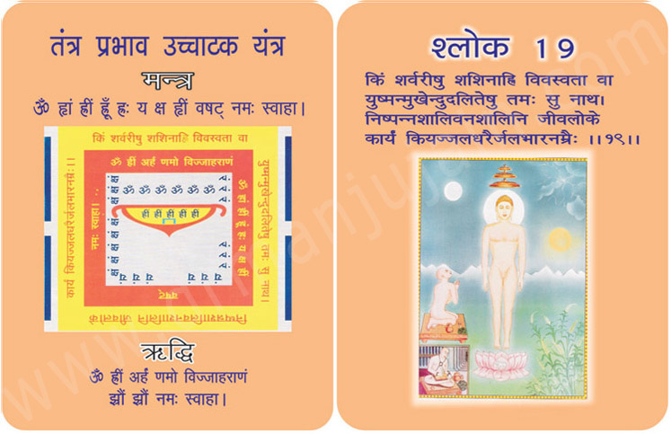

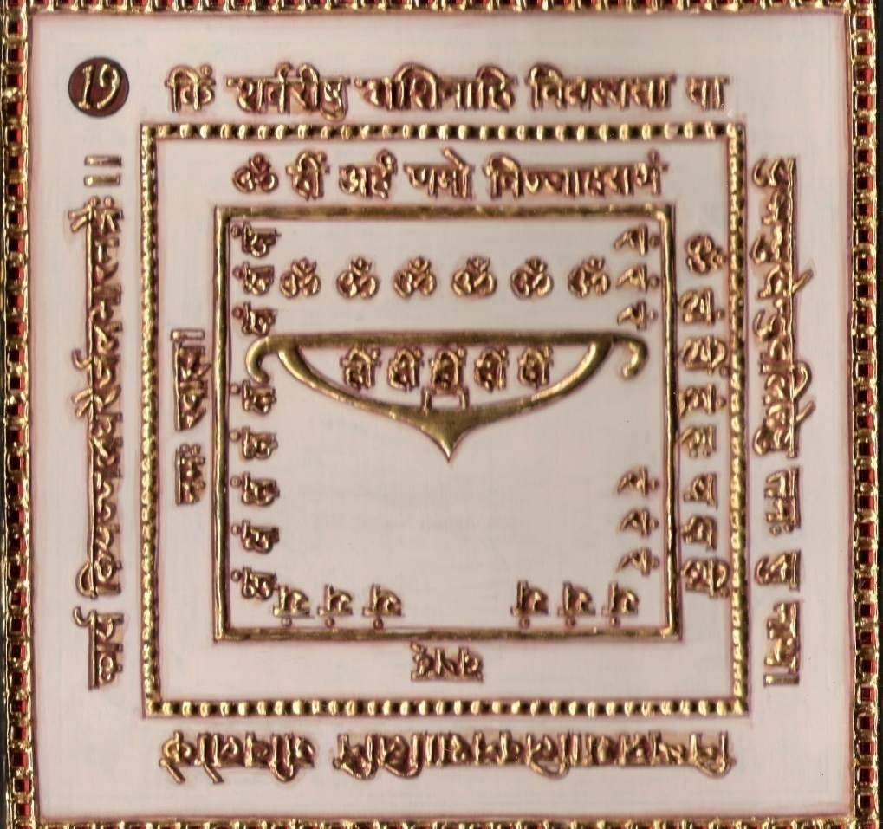

1. Purpose
1.0 Keeping the Yantra near, we adorer who is unable to earn will start earning.

2.0 Scope
2.1. ‘O’ Lord, the moment your lotus like face appears then what’s
the use of sunlight in the day and moonlight in the night.

3.0 Method
3.1 After taking bath in morning one should put on clean dress. With concentrated mind chant the 19th Shloka, Riddhi and mantra syllables 108 times.

4.0 Resources
Concentrated Mind, Yantra, Mantra, Riddhi & Verse

Shloka - Repeat 9 times

KIM SHARVARĪSHU SHASHINĀ VIVASWATĀ WĀ
YUSHMAN-MUKHENDU DALITESHU TAMAHSU NATHA!
NISHAPANNA-SHALI-VANA-SHALINI JIVA-LOKE
KARYAM KIYAJ-JALADHARAI-JALABHARA-NAMRAIH

Meaning
Oh Lord! What is the use of the moon in the night; and that of the Sun in the daytime! Is it necessary to depend on Sun and moon to dispel the darkness?
No… No… No! On the contrary, they are not aware that the enlightenment which has come out of you has already removed the blinding darkness within no time! They have nothing to do.
Those black clouds are filled with water and are ready to rain. But where is the need of rain for the harvest of rice grown-up in the field!
Lord, you have already cleared the darkness of ignorance.
And so, oh Sun and Moon! Your process of rising and setting as usual is now a mere routine! And you have nothing to do guide the living beings.

Mantra - Repeat 108 times
Om hrām hrīm hrūm hah ya ksha hrīm vashat namah swāhā

Riddhi (le pouvoir surnaturel)
Om hrīm arham namo vijjāharanam
(Jhraum jhraum namah swāhā)

Evidential Story - 19
Sukhanand was jailed for 6 months with rigorous punishment. All the lanes of Hastinapur was filled with this news. Everyone was shocked and questioned how such a good person, so God fearing could and neighbor loving and just person like Sukhanand get such a severe punishment. People began to speak out saying that great injustice was done to Sukhanadkumar surely there is some sort of conspiracy. In time the truth will be revealed now his forehead is covered with black spots, then all will see that today's black spot will be turned into the auspicious mark of justice and victory. It must be the Fire test for some misdeeds he might have done as you recall that some great men also were born in jails.

Some of our great national leaders also were in jail for years. Today they are held high as national heroes. We see adulteration as such a common thing today, but it is not so, because it is as old as human beings, as the Rakshas's nature entered into them.

Ratnajyothi the chief jeweller who used to make the ornaments for the royal family had only cheated the kings. What he did was that he kept the original and real diamonds, Pearls, Precious stones, gold & emerald and used the duplicate materials in making the ornaments for the king. such people who have no fear of God what fear will they have of kings even if the king make out the duplicate, Ratnagiri thought to himself “I will tell that I had given the original pure ornaments to Sukhanand and he night have changed them into the duplicate. And that really happened. King believed the false story. Without even finding out from sukhanand what had happened, he punished him. Ratnagiri told the king that he wanted to inform the king that they were take gold, but he was afraid of the king.

Sukhanand was in prison for 3 days without food and water. But he was not afraid, sad or affected by all this. He had great faith in the Bhaktamar stotra and he often remembered shri Manathungacharya who also suffered from such conspiracy and was kept in a prison with 48 locks. But Raja Bhoj could do him no harm. “I am also cent percent innocent so in my case also justice will be done”. Sukhanand was immersed in reciting the 19th sloka of Bhaktamar stotra with ridhi & mantra. The great rumour about sukhan and kumar as a dishonest heat, a person with bad intention and a gold thief. In his heart he felt that as gold is purified in fire, sita had also undergone the fire test to prove her innocence. ‘So also after this fire test here in jail my soul will become holy and will appear before all one area might while he was asleep in the prison the Jain Devi Jumbhumati carried him to his home. Next day the king saw the prison doors open. All the guards were asleep and found the jeweller Sukhanand sitting peacefully doing his business in his shop. Then the king remembered the dream he had the late hours of the previous night and King surpal also became a faithful follower of Jainism. Non he put the conspirator jeweller Ratnagiri to prison to pluck & enjoy the fruits of his evil deeds. Where the desire starts, righteousness ends. What our minds become familiar with thought related to desires enter our minds. Thoughts are also smart and the dust of our thoughts fills our minds.

Testimonials:

Shloka No. 19 for getting Jobs,promotion and Earnings Gaurav Manek was introduced to me by my friend Marukh ,who is Regional Manager in HDFC bank.Gaurav was her colleague and was into financial trouble, things were not happening as per his wish .He started chanting 19 th Shloka daily early morning for 108 times for 21 days .To my surprise his Boss came to me saying that Gaurav has completed 73 insurance policies of RS.25000 Lacs each and is selected by company for Switzerland trip sponsored by Max Newyork His Boss admitted that Gaurav was of ordinary calibre but seeing this extraordinary performance by Gaurav the Boss inquired how did he achieve such result on this he answered that he got a tool of mind -Mantra for earnings which he did with sincerity and could achieve amazing goal.

A lady is disturbed as she is not getting a job and facing many problems. She approached Dr.Manju Jain. She was advised to chant 19th Shloka. She has started mantra chanting for 21 days. After 21 days she had received a job offer and now she is very much happy at her workplace. She also is chanting mantra for her children. Her husband was also facing problems at his workplace. She is chanting for him also. Surprisingly her husband’s all problems were get solved and he got an award also. Her entire family is now very happy.

20nd Shloka for Improving Fertility & Infertility By Unknown Cause

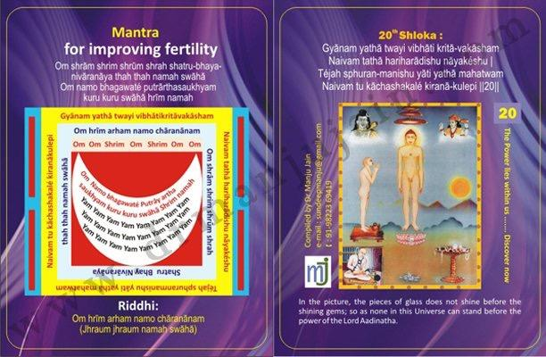

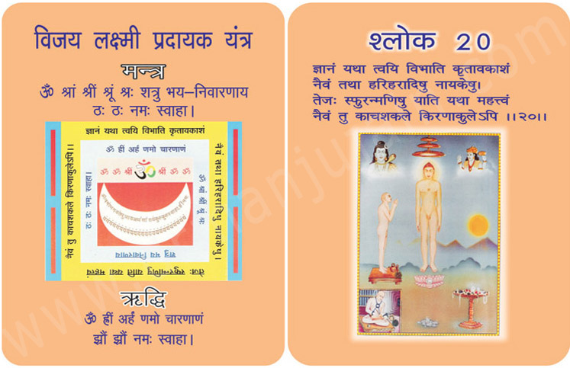
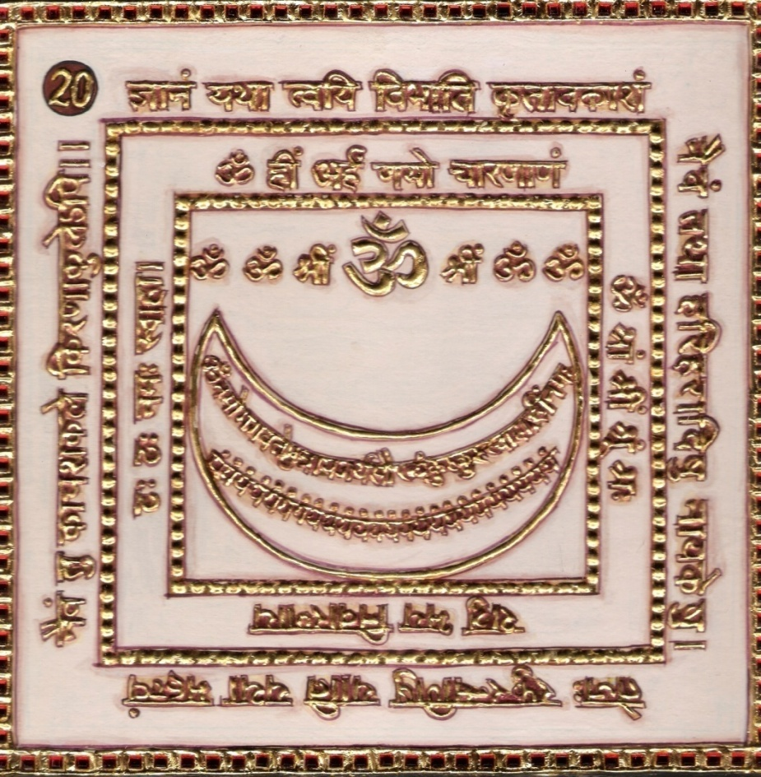

1.0 Purpose
1.1 Keeping the Yantra near and having chanted the Riddhi, Mantra syllables 108 times renders fertility, victory as well as development of intellect.
2.0 Scope
2.1. The other Gods such as hari & Har possess no such supreme knowledge as you have in you with its all illuminating quality; for the (rear) luster, which shines in the glittering jewels with its full splendor, can not be reflected in equal degree, by the glass pieces, even abounding in the rays of light.

3.0 Method
3.1 After purification in the morning and clothing in white, the Yantra is established for worship and worshipped. Then facing the east the verse, Riddhi and Mantra syllables are chanted 108 times after having chanted the Namokara Mantra 9 times. Everyday 108 flowers are offered having pleasing fragrance.

4.0 Resources
Keeping the Yantra near and having Riddhi, Mantra and Verse, 108 times chanting,Clothes in white. Namokar Mantra 9 times, 108 flowers with pleasant fragrance.

Shloka - Repeat 9 times

GYANAM YATHA TWAYI VIBHATI KRITA-VAKASHAM
NAIVAM TATHA HARIHARADISHU NAYAKESHU
TEJAH SPHURAN-MANISHU YATI YATHA MAHATWAM
NAIVAM TU KACHASHAKALE KIRANA-KULEPI

Meaning

Lord! You are the ocean of pure and exclusive enlightenment. All your attachments are gone and hence you belong to none and no one belongs to you. All the desires of yours have perished and hence you have no friends or foes. You are not bound by anyone, nor do you bind anyone!
It is therefore that you see the world as it is. It is therefore that your enlightenment is free of all preconditions and purely independent. This is the very reason of our very distinctive respect to you. Though we do not have any hate or disregard for Hari (Krishna) & Hara (Mahadev) or any spiritual or religious leader, but the imperfectness of their knowledge and their inclination towards attachment and hatred do not inspire us to follow their path, but that of the Jineshwara.
Lord, your pure enlightenment is the outcome of total awareness and total detachment.
Look at that glowing halo! Naturally, a piece of glass or stone cannot shine as much as a jewel. Glass and diamond do reflect; but the reflection from a glass is not as bright as the diamond and jewel.

Mantra - Repeat 108 times

Om shrām shrim shrūm shrah shatru-bhaya-nivāranāya thah thah namah swāhā
Om namo bhagawaté putrārthasaukhyam kuru kuru swāhā hrīm namah

Riddhi (le pouvoir surnaturel)
Om hrīm arham namo chāranānam
(Jhraum jhraum namah swāhā)

Evidential Story - 20

Seth Adol Dutt was a staunch follower of Jain religion. Everybody praised his faithfulness towards religion. But Sethji's only son Vishnudas in spite of having such a religious minded father who saw everybody as equal, was a false person like the darkness under the lamp.

One day a fraud sadhu arrived in the city. His long tresses were also false which were actually animal's hair fur painted black and artificially worn. In reality the fraudulent sadhvi. False and dirty character was hidden under his fraudulent deeds. The sadhu saw Vishnudas, the Seth’s son coming his way he thought that a golden bird was coming to be captured. He stopped his breath and sat in yogas and in a way as a crane fools the fish. Vishnudas prostrated before him and asked him to show him the way to cross the ocean of life and reach heaven. The Sadhu said “What you say is right but you devotees, don't care about our food and clothing and expect a discourse from us. If the country, religion, and devotees remain this way then we sadhus will have no option but to stay in huts in the Himalayas without food, chanting the name of Rama and will never step into your bad city. This bantering had its effects on Vishnudas. He looked after the fraud for weeks. He organised for food, clothing tobacco, ganja ( a type of intoxicating drug) etc. for the sadhu. He who never went to collect back the money which his father had lent to people was now collecting donation from door to door to open a school in the city as suggested by the sadhu. He collected thousands of rupees and deposited with the sadhu. The sadhu was very happy and was looking for some plan to slip away with the money. One day he told his followers that his religious sadhana was accomplished and he had to move away to some other place as the scriptures declare that sadhu and water should not stay at a place for long otherwise they get polluted. A sadhu can not be attached to a place as that becomes a reason for his downfall.

In spite of the follower’s request to stay back the sadhu moved away along with his chief disciple moving from city to city Vishnudas realized the reality and started hating his so called gurus. Who was looking out for an opportunity to escape? One night the fraudulent sadhu disappeared with all the money and Vishnudas developed hatred towards the fraudulent sadhus. The separation of his only son made Adol dutt very sad and worried. One day he was stunned to see his son falling at his feet and asking to be pardoned for his waywardness. The father was happy that the son was freed from the ditches of the fraud sadhu. One day a vitragi Digambar muniraj visited the city. The Seth took his son to the muniraj. Vishnudas was impressed by the divine glow on his face but having experienced a false sadhu he did not prostrate before the muniraj. He wanted to test the muni so he questioned him, “How to escape from this world?” The benevolent muniraj said, “Oh child! Understand the difference between the body and the soul. Reduce the attachments and hatred from your mind. Keep away from five sins violence, lies, theft, kusheel, Parigrah don't let anger, ego, illusion maya and greed enter your mind. Keep yourself under control in all spheres of life. Your soul will be purified thus and you will march forward in the right direction to escape this world”.

Vishnudas marvelled at the answer and felt that now he would be on the right path. But he had not fully recovered from the distrust he had developed towards sadhus. So he said, “Maharaj! Show me a miracle so that my belief in religion and sadhus strengthens”, Munishree taught him the 20th shloka of Bhaktamar stotra with riddhi and mantra and asked him to chant the shloka with riddhi and mantra before everyone and attain his wish. Next day Vishnudas chanted it with utmost devotion in the royal court. The Jin Bhrigunidevi appeared there and granted ashta riddhis to Vishnudas. Everyone hailed victory. Vishnu das along with everybody went to the jungle and fell at muniraj's feet and said “Lord today in our country fraud sadhus are cheating people doing false tapas in order to flinch money, you have saved me from such false guru's opening my eyes”.

Testimonial

A lady, Mrs. Sangita Jain is blessed with a baby boy at the age of 48 years. She is regularly chanting 20th Shloka for baby. She said that it was really a miracle and this is only by chanting of Bhakatamar Shloka. She and entire family thanked Mrs. Manju Jain.

21st Shloka for Keeping Family Members under Control
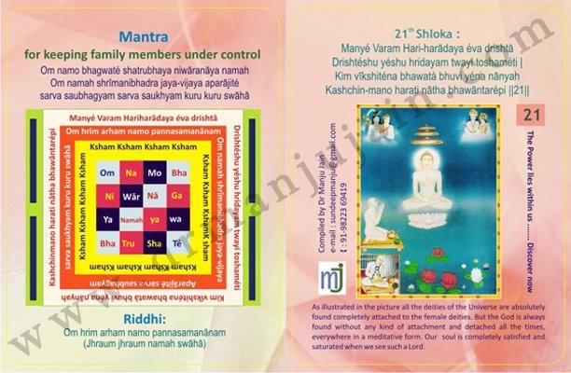

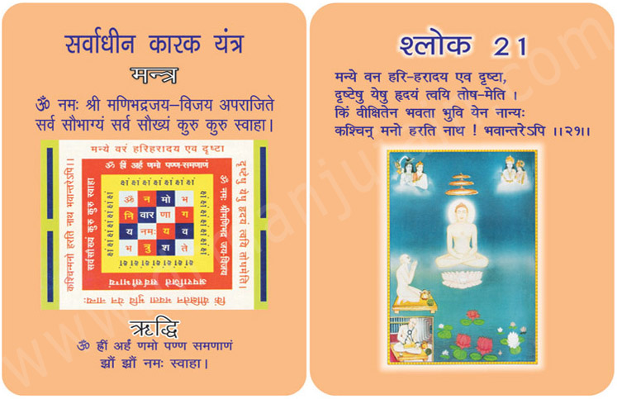
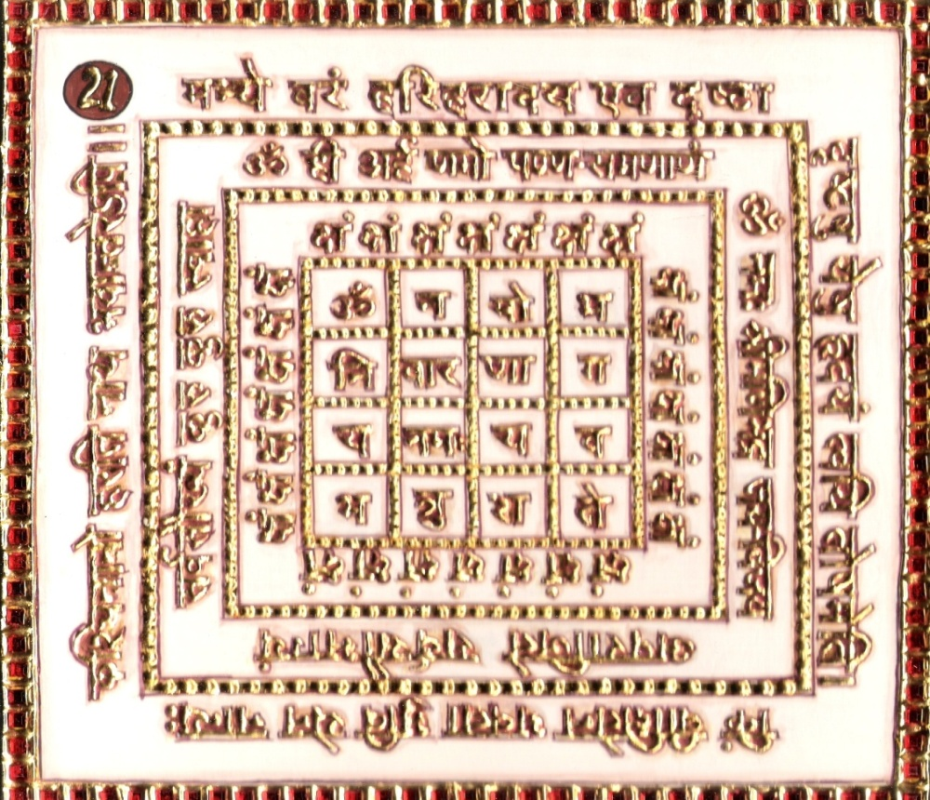

1.0 Purpose

1.1 The people in general and the own persons as well as members of family are made under control.

2.0 Scope
2.1. It is better that I have seen Hari and Har Dev. All the deities of the universe are absolutely found completely attached the she deities. But the God is always found without any kind of attachment and detached all the time, everywhere in a meditated form. Our soul is completely satisfied and saturated when we see such a Lord.

3.0 Method
3.1 After purification and having clothed in red the verse, Riddhi and Mantra syllables are chanted 10 times a day for 42 days with red rosary and 108 flowers are offered.

4.0 Resources
The people in general and the own offer 108 flowers.
Red clothes & Red Rosary, 108 times chanting for 42 days.

Shloka - Repeat 9 times

MANYÉ VARAM HARI-HARĀDAYA ÉVA DRISHTĀ
DRISHTÉSHU YÉSHU HRIDAYAM TWAYI TOSHAMÉTI
KIM VĪKSHITÉNA BHAWATÀ BHUVI YÉNA NĀNYAH
KASHCHIN-MANO HARATI NĀTHA BHAWĀNTARÉPI

Meaning

Oh my Lord of Lords! Good that I became formally the follower of other religious leaders like Krishna and Mahadeva. But it was so good that they made me realize the true nature of the Vitaraga and ultimately I decided to take shelter.
Oh the Almighty! It was also good that I saw you at last. Your conclusive touch is very pleasing. Now I will not think of any other deities. In case of my following you earlier, I might have thought of roaming around with other deities. Am I not benefited by your holy sight? No, my Lord! Now the truth realized by me will not allow me to go towards other religious leaders and their philosophies neither in dreams, nor in subsequent births.
You have impressed my heart to such an extent that not only during the remaining period of this life, but even beyond, no other deities will attract my Atma. This is my solemn affirmation till Moksha.

Mantra - Repeat 108 times

Om namo bhagwaté shatrubhaya niwāranāya namah
Om namah shrīmanibhadra jaya-vijaya aparājité sarva saubhagyam sarva saukhyam kuru kuru swāhā

Riddhi (le pouvoir surnaturel)
Om hrim arham namo pannasamanānam
(Jhraum jhraum namah swāhā)

Evidential Story - 21
This is a story of the great middle ages when the country was divided into small kingdoms. There was an expert thief named Sudutt who was so smart that he could never be caught inspite of all the efforts of the State Administration.
The king was much worried and disturbed. On a fine day, to his bad luck, Suddutt was caught red handed at the king’s palace. He was presented to the king. The king felt quite proud and happy. The king asked Sudutt “at last you are caugh. After all your tricks I see you in rags, but what about all the stolren property” ? He was not an only expert at robbery but also quite charming with his lies and magics. He replied saying Maharaj, all the stolen goods are kept with merchant Hemdutt. At this reply both the king and the merchant. Hemdutt were taken aback Hemdutt. The merchant quickly stated that he had never seen the fellow. “We Jains are very much against all sorts of violence and the
5 sins, and take a lot of care of every step we take. How am I connected to this man who is only telling us lies to escape? Hearing the truth of the Setth, Raja seemed pleased. So the thief started a new drama. Weeping he asked the Seth “are you not afraid of righteousness? If you want to be drowned you may do so, why do you want this poor man to be drowned? I have handed all the stolen goods to you, I did only what ever you had told me, Is this the reward for that, you save yourself and ruin me? My family will be starved to death. Doing such injustice you are not afraid of God, even?” Before even the thief could finish his story the king ordered his soldiers saying that the merchant is a traitor and the chief of thieves. To his feet hands and throw him into the dark well in the dense forest. The soldiers executed the orders. With out food & drink, hungry & thirsty the merchant lay in the well as he was bound hands and feet for 3 days. He understood that this was the fruit of his inauspicious deeds, with this realisation he lost all the body pains and began to get deeper into himself. 1st Tirthankar Bhagwan Adinath began to become visible to him. With excruciating pain he began to chant the yugal shloka from Bhaktamar Stotre. With the divine light his eyes were opened, all his bindings removed he found a bejewelled throne & there he found a Devi, she spoke saying “I am the administration Devi Vijaya. Your yugal sloka & mantra have brought me here. Saying this she disappeared. After some time his guards saw the light and the feth quite well, comfortable. This miracle was reported to the king. King understood that the merchant was innocent and the king came himself and with much honor took the seth to the palace, sought his forgiveness and punished the thief. Inspired by the yugal sloka of Bhaktamar stotra created by muni Thunkacharya, the king and his subjects accepted Jainism.

With the power of Bhaktamar Stotra the falsehood was defeated and truth triumphed Practising the virtue of justice the king, punished the thief severely.

Testimonial

22nd Shloka for Removing Turbulence By Ghost and Devil

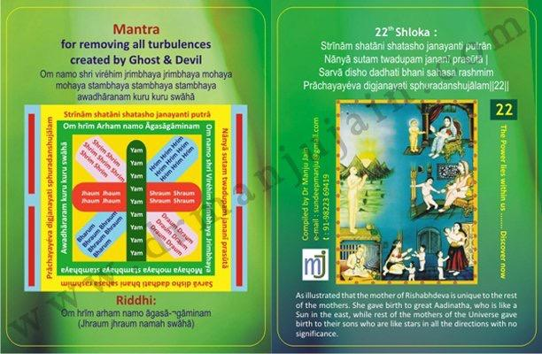

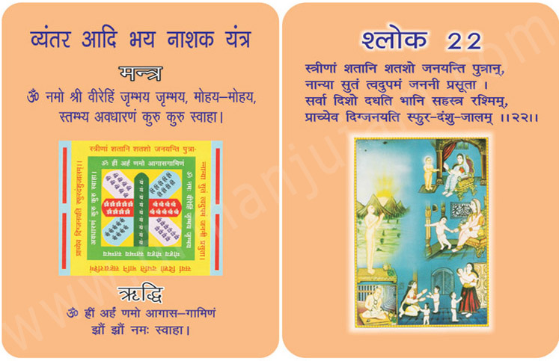
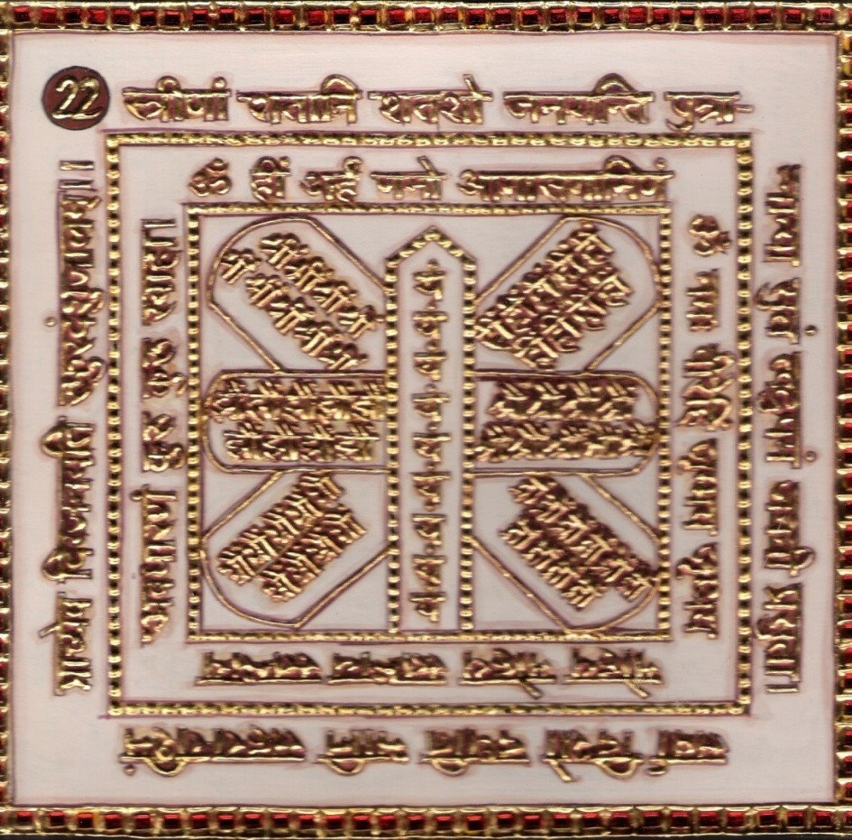

1.0 Purpose
1.1 Removes all the turbulences and interruptions made by devil & ghost.

2.0 Scope
2.1 Hundreds of women given birth to sons by hundreds but no women can give birth to a son like you for all (the eight) directions may hold stars but it is the east only that can produce the Sun, profusely abounding in illumining rays.

3.0 Method
3.1 The Yantra is worshipped after having bath and clothed in clean dress. Placed the pitcher, candle kindled. The facing to east the verse, Riddhi and Mantra syllables are chanted 108 times a day. The Yantra is garland in the neck.

4.0 Resources
The piece of knot of turmeric (Haldi) is made mystic through 21 chants of Riddhi & Mantra. The Haldi is chewed.

Shloka - Repeat 9 times

STRĪNĀM SHATĀNI SHATASHO JANAYANTI PUTRĀN
NĀNYĀ SUTAM TWADUPAM JANANĪ PRASŪTĀ
SARVĀ DISHO DADHATI BHANI SAHASA RASHMIM
PRĀCHAYAYÉVA DIGJANAYATI SPHURADANSHUJĀLAM

Meaning

Oh great Rishabhadeva! Oh God Adideva!
Birth of babies is common course of affairs on the earth; but oh my Lord, Mother Marudevi was the greatest mother of whom a great child, yourself was born, who first preached the religious values, code of conduct, law of ethics, various Sciences, Arts and aesthetics and path of salvation of life. Undoubtedly true, the Godly children cannot be born of all mothers.
Look at that Northern, Southern and Western directions. Just on the onset of night, lots of stars are seen and the whole sky is filled with them. But who produces the lamp to brighten the whole Universe? The East only. Oh Lord! Your mother Marudeva was also a mother like eastern direction. A Great Mother, a unique and unfore-existed Mother! Salutations unto such a Great Mother of yours!

Mantra - Repeat 108 times

Om namo shri viréhim jrimbhaya jrimbhaya mohaya mohaya stambhaya stambhaya stambhaya awadhāranam kuru kuru swāhā

Riddhi (le pouvoir surnaturel)
Om hrīm arham namo āgasā-¬gāminam
(Jhraum jhraum namah swāhā)

Evidential Story - 22

Since ages immemorial battles had been fought between Jindevi devatas and false devi devatas. This story is also about such an interesting episode. The king of Ujjain shri Chandra was a faithful religious man. Mahichandra was the only son of his minister. Motisagar. The king had taken up on himself the responsibility of educating the promising son of his minister. As a result the boy Mahichandra became well versed in both earthly and spiritual matters. By the grace and guidance of his guru he became greatly devoted to Mahaprabhanak Bhaktamar stotra.

One day a vitaragi named Digambar muniraj came along searching for a quiet place for meditation and reached an uninhabited and neglected cave. He found the lonely place fit for concentration and meditation. He sat down there in padmasana for meditation. No one was aware that Vijantar sects Devi Kali resided in that old and uninhabited came. The appearance of chandi (Kali) was like her name i.e. dreadful, scary expression, violent weapons, her attire decorated with weapons of a terrorizing nature. How could she tolerate some other persons intruding into their residence?

As per her nature she became violent. She scared the muniraj who was peacefully meditating and let loose violent animals on him. But the muniraj immersed in deep meditation was not at all disturbed. He considered all these as the fruits of his past deeds. While the world outside was thinking that the muniraj was in great trouble in reality he was blissfully in contact with his soul. When king Shrichandra heard that a muniraj was being troubled by chandi Kali in a cave he immediately called Mahichandra and asked him to oust her from there. Mahichandra Chanted Namokar mantra sitting near the muniraj and started reciting Bhaktamar stotra. As he reached the 22nd and 23rd shloka, devi Manastambhinidevi appeared and asked him what he wanted. He said.”I do not want anything for myself, Devi chandis terror is causing a lot of problem in my meditation. I want peace here”. Devi said, “Probably she does not know that Peace defeats violence always.

Probably she does not even know that violent feelings come from outside whereas feeling of peace is the nature of the inner self -soul.

As the Jindevi Man stambhini smilingly closed her eyes and lifted her right hand up, chandi Devi’s weapons started falling from her hands. Magical ghosts, wolves, cheetahs, all types of violent animals ran away and chandi devi fell at the feet of Manastambhini devi and asked for Pardon. Devi said, “Oh wicked one ! By troubling others you feel happy”. Not me but this peaceful muniraj only can pardon you”. But how could muniraj pardon? Munis are always peaceful and see everybody as equals. He is not bothered about pardon or anger. His nectarly words transformed the wicked chandi Devi into a Jin devotee. Now the atmosphere was non-violent and peaceful. The feelings of anger and violence had surrendered to those of peace. The wicked chandi Devi obtained equanimity.

Testimonial
Destiny from Nigeria was suffering from black magic effect and wastrembling frequently, he searched for some relief and came acrossspiritual healing through bhaktamar technique, inquired on phone andcame to Nagpur, India to take treatment for getting relief from evil spirits effect, he was advised to chant 22 and 23 shloka of bhaktamar and within 3 days he told media person from Dainik Bhaskar who came for short visit that his black magic effect was released by 70 % and later by chanting it for 15 days he was completely cured, he was very systematic in offering clove ets meticulously and only problem he faced was squatting position while sitting in Prayers ( Vidhaan ) . Destiny again came to India after 1 month to learn all the shlokas with mantras and riddhi and after that he got Security Head job in
Casino in London, he was very happy for his mother Faith and his sister Patience.

23rd Shloka for Eradicating Headache & Court Cases
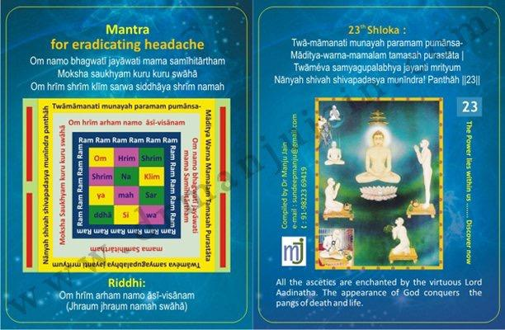

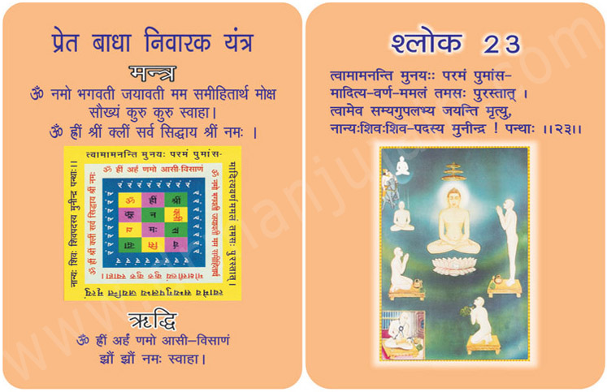
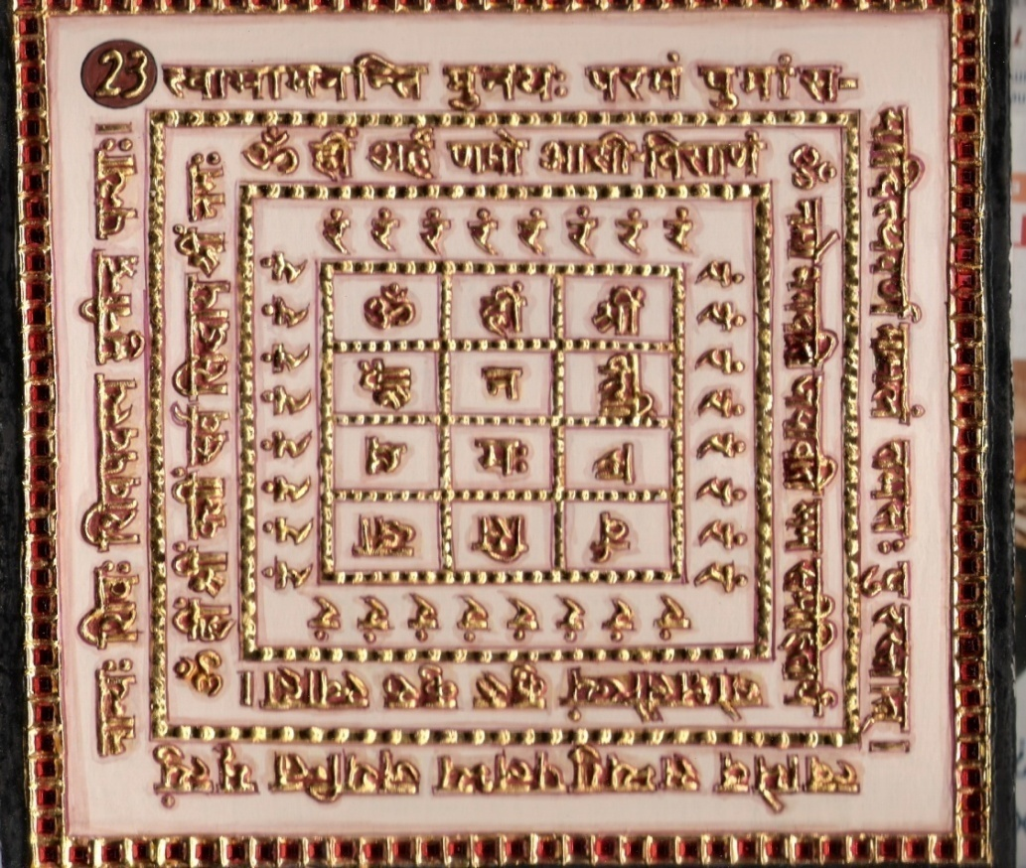

1.0 Purpose
1.1 For the safety of the body first the verse, Riddhi and Mantra syllables be remembered 108 times. Repeat spells removes the interruption by the evil spirits.

2.0 Scope
2.1 Great sages are considered to be Supreme Being who possesses the effulgence of the Sun, is free from all the blemishes and is beyond darkness. Having perfectly realized you, men even conquer death. ‘O’ sage of sages! There is no other a auspicious path (except you) leading to blessedness.

3.0 Method
3.1 After purification at an auspicious occasion being clothed in white, facing to the north keeping the Yantra there. Auspicious pitcher may be placed and a candle kindled. The Yantra is worshipped and then Riddhi and Mantra syllables are adored 4000 times with white rosary for evincing the Mantra.

4.0 Resources
Yantra, Mantra, Riddhi & Verse
White clothes, Candled kindled on auspicious pitcher, White Rosary

Shloka - Repeat 9 times

TWA-MAMANATI MUNAYAH PARAMAM PUMANSA-
MADITYA-WARNA-MAMALAM TAMASAH PURASTATA
TWAMEVA SAMYAGUPALABHYA JAYANTI MRITYUM
NANYAH SHIVAH SHIVAPADASYA MUNINDRA! PANTHĀH

Meaning
O the Master of Monks! Upon lot of thoughts and hypotheses, the scholar-saints have finally concluded that you are the only preacher and giver of KEVAL JNANA the ultimate enlightenment, and hence you are a PARAM PURUSHA – the Supreme Super human! The thinkers, who attained their status after a great penance, rightly address you as AMAL because there is no trace of any impurity in you. Your omniscience and total detachment are seen in highest esteem by scholars and they rightly address you, your delusion less as “TAMASAH PARSTAT” beyond darkness! Hence oh Lord! I am fully convinced that death – the cycle of birth & death-can be overcome and Moksha can be attained by following your preaching’s. One may try any other path for enlightenment, but oh Lord, the path preached by you is the shortest, safest and ultimately accepted by all.

Mantra - Repeat 108 times

Om namo bhagwatī jayāwati mama samīhitārtham
Moksha Saukhyam kuru kuru swāhā
Om hrīm shrīm klīm sarwa siddhāya shrīm namah

Riddhi (le pouvoir surnaturel)
Om hrīm arham namo āsī-visānam
(Jhraum jhraum namah swāhā)

Evidential Story - 23

The measures of power is not being in great numbers. One strong person in one strong person in better than many weaklings. In the same manner the one who sings praises of God is putting all living beings in one category and the Tirthankars in another category. Great people are found rarely. Jain Puranas give evidence of holy persons being found limited members. This is the reason why in any age only 24 Thirthankars are found and not more, where as ordinary beings number is not fixed.Great men may be very few, may be just one, even then the amount of good works they do is much more than weak persons. Now we have a very good example from the writer. Though the countless number of stars illumines the sky, it cannot light up the world nor dispet darkness. Though they are numberless their strength doesn’t increase. Sincerely the sun is just one yet its redness brightens the whole world, and awakens consciousness around. The writer tells about such a great person.

“You are blessed from your mother’s womb and you do so much good which in turn your mother even more blessed. At present human population has increased just like worms and insects, yet unable to do any good to themselves or others. Crores of mothers give birth to crores of sons, yet they stand no where in comparison to your strength. This is the reason why at we can neither see more sons like you nor mothers like yours. God Paramatma alone is worthy of utterance. All religions address God in different ways. The vedic Rishis address God as mrityunjoy which means one who defeated death, Acharya Manathunga explains mrithyun joy as one who eradicates birth old age and death. Every Jain Thirthankar is no a liberated person who will never again be born or die. Not only every Thirthankar has achieved moksha but every devotee who takes his name faithfully will win over birth and death and when the people greet him Kailashpathi the ruler of Kailash mountain. All thee synonyms are meant for Thirthankar because welfare or wellbeing is known as Shiv and because you are the Shiv who alone care for the well being of all and there can never be another one.
Testimonial

24th Shloka : for removing Half Headache & Vertigo problem

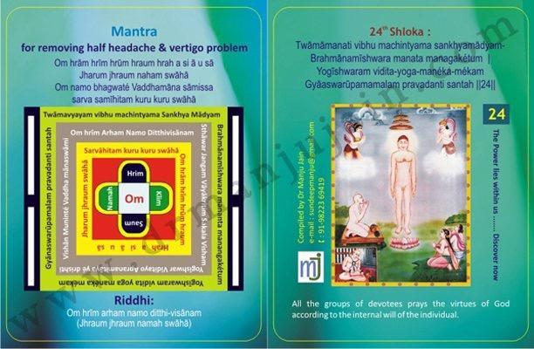

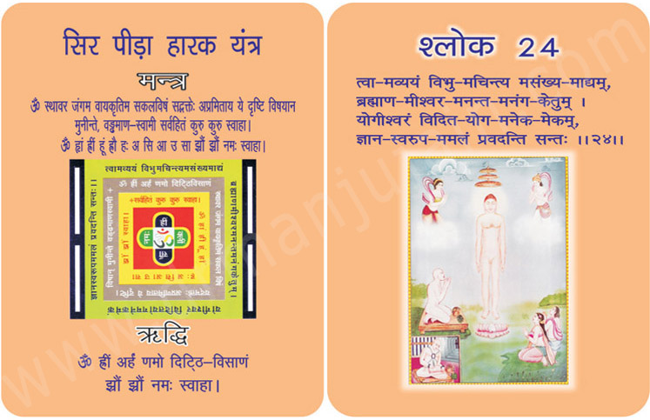

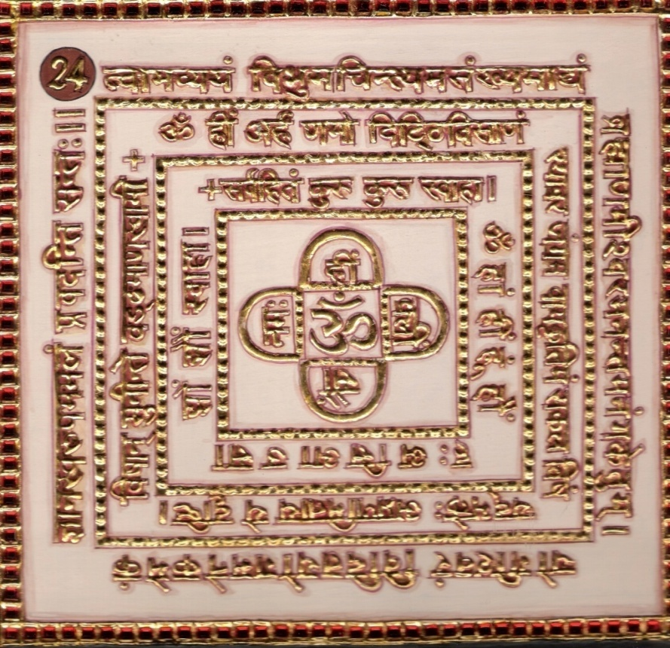

1.0 Purpose
1.1 Relieves half headache solar humor (suryavata) and vertigo including all types of headaches.

2.0 Scope
2.1. The sages regard you as the imperishable store of super human qualities incomprehensible, innumerable, the first and principle Tirathankar the supreme and highest soul Lord of Gods infinite, the destroyer of cupid, the chief among yogas, conversant with yoga, endowed with supreme knowledge and free from impurities.

3.0 Method
3.1 After purification, one should be clothed in the dye of ruddle (Geru). The Mantra is established and worshipped with kindled lamp and moving flame Arati) The Riddhi and Mantra are chanted 108 times a day in the beginning and then adored 1000 times a day for 7 days.

4.0 Resources
Geru, Clothes, Yantra, Mantra, Riddhi & Verse.

Shloka - Repeat 9 times

TWAMAVYAYAM VIBHU MACHINTYAMA SANKHYAMADYAM-
BRAHMANAMISHWARA MANATA MANAGAKETUM
YOGISHWARAM VIDITA-YOGA-MANEKA-MÉKAM
GYAASWARUPAMAMALAM PRAVADANTI SANTAH

Meaning

Oh my Lord!
Noble and serene saints and scholars pray you with their following words and attributes.
Your eternal power is not going to corrode for time immemorial and hence they call you “AVYAYA”.
Your presence in the form of enlightenment is spread in all the beings of the universe and hence you are known as “VIBHU”. The scholars think about you with utmost reasoning. But ultimately they conclude that it is not possible to comprehend your eternal qualities and properly shape their ideas regarding you. Hence they finally resign and say that you are “ACHINTYA”. Your countless qualities are unaccountable and hence scholar statisticians define you as “ASANKHYA”. Oh God! You have incepted Dharmateertha and you are the first Tirthankara. Therefore you are called “ADYA”. Thinkers think that you have achieved infinite happiness.
Thinkers think that you have achieved infinite happiness, “Brahman” and hence you are the “BRAHMA”. As you are worshipped by innumerable Devas, you are rightly the Lord of the Devas.
As you have conquered the death, you are ANANT deathless. The sexual desire is called the KAMA and the mythological deity for the success of KAMA is called Kamdeva, but you are the supreme Conqueror of sexual desire and hence you are called ANANGAKETU, the foe of the Kamdeva.
The physical, mental and oral activities of ATMA are known as KAYAYOGA MANOYOGA AND VACHANAYOGA respectively. Those who master these YOGAS are YOGIS and you are the supreme amongst them YOGEESHWARA.
In spite of the eternal settlement of Yogas in yourself, you have remained absolutely unconcerned as if they are not present, which is the height of your awareness and therefore the scholars have rightly defined you as VIDITYOGA.
Samavasarana is the place occupied by Tirthankara for his preaching. Tirthankara faces eastern direction while addressing the disciples and listeners. Devas in their act of overwhelming devotion, create your divine images in all other directions as well. So you are known as ANEKA.
God! Scholars could not find out any other similar personality like yours and therefore they say, you are the only one, only one and only one…. You are unparalleled, UNIQUE
Oh my God! You are the ocean of knowledge, so you and the knowledge are just the same. Therefore scholars say that you are JNANA-SWAROOPA.
God! The critics and faultfinders tried to find out your limitations and shortcomings; but it was all in vain, because there is no existence of any vice in you. You are therefore known as AMALA the spotless personality.
O, Bhagawan Rishabhdeva! You have been praised in various forms as mentioned here above by the saints of the world as you possess infinite virtues; words fall short to describe you.

Mantra - Repeat 108 times

Om hrām hrīm hrūm hraum hrah a si ā u sā
Jharum jhraum naham swāhā
Om namo bhagwaté Vaddhamāna sāmissa
sarva samīhitam kuru kuru swāhā

Riddhi (le pouvoir surnaturel)
Om hrīm arham namo ditthi-visānam
(Jhraum jhraum namah swāhā)

King Jitshatru was very a flirtatious and sensuous man. He married not one or two but 36 princesses. It was spring season. The chirping of the cuckoos and the pleasant breeze was arousing the sensuous feelings in such people. The earth and trees were clothed in green leaves.
King Jitshatru sent his 36 queens and their maidservants to play in the forest. In the pond of lovely and uninhabitated forest bath (ing) was organized. The queens wearing transparently thin and beautiful clothes jumped into the pond. The king and the queens were engaged in the water play for hours. The queen’s thin and wet clothes were changing to their bodies. The king, was very pleased to see their enchanting forms. History is witness to many saints, ascetics who dwindled from their holy path because beautiful woman stole their hearts and put off the kindled lamp (light). So why wouldn't the king lose his discrimination seeing the half naked enchanting forms of his 36 queens ? He ordered for song and dance. The minds started playing instruments and the queens started dancing. After the dance the tired queens were returning but the lord of the forest could not tolerate this pride of the queens. His angry look made all the queens go mad. Some started crying while some started shrieking felling some mired their bodies. Some tore of f their transparent clothes, some were laughing and pushing the king into the water. The king tried to save himself from the frenzy queens.
A merchant's son was crossing the dense forest on his way to business. Seeing the king he went to greet him but the half mad queens played havoc with him. The king was annoyed with them but the queens played havoc with him too. This misbehavior made the king and the merchant’s son worried. Now the song and dance party had gone astray.
At last the merchant son suggested that they seek refuge with Shanti Kirti muniraj in the nearby forest. Seeing the lustful naked digambar muniraj the queens botching with desire became even more aroused. The principal wife of the king threw away her clothes and spreading her arms as she proceeded towards munishree she felt that someone had tied her feet with iron chains. She could not move. Everybody stood stunned as if paralised.
The supremelypeaceful. Sober and kind Shantikirti muniraj took a handful of water from his pot, chanting the 24th shloka (twamvyayam vibhamchintyam Sankhymadyam) and the 25th shloka (Buddhist vamd eva vibudharchit padpites) repeated by sprinking water on the aroused queens as if playing holi. But this was not the water play held earlier. Instead it was the hollt (play) of detachment. As a result of these two shlokas of Bhaktamar stotra, an agitated or mad person also gets healed. This supremely effective Bhaktamar Stotra is auspicious for everyone always. When the king and the queens regained consciousness they felt very ashamed of their semi naked state. The maids ran towards the royal palace to bring new clothes. Everybody faithfully payed obeisance to the muniraj. The king promised the muniraj that he would keep away from sensuous life.

25th Shloka for Rescuing From Enemy’s attack And Evil’s Eye

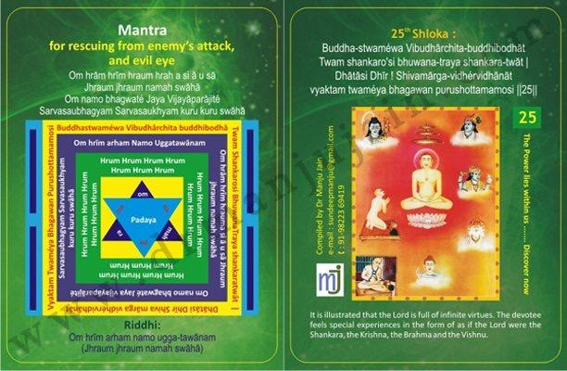

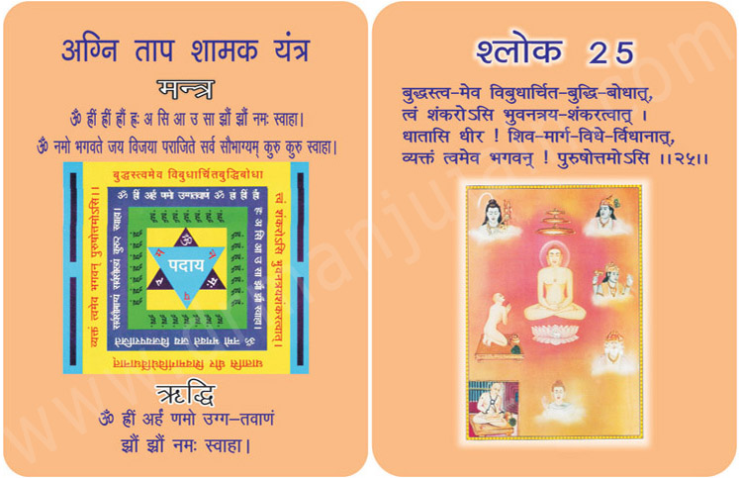
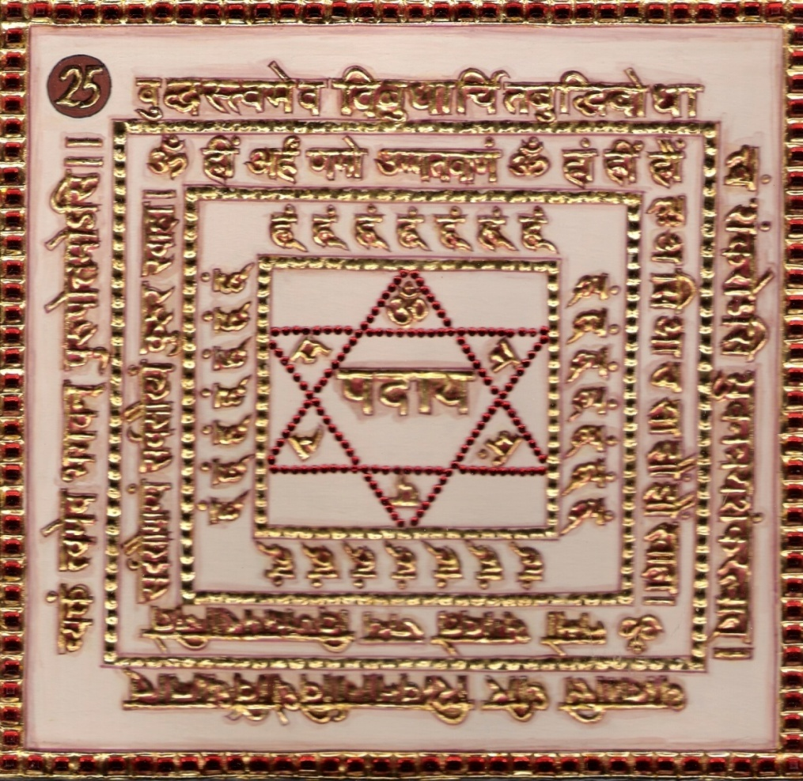
1.0 Purpose
1.1 Remembering the verse, the Riddhi and Mantra syllables saves from being prey to evil eye sight faults and effects of fire. The weapon in the hands of the enemy falls down and he cannot attack.

2.0 Scope
2.1. You are God Buddha as the other Gods and leaned persons (Gandhar) have worshipped and praised your knowledge, being the source of the prosperity of all living beings you are the only God Shiva. ‘O’ resolute one, as you laid down rules, serving as a guide to road of salvation you are the creator and what more Oh God! You being the best among the persons are the only Narayan.

3.0 Method
3.1 After having bathed and clothed in red, the Yantra is established and worshipped through flame as well. Then at night in isolation with fearlessness the Riddhi and Mantra syllables are chanted 4000 times for proving the mantra.

4.0 Resources
Red clothes, moving flame of Deepak, Isolation

Shloka - Repeat 9 times

BUDDHA-STWAMEWA VIBUDHARCHITA-BUDDHIBODHAT
TWAM SHANKARO’SI BHUWANA-TRAYA SHANKARA-TWAT
DHATASI DHIR! SHIVAMARGA-VIDHERVIDHANAT
VYAKTAM TWAMEYA BHAGAWAN PURUSHOTTAMAMOSI

Meaning
Oh God of the Gods!
Some people asked me, “It is all right about God Adinatha, but who are BUDDHA, SHANKARA and BRAHMA?
Lord I have no words to describe their characters, I expressly told them that I know one and the only Veetaraga, one and the only ADINATH, one and the only TIRTHANKARA. Then I told them to listen the true meaning of their names:
The one who possesses the entirely developed intelligence of KEVALJNANA is BUDDHA.
SHANKARA also is a direct meaning of you attribute. “Shan” means Kalyana and “Kara” means the performer. So these words mean that the one who performs the process of implementing eternal bliss in mankind is “Shankara”
By your lustful observations, pious character, constant awareness and Supreme Enlightenment, you are the only one, by practicing whose preaching’s, one can attain salvation; and hence you are the true BRAHMA.
Your life is full of penance, awareness, enlightenment and is absolutely neutral. These attributes easily define you as the Greatest Man (Purushottama)

Mantra - Repeat 108 times

Om hrām hrīm hraum hrah a si ā u sā Jhraum jhraum namah swāhā
Om namo bhagwaté Jaya Vijayāparājité Sarvasaubhagyam Sarvasaukhyam kuru kuru swāhā

Riddhi (le pouvoir surnaturel)
Om hrīm arham namo ugga-tawānam
(Jhraum jhraum namah swāhā)

Evidential Story - 25
The composition of Bhaktamar Stotra is now progressing from worship (Eulogy of Lord Rishabhdeva) towards “Tatvagyan”. In the following shlokas he has described the true meaning of religion. In this shloka Acharya Mantunga submits that O Lord ! Viewing you In different perspectives the sages address you as “AMARNITHINE” (in existence). The pedestal on which you are seated in surmorentable. You are unfathomable in perception. You are all pervading in knowledge. You are infinite in virtues.

You can accomplish all tasks thus you are Vishnu. You are detached from the worldly needs. Until anyone forsakes the thoughts of need and desire, he cannot even approach you. Just as all rivers flow into the mighty ocean, similarly all pious thoughts flow into your infinite virtues. You are perpetual and are in existence always. Thus you have immense strength. You have conquered the Kamdeva and have unfurled the flag of Jainism in the entire universe. You are seated in the position of total knowledge and all yogis and saints eulogise you for your virtues.

Testimonial

26th Shloka for removing Labour pains of lady.

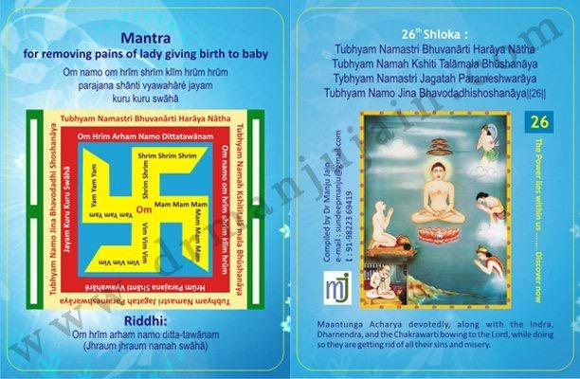

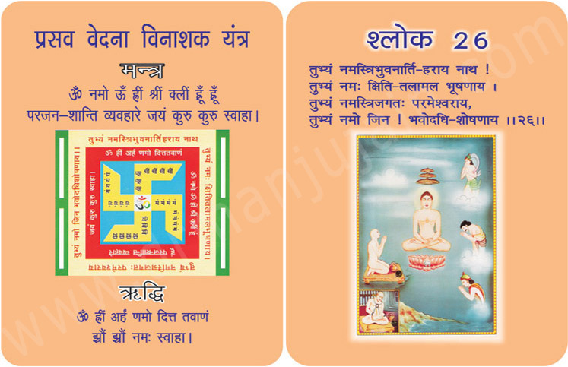
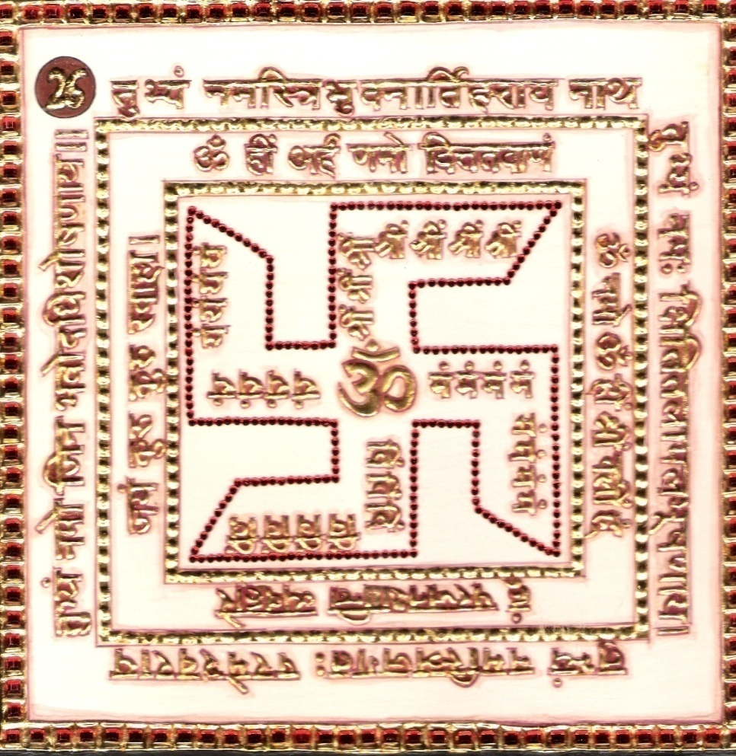

1.0 Purpose
1.1 Removes half headache and pains of lady giving birth to baby. It also saves from fatal diseases.

2.0 Scope
2.1. ‘O’ Lord! Bow to you who are the destroyer of the pains and suffering of the threefold world. Bow to you, the pure and genuine ornament on the face of the earth. Bow to you the paramount Lord of this creation. ‘O’ Jina! Bow ‘O’ Jina! Bow to you as you are capable of destroyer of all sadness of the worldly existence. Getting rid of all their sins and misery while bowing to Lord.

3.0 Method
3.1 After bath and putting on red dress, keeping face to the North, the Yantra is established and worshipped with moving flame (Arati). Then Riddhi and Mantra are chanted 12000 times from the midnight to the afternoon for evincing the Mantra.

4.0 Resources
Red clothes, Mantra, Yantra, Riddhi & Verse, Moving flame (Arati Deepak)

Shloka - Repeat 9 times

TUBHYAM NAMASTRI BHUVANĀRTI HARĀYA NĀTHA
TUBHYAM NAMAH KSHITI TALĀMALA BHŪSHANĀYA
TYBHYAM NAMASTRI JAGATAH PARAMESHWARĀYA
TUBHYAM NAMO JINA BHAVODADHISHOSHANĀYA
Meaning
Oh my God! I simply bow at your feet because you are the destroyer of the troubles of all the three Lokas! Oh Great Ornament of the earth accepts my salutations in your feet.
Oh Supreme God of Tribhuvan (i.e., Devaloka, Manav Loka ad Davan Loka!) Accept my offerings in your feet. God! You are the only source with whose blessings; I can swim across the salty waters of the Samsara-Sagara and overcome my shortcomings of Adhi, Vyadhi and Upadhi. Kindly accept my offerings for lifting the humankind to Moksha.
Salutations…! Salutations…! Salutations…!
Crores and Crores of salutations unto you!

Mantra - Repeat 108 times

Om namo om hrīm shrīm klīm hrūm hrūm parajana shānti vyawahāré jayam kuru kuru swāhā

Riddhi (le pouvoir surnaturel)
Om hrīm arham namo ditta-tawānam
(Jhraum jhraum namah swāhā)

You must have heard the name of Nrayan Shrikrishna's Sudama. Sudama was the friend and also the devotee of Shri Krishna Inspire of being very poor he never asked anyone for anything. He was satisfied even in his poverty. Narayan Shrikrishna tested his devotion and he was stained. There is one such true story which is known by the name of Bhaktamar's Sudama. Who was that Bhaktamar's Sudama? He was a beggar who had to tolerate the harsh words of others and lived on the left over's of people. He had a wife who with tatters covered her body. Away from the city and society he lived in a hut made of straw. The hut was in such a decrepit condition that even a gust of wind could bring it down, a shower of water could make it roofless and as if the rays of afternoon sun was waiting to burn it down. Both were passing their time in such a hut. Even today about 40% people live below poverty line. Millions of people in India are born on footpath or in dirty localities in huts and spend their entire life there. Poverty was always there. The case of Shrikrishnas Sudama and beggar sudama is a proof of this. The truth is that this evil i.e. The difference between the rich and poor will never change. This evil continues due to the good and bad deeds done by man. As a result of good deeds one becomes rich. Whereas bad deeds lead to poverty. If this difference was not there, the world would be called salvation. It is said that even the time changes good time’s dawn for dung heap, then why does it not change for these poor souls? Yes times do change but not for all. Due to the fruits of good deeds times change for some people. The days of Sudama changed with the grace of Lord rightful (Samyagdarshan) rightful knowledge (Samyagyan), and rightful conduct (Samyagchritra) you have explained all objectives and knowledge to the living of this universe. You are the
Shrikrishna. Where as in the case of beggar sudama the chanting of the 26th
Mahaprabhavak Shri Bhaktamar stotra changed the days for the better.
shloka of Progenitor of Philosophy. You are perpetually blissful. You are Majestic in glory. You purity is eternal, serene and unaffected by sensuality. You are the Lord of ascetics who are in deep meditation. You are the Preception of the Yoga Philosophy. You are Muthdimensiond in perspective. You are unique. You are omniscient in form and Pure and free from all vices. There is none like you in the three realms.
Due to the inspiration and force of his wife sudama left his dilapidated hut and proceeded towards his beloved Shrikrishna who resided in Dwarika and our beggar proceeded towards Nirgranth Digambar muni. May be he thought of him as one of his kind. His warmth could have attracted him. Probably he thought that this naked muni was poorer than him. But then why do so many people follow him shouting hail victory (Jai ho !). Why do so many rich people prostrate at his feet. It was due to culmination of the misdeeds of the past that the beggar too sat at his feet. He too prostrated before him and kept on looking at him.

Testimonial

27th Shloka for Subduing Enemy
Image

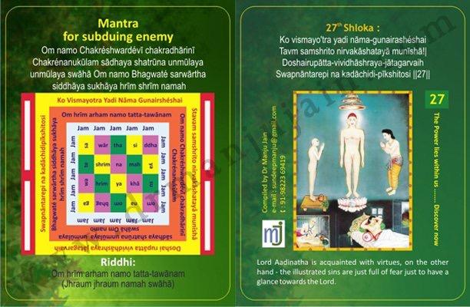

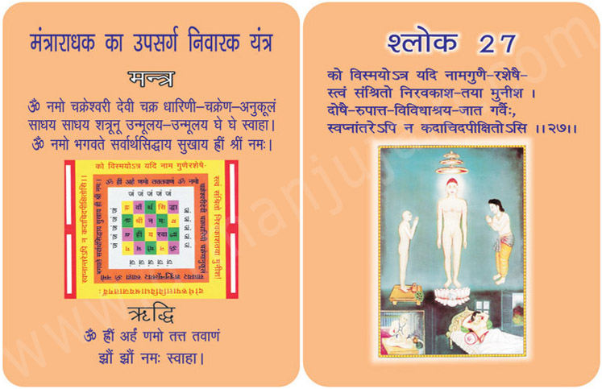

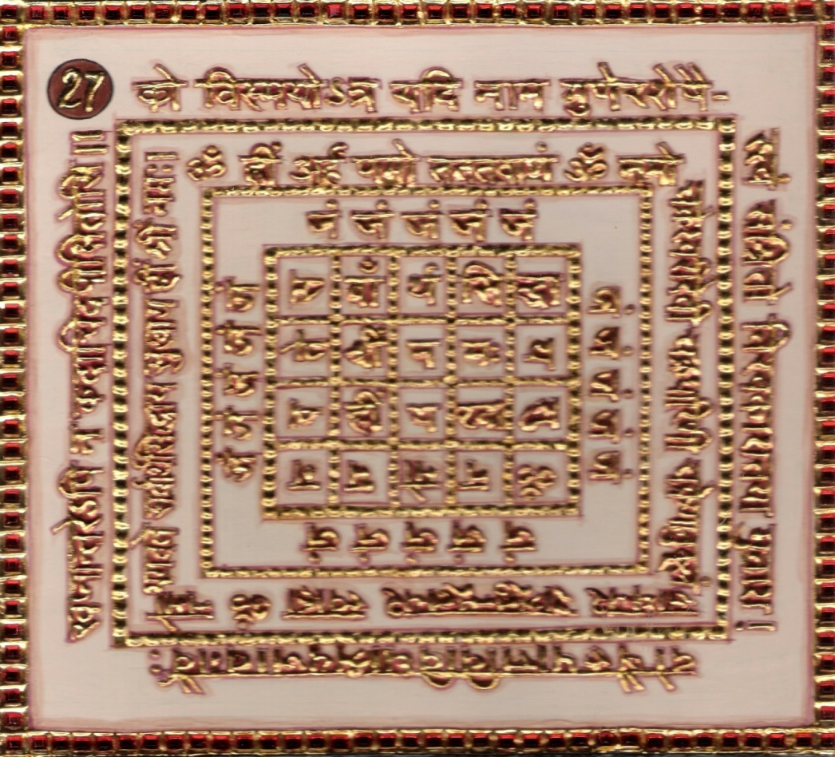

1.0 Purpose
1.1 Enemy cannot hinder your chanting of Mantras. Enemy is subdued if Yantra is kept near.

2.0 Scope
2.1 Lord Adinath is acquainted with all the virtues; on the other hand the illustrated sins are just full of fear just to have a glance towards the Lord.

3.0 Method
3.1 After purification, black dress is put and Yantra be established after writing it in red Sandalwood. Then the verse, Riddhi, Mantra syllables are chanted 108 times a day for 21 days with a black rosary and offering of flowers. Food without salt to be taken once a day. Burnt offerings are cast with olibanum of Black pepper.

4.0 Resources
Black dress, Red sandalwood, Black Rosary and 108 flowers. The verse, Riddhi, mantra and syllables.

Shloka - Repeat 9 times

KO VISMAYO’TRA YADI NĀMA-GUNAIRASHÉSHAI
TAVM SAMSHRITO NIRVAKĀSHATAYĀ MUNĪSHĀ!
DOSHAIRUPĀTTA-VIVIDHĀSHRAYA-JĀTAGARVAIH
SWAPNĀNTAREPI NA KADĀCHIDI-PĪKSHITOSI

Meaning

Oh my God! Someone asked me “How is it that your God has all the good qualities only and no shortcomings at all?
I replied, “Look! There are envy and ire, desire and attachments, wants and miseries and endless vices. I asked them (the vices) as to why do they avoid approaching Bhagawan Adinatha?
They all replied together, “We have found our comfortable abodes elsewhere,” For example, anger with Mahadeva, pride with Parashuram, politics and attachment unto multiple rasas of senses with Krishna and sluggishness with Brahma. Your Adideva is KEVALJNANI, therefore, what is the use of approaching him? He is having total enlightenment and constant awareness. How can we go there? We have no place to enter!”
So, my dear friend, my reply to you is simple: My adinatha is not seen with any of the vices even in dreams.

Mantra - Repeat 108 times

Om namo Chakréshwardévī chakradhārinī Chakrénanukūlam sādhaya shatrūna unmūlaya unmūlaya swāhā
Om namo Bhagwaté sarwārtha siddhāya sukhāya hrīm shrīm namah

Riddhi (le pouvoir surnaturel)
Om hrīm arham namo tatta-tawānam
(Jhraum jhraum namah swāhā)

Evidential Story - 27
Everyone wants his worldly desires to be fulfilled. To fulfill his desires he has recourse to every possible means. His desires would be fulfilled or not he does not know but while trying to do so he traps himself in the web of confusion. This was the case of king Harishchandra and his wife Chandragati. They were sterile like a tree without fruits. Both used to remain unhappy all the time. They were prepared to do anything for a son. This world is full of frauds who eagerly wait for such opportunities. King Harichandra was cheated by pujarees in the name of performing some Yagya and fraud sadhus would also squeeze money out of him. Let's see how the king and the queen got trapped in their web in order to fulfill their desire. One day a sadhu came at their door and after receiving alms asked the queen “Oh fortunate daughter ! what do you desire ? The queen told him her desire. To this the sadhu closed his eyes and said. “You are suffering due to the displeasure of a sadhu in your previous life. If you give food in charity to sadhus, all your desires would be fulfilled”. The queen fed him good food and sweets. The sadhu filled himself so much that he could hardly sit or stand. (2) One day a well known astrologer came to the royal house and said “Planet satara is causing you distress, Oh queen ! If with pure heart you feed 100 brahmins and give charity to royal astrologers according to, their wishes, Lord Saturn's evil vision can be removed. (3) Another day the royal physician suggested, “Oh queen ! for both of you gold charity and taking (eating) gold bhasma (ash) would be appropriate”. Etc, etc. This way the king and the queen were wandering aimlessly in order to get a son. But their desire was not fulfilled.
One day munishri Shrutkirtiji Maharaj visited the garden on the outskirts of the city. The king and the queen also went for his darshan. As they had lost faith in sadhus, astrologers etc. they were not willing to express their sorrow to Munishree. But the muni read their thoughts and to relieve their troubles, explained the secret of Bhaktamar stotra and chanting the 27th shloka told them its importance. But the king and queen were not very interested or enthusiastic about it. Munishree continued to recite the 27th shloka of Bhaktamar stotra sweetly. King Harischandra got up in between had his bath and changed his clothes and went to the Jintemple and sat in padmasana before the idol of Lord Adinath and started chanting loudly 'Ko vismayotra yadi'. With great concentration he recited the shloka for 2 hours but seeing no result he was disappointed. It was possible that while reciting the shloka he had his desire only in mind forgetting about Jindevotion. The disappointed king came out and grumbled before the waiting courtiers “Religion is nothing but deceit (illusion). Its followers are not bothered about religion but are selfishly using it to earn their livelihood. The minister was surprised and sad at the change in the king's feelings. The wise minister understood that the king chanted the shloka of Bhaktamar shloka for the fulfillment of his desire and not with selfless (desire less) devotion. Therefore he got up immediately went to the temple and wearing pure clothes started chanting the same 27th sloake with utmost devotion sans/(without) any desires. After some time the Jain Dhritadevi appeared to him and told him to ask for a boon. The minister said ‘devi I want nothing for myself. I want that the king should have firm faith in the Jinreligon that saves man from unlimited sorrows of (in) the world and grants him salvation. For this please grant the king the boon of a son.” Devi said 'So be it', and vanished. After 5 years when the munishree visited the city again the king and the queen went for his darshan with family. They prostrated before him placed their four year old son at his holy feet and said' “Lord! bless him”. Jin religion had its great impression on the city.

Testimonial

28th Shloka for Curing Leprosy

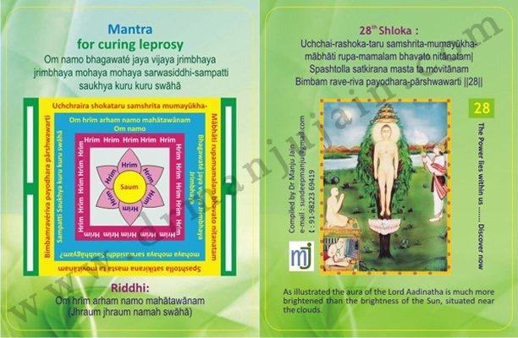

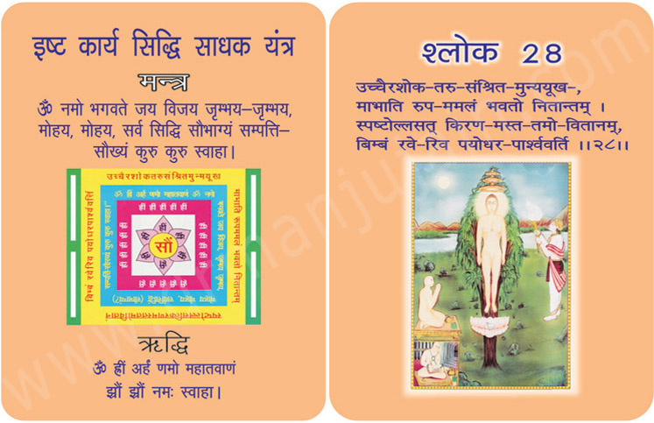
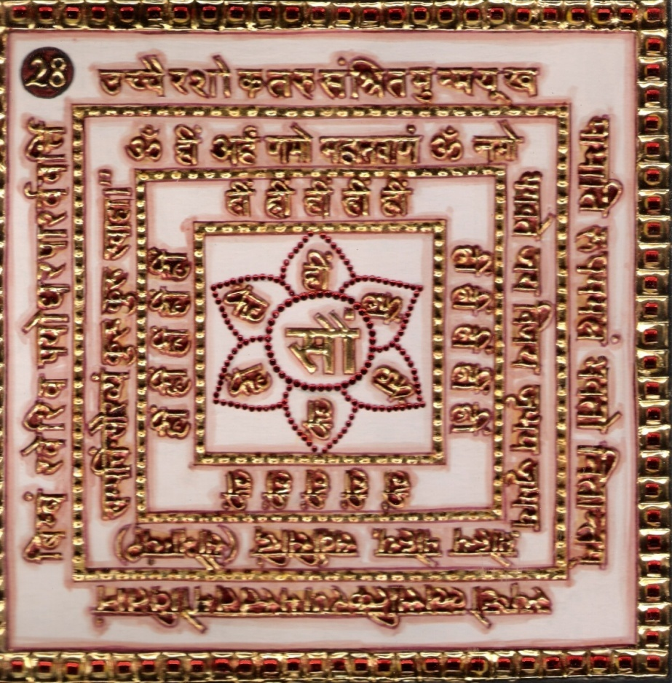

1.0 Purpose

1.1 Profit in business, prosperity, fame, victory, Respect and glory in royal court, Curing of Leprosy.

2.0 Scope
2.1 Lord while sitting under the tail Ashoka tree your white body giving our rays at light appears like the rise of the Sun, which being in close proximity of clods and dispelling the great expanse of dark, shines with brilliant rays of immense radiance.

3.0 Method
3.1 After bath one should be dressed in yellow and establish the Yantra in North or East and worship it. Then seated on yellow base the Ridhhi Mantras syllables are chanted 1000 times a day with a yellow rosary finishing 12000 chants, with yellow flowers.

4.0 Resources
Verse, Riddhi, Manra, Yantra, Yellow Base, Yellow clothes,
Yellow Rosary

Shloka - Repeat 9 times
UCHCHAI-RASHOKA-TARU SAMSHRITA-MUMAYUKHA-
MABHATI RUPA-MAMALAM BHAVATO NITANATAM
SPASHTOLLA SATKIRANA MASTA TA MOVITANAM
BIMBAM RAVE-RIVA PAYODHARA-PARSHWAWARTI

Meaning

Oh my God! I saw you with my inner eyes in the midst of several sages, saints, kings, herds and people from all walks of life. You were seated majestically in the Samavasarana under the shadow of Ashokavriksha which is twelve times taller than you.
Your golden appearance below the dark Ashoka tree made me feel like the golden edge of sunbeam shining on jet black clouds.
You seem magnificent under the Pratiharya of Ashoka tree.

Mantra - Repeat 108 times

Om namo bhagawaté jaya vijaya jrimbhaya jrimbhaya mohaya mohaya sarwasiddhi-sampatti saukhya kuru kuru swāhā

Riddhi (le pouvoir surnaturel)
Om hrīm arham namo mahātawānam
(Jhraum jhraum namah swāhā)

Evidential Story - 28

The intoxication of youth is such, that it makes even good people stray from the good path. In the intoxication of youth the intoxication flower laughs (out) almond for one day, i.e. it blossoms for one day, but the very next day fall on the earth on their face. Young age is like a blossomed bud, on which bees hover take its nectar and then leave it half spirited (energized).
Roop kundali was the extremely beautiful daughter of king Prithvipal. She was intoxicated with her beauty and youth. Her beauty was such that it could make cupid blush (cupid would feel ashamed or modest). Her beauty with the glow of the moon looked like a celestial maid (apsara). At the age of 16 her intoxicating youthfulness made her all the more intoxicated. Due to this pride she would consider her friends inferior to her and would show off her beauty to them. One day as she was taking a stroll in a garden a naked digambar muniraj crossed (came) by. Intoxicated by her youth Roopkundali signalled her maids to tease him. Munishree tolerated it without feeling anything. Roop Kundati also slandered him for his ugly body and nakedness. Not only that but intoxicated by her youthfulness Roopkundali drew colourful pictures on the naked body of Munishree who was seated on a rock and made him resemble a cartoon. Thus making fun of him she went back to her palace. Munishree finished his dhyan (Meditation) and without any sorrow, spite or anger walked towards he forest. Children were laughing at him but he did not bother. It is a rule of nature 'as you sow, so shall you reap”. Roop kundali had sinned being proud of her beauty and youth and by further slandering and insulting the muniraj she had sinned terribly. The pots of sins were filled. As she reached home her beautiful body, due to terrible sin of slandering the muniraj, became infected with leprosy. At last her pride for her beauty and youth fell flat on the earth. Now an average ugly looking youngman would also turn away with repulsion. Friends would say sarcastically “Where are you oh beautiful Roopkundali who would, defeat kamdar (cupid) ? When the great physicians also could not cure her leprosy she understood that it was the fruit of the sin she had committed in slandering the muniraj. Realizing this she went to the forest and fell at his feet and said, “Oh ocean of mercy! I was blinded by pride of my beauty therefore (and) I sinned terribly by insulting you as a result of which I am suffering. Oh Lord ! Please rid me of this sin.” Vitaragi muniraj did not know that someone was suffering because of him. In order to annihilate the suffering he said compassionately, lady (devi) ! By chanting the 28th shloka of the effective Bhaktamar stotra with riddhi and mantra you will get rid of this terrible disease. The fruits of Roopsundali's past misdeeds were coming to an end therefore she was very pleased to hear the discourse on Jain religion by the great muniraj who dealt everyone equally. She prostrated at his feet and returned home.
She recited the Bhaktamar stotra without break and chanted the 28th shloka with riddhi and
Mantra relentlessly for 3 days and nights. As a result, her entire body glowed like gold again. When the news reached the palace the king Prithvipal along with his wife reached the leper home which was situated on the eastern side and was delighted to see their daughter healthy and beautiful. In order to glorify the Jain religion the king got a Jin temple constructed near the leper home and installed a great and beautiful idol of Lord Shri Adinath.
After some time then king found a good match in Gunashekhar for his daughter's marriage. But Roopkundali had understood now how to use this perishable body which she had got after much spiritual merit. Therefore politely and with great firmness she refused to get married and vowed to remain a celibate all her life and become an aryika.

Testimonial

29th Shloka for removing effects of drugs

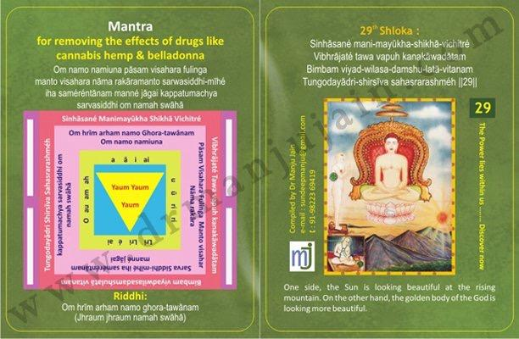

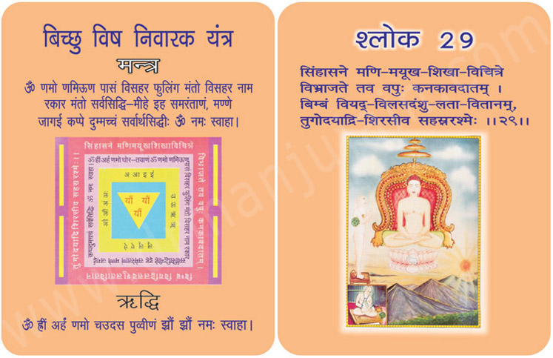
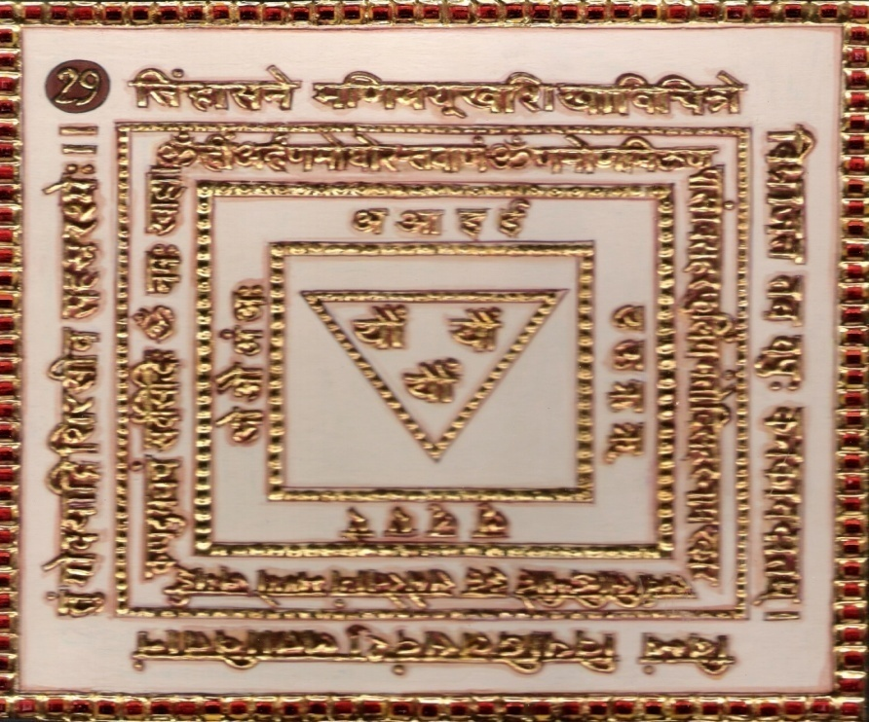

1.0 Purpose
1.1 Keeping Yantra near and chanting of the Riddhi mantra syllables and the verse 108 times for enchanting water which is used to remove effects of drugs like cannabis, hemp and belladonna.

2.0 Scope
2.1. Lord thy gold luster body shines verily on the throne like the disc of the Sun on the summit which is variegated with mass of gems of the high rising mountain, the ray of which (disc), spreading in the firmament like creeper, look exceedingly graceful.

3.0 Method
3.1 After having bath sky colored dress is put on and the Yantra is established facing north and it is worshipped with moving flame and offering of Malati (Moonlight) fragrant flowers. The chants of Riddhi mantra syllables are performed 1000 times a day.

4.0 Resources
Verse, Mantra, Sky colored dress, Moving flame,
Malati (Moonlight) flowers.

Shloka - Repeat 9 times

SINHASANE MANI-MAYUKHA-SHIKHA-VICHITRE
VIBHRĀJATÉ TAWA VAPUH KANAKĀWADĀTAM
BIMBAM VIYAD-WILASA-DAMSHU-LATĀ-VITANAM
TUNGODAYĀDRI-SHIRSĪVA SAHASRARASHMÉH

Meaning

Oh my God!
My Voyage of concentration proceeds further and I see a golden throne of excellent workmanship and decorated with innumerable diamonds and precious stones.
You, with your golden body, look entirely majestic while seated on the throne. Your halo spreads like sunbeams rising from behind the Udayachala Mountain.
God! The emittance of golden aura from yourself, sitting on a golden throne, may shower blessings on me and may bring the golden sunrise in my life!

Mantra - Repeat 108 times

Om namo namiuna pāsam visahara fulinga manto visahara nāma rakāramanto sarwasiddhi-mīhé iha saméréntānam manné jāgai kappatumachya sarvasiddhi om namah swāhā

Om hrīm arham namo ghora-tawānam
(Jhraum jhraum namah swāhā)

Evidential Story - 29
If both husband and wife are religious then they can make very good use of this life. But unfortunately if even one of them is non believer in God or on a wrong path then the family life is derailed. This story is about such a royal family. One day in that family “Wherefrom has this naked, uncivilized and wild creature come? He is not at all ashamed? Look at him ugly body, layer of dirt on it, as if since years he had not bathed. Look at the way he eats ! can't he sit and eat ? Even a beggar eats in a leaf but look at him he is eating in his hands mixing up everything ! Doesn't he know the different tastes of food ?” These are the thoughts of the beautiful queen who is proud of her beauty and who is admiring herself in front of the mirror. Who considers this perishable body as the soul and everything else who considers decking up this temporary body as the main goal of her life? These thoughts are of the queen Jayasena who saw the great Munishree Gyanbhushanji Maharaj who is patient, won over desires, engrossed in meditation being taken to the royal palace for meals by her husband. The question is whether this atheist queen who has strayed away from the right path who is talking ill about Digambar Munishree the one who considers everybody equal is he harming anybody? Or is she with her bad thoughts and bad feelings telling her own soul ? Probably this ignorant woman does not know that the soul within is eternal and the good or bad thoughts or feelings are imprinted on the soul. Then they bring us sorrow or happiness as time comes. According to Jain religion our good or bad deeds are work for God and those deeds we call Vishwakarma also. So whatever wrong she said against the muniraj not only spoiled not only her future but also her present. All the bad thoughts, words and deeds which were imprinted on her soul appeared soon. The muniraj who was always at peace and who looked at everyone equally did not pay any attention to her bad words but the queen invited trouble for herself. Within a few days she was infected with leprosy. The body, for which she took so much care to make it look beautiful, was stinking horribly due to the disease and nobody but flies would be her companions. That is why scriptures tell us that one should never insult or slander a saint. Don't look at the outer body of muniraj instead look at the pure soul that resides within, look at his sacrifice, look at his self control. Don't discern the body instead discerns the soul. There are many people who learn nothing from holy books or gurus but learn only after being punished for their misdeeds and then follow the right path.
Queen Jayasena also learnt the hard way. She understood that her present state was the result of her slandering the muni. If I plant a babool tree thn I should be prepared to be hurt by its thorns. Therefore to get rid of the painful illness she sought refuge in Munishree Gyanbhushanji Maharaj Yogiraj munishree who advised her to recite daily the 29th shloka of Bhaktamar stotra “Singh sane”. Manimayukh shikha vichitre”… with riddhi and mantra to get rid of the difficulties she did it. As a result her trouble was removed and her body regained the luster and became pure. Just the way Seth shrepal's body had regained health because of his queen Mainasundari who observed siddhachakra rite. The queen soon after gaining health prostrated at the feet of Munishree and became a Jin devotee.
Testimonial

This Shloka is very good for getting rid of any kind of addiction. I gave it to a mother from Hyderabad whose son was addicted to smoking. After a month she revealed that he has quit smoking. A school child did it for her father who was alcoholic and his father left alcohol & drinking habit. This is the power of this stotra.

30th Shloka for getting Prosperity & Victory

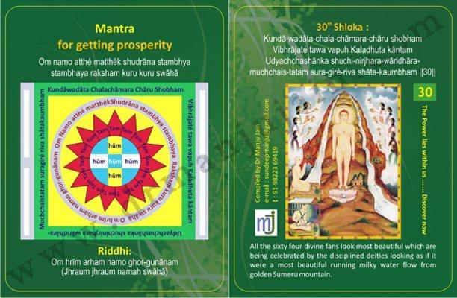

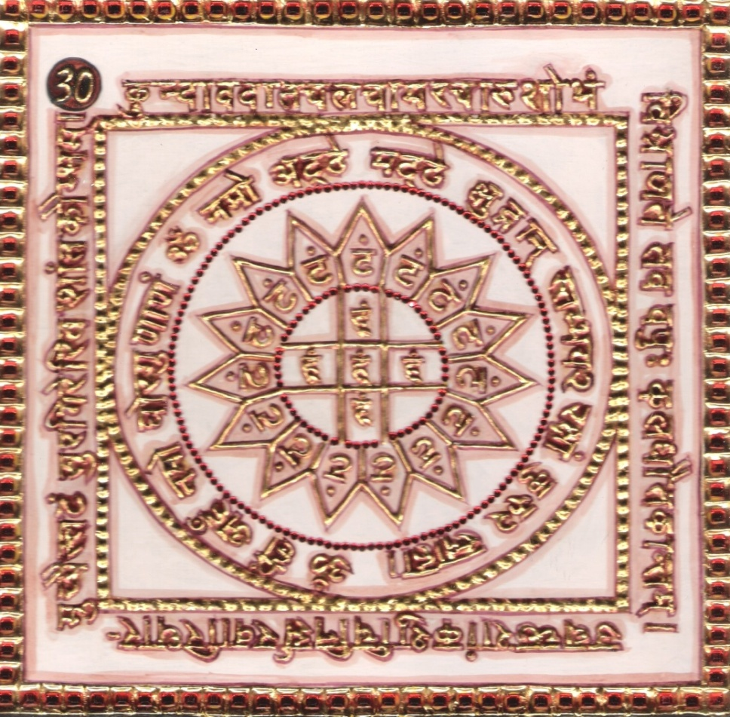

1.0 Purpose
1.1 The enemy is paralyzed if Yantra is placed near. All fear are removed i.e. fear from thief, wild animals like lion, etc. Poverty is changed into prosperity.

2.0 Scope
2.1. Lord your body, shining as bright as gold & being greatly beautified by the waving of white chowrees, looks like a lofty peak of golden Sumeru Mountain where the stream of water as white and clear as the rising moon, flows down in great torrents.

3.0 Method
3.1 After bath and dressed in white, the Yantra being established facing east, it is worshipped with white flowers and moving flame. Then having a seat on white base, the Riddhi Mantra (spell) syllables are chanted 1000 times everyday with a rosary of quartz crystal for proving the spell.

4.0 Resources
White dress, white flowers, white base, Riddhi, Mantra, Verse and Yantra, Rosary Quartz .

Shloka - Repeat 9 times

KUNDA-WADATA-CHALA-CHAMARA-CHARU SHOBHAM
VIBHRĀJATÉ TAWA VAPUH KALADHUTA KĀNTAM
UDYACHCHASHĀNKA SHUCHI-NIRJHARA-WĀRIDHĀRA-
MUCHCHAIS-TATAM SURA-GIRÉ-RIVA SHĀTA-KAUMBHAM

Meaning

Oh my Adinatha!

I saw your throne; it was a marvelous experience! I further saw during my voyage of concentration that the milky white Chamars looking like daisy flowers are slowly fanning the air on your golden body. An unforgettable experience!
God, it looks as if the white streams are flowing from the top of Mount Meru, giving the cool and soothing effect like a rising moon.
The whole sight is very pleasing!

Mantra - Repeat 108 times

Om namo atthé matthék shudrāna stambhya stambhaya raksham kuru kuru swāhā

Riddhi (le pouvoir surnaturel)
Om hrīm arham namo ghor-gunānam
(Jhraum jhraum namah swāhā)

Evidential Story - 30
There was a poor farmer named Gopal. For three consecutive years it had not rained therefore the crops were very poor. His yield was less than the seeds he was sowing. The interest he owed to the money lender became double the principal amount. Then he had three daughters to marry, who were fast growing. When Gopal could not earn from his fields he took up the job of a shepherd under the king. But here also his earnings were so meagre that he had to remain hungry for days. How could poor Gopal have faith in removing his miseries? So like others he too knocked the doors of Pandits, pujarees, malavies etc. Borrowed some money to please them to satisfy their whims. But found no solace for his troubles. By his good fortune, one day Gopal went to a digambar munishri Dharmakirtiji and said, Lord! I am ignorant. We are suffering from extreme poverty. Please let us know some way out of these miseries. The king muniraj blessed him and said “to be rich or poor is the fruit of your deeds. The worry about keeping the hearth burning (running the kitchen) makes many good people also stray away from True religion at the sametime. You follow the noble virtues and chant the 30th and 31st shloka of Bhaktamar stotra regularly to free yourself from poverty”.
Next morning when Gopal took the cattle to the forest for raizing, he sat on a clean piece of rock closed his eyes and started reciting the 30th and 31st shloka of Bhaktamar stotra. But he would open his eyes in between to see whether some devi has appeared. Sometimes he would throw a glance towards his cattle to check that they were all there. He couldn't gain much due to lack of proper concentration. He considered Bhaktamar stotra like the pujas done by pandits therefore he could not have unshakeable faith in it.
After the king of Haripur died there was a confusion about his successor. The king had no son so the chiefs began to fight among themselves. At last the sarpanch of the place held a meeting and got the king's elephant decorated and gave it a flower garland. It was announced in the city that whoever the elephant garlands will be the undisputed successor of the king. Hearing this announcement people started walking in front of, beside and behind the elephant, hoping it would garland them. That day Gopal was returning from the forest with the cattle. Chanting the Bhaktamar stotra. Hearing lots of noise he proceeded in that direction out of curiosity. He saw an elephant running towards him carrying a garland in (its) trunk. He got scared, sensing danger started running away from the elephant, chanting 30th and 31st shloka of Bhaktamar stotra. But the elephant did not stop. Then Gopal shut his eyes and started praying the shloka aloud. Gopal sensed that the elephant was trying to touch his neck. Reciting the shloka he was running to save his neck and the elephant was running behind him with the garland. At last after some running around, the elephant succeeded in garlanding Gopal. The sarpanch announced Gopal, as the king of Haripal kingdom and congratulated him. Gopal was crowned. Now he understood the whole thing. In his heart he prostrated at the feet of Lord Adinath. His faith and devotion towards Bhaktamar stotra knew no bounds. All around people shouted hail victory to the new king and took him with great honours, to the throne. The cows were also following him happily that their protector and guard has now become the protector of the kingdom.

Testimonial

Mr. X came to my house searching for Shloka which can give him Victory, I was not aware I started searching for the shloka and found one No. 30, I immediately gave him my thesis and he went away saying that he would come back soon. After few months he came to my in a big car and with beautiful wife and told me that he was buying Hotel Upvan – the deal was worth some 10 Crores as they were planning for some scheme of Bungalows with some renowned builders.

31st Shloka for curing Skin Diseases
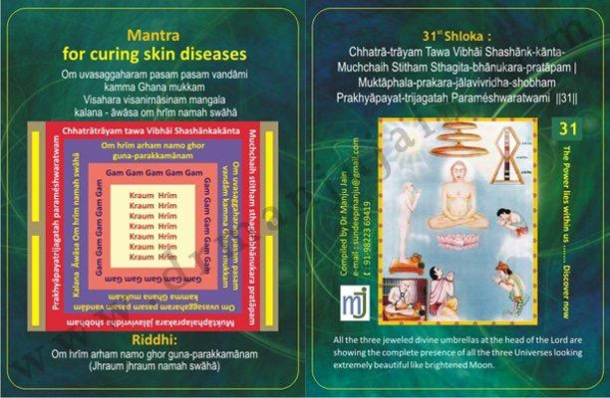
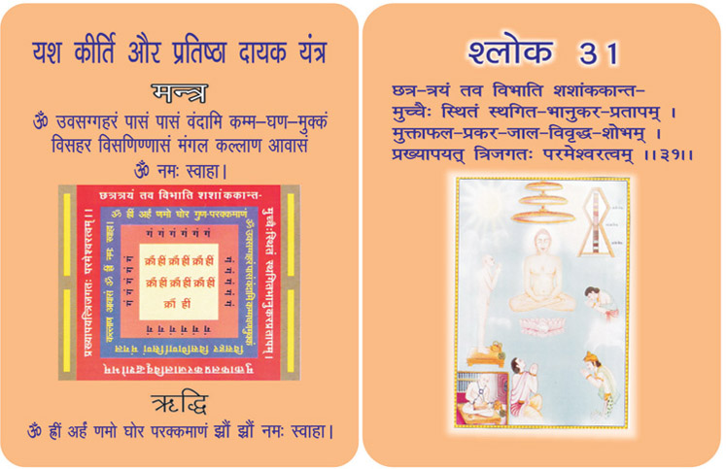

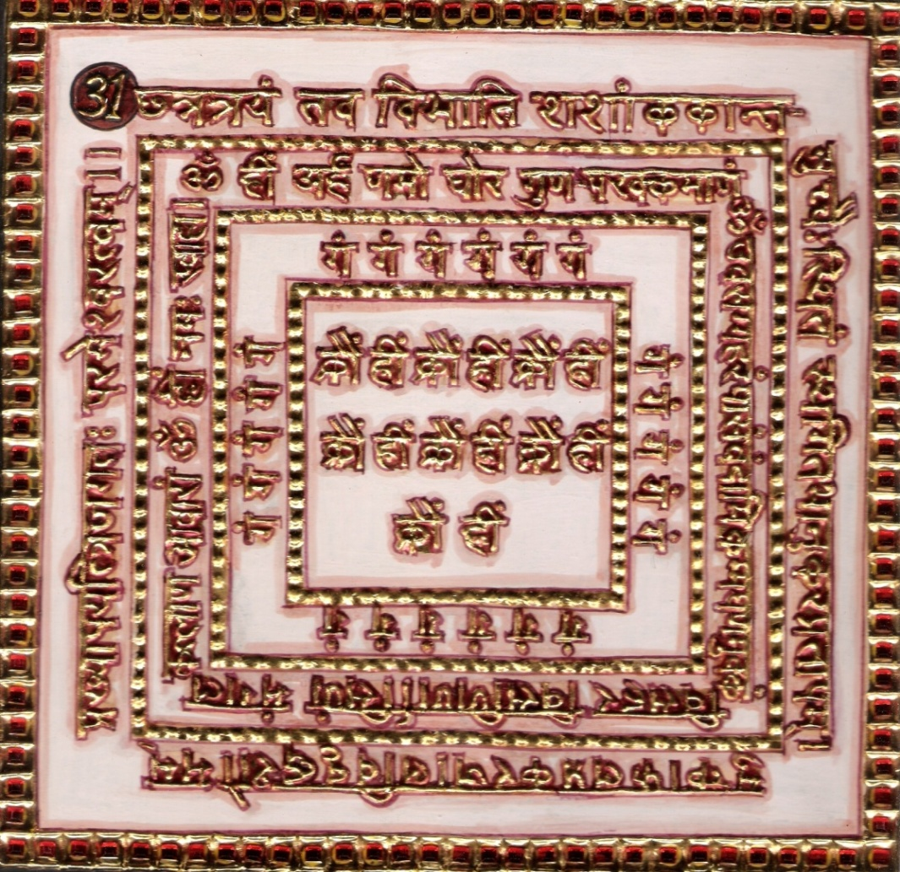

1. 0 Purpose
1.1 To enhance strength of body and mind. Humour is attained in royal court. Kings attain fame.
Skin diseases are cured.

2.0 Scope

2.1. Your moonlike three folds umbrella which being raised high and greatly beautified by a great number of pearls, heaps off heat of sunrays is like an indicative evidence of your paramount supremacy over three worlds. All the three jeweled divine umbrellas at the head of the Lord are showing the Plete possessive of the entire three universe looking extremely beautiful like brightened moon.

3.0 Method

3.1 After bath and dressed in blood red, one should establish the Yantra and worship it placing waterful pitchers. Then taking a red seat facing north in the lotus posture one should chant riddhi and mantra syllables everyday completing in all 7500 chants.

4.0 Resources
Blood red dress, waterful pitchers, Lotus posture facing north, verse, Mantra, Yantra and Riddhi

Shloka - Repeat 9 times

CHHATRĀ-TRĀYAM TAWA VIBHĀI SHASHĀNK-KĀNTA-
MUCHCHAIH STITHAM STHAGITA-BHĀNUKARA-PRATĀPAM
MUKTĀPHALA-PRAKARA-JĀLAVIVRIDHA-SHOBHAM
PRAKHYĀPAYAT-TRIJAGATAH PARAMÉSHWARATWAM

Meaning

Oh my Adinatha!

My inner pilgrimage of contemplation goes ahead. Once again I see above your throne. I find three silvering ornamented umbrellas on you; below the leaves and branches of Ashokavriksha protecting your body from the harsh sun-rays.

But my Lord, I know that those three umbrellas are not just making a silent appearance around you. They are cheerfully announcing that they are privileged by their position above yourself and making it known to all that you are the undisputed emperor of all the three Lokas.

Mantra - Repeat 108 times

Om uvasaggaharam pasam pasam vandāmi kamma Ghana mukkam
Visahara visanirnāsinam mangala kalana - āwāsa om hrīm namah swāhā

Riddhi (le pouvoir surnaturel)
Om hrīm arham namo ghor guna-parakkamānam
(Jhraum jhraum namah swāhā)
Evidential Story - 31

Tirthankars by birth are rich in strength and beauty. Then by meditation and penance their body glows like gold. The light (glow) which is the result of penance and wisdom and knowledge of being one with God makes them appear extremely beautiful in the religious assembly. Under the Ashoka tree Shri Jinendra Dev is sitting on a throne. The Yaksha attendants with are whisking with 64 whiskers (chanvars) to drive away insects, flies etc. just as servants of a king serve him. The colour of the whisker's is extremely white and bright like that of a jasmine flower.

The unique, heavenly scene is imprinted on the heart of the devotee. He is comparing the divine beauty with the heavenly natural beauty when the milk like stream falling from a high mountain waterfall appears like moonlights, its natural beauty fills a dry heart with love. Then just imagine the waterfall cascading from the golden sumeru mountain would be so enchanting and a real treat for the eyes.

When the earthly nature is so enchanting then what can one say about the spiritual beauty of the divine body which is immortal (firm) and glowing like the golden sumeru mountain and on which 64 waterfalls (whiskers) are being fixed. As if the whiskers moving continuously (constantly) from up to down (high to low) are telling the world that those who fall at the feet of the Lord, by law, will rise up i.e. they will be raised, delivered from all evils.

The kings of this world are honoured with decorated umbrellas on their thrones. These umbrellas are used not for protection from sun rays or rain but to show their grandeur and majesty. In the religious assembly shree Arhant Dev is seated with three umbrellas with fringes studded with jewels and pearls place one on another. They appear more beautiful and cool than the glittering moonlight and they have even prevented strong sunlight with their glow. Here the writer glorifies the three umbrellas saying. “Oh Jinashwar dev ! the three umbrellas above your head signify that you are the one and only ruler of the world above, middle and below.

For the fulfilment of a work or plan mantra chanting is one solution (way) by which we can please devis and devtas. The works which are very difficult or seem impossible can also be achieved through this. By chanting mantras the devotee can enhance strength of mind, words and body. This way one can develop a very good personality. But one thing is sure that only when the right time arrives only the mantras and tantras become fruitful. While doing bad deeds one can not gain much.

Testimonial
Case Study:
Ms. Nina Jaiswani, a lady had 21 days food without salt stayed at my house had one meal a day and fruits and tea in evening and her disease, Psoriasis got cured.
Dr. Bipin Mehta has issued a Certificate stating that she is cured by chanting of Bhaktamar Stotra and he said he had firm belief in this system and even asked for two Yantras of 45th Shlokas for his patients.

PATIENT'S CASE HISTORY FORM

Doctor’s Name: Dr. Bipin Mehta, Nagpur
Patient’s Name: Ms. Nina Jaiswani
Age: 50 years Sex: Female Address: Amravati Road, Nagpur
Patient’s Complaint:
Patches on her hand, leg, stomach & back, even her head is full of this fungal infection which keeps on peeling off. The patches are erosions and there is high inflammation and irritability on the affected area.

Though the disease is not contagious still at times blood oozes through these wounds spread on skin.

All the medicines have been tried on her for last twelve years. Best of Allopathic doctor give his treatment for years. No improvement.

She was treated with Homeopathic medicine for prolonged period but there was no relief.

Diagnosis: Prolonged case of Psoriasis, a skin disease

Treatment by Spiritual Healing:
Ms. Nina Jaiswani was brought to spiritual healing centre.
Bhaktamar Vidhan, Abhishek on 45th yantra and one time meal without salt done by the patient for 7 days.
The effect of Bhaktamar chanting was miraculous.
Her skin started rejuvenating and within span of 3 months, her hands, legs, back, stomach and head has been cured of all the erosion and normal skin has grown.
She says that she keeps on chanting mantra wherever, whenever possible.

Dr. Bipin Mehta has issued a Certificate stating that she is cured by chanting of Bhaktamar Stotra and he said he had firm belief in this system and even asked for two Yantras of 45th Shlokas for his patients.

32nd Shloka for curing Abdominal Pain & Diarrhea
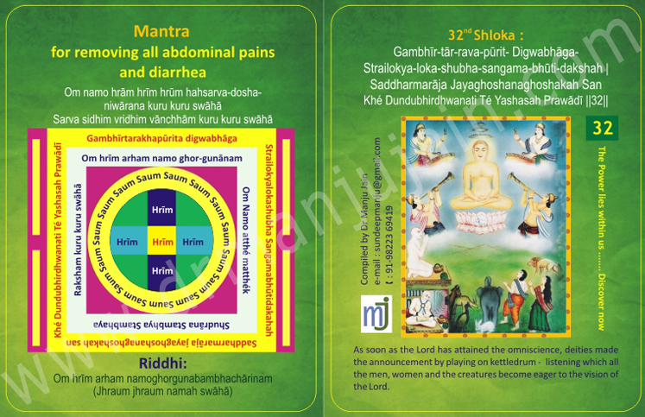

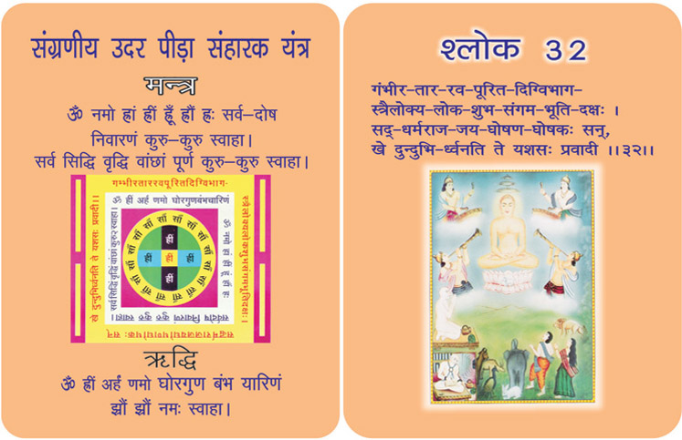
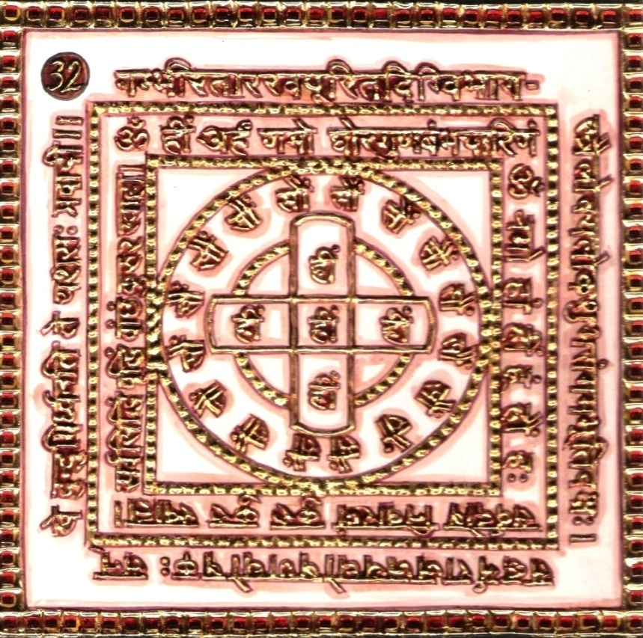

1.0 Purpose
1.1 All types of pain in abdomen & diarrhea are cured. Leprosy is cured.

2.0 Scope
2.1. There are sounds in the sky the celestial drum, which fills the directions with its deep and loud note and which is capable of bestowing glory and prosperity on all the doings of the three worlds, and which proclaims the victory. Sound of the Lord of supreme righteousness, proclaiming thy fame. As soon as the Lord has attained the Orin science then the group of deities made the announcement of by playing on kettle drum listening which all the men, women and the creatures have become eager to the vision of the Lord.

3.0 Method
3.1 After purification, clothed in yellow, the Yantra is established keeping an auspicious pitcher by the side. After its worship sitting in lotus posture facing to the east Riddhi Mantra syllables are chanted 1000 times with Yellow Rosary. Taking a week string it is made mystical through 21 or 108 times chants. It is tied to the neck of a virgin and the Yantra is kept near.

4.0 Resources
Yellow clothes, Yellow Rosary, Yantra, Verse, Mantra, Riddhi

Shloka - Repeat 9 times

GAMBHĪR-TĀR-RAVA-PŪRIT- DIGWABHĀGA-
STRAILOKYA-LOKA-SHUBHA-SANGAMA-BHŪTI-DAKSHAH
SADDHARMARĀJA JAYAGHOSHANAGHOSHAKAH SAN
KHÉ DUNDUBHIRDHWANATI TÉ YASHASAH PRAWĀDĪ

Mantra - Repeat 108 times

Om namo hrām hrīm hrūm hahsarva-dosha-niwārana kuru kuru swāhā
Sarva sidhim vridhim vānchhām kuru kuru swāhā

Riddhi (le pouvoir surnaturel)
Om hrīm arham namoghorgunabambhachārinam
(Jhraum jhraum namah swāhā)

Evidential Story - 32

The marriage of Prince Ratnashekhar was fixed, only few days were left for the great day. The Prince was eagerly waiting for that. At last the day of the marriage arrived. He was immersed in imagination that the bride would be extremely beautiful and virtuous. His friends were not left behind. One would say that she would be an expert in classical dance. The other would imagine her to be more beautiful than Urvashi and Rambha - the celestial beauties. Yet another would say ‘don’t forget your royal duties listening to the new bride’s melodious singing in the tone of the great Tansen.

The marriage procession arrived with much pomp and glory. After all Ratnashekhar was the only son of the king. The melodious sounds of the band peruaded the entire city. Dancers were entertaining the bridegroom’s side. The marriage ceremony was celebrated with much gaiety and happiness. Before the sacred fire and the entire society the Prince accepted her as his wife. The marriage party returned home.

At night Ratnashekhar removed the veil of the bride Madan Sundari expecting her to be a celestial beauty. Just as a blind person is wrongly named Nayansukh or a beggar Dhanpati or a coward Shersingh, the new bride Madan Sundari was extremely ugly with brown short hair, a flat nose, protruding teeth, fat waist, with marks of leprosy on her body and suffering from asthma and cough. The Prince was shocked. All his dreams about his future life were shattered. But he said “Devi I accepted you, as my wife before the sacred fire therefore inspite of your form, I’ll remain your wellwisher through out life. I’ll treat your physical. Sufferings as mine, and shall try to remove them.” At this Madan Sundari said in a very thick and broken voice, “Lord! I am suffering from leprosy, more over Cough and asthma makes me miserable”. Listening to her painful voice he could no more remain on his bed and he went out of his kingdom to a place where Digambar minishre Dharmsen was residing with his disciples. Ratnashekhar took his refuge there and became engrossed in meditation and religious study. As directed by the munishree he started reciting the Bhaktamar Stotra daily with utmost devotion. One day Prince Ratnashekhar was reciting the 32nd and 33rd shlokas (gambhirtarakh purit digivibhag) and (mandarsundaranmeru supari jat”) of the Bhaktamar stotra with great concentration in a very sweet voice when Jin devi Padmavati appeared to him and said. Son your age is not fit to do austere penance. Your father has fallen ill eagerly remembering you and waiting for you and your learned wife Madan Sundari is looking after him.” The Prince became curious about his wife and asked, “devi ! How is Madan Sundari’s health now?” Padmavati said - ‘Son! When two days back you were reciting the Bhaktamar stotra without break (constantly) then only her leprosy afflicted body has transformed into divine body.” Saying so the Devi disappeared (Vanished). The Princess heart was full of joy he prostrated at the feet of munishree, took his blessings and left for his palace. His father was overjoyed to see him as if his (father’s) life was restored to him Ratnashekhar’s learned wife fell at hisfeet and washed them with her tears of joy.
Testimonial

33rd Shloka for removing Fever

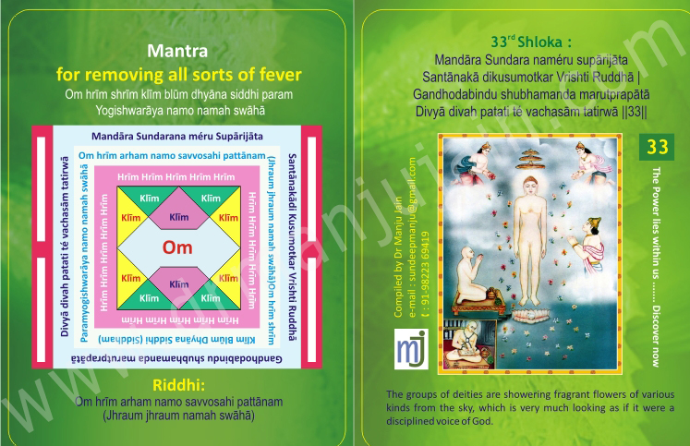

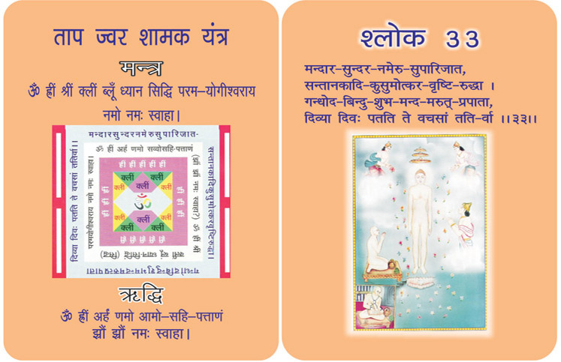
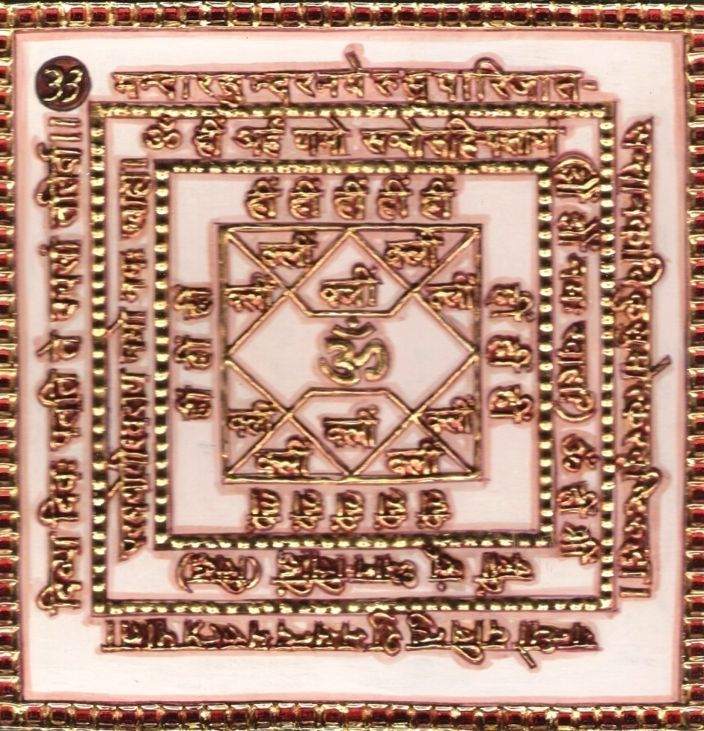
1. 0 Purpose
1.1 Removing all sorts of fever.

2.0 Scope
2.1. ‘O’ God of Gods! The celestial deities are ever anxious to serve you. They aspire to remain at your feet forever. But it is not possible for celestial deities as they are residing in heaven. Therefore, they shower the divine flowers of heavenly trees of Kalpavriksha, Mandar, Sundar, Namera, Parijat, etc. These flowers falling down from the sky with flowers grown in water and on earth are mixed with cool and gentle breeze. But when these flowers come down and reach up to your lotus mouth, it seems as if your divine speech is beings showered in form of rain of flowers on the earth.

3.0 Method
3.1 After purifying and clothing in white, the Yantra is kept facing east and worshipped. Then occupying a white seat facing towards north the Riddhi and Mantra syllables are chanted 1000 times with a white rosary casting oblibanum of bdellium mixed with ghee.

4.0 Resources
Mantra, Yantra, Riddhi & Siddhi

Shloka - Repeat 9 times

MANDĀRA SUNDARA NAMÉRU SUPĀRIJĀTA
SANTĀNAKĀ DIKUSUMOTKAR VRISHTI RUDDHĀ
GANDHODABINDU SHUBHAMANDA MARUTPRAPĀTĀ
DIVYĀ DIVAH PATATI TÉ VACHASĀM TATIRWĀ

Meaning

O God of Gods! The celestial deities are ever-anxious to serve you. They aspire to remain at your lotus feet forever. But it is not possible for these celestial deities as they are residing in heaven. Therefore, they shower the divine flowers of heavenly trees of Kalpavriksha, Mandar, Sundar, Nameru, Parijat, Santanka, etc. These flowers falling from the sky and the flowers grown in water and on earth are mixed with cool, gentle breeze. But when these flowers come down and reach unto your lotus mouth, it seems as if your divine speech is being showered in from of Rain of Flowers on the earth.

Mantra - Repeat 108 times

Om hrīm shrīm klīm blūm dhyāna siddhi param Yogishwarāya namo namah swāhā

Riddhi (le pouvoir surnaturel)
Om hrīm arham namo savvosahi pattānam
(Jhraum jhraum namah swāhā)

Evidential Story- 33

The “Gandhar Acharyas” who were present in your “SAMAVSWARAN” have preserved your teachings and discourses. They have decorated your teachings and have presented them before all beings for their welfare. They have explained what is religion. They have explained that which causes all living beings to force their miseries and leads them to eternal peace and dignified position is the real religion. The Ten Commandments (Das Lakshan Dharma) lead to real religion. They have explained that theory of relativity and concept of Multiplicity (Anekantavad) lead to the Rightful thought, rightful knowledge and rightful character, which is the basis of true Jainism. The divine trumpets are pervading your during thoughts, teachings and discourses eternally in all the three realms. The deep resonant during dreams are ever awakeniy the beings from their slumber and leading them to the rightful path. All space is rever berating and echoing with the announcement of victory of the true religion over all evils.

O Tirthankar ! the divine spray of performers and shower of fragrant heavenly flowers like MANDAR, SUNDAR, NAMERU, PARIJAT etc. float towards you with the drift of mild breeze. This enchanting scene creates an impression, as if the pious words uttered by you have turned into flowers and are floating towards the earthlings.

Testimonial

Mrs. Babli Jain’s daughter had very high fever; there was no one in the middle of night to take to Doctor. So, she started chanting 33 No. Shloka which said it brinigs doen the fever and with help of cool pach and chanting she brought down the fever from 104 ºF to 99ºF. My son asks me to chant Shloka whenever he gets viral infection and with chanting and Dr. Sara’s homeopathi medicine his viral gets cured. No need of antibiotics.

34th Shloka for Prevention Of Premature Abortion
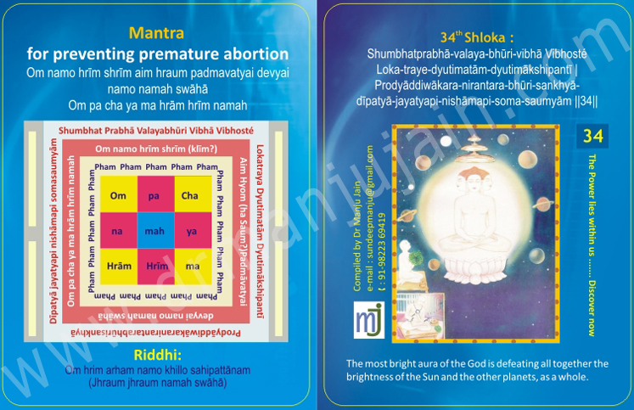

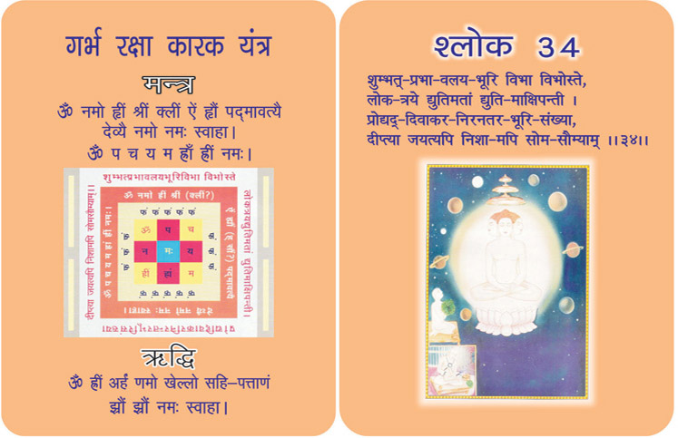
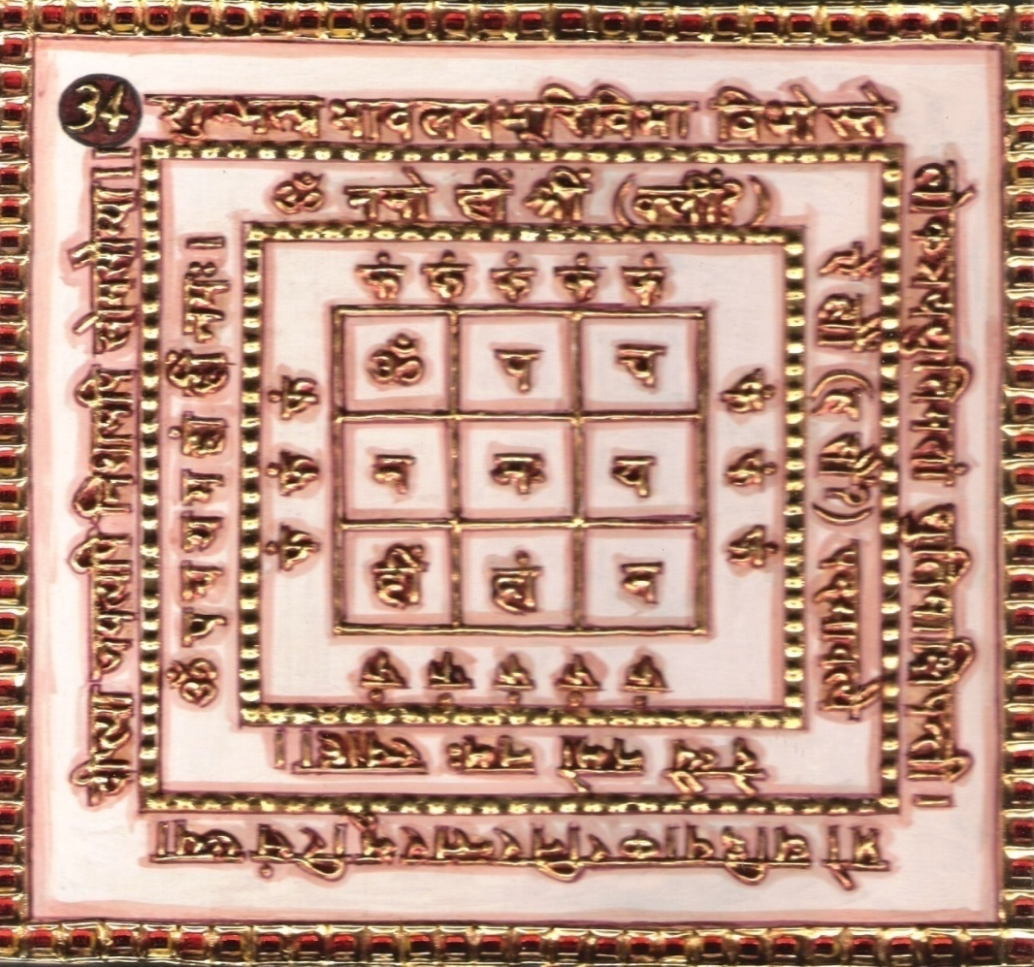
1.0 Purpose
1.1 There is no premature abortion, when the yantra is near paralyzed abortion.

2.0 Scope
2.1. ‘O’ Lord! The excessive light of your shining halo, rivaling as it were, the blaze of the densely clustered suns and surpassing the luster of brilliant objects of the three words, overcomes (the dark of) the night; even though it is gentle and mild as the light of the moon.

3.0 Method
3.1 After being purified and dressed in white, the Yantra is established facing to the North with an auspicious pitcher and worshipped. Then having seated on white base the Riddhi and Mantra syllables are chanted 12000 times in lotus posture with rosary of quartz crystal. The string is colored in saffron color and made mystical through 108 chants of the verse, Riddhi and Mantra syllables. It is given smoke of burnt bdellium and tied to neck or waist.

4.0 Resources
Yantra, Mantra, Riddhi, Verse and String of Saffron color, bdellium (smoke of burnt bdellium)

Shloka - Repeat 9 times

SHUMBHATPRABHA-VALAYA-BHURI-VIBHA VIBHOSTE
LOKA-TRAYE-DYUTIMATĀM-DYUTIMĀKSHIPANTĪ
PRODYĀDDIWĀKARA-NIRANTARA-BHŪRI-SANKHYĀ-
DĪPATYĀ-JAYATYAPI-NISHĀMAPI-SOMA-SAUMYĀM

Meaning

O Luminous God! A grand Aura-circle, proving him unprecedented achievements of supreme Yoga Sadhana, is glittering behind your head. Oh, what a shining is of the Aura before which the light of all the three worlds fall pale! In the presence of your Aura-circle, the lights not of only one, but of several suns also become dim!! And however, this Aura-circle, but without any heat…! There is beauty of moon in your Aura – circle, but without shivering cold in it!!
Mantra - Repeat 108 times

Om namo hrīm shrīm aim hraum padmavatyai devyai namo namah swāhā
Om pa cha ya ma hrām hrīm namah

Riddhi (le pouvoir surnaturel)
Om hrim arham namo khillo sahipattānam
(Jhraum jhraum namah swāhā)

Evidential Story 34
King Bhimsen was the Emperor of Banaras. His might (Supremacy) had spread to nearby kingdom. The king had only one weakness that he used to be surrounded by flatterers. The king was inclined towards religions to some extent, but the pride of his might was an obstruction to become a true follower of religion. Using this weakness, his flatterers requested the king to establish a new religion which would have the essence of all religions. Now the king got addicted to this idea. He entrusted this work to many scholars but they could not concoct the mixture. At last the king himself compiled various principles of religions and established a new religion. This swelled his pride. He constructed a temple of new religion near his palace. He made it compulsory for everyone to follow the new religion and visit the new temple leaving temples of their choice. This compulsion displeased many, they left the kingdom and settled elsewhere. Many powerful people started conspiring against the administration. Irritated by this the King got the temples and mosques of other religions dis mantled and got temples of new religions constructed. Completely intoxicated by power he forgot that not everybody can establish a religion. Men can be benefitted by religions established by Tirthankaras, Devas and prophets. The king by demeaning other religions had committed servers in. The fruits of his inauspicious deeds started surfacing soon when this so called prophet’s today was inflicted with leprosy with the six months. His strong and beautiful body had now become very weak and ugly. The bones, flesh and skin had dried up. His favorite queen Sudarshana was scared to look at him. The king whose order was obeyed like that of God was now ignored by his subjects and officials.

While touring for spreading the Jain religion, Munishree Buddhakirtiji arrived in Banaras king Bhimsen also went for his darshan, prostrated at his feet and narrated his unfortunate story. Munishree thought for a while with his divine vision and then said, ‘O king ! It's a great sin to defame any religion. The intoxicated elephant plunders and ruins but when he sobers down (intoxicated) he becomes weak and suffers a lot. Intoxicated by youth the young misuse their power but they repent later in old age. Similarly you intoxicated by power defamed other religions, put restrictions on their followers and committed severe sin by destroying and desecrating temples. But now you are suffering (due to) its ill effects”.

The kings pride was washed away (meited) by now therefore with great humility he requested - “Munishree please give me a remedy for my suffering”. The Munishree taught him the
34th and 35th shlokas of Bhaktamar stotra with mantra, explained its meaning and said - “If chanted with devotion your sufferings will annihilate”. King Bhimsena did great penance for three days and chanted the 34th and 35th shlokas of the great Bhaktamar stotra with mantras, without break that the Jindevi Chakreshwari appeared and said - “get up son ! Your desire will be fulfilled. Do abhisheka for Lord Adinath and sanctify your body with gandh”. Saying so the devi vanished. The king did as told. The next day all the queen's found the king healty once again and devotedly did his aarti. The courtiers welcomed the king and the entire city and the palace echoed with auspicious songs.

Testimonial
Case Study of Abortion of Mrs. Jain, Pune.

A Homeopathic Doctor, asked me to treat Mrs. Jain from Itwari, Nagpur. Sahe had conceived and Doctor was saying to get it aborted but, she did not wanted to and was hopeful that the child would be born. I gave her 34th Shloka and Yantra which helps in growth of the foetus and stops the abortion.

She took the yantra and was chanting Mantra regularly for few months continuously, she has kept Yantra in temple and was receiving holy water from the abhishek of Yantras (Bathing of yantra with pure water).

She called up that, she wants to do Ph.D. in child Psychology and wants to register in Zoroastrian College from where I had done Doctorate in Spiritual Healing. She also informed that her in laws were coming to take her back to Mumbai and she will deliver her baby in Mumbai. Her husband got a job in Singapore and all good things were happening by chanting of the 34th Shloka of Bhaktamar Stotra.

Recently few weeks ago, I received a call from sister-in-law saying that, she has delivered a healthy baby boy in Pune. This is the amazing power of the Bhaktamar Stotra and particularly the chanting of the 34th shloka.

35th Shloka for Saving From Epidemics, Hysteria & Famine

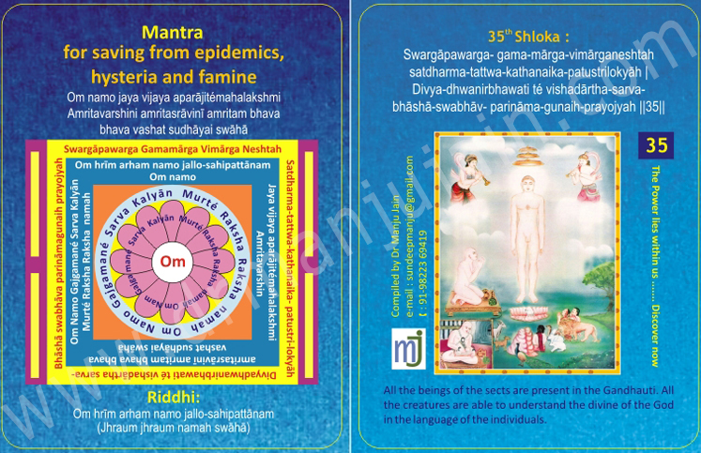

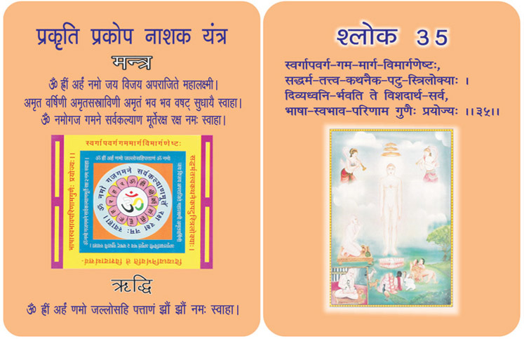
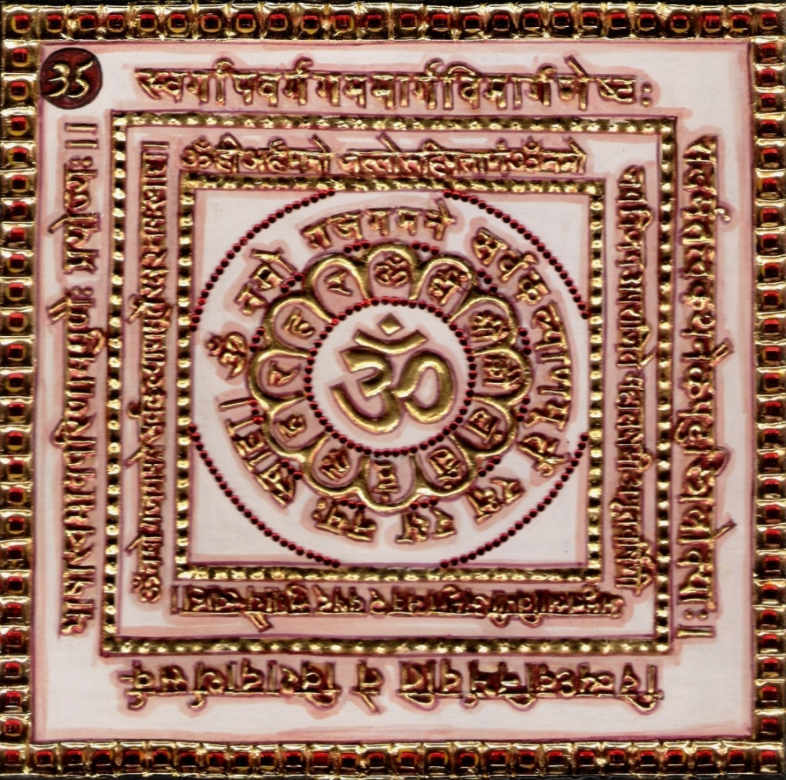
1. 0 Purpose
1.1 Keeping the Yantra near and the adoration of the verse, Riddhi and Mantra syllables removed and keeps safe from epidemics, hysteria, theft, famine, fear from state, etc. There is gain in trade and respect in kingdom. The words are regarded as authentic.

2.0 Scope
2.1. Your singular speech, which is indispensable in seeking out the paths to the heaven and salvation, proficient in expounding the philosophy and principles of the right faith and coupled with the clear and exhausting meaning is life with the distinctive features of its comprehensive faculty.

3.0 Method
3.1 After being and clothed in yellow the Yantra is established facing to the North and worshipped with yellow flowers and kindled candle. Then the Riddhi and mantra syllables are chanted 108 times a day with Yellow rosary till 4000 chants are over.

4.0 Resources
Yantra, Mantra, Riddhi & Verse
Yellow flowers, Kindled Candle, Yellow Rosary.

Shloka - Repeat 9 times

SWARGAPAWARGA- GAMA-MARGA-VIMARGANESHTAH
SATDHARMA-TATTWA-KATHANAIKA-PATUSTRILOKYAH
DIVYA-DHWANIRBHAWATI TE VISHADARTHA-SARVA-
BHASHA-SWABHAV- PARINAMA-GUNAIH-PRAYOJYAH

Meaning

O Sweetest, Supreme – most Lord! Your discourse always flows in Raga Malkauns, but where there is song the music should be there. In this speech of yours, the celestial deities provide accompaniment of their divine musical instruments… As a result, your speech seems to be divine speech. This divine speech, flowing wherever and whenever very exactly clears the path of heaven and salvation. It wisely proclaims the sense of righteous religion. And the greatest of surprise is that this speech is understood in their respective languages by all celestial beings, by human beings of all the nations and by the animals lf all the places. All the living beings understand this speech of yours in their own languages… and all the substances of the world become crystal-clear to these listeners.

O God! Your speech only is the savior and uplifts of those worthy people who want salvation.

Mantra - Repeat 108 times

Om namo jaya vijaya aparājitémahalakshmi Amritavarshini amritasrāvinī amritam bhava bhava vashat sudhāyai swāhā

Riddhi (le pouvoir surnaturel)
Om hrīm arham namo jallo-sahipattānam
(Jhraum jhraum namah swāhā)

Evidential Story - 35

Singing glory of (glorifying) Shri Tirthankarji, who is decorated with fory six virtues, digambar Saint Shri Manatungaji says - “O lustrous one ! Your aura is like that of millions of suns but it devoid of the rage and heat whereas the rage heat and brightness of one sun God can not be tolerated by people living on the earth. In spite of having the lustre and valour of countless suns, your aura is pure, cooling and soothing like that of moonlight. Comparing the incomparable Lord’s aura with that of a millions of suns the creator of the stotra disdains the sun. Soon his attention is dream towards the pure, cooling and soothing moonlight but the very next moment the moon also becomes insignificant before the incomparable Lord. He says that your aura does not does not glorify (make more beautiful) the might but wins over the might. It wins over the night of the dissolution of the world so also the darkness of untruth. The aura is actually the absolute rays emitting out of His divine body, the ring of (divine) light, the incomparable body of luster before whom millions of scenes become lacklustre. The artal made aura is used to devote the aura of the Lord. When the normal saints and Mahatmas have a soothing glow and lustre on their face then what to say about that of the lord ? When their lustre is so much cooling and peaceful for the living beings then surely the glory of spritual the aura (halo) made of absolute rays would be unique. In the pure shade (shadow) of Shri Jinendra Dev, the magnificent beings see their past, present and future seven briths as if in (a) mirror. When the majesty of his body aura is so great, than what to say about the light emitting from his consciousness (the soul). In fact if His aura (the rays of hisaura) pierces through our dusty intellect and makes us witness our seven births, would be no wonder. When we place a mirror under the sun, if reflects the light and makes an age old cave filled with darkness, shine with brightness even though the sun rays may never reach there directly. Acharya Shri glorifies the divine Aumkar sounds of the supeme tirthankaras who have won over desires and who advise for the welfare of all. He further glorifies the leader of the religious assembly - Shri Adishwarji saying -”O leader of the religious assembly ! Your unsyllabled divine sound(s) show the supreme path that leads to heaven and liberation. It is capable of explaining the meanings of the elements of Jain religion. It has the unearthly power to transform into the language of the listners”. In fact all the wisdom and knowledge is the essence of the Aumkar sound which is organished (woven) in the form of sutras the three worlds are benifitted infinitely by his divine deshna.

Testimonial

36th Shloka for Gaining Wealth In Trade Of Gold & Other Metals

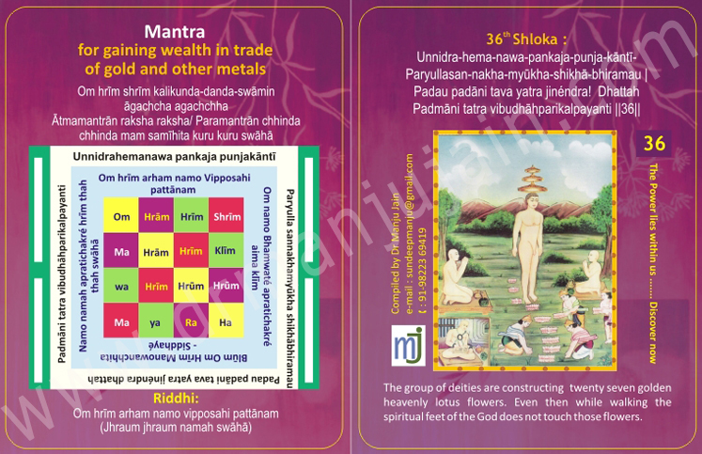

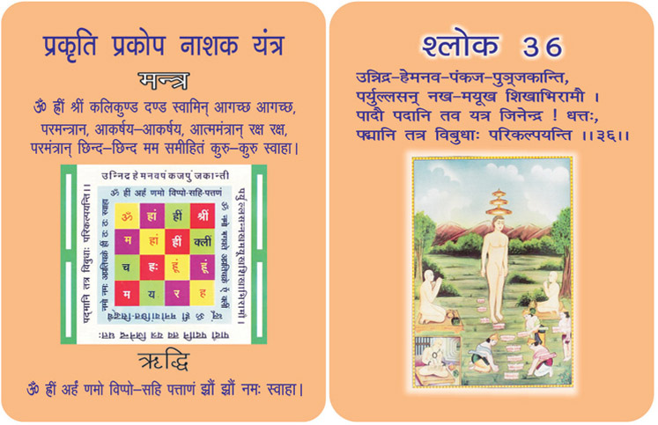
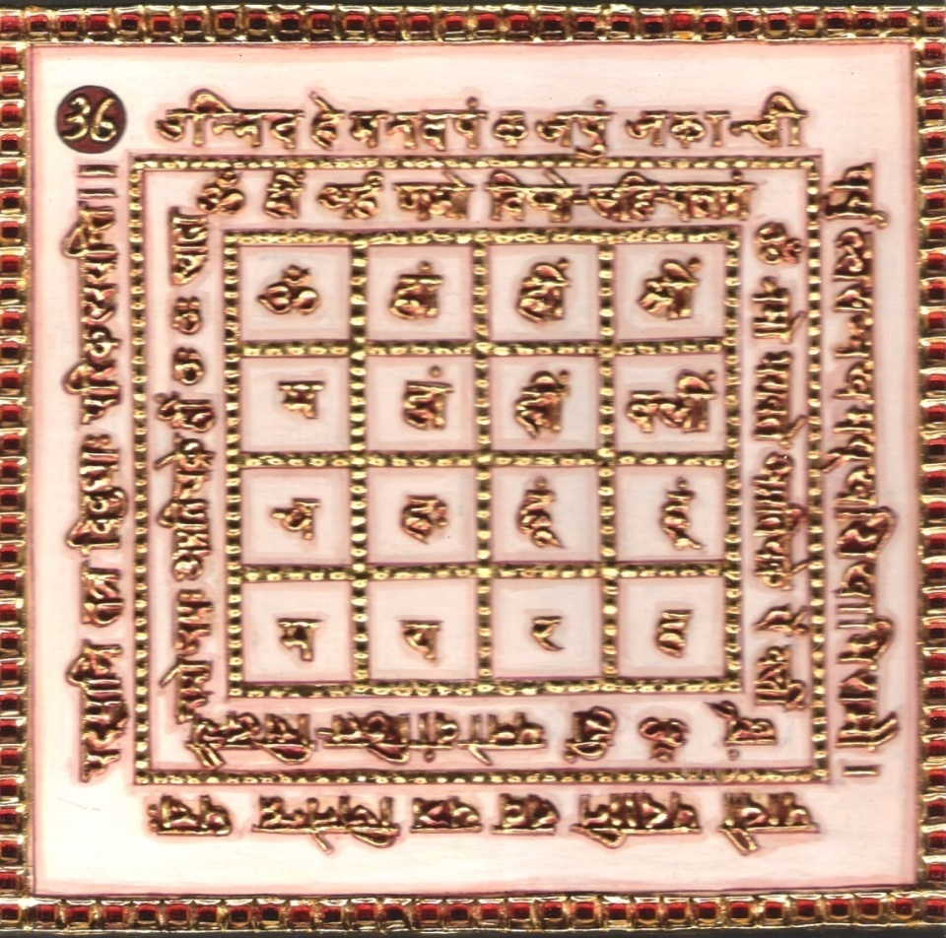
1.0 Purpose
1.1 On keeping the Yantra near and chanting the verse, Riddhi and Mantra syllables 108 times a day, wealth is gained in trade of gold and other metals, honour is attained in the state and talk is regarded authentic among the five mediators.

2.0 Scope
2.1. ‘O’ Jinendra! Gods arrange lotuses at whatever you set your feet which, being beautified by the rays of light, reflected from the sparkling mails, possesses the luster of a large member of recently flown lotuses of gold.

3.0 Method
3.1 After having bathed, dressed in yellow, the yantra is established facing north and worshipped with yellow flowers and then candle in kindled, then the Mantra is proved through 12000 chants.

4.0 Resources
Yantra, Mantra, Riddhi & Verse, Yellow dress.

Shloka - Repeat 9 times

UNNIDRA-HEMA-NAWA-PANKAJA-PUNJA-KANTI-
PARYULLASAN-NAKHA-MYŪKHA-SHIKHĀ-BHIRAMAU
PADAU PADANI TAVA YATRA JINENDRA! DHATTAH
PADMANI TATRA VIBUDHAHPARIKALPAYANTI

Meaning

O my God! Oh Indra of Jinas!
Your personality clad with offerings of flowers by the deities at the time of your imparting enlightenment is lovely. How to explain the scene of your movements! The deities make offerings of golden lotus at all the places where your holy feet are to be stepped.
To fulfill the desire of having you in their hearts, the deities wish that they could have pulled their heart out of their body to record your footprints on it. Alas, they could not do so, and to show their deep feelings of gratitude, they spread golden lotuses on the places where you step on.

Mantra - Repeat 108 times

Om hrīm shrīm kalikunda-danda-swāmin āgachcha agachchha
Ātmamantrān raksha raksha/ Paramantrān chhinda chhinda mam samīhita kuru kuru swāhā

Riddhi (le pouvoir surnaturel)

Evidential Story - 36

The daughter of Patna Naresh, named Sur Sundari, Gagan Chumbi was sitting on the 7th floor of their Palace; playing with her friends. Her daughter was so amusing that it attracted even those who were walking on the road down below. Though the people kept walking on; their eyes were drawn towards the Princess.
It was not only their eyes, infact the whole society was tempted by her. While the living moves towards heaven they are allured by the worldly things, and are badly caught up below. Whenever we look down from a higher sphere things below seem too tiny except our selfishness gets magnified and imagines the whole world as nothing except SELF who alone is great & big.
Rajkumari Sur Sundari was someone like that. Because of her beauty and youth feluness she was caught up with evil passions. With that attitude she spat out the pan she was eating, on Sadhu Digambar who was walking around the palace. But the great soul Digambar was in no way affected by her pride, but Sur Sundari was the loser; because when one loses his/her character, everything is lost for them. One who lives in the palace with her ear-rings, nose rings and bracelets and covered with all types ornaments, is absolutely ignorant of the troubles in the world. And one who enjoys the pleasures of the world is unable to understand the greatness of a saint who has given up everything of the world and lives an austere life.
“How can the bubbles of the water take pride in itself ? It is totally ignorant of the shortness of its existence. How can the perishable beauty survive for long in this fragile world ? How long can Powder, sent or all cosmetics keep on ? or the Derishable bodies last ? As one advances in age, all the beauty of their youth fades and wrinkles start growing.So Sur Sundari too did not take long to realize the sins she committed by spitting on an Sadhu Digambar as she began to grow ugly.

The present age is so caught up with the vanishing Pleasures of this world and to days generation is ignorant of the present reality, the past sinfulness and has no thought of theinfuture “Yesterday's evil deeds have brought down the misfortunes of today.
Now Sur Sundari has because so ugly, the same world allured by her, started hating her and she has become a laughing stock of the world. ONE WHO SPAT ON OTHERS IS RECEIVING the SPITTLE OF THE whole world. This is the play of our every deed because of the misdeeds of humanity the whole environment is changing rapidly. This life is a rotation of light and darkness, joy and sadness, healing and ailments, bondage and FREEDOM. Hence, the need for us to work.
Though Patna Naresh had taken all the possible means to change the unfortunate situation of his only daughter to a fortunate state he could do nothing. But “when the time comes everything turns according to law”. Only ONE can change, ever wrong into right and that is God. Raja Patna Naresh met the Jain Saint Digambar, an ocean of mercy & goodness. He called for a bowl of water as is written in the 36th slogan of Mahaprabhak Bhaktavan. He prayed over the bowl of water and told the Raja to “Put it into a pond. If Sur Sundari bathes continuously for 36 days she will be relieved of all her pain and agony. “But you must promise that when she is OK you will stop keeping her in your bond of love, and she will be able to win the whole world with her austerity of life”.
“This devoted Virgin will be called for greater beauty, will be glorified & welcomed to become moved more beautiful. Dharivahan fell at the feet of munishri and said “Maharajsree” It will happen and when the time comes she will go to the Arthickmata and learn.

Testimonial
When I went to Bangalore as a Spaker, Mr. Brahma Prakash came to pick me at the airport. On the way to the temple where seminar of Bhaktamar was conducted he told that Madam I am very selfish person. I did not chant 45th Shloka – cure for incurable disease. But I looked for Shloka which will help in business. I came around 36th Shloka which said, it is very good for trading in Gold plating business. As he was into gold plating business, he started chanting this shloka with mantra 108 times in morning at 5.00 a.m. and revealed that whenever he had meeting with Tanishq people (Tata’s Venture). Whatever proposal he would give, Tata would accept it, which was impossible for a small person like him in front of Giants Tata.

37th Shloka for Changing Cruel Persons

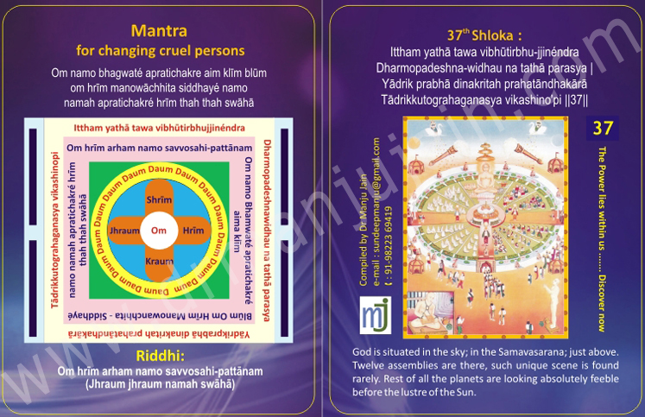
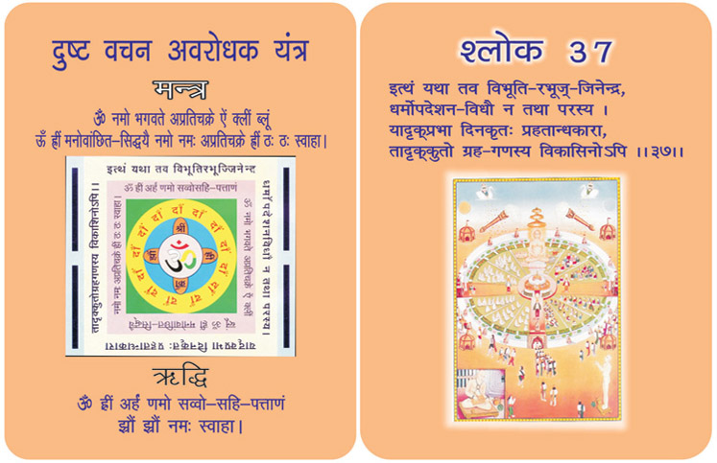
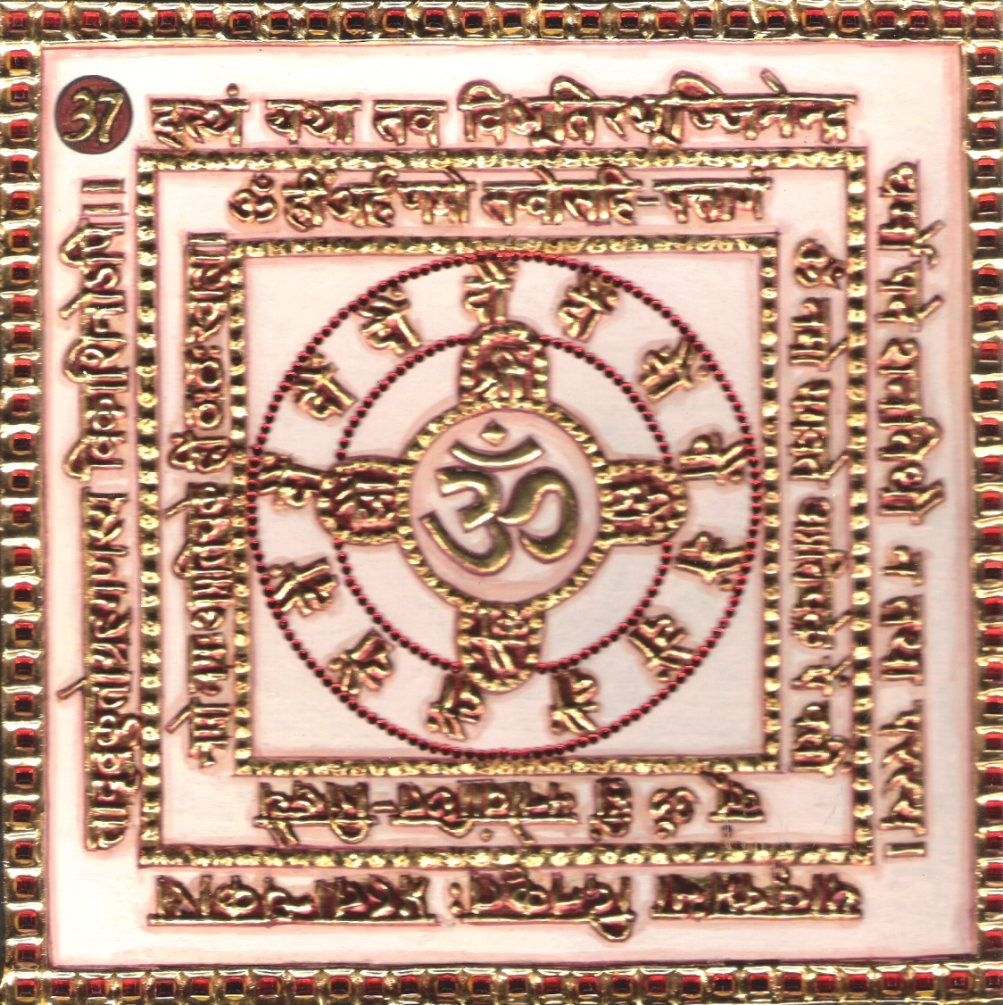

1.0 Purpose
1.1 Keeping the Yantra near and making water mystical through 21 chants of the verse, Riddhi and Mantra syllables, the water is sprinkled on the face. This paralyzes the cruel person and he is subdued to be speechless. There is increase in fame and reputation.

2.0 Scope
2.1. Thus no other Gods can aspire to resemble you in super human excellence which is the distinctive characteristic of your instructive style of expounding Tatvas. How can the light of starts possess the same faculty of destroying darkness as is owned by the Sun?

3.0 Method
3.1 After bath, white dress is put on and the Yantra is established facing north and is worshipped. Then sitting on a white seat, 1008 balls are prepared from bdellium, camphor, saffron and musk, and the Riddhi mantra syllables are chanted, each time dropping a ball in the fire of the altar.

4.0 Resources
Yantra, Mantra, Riddhi and Verse
White dress and White Seat
Balls made of Camphor, Saffron, musk and bdellium

Shloka - Repeat 9 times

ITTHAM YATHĀ TAWA VIBHŪTIRBHU-JJINÉNDRA
DHARMOPADESHNA-WIDHAU NA TATHĀ PARASYA
YĀDRIK PRABHĀ DINAKRITAH PRAHATĀNDHAKĀRĀ
TĀDRIKKUTOGRAHAGANASYA VIKASHINO’PI

Meaning

Oh my Lord of Jinas, Many prophets deliver sermons of their religions and beliefs in their own ways; but the method of imparting the philosophy and religion by you is quite unique. I have not even seen such a unique décor at all.
My Lord, let indeed the planets like Jupiter, Venus or all of them rise together, but they cannot break the supremacy of the pitch darkness of the night. It is only the light of the Sun which melts the darkness instantaneously and single handed.
Oh God, those so called proud and big prophets and preachers are, in reality, twinkling starts only, whereas you are the King of the Galaxy- the Sun. Where is the comparison? No match!

Mantra - Repeat 108 times
Om namo bhagwaté apratichakre aim klīm blūm om hrīm manowāchhita siddhayé namo namah apratichakré hrīm thah thah swāhā

Riddhi (le pouvoir surnaturel)
Om hrīm arham namo savvosahi-pattānam
(Jhraum jhraum namah swāhā)

Evidential Story - 37
Gold & diamond are almost related. Dhan & Daulat, rupees etc. are similarly related. If all these convey the meaning of wealth are who is fond of Gold & wealth becomes mad. A Poet has said that Kanak & Kanrk sounds similar yet one is gold the other is a bitter fruit. When you find dhatura and gold the gold makes you more mad. When everyone eats Dhatur he becomes mad, and a person who finds gold is more disturbed.
There is a saying “when wealth comes it kicks one and at this break, an his chest becomes broader; but when the kick is on the chest he bends down. When the word daulat is divided into dav and lat means 2 kicks _ (2 lat). With these kicks humanity is divided into two societies one rich the other poot but who are disturbed ? And this group with very simple clothing moves fast reflecting on their past life. He has lost much in his business and he becomes poverty stricken and comes to Sughat Jee millionaire’s house. As he humbly sat the millionaire welcomed him Very politely. He said Seth jindaiji welcome “If is a long long time since we met. As the millionaire smoking was eating Pan, spent out & said “Please speak, how can I help you ? What can I do for you” ? Before he could speak Jindal's eyes were drawn to the golden spittle pot & kept fixed at it. Instead of reflecting he was wonder struck, & he was in a mental storm. The more I worship this gold, it is going away while the millionaire is spitting on it, Yet it remains with him. Seth Sugathjee could read the mind of jindas the already disturbed fellow and he said “friend listen, all these king & sadhus have worn the cloth of austerity and at their feet the great kings also bend before these sages who have left all the worldly things behind them.
The real treasure is within oneself why is man searching for worldly goods & forgets his soul? The one who is able to become God like is going round like a beggar for the Perishable things of this world. This Point touched him & the eyes of wisdom of Jindas were opened. As he was about to leave Seth Sugath gave a bag full of money & said “Please take it and start your business again. Jindas took the bag of many and went home. See the fortune & wealth how fickle they are. Suddenly his bag of many fell & spread all over. At sound of it the crowd gathered and instead of Picking up & giving the money to the owner they looked because if was in their fortune they got it. What happened at then
? was the purse turn ? some said if the banana peel was not thrown this would not have happened ! This happened because it was already written in his fortune.
But Jidas was not at all disturbed with all these happening because he already knew the secret of nature's mayas. If it is in my favour I will surely get it. Thinking of all these, while returning to the city he met the Rishimuni and according to his advice on the Diwali day he worshipped Bhaktamar then the Jain's Bhakt Lakshmi Devi presented him with a precious magic glittering stone, and the palace of Jindas was lighted up with the light of that getting stone.

Testimonial

38th Shloka

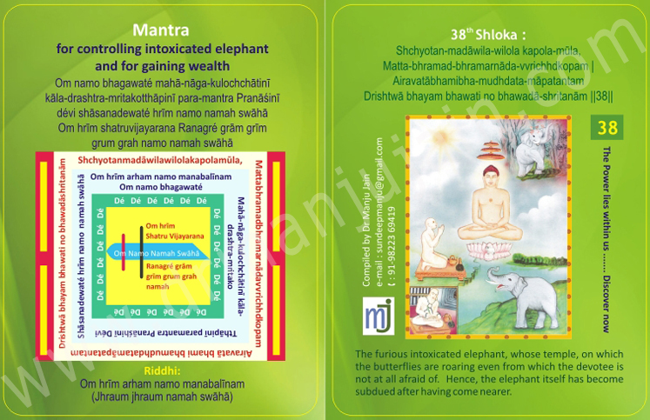
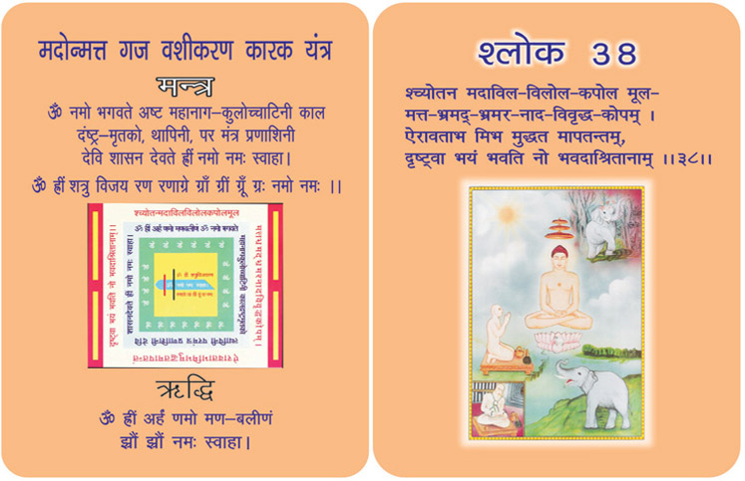

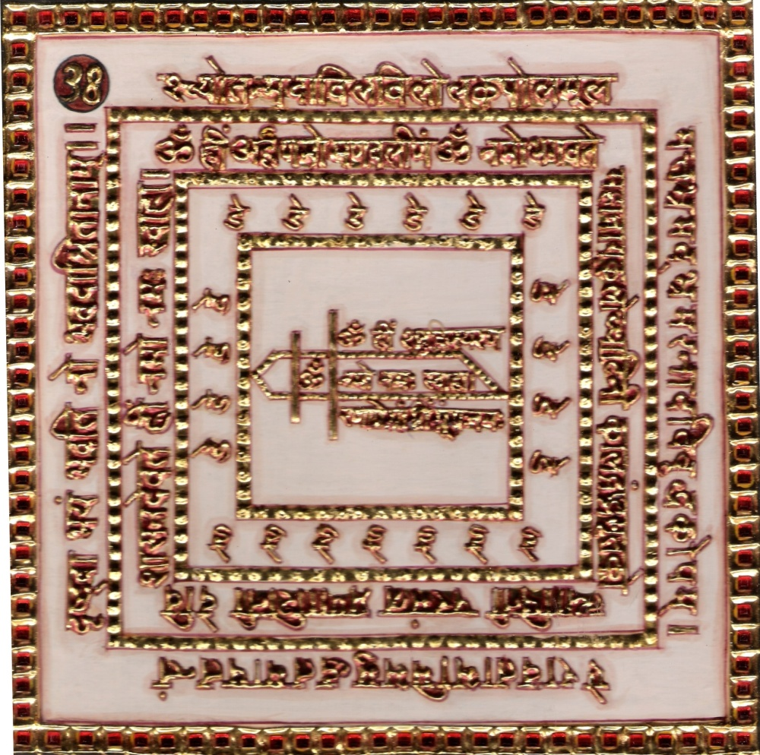
1.0 Purpose
1.1 On adoring the verse, Riddhi and Mantra syllables frequently and keeping the Yantra near, the intoxicated elephant is subdued and there is a gain of wealth.

2.0 Scope
2.1. Your devotes are not terrified even in the least when they see themselves attacked by the unruly and huge (Airavat like) elephant, provoked to anger by the humming of bees; which being excited fly near the frontal globes of elephant, which are dirty and unsteady on account of the dripping down of ichors.

3.0 Method
3.1 After purification and putting on yellow dress, the Yantra is established facing north and worshipped and adored. The seated on a yellow base the Riddhi mantra syllables are chanted 1008 times with yellow rosary.

4.0 Resources
Yantra, Mantra, Riddhi & Verse
Yellow Seat & Yellow Rosary

Shloka - Repeat 9 times
Shchyotan-madāwila-wilola kapola-mūla,
Matta-bhramad-bhramarnāda-vvrichhdkopam |
Airavatābhamibha-mudhdata-māpatantam
Drishtwā bhayam bhavati no bhawadā-shritanām
Meaning

Oh my God of the Gods! Oh my Lord, I was just praying and singing the hymns of your virtues till now. I know that those who come to your shelter grow into great people.

There is a mammoth elephant amidst the thickest wood with very erratic and obstinate mind. His madness is multiplied by several wasps muttering around the temple. He looks most frightening and powerful like the Airavat (mythological elephant having extraordinary strength, adorned with royal clothing and jewellery, who serves Lord Indra, the King of Devas) even these types of mighty mammals are incapable of frightening your disciples because of the greatest strength in your shelter.
Obviously, I am not worried of such elephants approaching me. However, there is a dragonic elephant in form of uncontrollable mind that creates a big chow in my life. Lord, provide me sufficient strength to control the mammal of my wavering mind and feel the conclusive touch of your warm lap.

Mantra - Repeat 108 times

Om namo bhagawaté mahā-nāga-kulochchātinī kāla-drashtra-mritakotthāpinī para-mantra Pranāśinī dévi shāsanadewaté hrīm namo namah swāhā
Om hrīm shatruvijayarana Ranagré grām grīm grum grah namo namah swāhā

Riddhi (le pouvoir surnaturel)
Om hrīm arham namo manabalīnam
(Jhraum jhraum namah swāhā)

Evidential Story – 38

If you are disturbed you become a terror. When a simple dog becomes mad if disturbs the environment greatly. Because of its danger all close their entrances inorder to be protected. In the same manner a wild elephant also frightens everyone. If you think of all others you also will become mad & wild with fear. We don't have such incidents as the number of animals are on the decrease because minds of greed for wealth while earlier times animals were used in battes, how bombs, tanks and the guns have taken their place.
But olden days the Presence of the elephant’s greater strength was shown. During the wars the elephants were given liquor to make them stronger. Under the influence of liquor the elephants grew mad & crushed the enemies even their own masters at times. It is rather difficult to control them under such in circumstances. Who will dare to came to a mad elephant & play with his own life.
As the snake charme puts his life in danger and catches the snakes, in the same manner the soldiers also play the same tricks to control the elephants. Exactly like them somdutt also played the trick. But who was this Samdutt that he was able to control the mad elephant, and whose mercy & grace controlled him ? Somdutt was the Prince Virpur. To his bad luck he had a son who was spotted out as a bad person who not only destroyed but his father's kingdom which got divided & ruined and became a beggar going round begging.
Somdutta was always with a disturbed mind because of his witched son's cruel deeds. At last he left virpur & reached Hastinapur, there he not only stayed but got back his, kingdom married the princess Manorama and got Vijanagar Kingdom as dowry. How did this miraculous events take place and by where grace ? Whose blessings ? All these happened with the compassion of Sri Vardhaman muni, who taught Somdutt the Bhaktamar sloka 38 and gave him religious training especially the shloka 38 which was very helpful doing his bad days. This is the sloke meant which can control terrorists, and evildoers. This shloka 38 controls all madness into gentleness and calmness.

Testimonial

39th Finding Forgotten Way & Lost Items

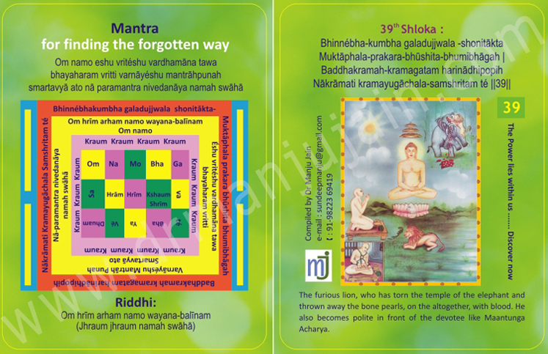

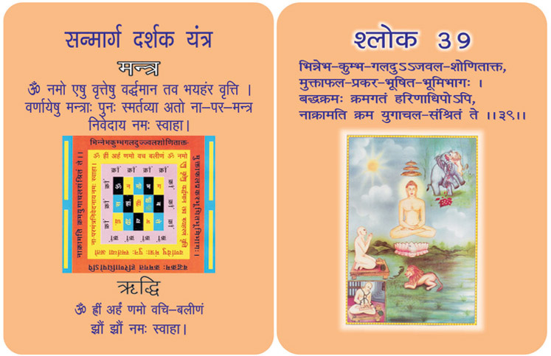
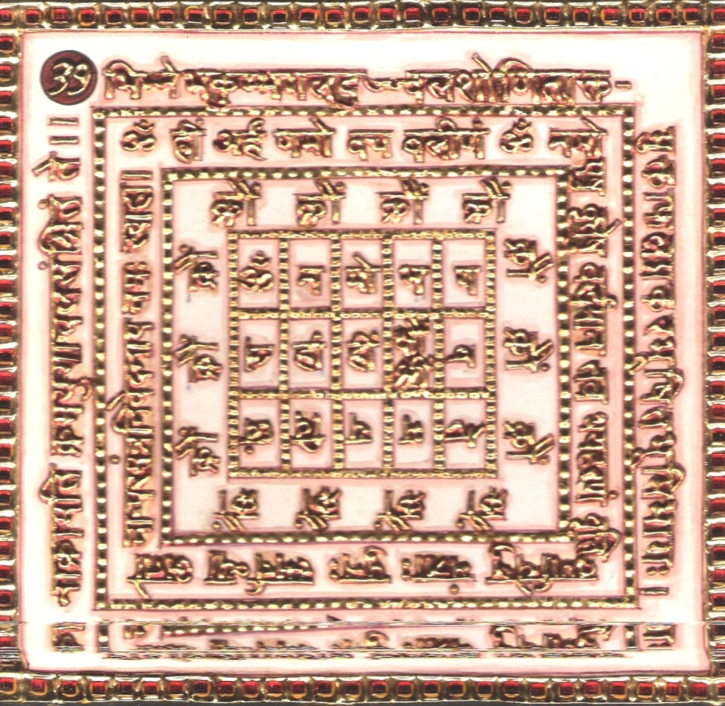
1.0 Purpose
1.1 On keeping the Yantra near and chanting the verse, Riddhi and mantra syllables to here remains no fear from snake, lion, tiger, etc., who are violent, cruel and wild animals, the forgotten way is found easily.

2.0 Scope
2.1. The lion (King of the beasts) who has adorned the ground by (scattering) lot of white pearls, which being covered with blood have fallen down from the rent temples of an elephant and has assumed a posture for assailing cannot attack upon men, even fallen in his clutches after their having taken refuge under your mountain like feet.

3.0 Method
3.1 After being purified and dressed and in yellow the Yantra is established facing east and worshipped. Then being seated on yellow base facing north, the Riddhi mantra syllables are chanted 1000 times with a yellow rosary, pure mind and phases. After each chant the olibanum of bdellium, saffron and camphor and ghee is cast into fire of the alter.

4.0 Resources
Yantra, Mantra, Riddhi and Verse
Yellow Seat & Yellow Rosary
Saffron, bdellium, camphor and ghee, Fire

Shloka - Repeat 9 times
Bhinnébha-kumbha galadujjwala -shonitākta
Muktāphala-prakara-bhūshita-bhumibhāgah |
Baddhakramah-kramagatam harinādhipopih
Nākrāmati kramayugāchala-samshritam té
Meaning

Oh my Lord! I saw a lion; dangerous even than that mammal, After all, lion is the king of all animals.
That roaring lion just drilled the head of an elephant with his powerful teeth and nails. The earth is now shining with the bright pearls red with bloodshed which fell on the earth from the elephant’s temple. The lion is extremely irate; he is not ready to let go anyone seen by him.
Incidentally your disciple is just in the way of that lion. The lion is not aware that the person is having shelter in your lotus feet. God, now your feet become the insurmountable mountain for the lion. His fanatic efforts to jump and bleed your Bhakta prove in-vain, futile and fruitless. The lion pales and becomes quiet.
God, the question of attack by such a lion may or may not arise in my life. But the lion of desires and envies in my mind are constantly attacking me. Lord, protect me from these enemies of my soul!
Protect me O Jineshwara!

Mantra - Repeat 108 times

Om namo eshu vritéshu vardhamāna tawa bhayaharam vritti varnāyéshu mantrāhpunah smartavyā ato nā paramantra nivedanāya namah swāhā

Riddhi (le pouvoir surnaturel)
Om hrīm arham namo wayana-balīnam
(Jhraum jhraum namah swāhā)

Evidential Story - 39

To be freed from the Various fears of the world, we are given slokas 38 & 39 by munivaria muktan mantis. During the great Battle between the pandavas and Gouravas the Gauravas had greater number of horses, elephants and Armies all the required equipments, as well as the great warrior’s Daughter, kern Drone on their side which naturally made it impossible for anyone to Defeat them. Yet the Pandavas, who were just 5 in number and had no strength on their side to fight the Gouravas won the battle easily because they were devoted of God Narayan and Krishna who were with them. Though the horses jumped neighing and the elephants trumpeted running mad, to destroy the Pandavas, their faith in God saved them and they could easily defeat the Gouravas.
Just as the sun rises and its rays pierce through the darkness and dispel it so also those who trust in God will be able to defeat all evil powers against them the one who worships God can be defeated by no one on earth. Whenever slogan 38-39 is recited with faith and “devotion, all battles will be won for that very reason this sloka is written. Much strength, vigour and boost is given by the 38th sloka. They through this sloka bravery, strength and boost are supplied to the fighters against their enemies, but infront of God all these are nothing when the battle field is turned to a river of blood, the brave soldiers will keep on fighting. This is the work of the slok written for them and the enemies gets angry and this sloka shows the rudraraju? The battle is so terrifying that one shudders in fear. In the sad situations also bravery, hatred and virus can only be defeated by calm and cool persons who are fully immersed in God. God is so kind, soft and gentle as a lotus and the good are people always found under his feet.
All the Anger, hatred and bravery will disappear before God's mercy and gentleness. Bhakt Siromani Acharya Manthum is attracted to muni Jittendra and his devot on is so great that he is lost in God. All the 9 nine evils are controlled. At least once you might have seen a circus, whatever is hown are rather difficult and even dangerous. All the animals like the lion, tiger, leopard are all very wild and yet how they are trained and tamed to do their job. When you play with a lion or tiger are you're not playing with you life ? Have we ever thought of the secret of the success of all these artists ? These animals are trained from their early babyhood and are thus controlled as a small plant is guided when it is only a sapling also are these moulded. As they train these according to the way they want, they learn the tricks and perform them to the wonder of the audience. What is magic ? making yourselves consciously aware of yourself and making others to come to the state you want them you bring them under the control of your fingers and that is magic will & soul gets linked to the Mantra. If you unite mantra with your will and nonviolence then there is fruitfulness.
During the ascetic period of Mahavir and Mahatma Budh and so many other yogees, the lamb and lion drank water from the same pot, unlike the percent age when these wild animals are controlled by electric power and other aids. Earlier the wild animals were touched by the austere and ascetic life of the sages and were transformed into gentle beasts. Actually there is great strength and power in nonviolence. It is the greatest of all powers, From now about hundred years earlier there was a true story. Even today the name of Divan Amarchand is held very high in Jaipur of Rajasthan. People take pride in recalling name. He was so polite, and civilized when ever he listened to all the people. But same others were very jealous of him. One day his own colleagues who were against him maligned his name telling that he was proud of nonviolence. Infront of nonviolence even the wild breasts also shakes their tales like the dogs. Why not try him ? Raja Nidhar ordered Divan Amarchand to be caged with the lion. Divan Amarchand was not at all disturbed. He was convinced of the power of Nonviolence. His whole self, body, mind, will and ideas were possessed by the atoms of nonviolence.
Before he entered the lion's cage he had a plate of fresh gillebi (sweets) with him. When he entered the lion’s den fearlessly and powerfully he addressed the lion and said “Friend you have made yourself the king of the deers. Hiking of the forest ! your habit is to eat the flesh. But can you ever keep your belly filled with fresh mutton ? Other powerful animals like the horse, elephant also live, but they live on what you don't eat ? That means you are not a vegetarian like them.You control your greed for eating flesh king of the forest. In 24th Thirthnkar Bhagwan mahavir was in your womb. You can also become a very good being if you change your views and ideas”. As Amarchand spoke so gently and with compassion the Lion's heart was touched. He transformed the wild beast which was roaring so fiercely stand like a statue, slowly shedding tears. After that the wild lion ate the jilebi happily filling his stomach ! Then what happened ? All the kingdom hailed Nonviolence and soon all accepted nonviolence as their way of life. Sloke 39 of srceman Thumkacharya Bhaktamar is a great mantra to control the ferocious beasts.

Testimonial

40th Shloka for Curing Effect Of Poison and Controlling Snakes

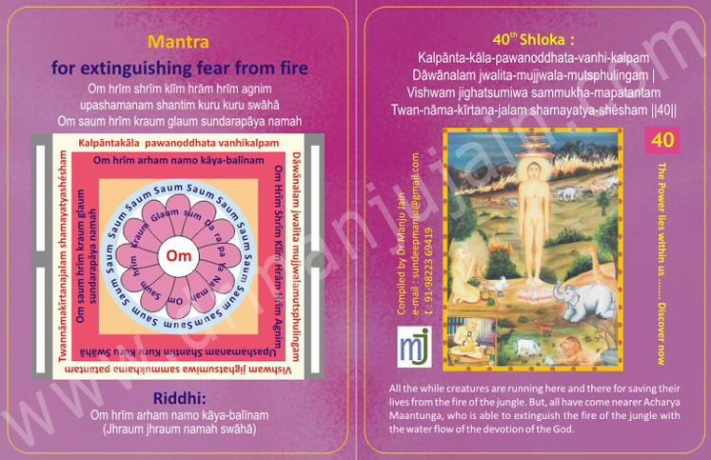

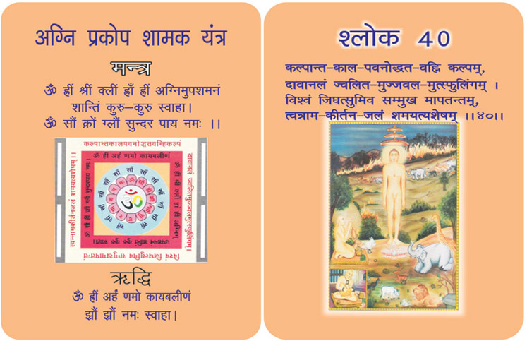
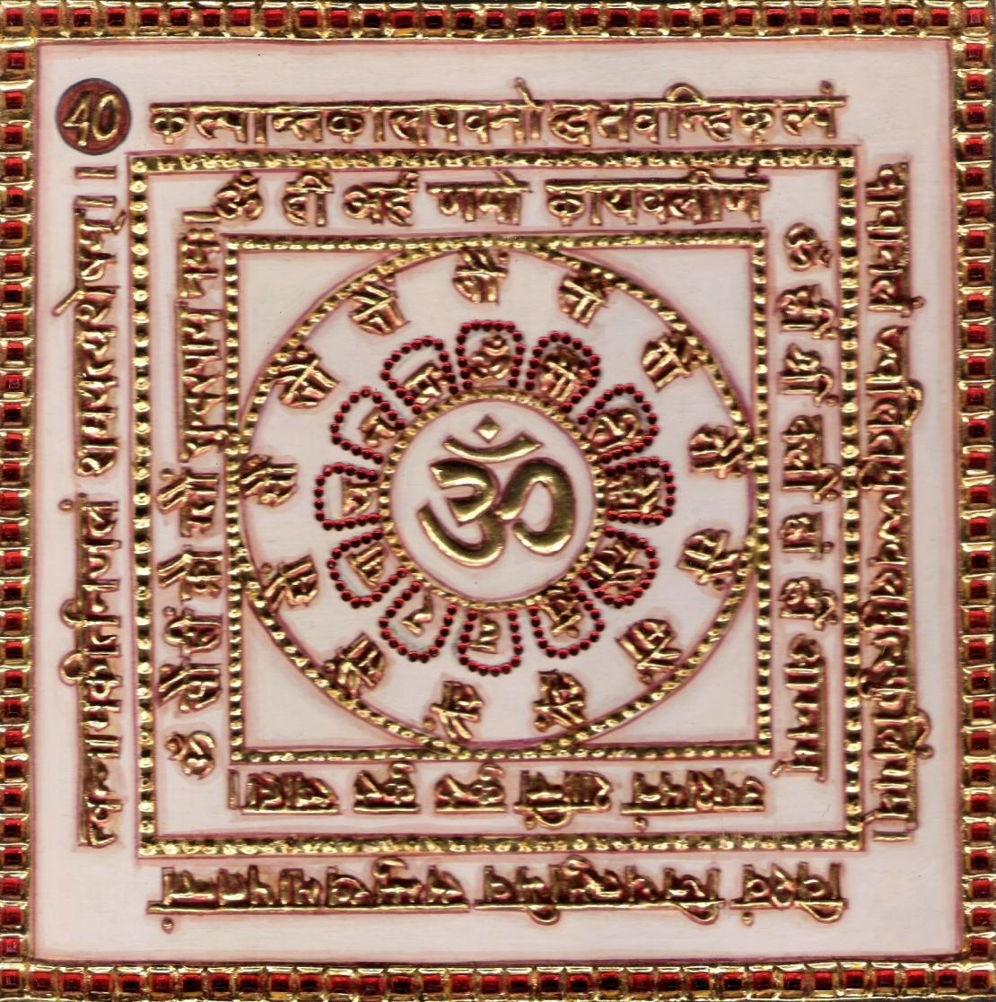

1.0 Purpose
1.1 The Yantra is kept near and the 21 chants of the verse, Riddhi and mantra syllables are performed to make water mystical which when sprinkled wards of fear from fire.

2.0 Scope
2.1. Repeating of the verse is able to extinguish the fire of the jungle with the water flow of the devotion of the God. Before chanting all the wild creatures were running here and there for saving their soul from the fire of the jungle, but as they came nearer Acharya Manatunga they sat quietly.

3.0 Method
3.1 After purification and dressed in red keeping the auspicious pitcher facing east and Yantra facing north it is worshipped. Then occupying red scat and facing east the Riddhi and mantra syllables and chanted 12000 times with red rosary.

4.0 Resources
Yanra, Mantra, Riddhi and Verse
Red dress, Red Seat and Red Rosary

Shloka - Repeat 9 times

Meaning

Oh my Lord! The wildfire is a fire advancing in leaps and bounds, emitting glittering sparkles in all directions. The fire is as stupendous as the one at the end on an eon, narrated in scriptures.

I see that the furious flames are spreading to engulf your Bhakta too. He prays to you; he remembers you as Adideva; and to a great surprise, the wildest of the fire extinguishes. God! What a cooling soothing and watery effect of your name! The fire is cooled down. God! I know that the Glory of your name will save me from such a fire, I desire so, but I earnestly pray to please relieve me of fiery thoughts, jealousy and envy. Extinguish the evil fire burning in my mind.
I am not going to dive up chanting your pious name till then.

Mantra - Repeat 108 times

Om hrīm shrīm klīm hrām hrīm agnim upashamanam shantim kuru kuru swāhā Om saum hrīm kraum glaum sundarapāya namah

Riddhi (le pouvoir surnaturel)
Om hrīm arham namo kāya-balīnam
(Jhraum jhraum namah swāhā)

Evidential Story - 40

Fire was seen all over, no one knew where it came from ! But it destroyed all the belonging of the traders and lakhs of costly items like bullock cart and many precious goods were destroyed. People were horrified and shorted for water. So much so the number of people shouted for water exceeded the number who actually brought in water. Friends of Lahshindhan Lakshmi dhar were so scared, and became speechless as their minds got locked. And the flames looked as if they touched the sky. In those days there were no fire brigades to control the fire. But there was a sloke Agni namak mantra the fire control known as the fire brigade mantra. Those who were devoted to religion used the mantra to control the angry fire.
When sita's truthfulness and loyalty were tested by fire, Agnikant Jain religion's power proved effective so there is no reason that Lakashmi Dhar could not have put off the fire in other words Lakshmi Dhar could have put off the fire. Lakshmi dhar was in the least affected or scared at that terrible time. In his religious life he had burnt up all his evil desires and sins as in that of Holi. Very calmly and devoutly he could see this present situation as Jitendra Bhagwan could foreseen the eight evils of the present time. Lakshmidhar thought that when misfortune comes what cannot happen ? that means everything will be disturbed.

If Ravan's Golden Lanka was burnt to ashes what cannot happen to me ? What is wealth afterLakshmidhar used sloka 40 & Mahaprabhavak Bhaktamar with much devotion and faith to destroy the misfortune. Some people were angry, mockingly remarked against Lakshmidhar and said “Sethji please provide same water to control the fire instead of praying your slokas, because your devotion and mantras will not work here. “Lakshmidhar was not all disturbed but was immersed in reciting his mantras. In the govt constitution whether it is late or dark, whether people get justice or not, but in God's law, (law of karma work) there is no delay and no darkness.
Lakshmiji Bhaktamar was totally immersed in Shloka 40 he saw Devi Adithsthati Chakreshwari with folded hands standing before him. Learners would be keen to know who this lakshmidhar is ? How did the fire start ? Where did it start ? and under what circumstances it look place ? Let us see !
Listen lakshmi Dhar was a rich merchant of Pothenpuram. On Deepawali day, early morning, accompanied by business companions, were going for their business to Singhal Island. In the late evening they put up a tent on the way. Sethji said this evening is a suitable day, a great and holy festal day so we should worship Lakshmi he lighted the lamp and began to worship Lakshmi the Goddess of wealth. Being carried away by the thought of Lakshmi. He forgot that it was not the feast of Lakshmi actually it was a day to worship Mahavir and then only they were free to worship Lakshmi, so after worshiping the Goddess of wealth he slept off. After an hour he heard the shouting of people, he woke up and realized that he has worshipped Lakshmi instead of celebrating Deepavali and Diwali instead of holi.
He was lost in and touched by the sloka. Abhishti Chakreshwari Devi brought an incense boat to Lakshmi Dhar. In God’s Law there is no delay and no darkness so that wherever he sprinkled it the fire became calm and extinguished.

Testimonial
I was into audit and suddenly my HR Manager came running. Saying that Paint Booth is on fire. I went running and saw the fire, the rubber curtains were burning in Painting Booth. Immediately I started chanting. It striked to me and started giving paint cans to labour and they filled them with water tank near by and immediately with the help of 150 labours we extinguished the fire before the Fire Brigade came, although the fire Brigade cane on time. This is what Shlokas of Bhaktamar Stotra is miraculously effective to any problem.

41st Shloka Removing Fear From Fierce War & Terrorism
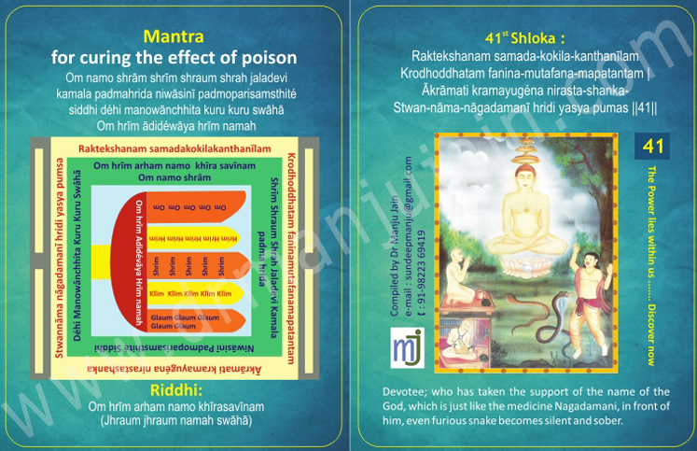
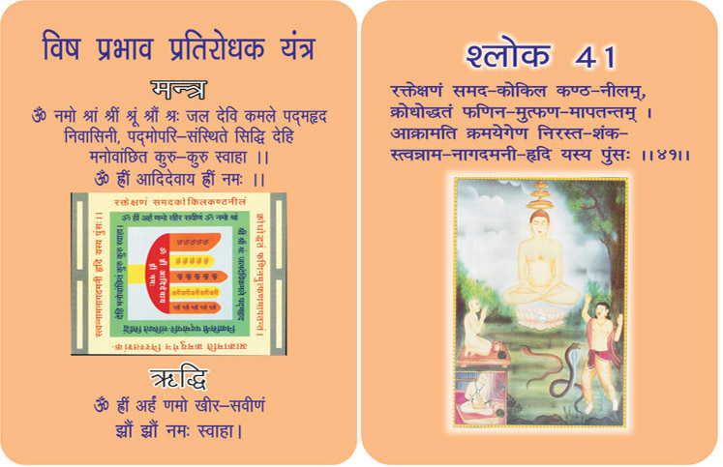

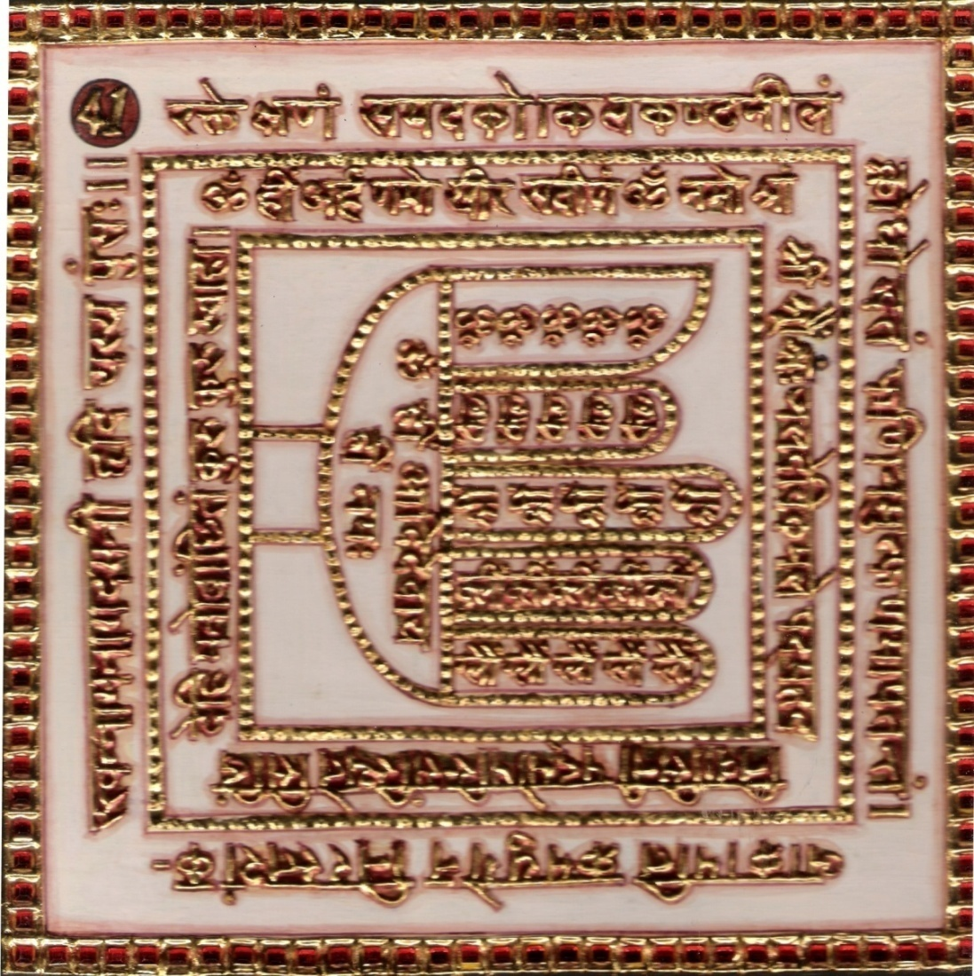

1.0 Purpose
1.1 Keeping the Yantra near and remembering the Verse, Riddhi and mantra Syllables frequently reputation in royal court is attained and celebrity is increased. Its repeated spells removes the poison of snake. When water in a bronze vessel is made mystical through chants the effect of poison is cured.

2.0 Scope

2.1. Devotee, who has taken the support of the name of the God, which is just like medicine Nagadamani, in front of him, even furious snake becomes silent and sober.

3.0 Method

3.1 After having bath, white dress is put on and the Yantra is established facing East and worshipped, the candle kindled and with moving flame adoration is performed. Afterwards, occupying the white seat facing north, the Riddhi and mantra syllables are chanted 12000 times with rosary of quartz crystal for evincing the mantra.

4.0 Resources
Yantra, Mantra, Riddhi & Verse
Rosary of quartz crystal, White Dress

Shloka - Repeat 9 times

Kalpānta-kāla-pawanoddhata-vanhi-kalpam
Dāwānalam jwalita-mujjwala-mutsphulingam |
Vishwam jighatsumiwa sammukha-mapatantam
Twan-nāma-kīrtana-jalam shamayatya-shésham

Meaning

Oh my Lord! An enraged snake rushes vehemently. Its eyes sparkle like carbuncles and poisonous black throat resembling the swollen neck of an overjoyed cuckoo.
However, your Bhakta has no fear, because he is reciting your name all the time. Your name works as Nagadamani, (the ancient herb to neutralize the effect of snake poison.) Your Bhakta is aware of this and hence, without any fright whatsoever, he crosses the cobra. The killer cobra becomes a tiny harmless insect before your Bhakta.
My God, I am not afraid of any such snake; but there is a most ferocious cobra-in the form of anger-in my mind. Please control my tongue of anger, which is ever ready to quarrel with others. Please protect me from the cobra of anger, because its single bite can destroy my age-old penance.

Mantra - Repeat 108 times

Om namo shrām shrīm shraum shrah jaladevi kamala padmahrida niwāsinī padmoparisamsthité siddhi déhi manowānchhita kuru kuru swāhā Om hrīm ādidéwāya hrīm namah

Riddhi
(le pouvoir surnaturel) Om hrīm arham namo khīrasavīnam
(Jhraum jhraum namah swāhā)

Evidential Story - 41

Two wheeler vehicles of any model like bullock carts bicycles, motorcycles, scooters, are run on two wheels of equality in size, quality in every aspect only can make these vehicles move fast and safe. And if any one of the wheel is not in order or different in size, the vehicle will not move for ward as it should.
Our families can be compared to these vehicles the husband and the wife are the two wheels on which a family runs so they too need to be like the above mentioned wheels, agree to be together in love, cooperation, mutual understanding, give and take attitude etc. in order to run their family smoothly. Failing in which, not only they will not move forward, but reverse happens. We they will not move forward, but turn reversely. We have a good model for such a one in Seth Sudatt’s family. As we have mentioned above this family did not run well, it went on somehow when one worked well the other went off. What was the matter? The wife was a very devoted lady and lived the Jain religion to its full, and Seth Sudatt, just the opposite. When the husband took the supper Night meal his wife would not permit it and gave him religious instructions, and whenever his wife went to the Jain temple the husband would taunt her. Instead of coming together as 63 (two numbers facing each other they were like 36 (the numbers turning their backs to each other) and always in fighting moods.
Now Seth Sudatt's wife was a saintly person full of goodness, holiness and deeply religious. So in spite of all the hardships she kept on bearing up and praying to bering her husband back to God.
How many ladies are there like her in our society of today? who try their best in a holy manner and fearlessly to being their husbands back to God, and vice versa ? This story conveys that Sudatt's wife was a good daughter in law, and she kept on praying Bhaktamar Sloka 41 with much devotion so the bad behavior of her husband and mother in law did not affect her, instead they failed.
Once Sudatt and his wife Dridvatha were sitting in their bedroom, Seth Sudatt began to shower extraordinary affection on to his wife. Wicked persons with evil in their minds speak one thing and act just opposite. It is interesting to note there was no one else in that room to witness their drama. Yes there were flower garlands and a lot of other valuables kept in a golden vase to play some trick. Because Dridvatha stood for truth, goodness and religion their planned trick also failed. Pointing towards the golden vase Sudath said to his wife Dridvatha “Look sweet heart, our love is as pure as ganga water. I am really impressed by your devotion to Jitendra Dev. I feel I too should leave my father’s religion and follow Jainism. Accepting you as my Guru I want to present you a gold chain that is kept in this gold vase. You please take it and wear it and accept my offering”. Dridvatha seemed happy to hear that Sudatt was going to accept Jain religion. So with deep faith and devotion she moved towards the vase, took that chain and went to her husband saying “This costly chain will not give me any added beauty. So I want to put it on your neck and honor you” and with great love she put the chain on her husband's neck. She walked backward to see how it looked on him. But what a shock? Oh goodness! she saw a black cobra moving around his neck ! and in a moment it bit him and Sudath fell lifeless ! A lot of thanthra mantra fellows surrounded him to remove the poison; but in vain! Then came the mother in law shouting hooting and felling at Dridvatha, blaming & cursing her saying “Is this witch (Dridvatha) going to eat up her husband and only then could she he satisfied ?
We see that this whole drama was preplanned by the mother in law to kill her daughter in law. Dridvathe was immersed in reciting Bhaktamar sloka 41 with much devotion and concentration while all this was going on and not an iota disturbed. Then she had a vision of Adish Dhatri Padmawati Devi telling here “Dridvatha, open your eyes take the water from the golden vase and sprinkle it on your husband” Dridvatha did as she was told and her husband woke as if from a deep sleep, alive and active. Seeing this the snake charmer and tan tricks stood wonderstruck, all shouted” Hail Jainism. Finally not only Seth Sudatt, but his mother the wicked woman, and the whole family accepted Jain Religion. “Truth and goodness prevail against all evils”.

Testimonial

42nd Shloka for Removing All War Fears In Battlefield

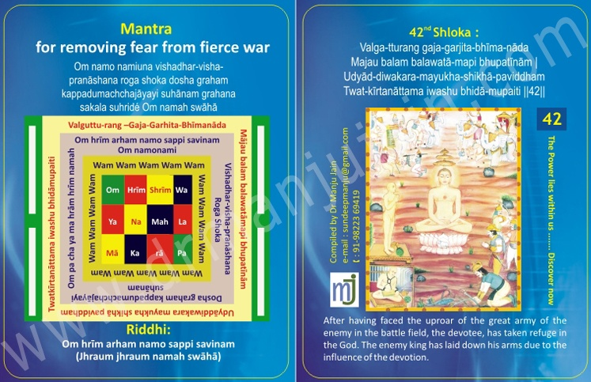

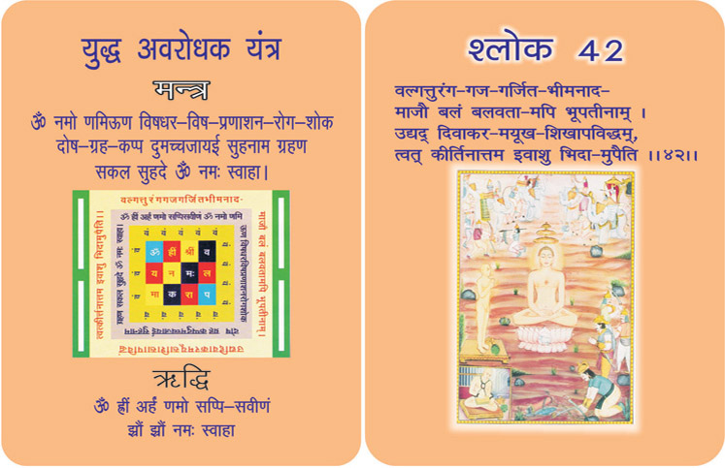

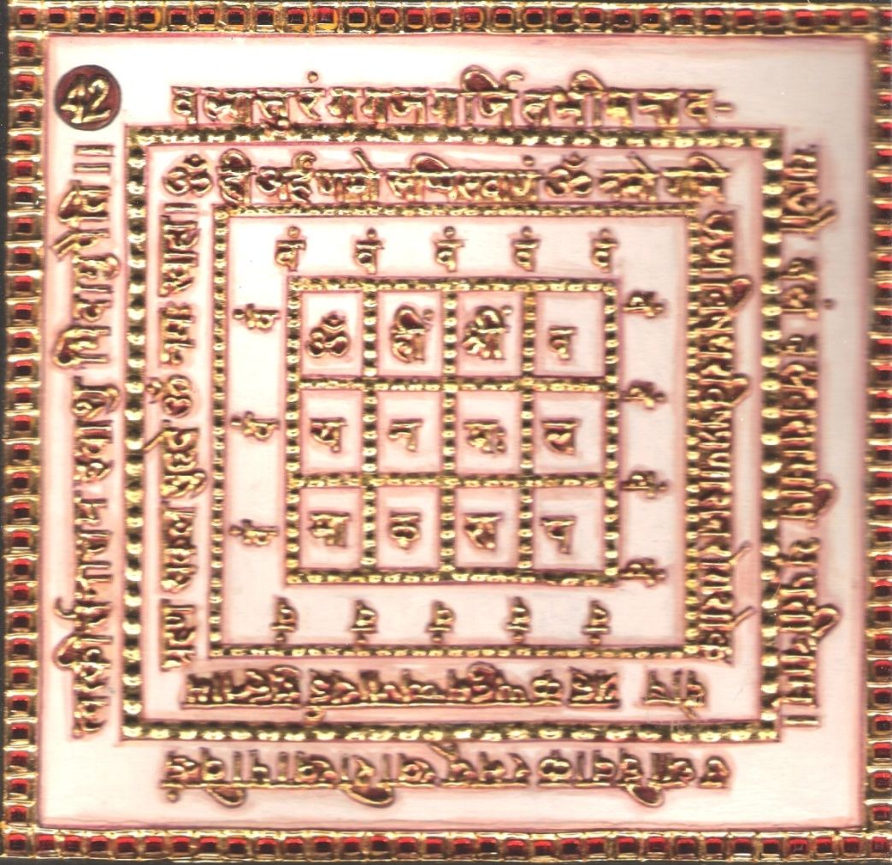
1.0 Purpose
1.1 The Yantra is tied to the arm and the Riddhi, Mantra syllables are frequently remembered. This does not produce any fear from a fierce war. The angry king becomes peaceful and subjugated to vanish away. Fame spreads all around like moonlight.

2.0 Scope
2.1. As the Sun is able to disperse the dark similarly your name is powerful enough to soon disperse the army of the great kings in a battle, resounding with the noise of the galloping horses and roaring elephants. If devotee taken refuge of God, great army of enemy will disperse.

3.0 Method
3.1 After purification, dressed in white, the Yantra written in red sandalwood is established facing east and worshipped along with kindling of lamp and moving flame. Then being seated on red seat, facing north, the Riddhi and Mantra syllables are chanted 12500 times with rosary in red.

4.0 Resources
Yanra, Mantra, Riddhi and Verse
Red sandalwood worshipped in kindling of lamp
Dressed in white, seated on red & with red rosary

Shloka - Repeat 9 times

VALGA-TTURANG –GAJA-GARHITA-BHĪMA-NĀDA
AJAU BALAM BALAWATĀ-MAPI BHUPATĪNĀM
UDYĀD-DIWAKARA-MAYUKHA-SHIKHĀ-PAVIDDHAM
TWAT-KĪRTANĀTTAMA IWASHU BHIDĀ-MUPAITI

Meaning

Oh Great Almighty! Your Bhakta, a King, is attacked by another King with a mighty army. A war is declared. The noises of warring elephants and horses have added the horror and hostility in the atmosphere of battle field.
Your Bhakta neither pulls his sword, nor does he call his army. He recites your hymns and songs of your worship. Surprisingly, the whole attack gets helter-sheltered in no time, as the darkness is dispelled by the rays of the Sun.
God! It was the impact of your Bhakta’s hymns and prayers that did the miracle.
Like armies of the enemies, the distress and disturbances do attack me time and again. They vigorously try to obstruct my faith and devotion. My Saviour, please take me through all such situations harmlessly throughout my life.

Mantra - Repeat 108 times

Om namo namiuna vishadhar-visha-pranāshana roga shoka dosha graham kappadumachchajāyayi suhānam grahana sakala suhridé Om namah swāhā

Riddhi (le pouvoir surnaturel)
Om hrīm arham namo sappi savinam
(Jhraum jhraum namah swāhā)

Evidential STory - 42
Humans should not always remain ignorant, but study the situations, and every word need to be evaluated in one’s own mind and then only act. One who listens must be careful and understanding towards the one who criticizes. Now, we find, brother against brother and the whole family getting divided, love diminishing what is the reason for it ? Generally speaking it is found that the ladies are the cause, no one knows what magic they play among husbands and wives who are so united as milk and water to make them enemies of each other. It happens only when the husband is not careful wise and sensible. Similarly the following is a true story. When Gumana came from Ginlaya to Mathura and entered the beautiful palace of his brother his brother red with anger shouted at him saying be careful, if you enter, stupid as you are, you are not worthy to be called the king's brother. I don't want even to see your face. Go back immediately as you came, and if you don't go, I'll order my soldiers to kick you out. He was unaware of what was happening hence stood speechless. But he realized that it was not his brother but that of the king.
After the demise of his father, his brother was the successor for the kingdom. He thought that when a person gets the throne and the power one becomes mad and unable of recognize right from wrong, justice from injustice. In such situations when one becomes blind and stubborn something happens that one forgets everything and starts helping the people do good works, protects religion honors others and shows the way to goodness. Whatever Srawan did to viveshen, whatever Bharat did to Bahubali, same manner Mathura Naresh Ramkethu did. Being instigated by his wife he ill treated his own younger brother and exiled him from his our country ? What a pitiable state was that simple humble young brother Gunvatha who was absolutely ignorant of all politics and laws, yet he was removed.
He was always engaged in religious practices, learning and other good works how could this injustice be meted out to him ? But who would oppose this injustice and the cruel king. Who would break their head to protect justice and truth ? History shows that the mighty wins always and all others take their sides. But the state minister tried his best to make the king understand. Unfortunate situations make everything fall apart. At these moments easily and quickly thoughts of reverse takeover. Doesn't it came in the slokas ? folk tales ? Sugri against his brother Bali, and vivishen against his elder brother Ram, took the help of Ramchanderji, Gunvatha was generous, holy broadminded and large hearted. He drank this unjust humiliations and did not utter a word. Like Bahubali he took this situation as the reason for his exils. If you keep on trusting in God and with devotion keep praying you will always be successful. But with bad thoughts in your mind even if you spent time in contemplation, prayer and yoga even then the obstacles will continue to be there standing in front of you.
It says that Gunvatha with devotion and concentration kept on reciting bhaktamar stotra 42, 43 renounced all the politics of life and was taught by ganeshwari and achieved heaven like Indra Dev.

Testimonial

43rd Shloka for removing all War Fears in Battlefield.

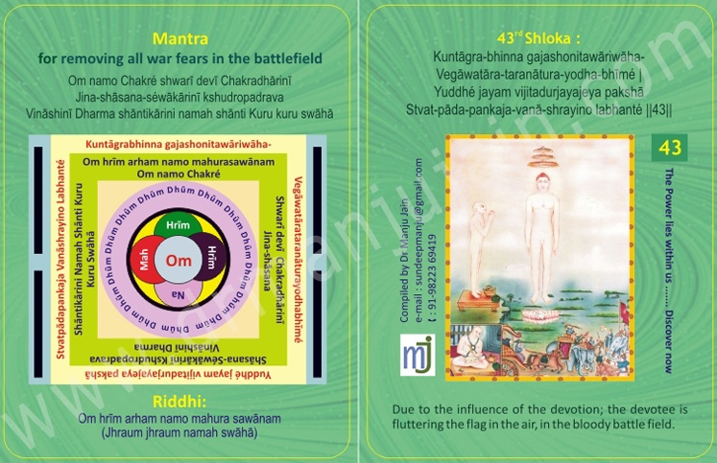

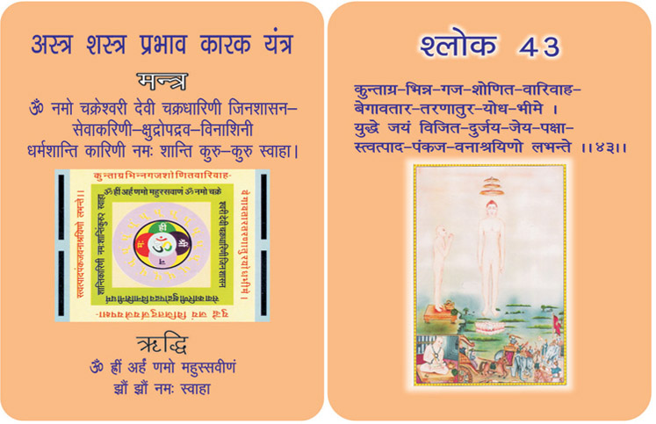

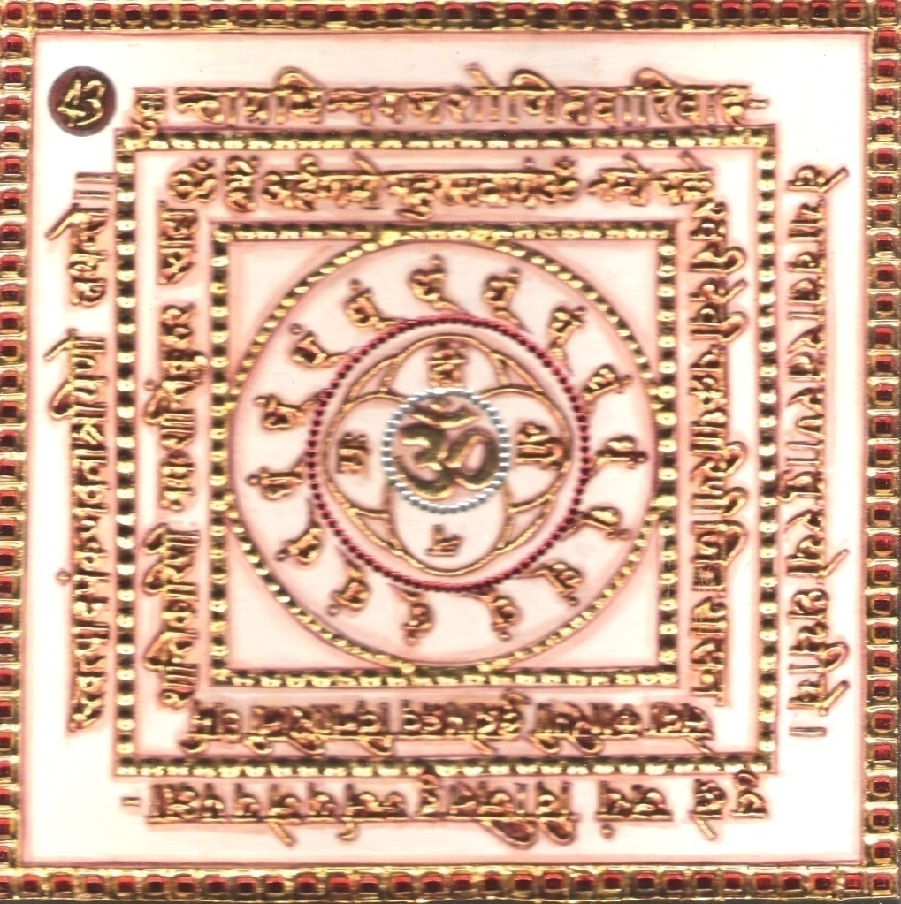

1. Purpose
1.0 On remembering the verse, Riddhi, Mantra, syllables worshipping the Yantra and keeping it near, all types of fear are removed.

2.0 SCOPE

2.1. Due to influence of devotion, devotee is fluttering flag in the air, in the bloody battle field.

3.0 METHOD

3.1 After bathing and being clothed in clean white, the yantra is established facing east and worshipped. Then occupying white seat and facing the north, the Riddhi and Mantra syllables are adored 12500 times with a white rosary.

4.0 RESOURCES
Yantra, Mantra, Riddhi & Verse
White Seat, White rosary

Shloka:

Kuntāgra-bhinna gajashonitawāriwāha-
Vegāwatāra-taranātura-yodha-bhīmé |
Yuddhé jayam vijitadurjayajeya pakshā
Stvat-pāda-pankaja-vanā-shrayino labhanté || 43 ||

Meaning:

Oh my God! You are not only my defender; but you are the architect of my victory over the unconquerable foes.

Let the enemies inflict the ears. The wars may be so horrifying that the points of spears and arrows may cause rivers of blood from the wounds of the elephants. The vengeful soldiers may be eager to swim through blood to win the opponents.

But when your Bhakta approaches your lotus feet, he is bound to emerge victorious.

God, I am aware that I do not have to worry at the time of such or even a greater war than this; but my past deeds and sins have already declared the war against me. However, they may not stop warring at all. But I am sure; I will attain victory by your grace. You are bound to make me victorious. I am your disciple, having taken the refuge in your lotus feet.

Riddhi

Om hrīm arham namo mahura sawānam
(Jhraum jhraum namah swāhā)
Mantra
Om namo Chakré shwarī devī
Chakradhārinī Jina-shāsana-séwākārinī kshudropadrava
Vināshinī Dharma shāntikārini namah shānti Kuru kuru swāhā

Evidential Story - 43
After creating various types of shlokas to free one from the worldly fears the eulogizer Munishree Manatungji presents the scene of fierce battle in 38th and 39th shloka and says - “Your devotee may be (get) trapped by the invincible (undefeatable) powerful army of the enemy yet he is never defeated and scatters the enemy camp, though being a normal person. The proof is the battle of Mahabharata, where the Pandavas side though being small in number and without kingdom, power or means were ultimate victors. As opposed to this their opponents Kauravas were not only large numbered but also great warriors with various capabilities. Dushasan, Duryodhana, Karna, Drona, etc. The great warriors were all on one side. To fight and win over such a powerful side is only due to divine grace. That divine grace was in the form of Lord Krishna himself who was on Pandavas side. It means that a person who is devoted to God although may be trapped by the powerful enemy or suddenly attacked by them. The atmosphere may be very grim. The enemy’s horses may be neighing, elephants trumpeting, panic, plundering and looting everywhere. But if the devotee wants to win, destroying the enemy, bravely facing the weapons of the enemy, remembering you contemplating you, in such adverse condition gains your support and soon (immediately) defeats the enemy. The enemy camp gets scattered and destroyed just as the sharp rays of the sun pierce through darkness. The countless weak forces cannot stand a chance before a devotee who takes support of the supremely powerful and pure God. This shloka has been created by the Acharyashri specially for kings who wants to win over battles, kingdoms and enemies. This shloka is not only the root (main) mantra for victory but also for infusing enthusiasm and courage. In this shloka by the way of battlefield, the rasas (feelings, sentiments) of rage (anger), fierce (terrible), courage (bravery), horror are picturised. But (at) the lotus feet of God which is the soothing (cooling) rasa, all other rasas or feelings bow down.

Look at the horrible scene of the battle field. Which depicts streams of blood of elephants and horses flowing warriors are eager to fight swimming across them this is the depiction of heroic sentiment (sentiment of courage). The enemy’s anger is boundless - this depicts the sentiment of anger. The heart shivers and trembles due to the fierce, terrible etc - are the examples of sentiments of horror and sentiments of compassion or tenderness. Yet the Prashant rasa - the feeling of peace wins over the others. Because your devotee has taken refuge at your soothing and peaceful lotus feet. All other sentiments lose their existence before the Prashant rasa. ‘Twatadpankajvanashryino labhante’ resonates this spiritual meaning. The Bhakta Shiromani Acharya Manatunga muni is so much immersed in Jinendra Bhakti that the so called literary navrasas - the nine sentiments also decorate it with their beauty.

Testimonial

44th Shloka for Removing Fear Of Storm In The Sea
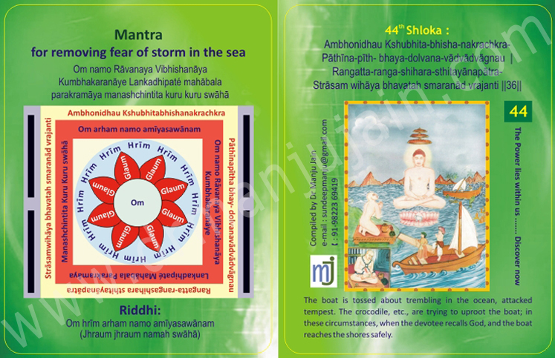

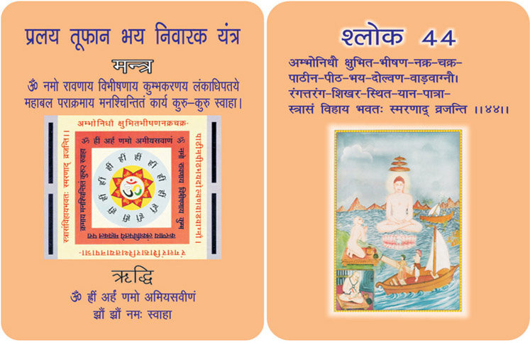
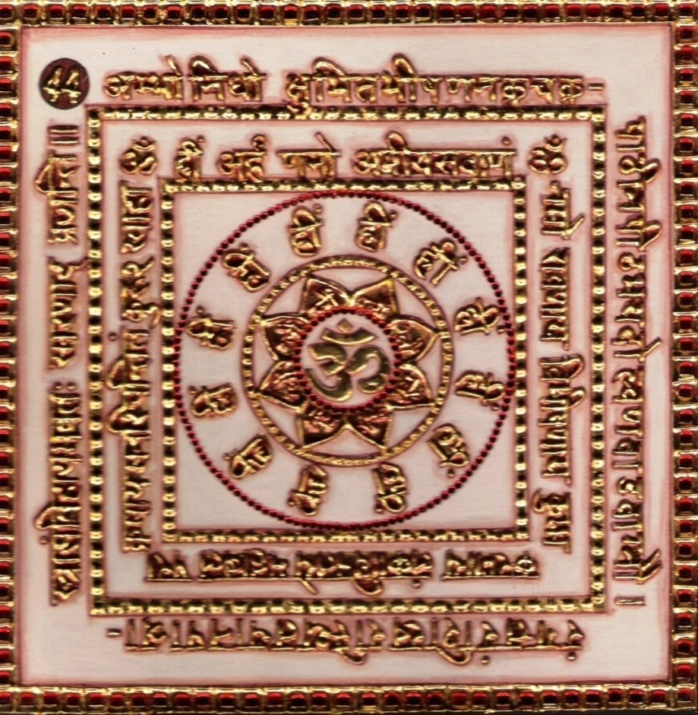

1.0 Purpose
1.1 Keeping the Yantra near and remembering the Verse, Riddhi and mantra Syllables frequently reputation in royal court is attained and celebrity is increased. Its repeated spells removes the poison of snake. When water in a bronze vessel is made mystical through chants the effect of poison is cured.

2.0 Scope
2.1. Devotee, who has taken the support of the name of the God, which is just like medicine Nagamani, in front of him, even furious snake becomes silent and sober.

3.0 Method
3.1 After having bath, white dress is put on and the Yantra is established facing east and worshipped, the candle kindled and with moving flame adoration is performed. Afterwards, occupying the white seat facing north, the Riddhi and mantra syllables are chanted 12000 times with rosary of quartz crystal for evincing the mantra

4.0 Resources
Yantra, Mantra, Riddhi & Verse
Rosary of quartz crystal
White Dress

Shloka - Repeat 9 times

Shloka:
Ambhonidhau Kshubhita-bhisha-nakrachkra-
Pāthīna-pīth- bhaya-dolvana-vādvādvāgnau |
Rangatta-ranga-shihara-sthitayānapātra-
Strāsam wihāya bhavatah smaranād vrajanti || 44 ||
Meaning:

O Lord! Your disciple is sailing his ship in the mid-sea. A great thunderstorm is raising gigantic waves. Horrifying creatures like crocodiles, sharks and whales are seen around the ship and moving about at their sweet will.
A frightening sea fire has also erupted from the bottom of the sea, to engulf the large quantum of sea waters.
It appears that the ship is about to wreck in the storm and sink your Bhakta is silent and serene. These calamities make no effect on him. He recites and remembers your name and reaches his destination without harm or hindrance.

God, I do not know as to when shall I have to be in such a vicious thunderstorm; but this ocean of sorrow and grief disturbs me now and again, bent upon to sink my ship of penance. Oh god, please protect me. Please take me safely through the Ocean of Births and Deaths to my ultimate destination, Moksha. I would sink myself in recitals rather than in the sea of sorrow and grief.

Mantra - Repeat 108 times

Om namo Rāvanaya Vibhishanāya Kumbhakaranāye Lankadhipaté mahābala parakramāya manashchintita kuru kuru swāhā

Riddhi (le pouvoir surnaturel)
Om hrīm arham namo amīyasawānam
(Jhraum jhraum namah swāhā)

Evidential Story – 44

Non-violence - A Mighty Power
In ancient times, there was a very famous dock known as tamralipti which was loved by all the Sailors and traders. There were no interference from the Government in trading, so the economically well off persons were engaged in trading among whom there was very famous trader known as Tamaralipti.

Tamralipti must be given the prestige and credit for the growth and development of trading, because he was a very good and strictly religious person who followed Bhaktamar very meticulously which was the secret of all his success. He was not merely religious but loved humanity intensely the six obligations given in the book were strictly observed by Thamaralipt.

In those days travelling in, ships was rather difficult and quite risky travelling in ships those days; because there was the danger of the sea wind which was like a sword on your neck. Then the mighty waves with all its fury ever ready to swallow up any ship at any time, Added to one’s fear, and anxiety that made the situation even more drastic. More over there were huge sea creatures like the whale etc. which added to the dreadfulness of one’s journey. In such pathetic situations one’s brain can’t think or plan of anything except keep on calling God who alone could be of assistance. Even then there were the distinctive Gods which were ever active in destroying the people of God and indirectly lead them to perform superstitious sacrifices such as human sacrifice even. But they were attacking only those who were not firm in any single faith but having wavering faith.

There were times when gigantic ships were frozen in the middle of the vast ocean which compelled people to perform human as well as animal sacrifices.
Once when Tamralipti was on his way back home in a ship loaded with all types of diamonds and other precious stones, he was caught by Jalawasniku Devi and was held up in the middle of the ocean, his ship moving neither backward nor forward, and he heard the voice of Jalawasniku Devi asking him to offer her an animal sacrifice. At this he got very annoyed as he was a man of great faith and devotion, and did not believe in any such superstitions. He was a man of nonviolence and strongly believed that violence can never defeat non violence just as right can never be wrong. In his whole life he never used any violence or allowed anyone to use it whether animals or humans.

After a while thinking of his own safety and that of others in the ship, he called for Jalawasniku Deviand told her to get away from his route failing in which the universal Goodess of all goodness would destroy her very being. He also reminded her of what had happened to Brahmadutt chakrawarthi, who tried to save himself from Vyanterdev by writing the Namaskar mantra on the water and wiping it away with his legs to his Ku Dev, was drowned for ever and is in hell to this day. Tamaralipti told her also that he was a lover of nonviolence therefore she cold do him no harm saying that he began to recite verse 44 of Bhaktamar stotra with his outer eyes closed and his innerself fully awake. This made the ship move slowly out of the clutches of the God of evil spirits. He also had the vision of Goddess Chakrashwari Devi, mighty and powerful catching Kuldevi by the hair and taking her away dragging her furiously on the waters.
Witnessing this scene, all the travellers shouted in joy “Praise, Praise to Nonviolence !

Testimonial

45th Shloka for Curing Incurable Diseases

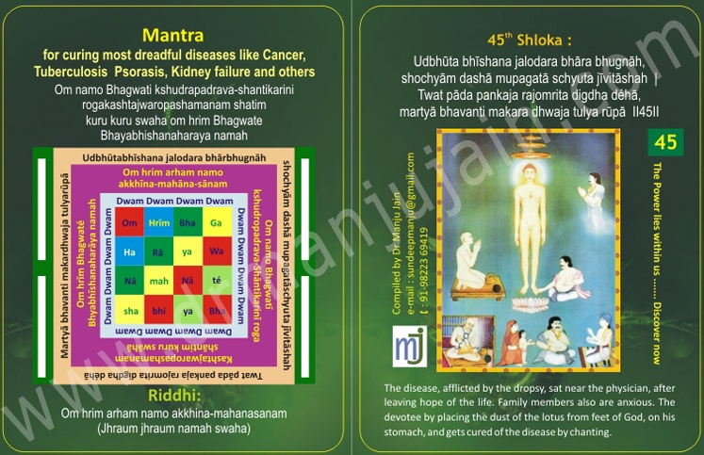

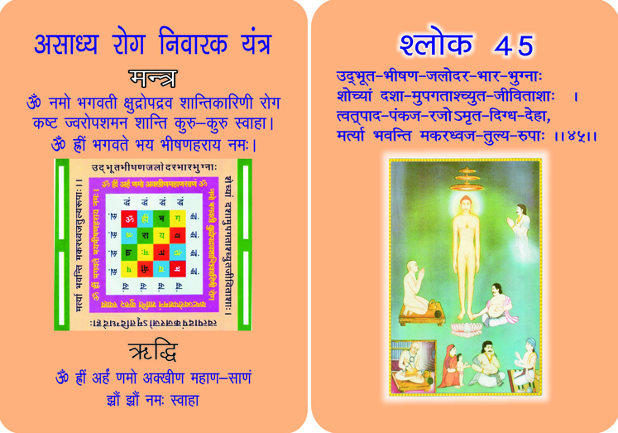
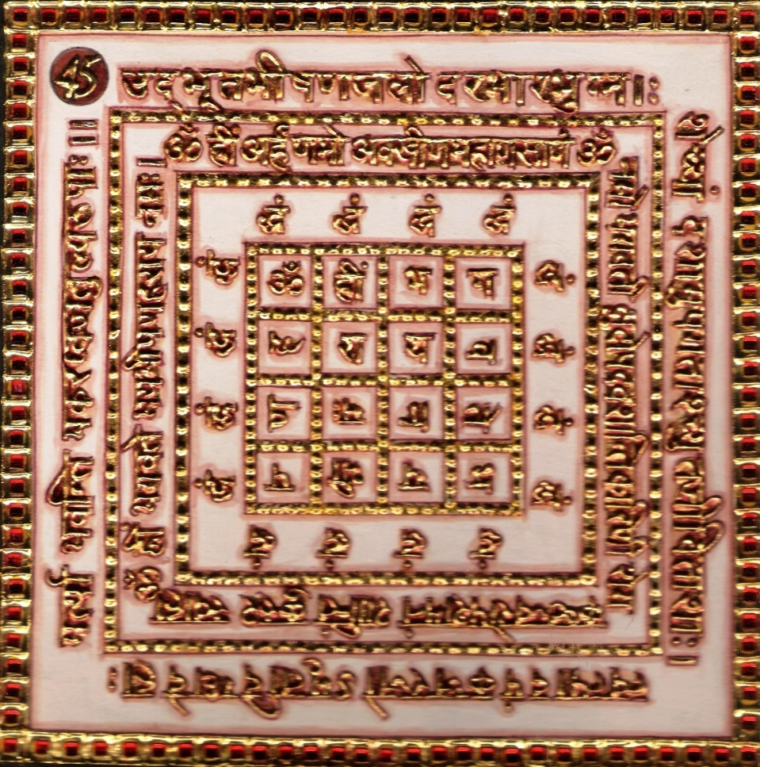
1. Purpose

1.0 The Yantra is kept near and the 21 chants of the verse, Riddhi and mantra syllables are performed to make water mystical which when sprinkled wards of fear from fire.

2.0 SCOPE

2.1. Repeating of the verse is able to extinguish the fire of the jungle with the water flow of the devotion of the God. Before chanting all the wild creatures were running here and there for saving their soul from the fire of the jungle, but as they came nearer Acharya Manatunga they sat quietly.

3.0 METHOD
3.1 After purification and dressed in red keeping the auspicious pitcher facing east and Yantra facing north it is worshipped. Then occupying red scat and facing east the Riddhi and mantra syllables and chanted 12000 times with red rosary.

4.0 RESOURCES

Yanra, Mantra, Riddhi and Verse
Red dress, Red Seat and Red Rosary

Shloka - Repeat 9 times

UDHŪTA BHĪSHANA JALODARA BHĀRA BHUGNĀH,
SHOCHYĀM DASHĀ MUPAGATĀS CHYUTA JĪV ITĀSHAH
TWAT PĀDA PANKAJA RAJOMRITA DIGDHA DÉHĀ,
MARTYĀ BHAVANTI MAKARA DHWAJA TULYA RŪPĀ

Meaning
Persons, bent down under the weight of the horribly risen dropsy, being in pitiable plight and with lost hopes of life, attain equality with the cupid in beauty by applying to their bodies the nectar of pollen of your lotus-like feet.

Mantra - Repeat 108 times

Om namo Bhagwatī kshudropadrava-shāntikarinī rogakashtajwaropashamanam shātim kuru kuru swāhā
Om hrīm Bhagwaté Bhayabhīshanaharāya namah

Riddhi(le pouvoir surnaturel)
Om hrīm arham namo akkhīna-mahānasānam
(Jhraum jhraum namah swāhā)

Evidential Story - 45

The progress of works is really surprising; these works sometimes make us cry, and sometimes they make us laugh. King of Nagpur Narish Mangari went for a walk with his officials. On the way he saw a weak and sick young man lying down under a tree. The king asked him, “Brother who are you?” What is your name? The young man answered “I am the prince Hansraj. I am the son of Nirpshekher. King of Ujjain”. The king enquired, “How did you come here?” The young fellow answered those who face misfortune and wander anywhere, oh! King, Man is subjected to Karmas. The wind of Karma carries him anywhere” The king said, “Son, you seem to be a prince, but what makes you lie here under a tree like a forlorn orphan groaning. Are you sick?” The young man said yes Sir I am very sick and I am suffering from multiple problem Rhumatasm, jaundice three times Rajvadiya has diagnosed dropsy, but he couldn't cure me but I have pain in my knee joint and suffering from cough and cold. You can see the markes of leprosy on my body. I am counting my days of death, but even it seems to be far away from me”.
The young man was overwhelmed with emotions and began to cry. Raja Mangari was a hard hearted person, but he heard of the prince sad story and saw his misery his heart was moved but then a hidden sign of happiness in his eyes. There was strong determination behind his smile as if he has found something he had hosted. Next day King Hangari's daughter Princess Kalawati decked up as a bride was standing in the wedding hall and Prince Hansraj too was there as a groom ready for the marriage. Anyway he was suffering from Karma. The priest, ministers and those who were present in the palace tried to stop the king, “Oh King! Why do you want to marry your only daughter to a lean, haggard, diseased youth? You are spoiling her life you will not even find a place in hell even. But the king was so proud and lost his temper he was not ready to listen to anyone, “He said this girl is my slave she eats from my table, still she speaks of Karma, I am eating because of my Karma she is ungrateful of my favours. Let's see how her Karmas help her in life. The Prince suffering from his Karmas is the right groom for her. “The couple was married. The marriage ceremony was performed in the pale hour of death. Her mother's heart wrenched with sorrow and grief. But what about kalavati she could not speak against her husband and just kept quiet suddenly her progress of karmas took a new turn. The day prince Hansraj and Kalawati were married, every day turned into a golden day and every night changed into a silver night.

It so happened that the couple found the 45th Mahaprabhavak Bhaktamar Shloka written by Param Digambar Saint. For seven days he repeated the Shlokas continuously which turned his body into a real beauty. After that the couple again visited the Muniraj, bowed before him and sat down. Then the Muniraj told that the young man was brought to this condition because his step mother gave him poisonous food to eat. It is good that the prince has left the palace and now he has received new life. These good and bad works have not even excluded the pilgrims. Due to these Karmas we are again and again made to wander into this world. These Karmas take men deep to the bottom of sorrows in their lives and sometimes they take them up on the highest summit of happiness. When the Karmas are destroyed by our penance that is the end of our wandering in this world. Destruction of all the eight Karmas brings about Moksha.

Testimonial

Dr. Mona Rai did MBBS from GMC Nagpur. After which I have had experience of working in various Govt. and private organisation. I have had the chance of working in the Regional Mental Hosital Nagpur. It was an experience of its kind. Dr.Mona Rai has taken up Palliative care as her interest and she has appeared for Palliative Care exam and is at Snehachal Palliative Care in Nagpur. She is helping me in my research studies. I am indebted to Dr.Mona Rai.

Lalita’s husband expired before 17 years, having 3 sons, 2 twins and all are unmarried. Earlier she was living in joint family and since 2 and half years living with her 3 sons. She was operated before 7 months for CA breast and last stage getting Convulsions, she is in Gasappin-she recovered and went home.

Dear Courtney Neal. I am enclosing my abstract for the abstract book as stated by you in email for 2015 APOS World Congress. Abstract Format: Clinical Research on Drugless Therapy Tittle: Effect of Mantra) chanting on terminally ill cancer patients. Background/ Purpose: Chanting and Pineal Gland known for Anticarcinogenic. Pineal gland is responsible for Rhythemic circadian cycle. Its hormones have antiaging and anticytotoxic properties. Psychologically it releases more of Melatonin Hormone which has immunostimulatory function. Methods: Most of the commonly used Quality of Life (QOL) instruments in oncology do not include spirituality as a core domain. However, previous research suggests that spirituality might be an important aspect of QOL for cancer patients and that it may, in fact, be especially salient in the context of life-threatening illness. This study used a large (n=1610) and ethnically diverse sample to address three questions relevant to including spirituality in QOL.

Pneuomonia Patient:

A 55-year-old lady was suffering from double pneumonia. She has difficulty in breathing and admitted in Dr. Tambe’s hospital in very critical condition. She was kept on ventilator from 28 days. Her husband approached Dr. Manju Jain, Spiritual Healer for healing. He started chanting 45th Shloka of Bhaktamara Stotra for 108 times. He was doing abhiskhek on Yantra daily and this holy water he used to give patient on daily basis in the hospital. After one and half month the an improvement was seen in the patient. Now she is breathing without ventilator and no need of oxygen cylinder also. She was then absolutely out of danger and discharged from hospital. The patient was not remembering from last last one and half month and what was happening. Her husband experienced this miracle of Bhaktamar Stotra. He said I had never experienced what it was to sing and chant this mantra. Both of them shares their experience of power of 45th Shloka with Dr. Manju Jain. They express their heartfelt thanks for this miracle to Dr. Manju Jain and give best wishes to her.

Dr. Amrita, Homeopath Doctor and Teacher of Art of Living had started Mantra chanting along with fast for 21 days without salt. She is doing this for her chronic patients like Psoriasis patients One patient was suffering from Psoriasis since 5 years. She had started this drugless therapy by chanting 45th Shloka for her. After 15 days, her psoriasis has been eradicated. She recovered very fast. There is an improvement in her health, hair growth, height and everything is overall growth, health.

46th Shloka for giving freedom from imprisonment

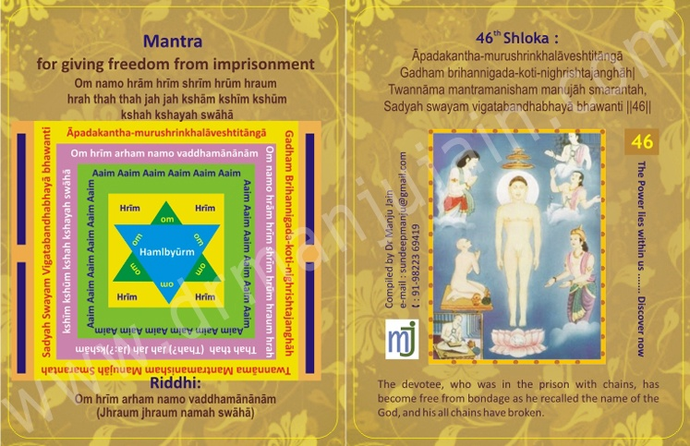

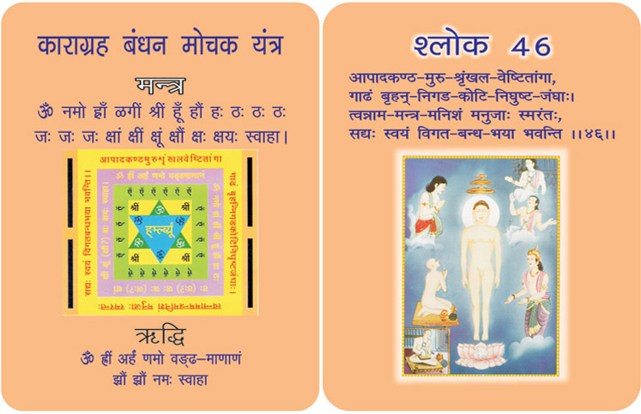
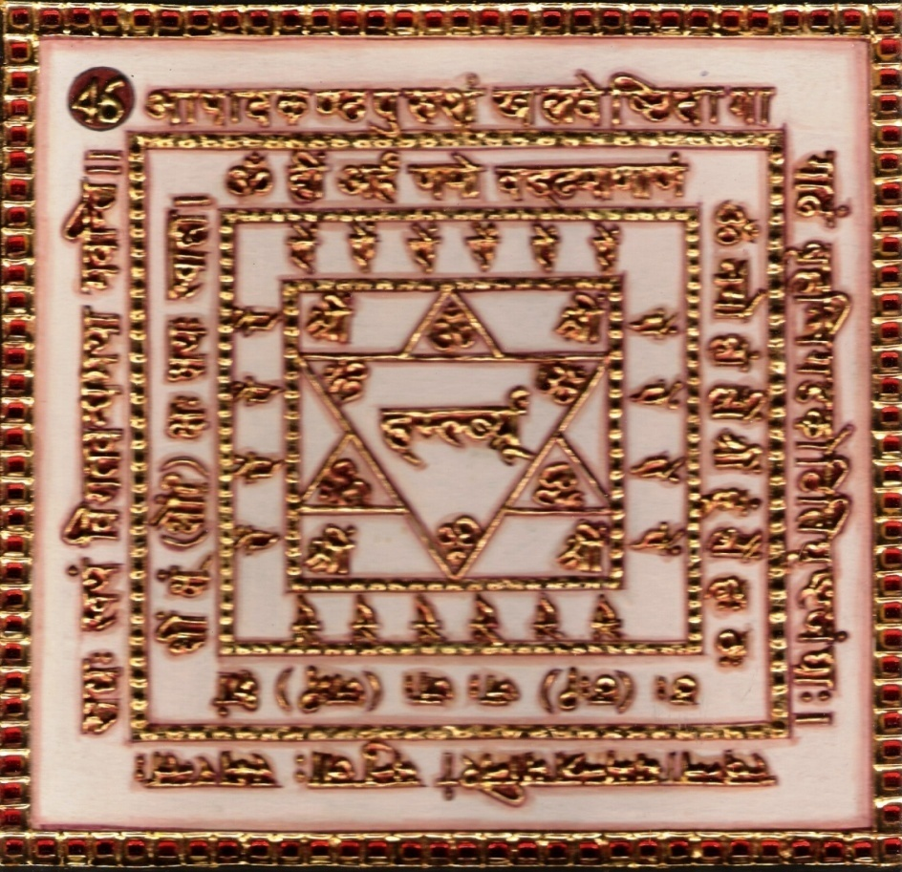

1. Purpose
1.0 At the time of emergent dangers, when bound in iron chains, one becomes free of the Yantra is kept near, and the Riddhi, Mantra syllables and the verse are chanted while worshipping the Yantra all the time.

2.0 SCOPE
2.1. Perhaps, constantly in irons from top to toe and with their thighs scratched over with the edges of the fast (bound) strong chains instantly get themselves off the fear of confinement by restoring to the charm of your name.

3.0 METHOD
3.1 After bath, yellow dress is put on and the Yantra is worshipped with yellow flowers. Keeping it facing the east, the auspicious pitcher is placed; candle is kindled and moving fame with one. Then seated on the yellow sat facing north the Riddhi and mantra syllables are chanted 12000 times with yellow rosary for evincing the Mantra.

4.0 RESOURCES

The Mantra, Yantra, Riddhi & Syllables, Yellow dress, Yellow flowers, Yellow rosary pitcher & candles kindled.

Shloka:

Āpadakantha-murushrinkhalāveshtitāngā
Gadham brihannigada-koti-nighrishtajanghāh |
Twannāma mantramanisham manujāh smarantah,
Sadyah swayam vigatabandhabhayā bhawanti ||46||

Meaning:
Perhaps, constantly in irons from top to toe and with their thighs scratched over with the edges of the fast (bound) strong chains instantly get themselves off the fear of confinement by restoring to the charm of your name.

Riddhi
Om hrīm arham namo arihantānam namo Jinanāma hrām hrim hrūm hraum hrah ā sā ā si ā u sā apratichakra fat vichkrāya jhraum jhraum namah swāhā

Evidential Story - 46
If we turn the pages of medieval history, we see the glorious sun of our civilization and religion going down, but at the same time there were some golden chapters radiant with sun rays of Bhakti Kal, surprising both the king and the subject. The history of the Rajputana's valour is world famous. Jain hero from Rajputana prince Ranpal was a beautiful, healthy, virtuous, adventurous and learned man. His father Urpal, King of Ajmer was seated upon his throne in the palace court. He was visited by a messenger from neighborhood, king of Waspur who was their friend. The messenger brought him a secret letter. The letter said, “Majestic King! May you both live long ! Joginpur Nawabshah Sultan is planning to make an attack on your kingdom. I am your friend, hence it's my duty to inform you and warn you in advance. Rest is fine. Awaiting your command. Yours, King of Waspur”.

When Urpal, the King of Ajmer read the letter at first he became serious, but after some time he declared with great courage and boldness “Is there anyone in this court so brave, who can fight Shah Sultan and bring him alive to me?” “I can bring him, O King !” Prince Ranpal accepted the challenge with boldness and he went on war with his soldiers. The medieval history of India is a witness to the truth that the brave sons of this Nation displayed courage and chivalry. They shed their blood for their motherland. The Rajputs and Hindus were not victorious, but the victory went to the Muslims and the Foreigners. The same was the result of the battle between Ranpal and Shah Sultan. Prince Ranpal was taken captive and was treated like an ordinary prisoner. Rajkumar Ranpal lay in jail without food for 2 days. He began to think about his works. The truth is that in times of trouble the only job that remains to be done in the solitude of the prison, is that one can relate to Parmatma. The values aquired during one's childhood guide the person. Ranpal began to recite the Mahaprabhavi Bhaktamar stotras which he had learnt during his student life. By the time he started repeating 46th verse the iron chains broke and he was free. He went to the Prince Shah Sultan's palace. The Sultan and all the courtiers were amazed to see him there.

The kotwals, darogas and the guards were thoroughly questioned. But everyone was surprised and kept quiet. Finally Shah Sultan personally bound prince Ranpal with iron chains and sent him to jai. He set guards to watch over him. He also personally kept a watch on him from his window. Sultan saw with his own eyes that Ranpal due to his bhaktamar devotion was freed from the chain and was moving towards the palace. Shah was amazed and he immediately went to the palace court and received prince Ranpal and said, “Yuvraj, today I have come to know that your meditation has so much power. You are a good and truthful person. One should be friend you rather than have enmity”. Saying this Shah Sultan hugged Prince Ranpal & with great honour sent him back with his message of friendship. As soon as Prince Ranpal was back there was rejoicing in the city of Ajmer. Prince Ranpal said to the full court that he had not captured sultan physically but he was himself bound with the thread of friendship. King Urpal's joy knew no bounds. The whole Ajmer was filled with shouts of triumph of the Jain religion. Today, non-violence has transformed the violent in to non-violent. In this way enmity was transformed into friendship.
Testimonials:
Mr. Sudhir was imprisoned for using license of trading in state Madhya Pradesh, whereas he was authorized for Maharashtra State. He was in prison for almos 1 year no solution was found even after spending a million of rupees. His wife and cousin came to me for some shloka for release of Sudhir from jail. Not knowing the power of this shloka, I gave him 46th Shloka which said it will help person come out of prison. Sudhir read this for few days and was shifted from prison to the hospital. Later his wife would chant all 48 shlokas with Riddhi and Mantra daily in temple and have food without salt for 30 days and Sudhir was released fromprison and also won the case, judgement went in his favor. He stopped doing the business of pesticides as it was killing germs which was against Jainism and started dairy development. He fasted for 10 days and now he is happy in his new business.

47th Astra-Shastra Nishkriya Kāraka
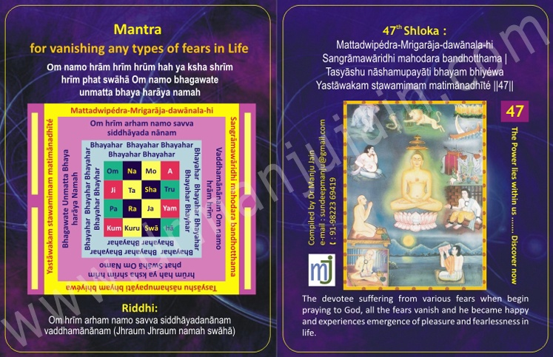

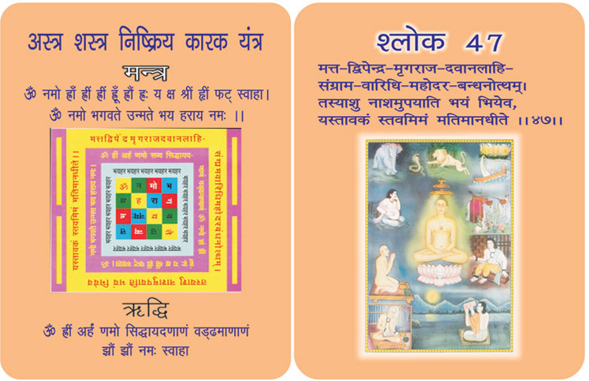
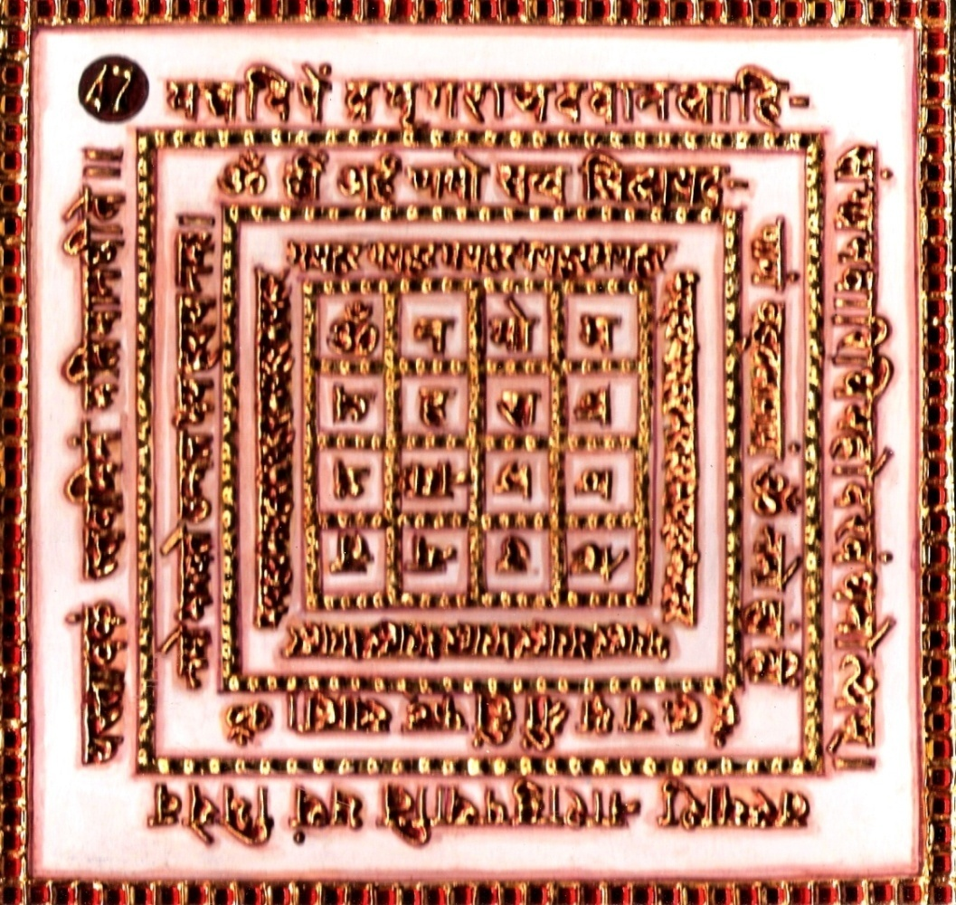

1. Purpose
1.0 To develop faith of people in Jainism (Defeating of enemies and becoming invulnerable to Weapons.)

2.0 SCOPE

2.1. No fear harms me in worldly matters; but I want only the emergence of inner strength to conquer the situations of love and hate, agony and ecstasy, greed and misery, pride and prejudices and so on.

4.0 RESOURCES

The Mantra, Yantra, Riddhi & Verse

Shloka

Mattadwipédra-Mrigarāja-dawānala-hi
Sangrāmawāridhi mahodara bandhotthama |
Tasyāshu nāshamupayāti bhayam bhiyéwa
Yastāwakam stawamimam matimānadhīté ||47||

Meaning:
Of a wise man who recites this eulogy of yours the fear, arising from these eight sources, such as intoxicated elephant, lion, fire, serpent, battle, ocean, dropsy and bonds suddenly dies away, as it were, being frightened.

Ridhhi:
Om hrīm arham namo savva siddhāyadanānam vaddhamānānam
(Jhraum jhraum namswāhā)

Mantra - Repeat 108 times

Om namo hrām hrīm hrūm hah ya ksha shrīm hrīm phat swāhā
Om namo bhagawate unmatta bhaya harāya namah

Evidentual Story - 47:

This is the 47th shloka of the very popular Mahaprabhavak Bhaktamar stotra. To achieve good works or seek justice mantras are an answer. Those who recite mantras should keep doing well by helping others. The person who praises recites mantras to rid himself of worldly desires; and Karma's. But if he does this only to get rid of worldly sufferings he should be careful to see that no one is killed or harmed in anyway.

One should not resort to ways of violence or physical harm: because the person reciting the mantras will have to go through a great deal of suffering. Moreover, if a person doing so commits a mistake, he has to immediately bear a punishment. The recitation of mantras is used to rid the society and religion of the problems and not for selfish ends. The main aim of the recitation of mantras is devotion. Only those mantras that are dedicated towards the gurus are successful. Those who recite mantras with a doubtful heart are never successful. External purification involves taking a bath & internal purification involves works of holiness which include getting rid of unclean thoughts like anger hatred lustful desires. To achieve such kind of holiness one should eat clean food and follow cleanliness regarding eating habits and daily practices. Only such people succeed in this. Such a person should work under a person who is expert in mantras. When reciting mantras one might see dreadful visions. If a person reciting mantras is scared, things can go from bad to worse. A chicken hearted person should not try to recite mantras. Just as lioness's milk can only stay in a golden vase in the same way a person with a bold spirit can only be successful in his recitation. Reciting mantras is a kind of knowledge. A person should get full information regarding mantra recital before starting it. The effect of Bhaktamar Stotra is great whoever memorizes these mantras on a regular basis with great devotion lets his heart blossom and the worshipper attains spiritual growth. In other words, the sweetest fruit of human life is Moksha. The worshipper of the Bhaktamar stotra acquires 'Moksha' The sweetest and greatest fruit humans is to consider himself blessed. There are many benefits to the regular recitation of stotras.

Testimonial
All types of fear are removed by chanting this shloka. You become confident in battlefield. Intoxicated elephant can be controlled by chanting this shloka. In Panchkalyanak the mad elephant started destroying the premises and suddenly they rushed to the Monk, Sagarji Maharaj. The monk started chanting this shloka and immediately the elephant sat down calmly. This is the power of Saint or the Shloka or combined power of both

48th Shloka for Money & Wealth

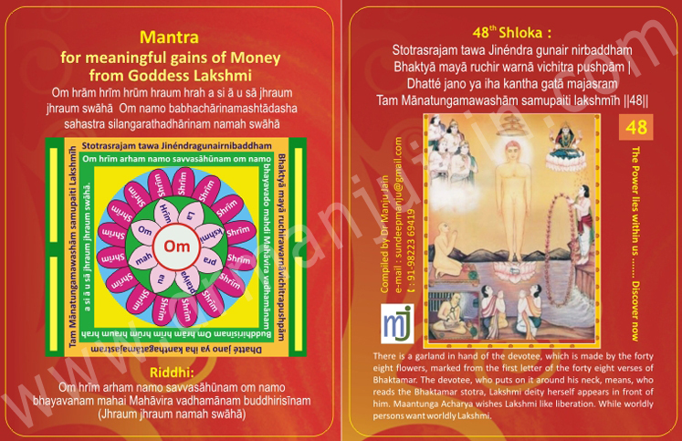

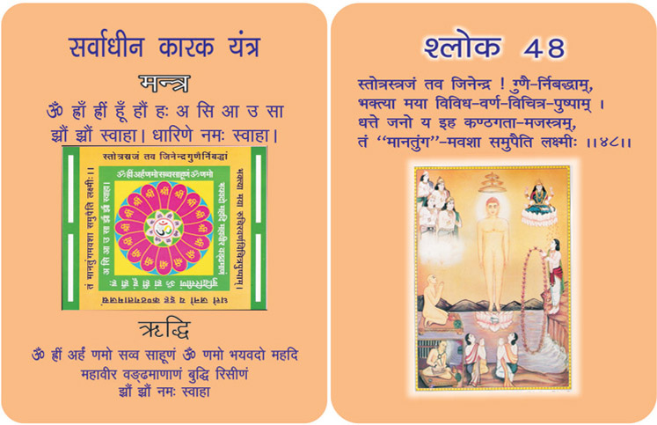
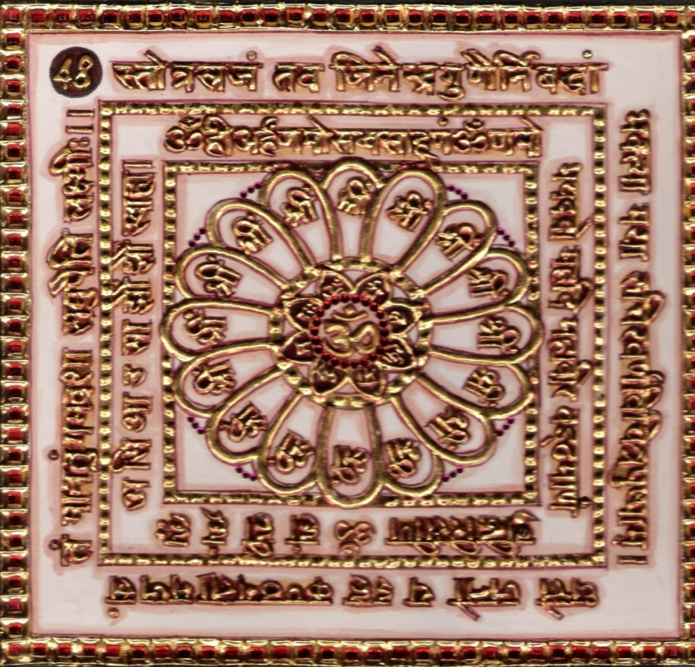
1.0 Purpose
1.1 Fulfilling of desires and bringing under spell desired persons. Offering to God in the form of the words of my devotion. The one who recites this daily will gradually and surely achieve the Godliness.

2.0 Scope
2.1 Lord, I am convinced by your grace that any person who recites
this Bhaktamar Stotra with full devotion and faith will become a person with superlative attributes, where measurement limit or no ego, even in its subtle form can reach.

4.0 Resources
48th Yantra, Mantra, Riddhi & Verse Yellow flowers, Yellow Seat, Yellow Rosary.

Shloka - Repeat 9 times

STOTRASRAJAM TAWA JINÉNDRA GUNAIR NIRBADDHAM
BHAKTYĀ MAYĀ RUCHIR WARNĀ VICHITRA PUSHPĀM |
DHATTÉ JANO YA IHA KANTHA GATĀ MAJASRAM
TAM MĀNATUNGAMAWASHĀM SAMUPAITI LAKSHMĪH || 48 ||

Meaning

The Goddess of wealth of her own accord resent to that man of high self respect in this world, who always place round his neck, O! Jinendra this garland of orisons, which has been strung by me with the strings of the excellences out of devotion, and which looks charming on account of the multi-coloured flowers in the shape of beautiful words.

Mantra - Repeat 108 times

Om hrām hrīm hrūm hraum hrah a si ā u sā jhraum jhraum swāhā.Om namo babhachārinamashtādasha sahastra silangarathadhārinam namah swāhā

Riddhi (le pouvoir surnaturel)
Om hrīm arham namo savvasāhūnam om namo bhayavanam mahai Mahāvira vadhamānam buddhirisīnam (Jhraum jhraum namah swāhā)

Evidential Story - 48

Every, creature in this world loves freedom; even though he may not understand its meaning. How much soever good slavery may offer to live in freedom is what everyone desires. Even though you keep a parrot in a golden cage for years but he will fly away at the first opportunity. An independent and self dependent person desires the joy of freedom despite all its sufferings. A morsel taken in slavery tastes like poison. A prisoner whether bound with iron or golden chains is still a prisoner that is the reason India fought for its freedom when it was bound in slavery. The British rule was disciplined orderly and that during that period it was said that the sun would never set on its empire. In spite of having a prosperous nation the patriotic leaders got independence for our country. History is witness, to the fact India always strived to set itself free from foreign rule and slavery. This a matter of political freedom.
The philosophical order is based on 2 facts 1) Bondage 2) Freedom
Complete moksha is complete freedom. There is complete freedom in Jain religion. All creatures are free by nature. Even if a cow may seem to be tied to a tree but actually it is free. According to Jain religion all is vanity. Here, Acharya Maharaj Shri while showing the path of freedom from the worldly and political bondage says that the person who recites God's name achieves freedom. The worldly creature is bound by his own works.
.

Testimonial

Shloka no. 48 for WEALTH CREATION There was lady who was into financial trouble, she had taken 5 lakh rupees loan from a bank and the due date for payment came and she was scared as bankers were pressuring her for repayment.She came to me asking for this amount I informed that tomorrow one of my fixed deposit is getting matured then I would be able to give her money but she insisted that she has to pay back that day only as it was last day for loan return otherwise bank would seize mortgage the property .I give her 48 th shloka for continuous chanting she did it with full faith and found some help and was able to clear the debt .Today her husband owns two showroom of SIYARAM suitings and she owns a ladies garments and cosmetics shop. This is the power of 48 th shloka -Lakshmi Goddess of wealth abundance blesses them.

######

